Mathematics Instructional Plan – Grade Three

The Point of Geometry
Strand: Geometry
Topic: Naming and identifying points, line segments, rays, angles and lines
Primary SOL: 3.11 The student will identify and draw representations of points, lines, line segments, rays, and angles.

Materials
- Vocabulary Match activity sheet (attached)
- Matching Cards (attached)
- Exit Ticket activity sheet (attached)

Vocabulary
angle, endpoint, line, line segment, point, ray, vertex, vertices

Student/Teacher Actions: What should students be doing? What should teachers be doing?
- Using the Matching Cards, have students work in pairs to match the picture with the name and the definition. Engage students in a class discussion on the way they matched each and create a class list of each. Have students glue their matches on the Vocabulary Match activity sheet. Students should include their own example of where each can be found.
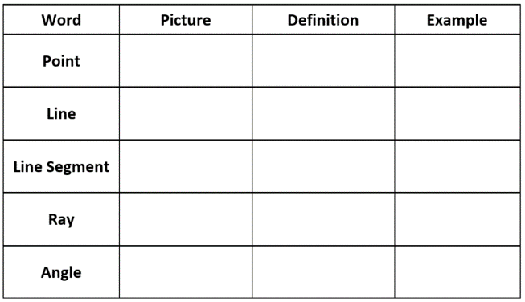
- Have students stand around the room with space to move about. Explain that you are going to physically represent each word on your list. Start with “point.” Have students hold up one hand and create a fist. Refer to the definition of a point: an exact location in space with no length or width.
- Next, demonstrate a line by stretching out both arms horizontally, with hands open and fingers stretched out straight. Refer to the definition of a line: a collection of points going on and on indefinitely in both directions. Have students create a fist on both hands and stretch their arms out. Refer to the definition for line segment: part of a line; has two endpoints and includes all of the points between the two endpoints.
- Ask students to show how they could physically represent a ray (one hand in a fist with the other stretched out horizontally with fingers stretched out). Ask them to physically represent an angle (arms stretched out at varying degrees with fingers stretched out).
- Once you have demonstrated each, randomly call out one at a time to have students practice representing each word physically.
- After students return to their seats, ask them to share the real-world examples they wrote for angle, line, line segment, point, and ray. Students may add new ideas they hear to their tables or write ideas in their journals.
Assessment

Questions
  - What is the difference between a line and a line segment?
  - How are angles and rays similar?

Journal/writing prompts (include a minimum of two)
  - What are some examples of angles, rays, and line segments that may be found at home? List them or draw examples.
  - Draw a polygon. How many angles are in your polygon? What is the relationship to the number of angles and the number of sides?

Other Assessments (include informal assessment ideas)

Exit Ticket

Extensions and Connections (for all students)
- Have students create pictures using lines, line segments, angles, rays, and points. They should clearly identify each in their picture.
- Go on a silent scavenger hunt around the school and search for examples of each. Draw examples you find. Share them when you get back to the room and see who came up with the same examples or who found unique examples.

Strategies for Differentiation
- The geometry standards are filled with vocabulary. Students would benefit from creating their own “Geometry Dictionary” or flash cards.
- A variety of vocabulary games would help students in remembering the meanings of words (e.g., concentration, bingo, games on the computer).

Note: The following pages are intended for classroom use for students as a visual aid to learning.

Virginia Department of Education Updated©2023

Vocabulary Match
Word | Picture | Definition | Example
Point
Line
Line Segment
Ray
Angle

Matching Cards
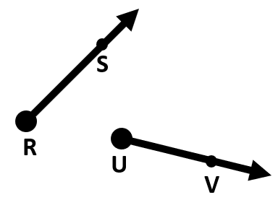 | A collection of points going on and on infinitely in both directions
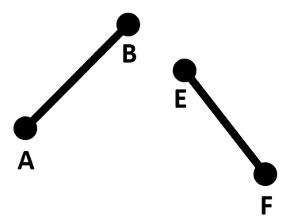 | An exact location in space with no length or width
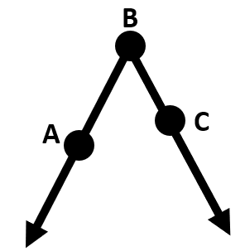 | Part of a line; has two endpoints and includes all the points between the two endpoints
 | Two rays that have a common endpoint
 | Part of a line; has one endpoint and continues on and on in one direction

Exit Ticket
Draw an example of each.
LINE | POINT | ANGLE | RAY | LINE  SEGMENT

Circle the box that has two rays and one line segment.
