Mathematics Instructional Plan – Grade Three

What’s the Temperature Now?
Strand: Measurement and Geometry
Topic: Reading temperatures
Primary SOL: 3.10 The student will read temperature to the nearest degree.
Related SOL: 3.15 a, b

Materials
- Outdoor thermometer that reads to the nearest degree Fahrenheit/Celsius
- It’s Getting Hot in Here! Temperature Game (attached)
- Fahrenheit/Celsius Thermometer Template (attached)
- Bar Graph template (attached)

Vocabulary
Celsius, Fahrenheit, difference, temperature, thermometer

Student/Teacher Actions: What should students be doing? What should teachers be doing?
Note: Before beginning this activity, students should have had practice reading temperatures in Celsius and Fahrenheit on real thermometers and on physical models of thermometers to the nearest degree.
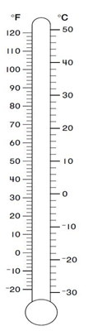
** This lesson should be done daily for approximately five consecutive days.
- Select three different times during the day that students may read and record the outdoor temperature. The times should be the same daily.
- Assign a group of about four students to read the temperature at each given time. All students in the group should have the opportunity to read the thermometer, and all should agree on the temperature. Have students record the temperature measured on a thermometer (provided) and write the time recorded and the temperature in degrees Fahrenheit. Throughout the process, all students should have more than one opportunity to read the thermometer.
- Display the data collected on a simple bar graph. Use a different graph daily so that you can look back and compare temperatures from each day.
- Throughout the process ask students, “How much did the temperature rise (or fall)?” “Is the temperature today warmer or cooler than this time yesterday?” “What is the difference in temperature?” “Which day had the greatest rise in temperature?”
- This activity can be repeated using a Celsius thermometer.

Assessment

Questions
  - If I have on a heavy coat, scarf, hat, and gloves, what could the temperature be in Fahrenheit? Celsius? How do you know?
  - If it’s 85° Fahrenheit, what might you be wearing? Draw a picture of yourself and your location. Why are you wearing this kind of clothing?

Journal/writing prompts
  - Read and record the temperature of the classroom to the nearest degree from a Fahrenheit thermometer and from a Celsius thermometer, and then write two statements comparing the two temperatures.
  - Research locations around the world with the coldest and hottest temperatures. Describe the landscape for each location.

Other Assessments
- Put students in pairs. Give one student in each pair a list of temperatures and the other student a set of pictorial representations of thermometer readings. Have partners work together to match the listed temperatures to the corresponding thermometer readings.

Extensions and Connections (for all students)
- Have students collect weather information for the local area from newspapers, television news, and/or the internet. Have students practice depicting the listed temperatures on physical models of thermometers.
- Have students work in pairs or groups to play the It’s Getting Hot in Here! Temperature Game. Use the Thermometer Template to make thermometers representing the temperatures listed on the game board (e.g., shade one of the thermometers to show 45˚F, and cut it out as one of the game cards).

Strategies for Differentiation
- Technology
- Have students look up the average local temperatures on the internet and graph the results, using a graphing software program.
- Multisensory
- Have students use two different colors to indicate temperatures in Celsius and temperatures in Fahrenheit.
- Small-group Learning
- Have students work together in groups of two or three to create, exchange, and solve five word problems dealing with the temperature changes that they have observed during the unit.
- Vocabulary
- Because this is a long-term activity, post a wall chart with the vocabulary words and corresponding visual cues so students can refer to them as needed.
- Student Organization of Content
- Have students develop a line graph of the temperatures they are tracking during the activity. The graph could be kept in a notebook and updated daily.
Note: The following pages are intended for classroom use for students as a visual aid to learning.
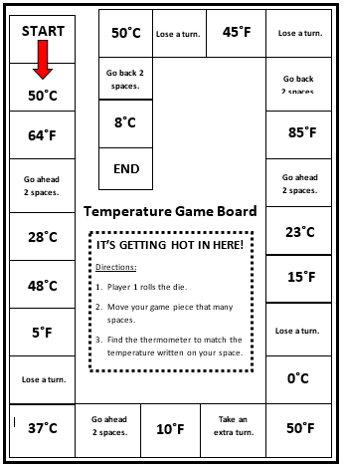

Fahrenheit/Celsius Thermometer Template

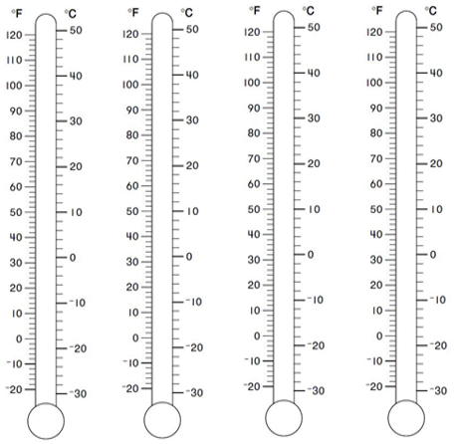

Bar Graph Template
