Mathematics Instructional Plan – Grade Three

Adding and Subtracting Fractions
Strand: Computation and Estimation
Topic: Adding and subtracting fractions with like denominators
Primary SOL: 3.5 The student will solve practical problems that involve addition and
subtraction with proper fractions having like denominators of 12 or less.
Related SOL: 3.2a, 3.2b, 3.2c

Materials
- Whiteboards/markers (one for each student or for each pair of students)
- Fraction Strips (attached, or use strips from Lesson 3.2c)
- Adding and Subtracting Fractions activity sheet (attached)
- Four-in-a-Row directions (attached)
- Four-in-a-Row Game Board (attached)
- Fraction Chart (attached)

Vocabulary
denominator, difference, improper fraction, fraction, mixed number, numerator, proper fraction, sum, whole number

Student/Teacher Actions: What should students be doing? What should teachers be doing?
- If students do not have premade fraction strips, have them color the attached fraction strips -- each fraction with the same denominator one color and each different denominator a different color (halves one color, thirds a different color, etc.). Have students cut out all pieces once they have finished coloring.
- Throughout the lesson be sure to use the terms fraction, whole number, proper fraction, improper fraction, mixed number, numerator, denominator, sum, and difference and encourage students to use the terms.
- Group students in pairs. Provide scenarios of practical problems such as: Sean has $\frac{1}{2}$ gallon of lemonade and Luis $\frac{1}{2}$ gallon of lemonade. How much lemonade would they have if they combined their lemonade?) Have student pairs to work together to see how they might use the fraction strips to model what is happening in the problem. It is likely that the pair will put two $\frac{1}{2}$ strips end to end. Ask, how much lemonade do they now have? Ask, is there any other way to represents the total? Then students how they might write an equation to represent the action in the problem. Have students write the equations on their whiteboards. Students will likely generate the equations $\frac{1}{2}$ + $\frac{1}{2}$ = 1 or $\frac{1}{2}$ + $\frac{1}{2}$ = $\frac{2}{2}$.
- Provide students with scenarios that involve addition and subtraction. A subtraction scenario might be: Lydia is riding her bike to school today. She lives $\frac{3}{6}$ of a mile from school. She rode her bike $\frac{1}{6}$ of a mile. How much farther does she still need to bike? Again, ask students how they might use their fraction strips to model the problem. Students will likely use three $\frac{1}{6}$ strips to model the distance Lydia lives from school, they may either remove a $\frac{1}{6}$ strip that shows the distance she has traveled, leaving $\frac{2}{6}$ mile she still needs to travel. Ask students to generate an equation that could be used to solve the same problem. Have students write the equation on their whiteboards.
- Provide additional practical problem scenarios that students can solve. Make sure to have students model the problems with fraction strips or other manipulatives available in the classroom. It is important that students explain their reasoning to their partners and to the whole group as appropriate. It is helpful during whole group discussions to have students compare strategies and models to make additional connections. It is important to keep in mind that subtraction problems can be solved as missing addend problems – so some students may complete the problem or equation $\frac{2}{3}$ + ____ = $\frac{3}{3}$ or 1?”
Ask, “How is the first equation related to the second equation? (1 - $\frac{1}{3}$ = $\frac{2}{3}$, or 1 - $\frac{2}{3}$ = $\frac{1}{3}$). This provides a great opportunity for students to make connections around the inverse relationship of addition to subtraction.
- Display the following problems
  - Tina had one candy bar to share with her friend. She gave her friend $\frac{3}{6}$ of the candy bar. How much did she have left? Model the problem using fraction strips. Draw a picture on your whiteboard and write the equation that shows the solution.
  - Mom baked a pan of brownies. She cut them into eighths. Dad ate $\frac{2}{8}$, and brother ate $\frac{3}{8}$. Together, how much of the pan of brownies did they eat? How much of the pan of brownies is left? Model each and write the equation.
- Ask, “What do you notice about the denominator in your sum, or difference, when adding or subtracting fractions with like denominators?” Have students explain why the denominator does not change.
- Ask, “What happens when you add fractions and get a sum greater than 1 whole? What kind of a fraction do you get?” (Students should be able to name both mixed number and improper fraction.)
- Distribute the Adding and Subtracting Fractions activity sheet. Have students model each problem using their fraction strips and write the equation for each problem.

Assessment

Questions
  - What kind of fraction do you get when your sum goes beyond the whole?
  - When we added and subtracted fractions, why did the denominator stay the same?

Journal/writing prompts
  - Draw a model and write an equation that represents the sum of $\frac{6}{8}$ and $\frac{3}{8}$. Create a story where you might use this equation in determining the solution.
  - Draw a model and write an equation that represents the difference between $\frac{6}{8}$ and $\frac{3}{8}$. Create a story where you might use this equation in determining the solution.
  - The answer is $\frac{4}{6}$. What might be the equation? Explain.

Extensions and Connections
- Draw a number line to include the whole numbers 0–4. Represent fourths for each number. Illustrate how to add fractions using the number line. Examples:
$\frac{1}{4}$ + $\frac{2}{4}$ ; $\frac{3}{4}$ + $\frac{1}{4}$ ; $\frac{3}{4}$ + $\frac{3}{4}$
- Adding and Subtracting Fractions activity sheet (attached)
- Four-in-a-Row Activity (practicing adding fractions with like denominators without a context) – includes proper fractions, improper fractions, and mixed numbers.

Strategies for Differentiation
- Use a variety of models to represent fractions. Students need to see fractions in many representations.
- Some students may benefit from using more-durable fraction pieces (e.g., foam, plastic, precut).
- Have students add fractions and mixed numbers with like denominators. Students should represent their thinking using pictures/models.

Note: The following pages are intended for classroom use for students as a visual aid to learning.

Virginia Department of Education ©2018
Adding and Subtracting Fractions
Name ________________________________ Date ________________
Model each using fraction strips and write the equation for your solution.
- Mom baked a cake. The recipe called for $\frac{2}{4}$ cup of flour and $\frac{1}{4}$ cup of sugar. How much flour and sugar combined did the recipe call for?
Equation: ___________________________
- Sam made a homemade pizza. He put pepperoni on $\frac{5}{8}$. The rest did not have pepperoni. How much of the pizza did not have pepperoni?
Equation: ___________________________
- Draw a model and solve. What do you notice about the answer?

$$\frac{4}{6} + \frac{7}{6} =$$
- The answer is $\frac{9}{12}$ what might be the equation? Write a story problem that would allow you to use the equation to solve the problem?

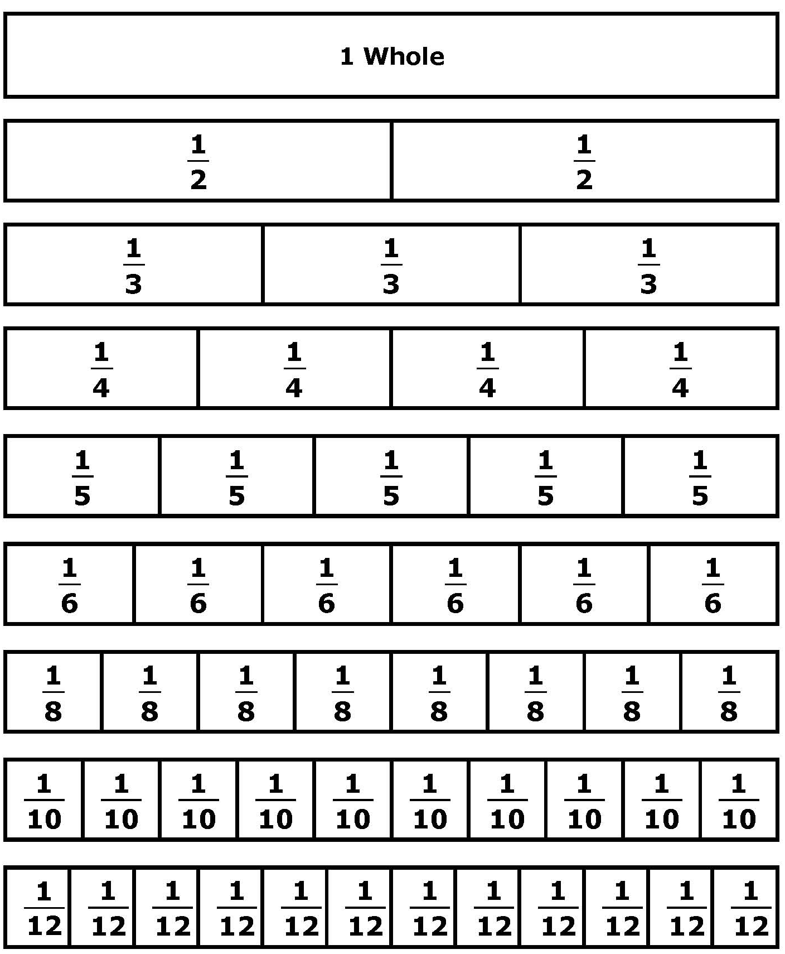
Fraction Strips

Four-in-a-Row
Directions
- Students play in pairs. Each pair needs:
- two sets of Fraction Strips
- a Fraction Chart
- a Four-in-a-Row game board
- pawns or markers
- an Adding and Subtracting Fractions Recording Sheet
- Let each student pair decide who goes first. Player 1 chooses two fractions on the Fraction Chart that can be added or subtracted to get one of the answers on the game board. Player 1 must demonstrate the problem with the fraction strips, after which he or she covers the answer with a marker. Once an answer on the game board has been covered, it cannot be used again. Have students record their plays on the recording sheet.

Four-in-a-Row Game Board

$\frac{1}{4}$ | $$\frac{3}{8}$$ | $$1\frac{2}{5}$$ | $$\frac{1}{5}$$
$$1\frac{1}{4}$$ | $$\frac{2}{12}$$ | $\frac{7}{8}$ | $\frac{1}{8}$
$$\frac{5}{6}$$ | $\frac{4}{12}$ | $$\frac{6}{10}$$ | $\frac{1}{3}$
$$1\frac{2}{10}$$ | $$\frac{4}{5}$$ | $\frac{2}{4}$ | 1

Fraction Chart

$\frac{7}{8}$ | $$\frac{2}{6}$$ | $\frac{1}{4}$ | $\frac{1}{3}$
$\frac{2}{5}$ | $\frac{2}{3}$ | $\frac{3}{4}$ | $\frac{2}{4}$
$\frac{1}{8}$ | $\frac{5}{8}$ | $\frac{3}{6}$ | $\frac{6}{8}$
$\frac{3}{5}$ | $\frac{4}{5}$ | $\frac{3}{8}$ | $\frac{1}{5}$
$\frac{9}{10}$ | $\frac{7}{12}$ | $\frac{3}{10}$ | $$\frac{3}{12}$$

