Mathematics Instructional Plan – Grade Three

Comparing Fractions
Strand: Number and Number Sense
Topic: Comparing Fractions
Primary SOL: 3.2 The student will
- compare fractions having like and unlike denominators, using words and symbols (>, <, =, or ≠), with models.
Related SOL: 3.2a, b; 3.5

Materials
- TOP SECRET activity sheet (attached)
- Envelopes (one per student)
- Fraction Strips sheet (attached)
- Scissors
- Colored pencils or crayons (nine different colors)
- Resealable plastic storage bags
- Mine’s Bigger! Fraction Comparison Game directions (attached)
- Mine’s Bigger! Fraction Comparison Game Recording Sheet (attached)
- Fraction Cards (attached)
- Paper bags

Vocabulary
benchmarks (0, ½, 1), compare, denominator, equal to, fraction, greater than, greatest, improper fraction, least, less than, mixed number, numerator, proper fraction

Student/Teacher Actions-What should students be doing? What should teachers be doing?
- Review the definitions for fraction, whole, proper fraction, improper fraction, and mixed number.
- Write the following fractions on the board:
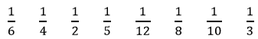
- Distribute the TOP SECRET Fraction sheet. Instruct students to write the fractions in order from least to greatest in the table on their sheets. Have students put their sheets in their envelope, label it TOP SECRET, and seal it. Tell them they will come back to it later in the lesson.
- Distribute the Fraction Strips sheet. Students will need a pencil and coloring tools of nine different colors.
- Have students label the top bar with a “1,” indicating that the bar represents the “whole.”
- Ask, “If this is the whole, what would the name for two equal parts be?” “Write $\frac{1}{2}$ in each space.” Continue down the page so that students correctly identify and write the name of each fractional piece on the page. Students should lightly color each fraction, so that the number can be read; use a different color for each strip representing the particular fractional parts (i.e., both halves are one color, thirds are a different color); and then cut apart all pieces.
- Students should have all pieces organized on their desks. Ask students to find one fractional piece greater than $\frac{1}{3}$. Find one piece less than $\frac{1}{3}$. How many thirds put together would be more than $\frac{1}{2}$. How many fourths put together equal $\frac{1}{2}$ ? How many fourths would be more than $\frac{1}{2}$ but less than 1 whole?
- Introduce benchmarks of 0, $\frac{1}{2}$ , and 1. Ask, “Would you say that $\frac{1}{12}$ is closer to zero, $\frac{1}{2}$, or 1?” “Why do you think this is?” “Would you say $\frac{3}{4}$ is closer to zero, $\frac{1}{2}$ , or 1? Why do you think this?”
- Have students take one fraction piece from each represented denominator. Tell students to put them on their desks in order, from least fractional size to greatest fractional size.
- Open your TOP SECRET envelopes and compare your prediction to the actual fraction pieces. Was your prediction correct or incorrect? Reflect on your prediction.
- Engage the class in a discussion on the correct order of fractions (from least to greatest) and ask what they “notice” about each fraction. Ask, “Why do you think the smaller denominator is the largest piece and the larger denominator is the smaller piece?”
- Explain the directions for the “Mine’s Bigger!” game. Students should use their fraction strip pieces to model the fractions they draw from the bag to decide which player has the bigger piece.

Assessment

Questions
- What part of a fraction do you look at to compare two fractions?
- Why is it easier to compare fractions with like denominators?
- Name 3 fractions less than ½. Explain your reasoning.

Journal/Writing Prompts
- Explain how benchmarks help you compare fractions.
- How could drawing a fraction model help you compare two fractions?

Other
- Have pairs of students play the Mine’s Bigger! Fraction Comparison Game (see attachment).

Extensions and Connections (for all students)
  - Have students work with a partner to test each other by finding fractions greater than ____ or less than ____.
  - Have students create models using rectangles or circles.
  - Make connections between fractions for halves and fourths to measurements on a ruler.
  - Create number lines for fractions such as thirds, sixths, halves, fourths, eighths, fifths, and tenths, etc.

Strategies for Differentiation
- Students may need physical practice making fractions from a whole by folding paper strips or cutting sheets of paper.
- Some students may benefit from using more-durable (e.g., foam, plastic or precut strips) fraction pieces during the lesson or activities.
- Use multiple representations for fractions (i.e., fraction circles, fraction squares, sets of objects, linear models such as number lines and rulers).

Note: The following pages are intended for classroom use for students as a visual aid to learning.

Virginia Department of Education ©2018
TOP SECRET
Fraction Order
Write the following fractions in order from least to greatest in the table below. Put your card in your envelope and seal it. Label it TOP SECRET!
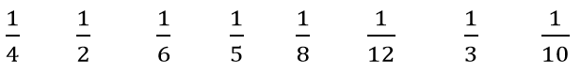

My prediction was: __________________________________

My Reflection:

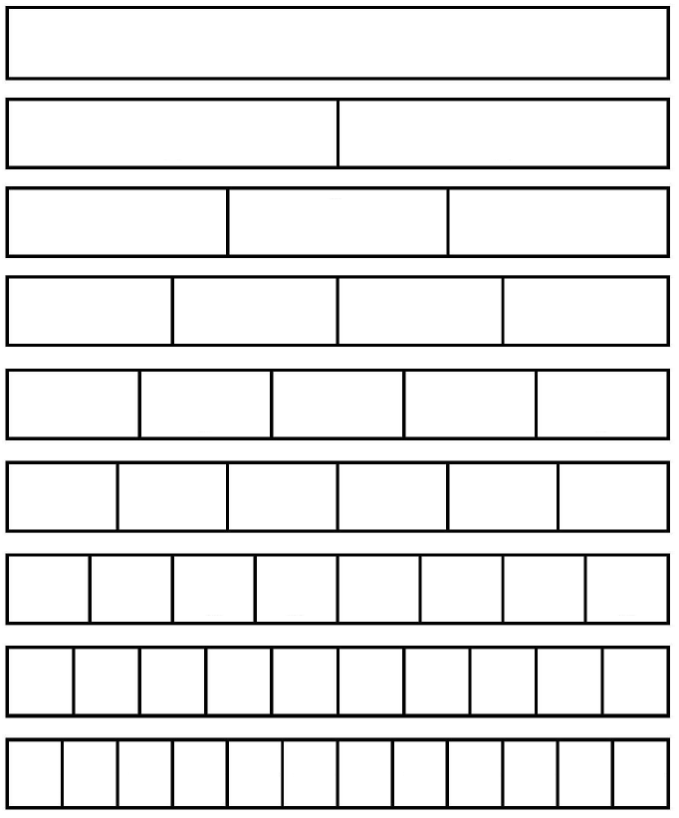
Fraction Strips

Mine’s Bigger! Fraction Comparison Game
Directions
- Decide who will be Player 1 and who will be Player 2.
- Player 1 draws a fraction card from a paper bag, and both players write the fraction in the first column of the chart.
- Player 2 draws a fraction card from the bag, and both players write the fraction in the third column of the chart.
- Students compare their fractions using fraction strips.
- Players must then use the symbols <, >, or = to compare the two fractions, deciding which one is bigger and writing in the fourth column.
- The player with the bigger fraction earns 1 point. If the fractions are equal, no points are awarded.
- The first player to get 10 points wins the game.

Mine’s Bigger! Fraction Comparison Game
Recording Sheet
Player 1’s fraction | <, >, or = | Player 2’s fraction | Which fraction is bigger? | Player 1’s points | Player 2’s points

Fraction Cards
Copy on card stock, and cut out on the dotted lines.
$\frac{1}{2}$ | $\frac{3}{4}$ | $\frac{1}{3}$
$\frac{2}{3}$ | $\frac{2}{6}$ | $\frac{3}{8}$
$\frac{4}{8}$ | $\frac{5}{6}$ | $\frac{1}{6}$
$\frac{2}{4}$ | $\frac{1}{8}$ | $\frac{3}{5}$

$\frac{1}{10}$ | $\frac{4}{6}$ | $\frac{3}{6}$
$\frac{3}{10}$ | $\frac{5}{10}$ | $\frac{6}{10}$
$\frac{2}{8}$ | $\frac{7}{8}$ | $\frac{6}{8}$
$\frac{5}{8}$ | $\frac{1}{4}$ | $\frac{2}{10}$
$$\frac{1}{12}$$ | $$\frac{2}{12}$$ | $$\frac{3}{12}$$
$$\frac{4}{12}$$ | $$\frac{6}{12}$$ | $$\frac{7}{12}$$
$$\frac{9}{12}$$ | $$\frac{10}{12}$$ | $$\frac{4}{4}$$
$$\frac{1}{5}$$ | $$\frac{2}{5}$$ | $$\frac{4}{10}$$
$$\frac{4}{5}$$ | $$\frac{5}{5}$$ | $$\frac{8}{8}$$
$$\frac{3}{3}$$ | $$\frac{7}{10}$$ | $$\frac{8}{10}$$
$$\frac{9}{10}$$ | $$\frac{8}{12}$$ | $$\frac{9}{12}$$
$$\frac{5}{12}$$ | $$\frac{11}{12}$$ | 1

