Mathematics Instructional Plan – Grade Three

Shapely Fractions
Strand: Number and Number Sense
Topic: Comparing fractions using like and unlike denominators
Primary SOL: 3.2 The student will
- represent fractions and mixed numbers, with models and symbols
Related SOL: 3.2 a, c 3.5

Materials
- Pattern blocks
- Fractions with Pattern Blocks activity sheet (attached)
- Fractions on a Number Line activity sheet (attached)
- Fractions and Mixed Numbers on a Number Line activity sheet (attached)
- Bump Directions activity sheet (attached)
- Mixed Number and Improper Fraction Bump activity sheet (attached)
- Mixed Number and Improper Fraction Bump Game Board (attached)
- Exit Ticket (attached)
- Counters
- Number cubes

Vocabulary
denominator, equal parts, fraction, improper fraction, mixed number, numerator, partition, proper fraction, whole

Student/Teacher Actions: What should students be doing? What should teachers be doing?
- Distribute pattern blocks to students.
- Give students time to discover the relationships between the pattern blocks and have them share their findings with the class. (Example: It takes three blue rhombi to make a hexagon.) During the discussion, review how to write fractions and what the numerator and denominator mean.
- Distribute the Fractions with Pattern Blocks activity sheet to students. Have students work with a partner. Say, “To begin, the hexagon represents our whole. Your task is to partition the whole into equal parts as many possible ways as you can. Record your thinking on your activity sheet.” The teacher may need to show students how to write the fraction and describe the meaning of the fraction. For example, in problem 1, because the hexagon has been partitioned into two equal-sized pieces, students would write the number for one of the pieces, which would be $\frac{1}{2}$ of the hexagon. Two pieces would be $\frac{2}{2}$.
- The students will continue to look at the different ways they can make a hexagon and write the fractions for the rhombus and the triangle. Allow students to verbalize their thinking by talking with a partner.
- Next, change the size of the whole and present students with the trapezoid. (You may have to bring students back to what a fraction is and review equal parts.) Say, “If our trapezoid is now the whole, what fraction of the trapezoid would be a triangle?” Have students turn and talk, and then share their thinking. Ask: “How did your thinking change as you considered the trapezoid as the whole?” “How was this similar and/or different to your thinking when the hexagon was the whole?” “If the rhombus is the whole, what fraction of the rhombus is a triangle?” Give students some time to think and then share as a whole group.
- Circulate among the students to take note of the types of relationships they are discovering and any misconceptions or difficulties students have expressing the relationship as a fraction. To deepen student thinking, ask: “Do you see any other relationships to the (shape)?” “Can you prove the relationship between (shape) and (shape)?”
- After students have had time to work through the problems, go over the answers and have students discuss the reasoning they used when they were completing the activity. Make sure students understand that the whole can change. This is also a time to make a connection to fractions on a number line. The teacher should draw a number line on the board and label it from 0 to 1 with $\frac{1}{2}$ in the center of the number line. Place dashes on the number line to indicate $\frac{1}{4}$ and $\frac{3}{4}$. Place a dot at the $\frac{3}{4}$ mark and ask students to name the fraction.
- Next, ask, “If a hexagon is the whole, how would you build $3\frac{1}{2}$?” “$1\frac{1}{3}$?” “$1\frac{5}{6}$?” “If the trapezoid is the whole, how would you build $2\frac{2}{3}$?” “If the rhombus is the whole, how would you build $2\frac{1}{2}$?” Can the students name the improper fraction for each mixed number? Can they prove their thinking with the pattern blocks? Again, make a connection to mixed numbers on the number line and see whether students can give the mixed number for where a dot is placed on the number line.

Assessment

Questions
  - How can you model $\frac{1}{3}$ using the pattern blocks?
  - How can you model $2\frac{2}{6}$ using the pattern blocks?
  - How can you model $\frac{7}{3}$ if your whole is the trapezoid?

Journal/writing prompts
  - Create your own pattern-block fraction problem, where you determine the whole and your answer is a fraction less than 1.
  - Create your own pattern-block fraction problem, where you determine the whole and your answer is a mixed number.
  - Draw a number line and show where $\frac{1}{3}$ would be placed between 0 and 1.

Other Assessments

Have students play Bump (see attached activity sheet).
  - Exit Ticket (see activity sheet)
  - Fractions on a Number Line (see attached activity sheet)
  - Fractions and Mixed Numbers on a Number Line (see attached activity sheet)

Extensions and Connections
- Students could write an equation to represent their whole using fractional parts.
- The teacher could connect this lesson to the addition of fractions or the decomposition of fractions.

Strategies for Differentiation
- Provide triangle paper to help students track their work visually.
- Assess students with simpler polygons, such as the trapezoid and rhombus.

Note: The following pages are intended for classroom use for students as a visual aid to learning.

Virginia Department of Education ©2018
Fractions with Pattern Blocks
Name ______________________________________ Date ___________________

Directions: Write your answers as a fraction.

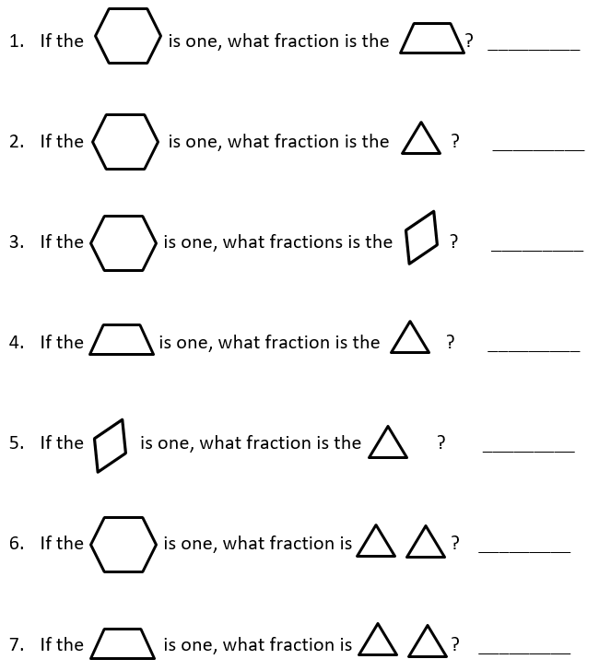

Fractions on a Number Line
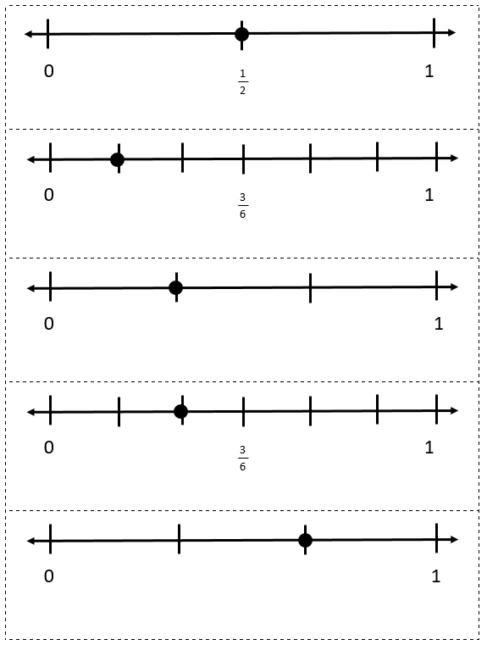
Fractions and Mixed Numbers on a Number Line
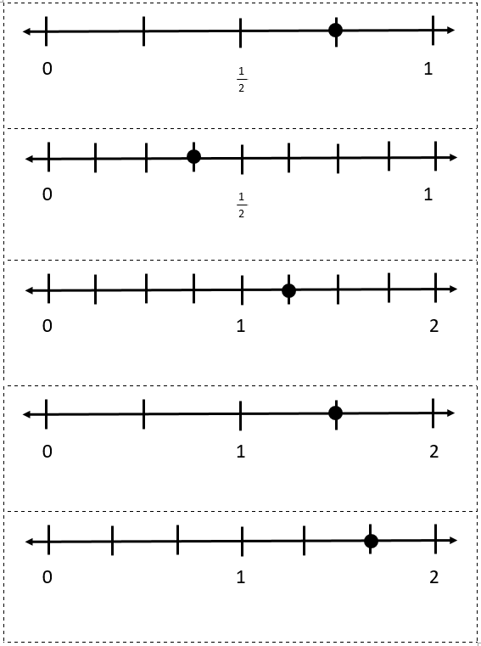
Bump Directions
- Each player takes 10 counters of the same color.
- The first player rolls both number cubes. The player finds the sum of both number cubes and finds that number on the chart.
- The player names the fraction represented by the model with a fraction, mixed number, or improper fraction, and covers the answer on the game board with one of his/her counters.
  - If the players rolls a number that has already been covered by the other player, they can bump the other player’s counter off and replace it with his/her own counter.
  - If the player rolls a sum that has already been covered by his/her own counter, the player can place a second counter on top of it. When there is a tower of 2, the player’s counters can no longer get bumped off by the other player. They are frozen.
  - If the player rolls a sum that has already been locked by either player, the players turn is over and must wait for the next turn.
- Play continues until one player has placed all 10 of his/her counters on the game board.

Mixed Number and Improper Fraction Bump
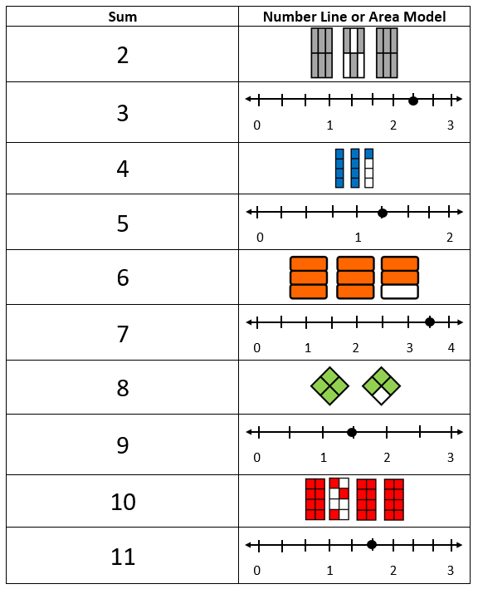

Mixed Number and Improper Fraction Bump Game Board
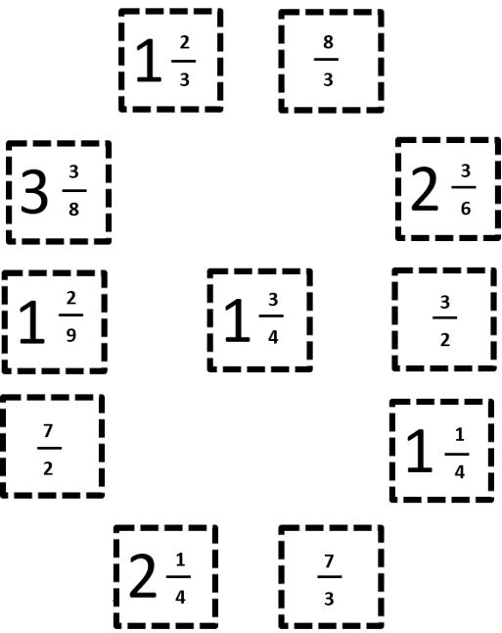

Exit Ticket
Directions: Take two hexagons. The two hexagons together represent a whole.

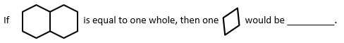

How do you know? ________________________________________________

________________________________________________________________

Exit Ticket
Directions: Take two hexagons. The two hexagons together represent a whole.

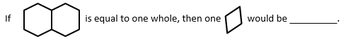

How do you know? ________________________________________________

________________________________________________________________

