Mathematics Instructional Plan – Grade Three

Naming and Writing Fractions
Strand: Number and Number Sense
Topic: Naming, writing and representing fractions
Primary SOL: 3.2 The student will
- name and write fractions and mixed numbers represented by a model.
Related SOL: 3.2 b, c; 3.5

Materials
- Pegboards and bands
- Pegboard dot paper (attached)
- Fraction Strips sheet (attached)
- Pizza Fractions activity sheet (attached)
- Paper Bag Fraction Game Board and Fraction Bars (attached)
- Counters or markers

Vocabulary
denominator, fraction, improper fraction, mixed number, numerator, proper fraction, whole

Student/Teacher Actions: What should students be doing? What should teachers be doing?
- Make a T-chart on the board and list what “A Fraction Is” and what “A Fraction Is Not.” Ask students to help define fraction. Ask for real-world examples of what a fraction is. Students may talk about sharing pizza, a candy bar, or measuring when cooking.
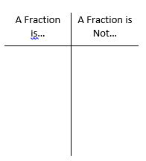
- Elaborate on the examples students give, and ask what the whole looks like compared to the fractional part to check for understanding of whole vs. fraction. Discuss the definitions of the denominator as the number of equal parts of the whole and the numerator as the number of counting parts in the whole.
- Using pegboards, have students create a 2 x 4 rectangle. Have them explore the different ways they can divide the (whole) rectangle evenly to make fourths. Ask, “Are you sure each piece is the same size?” “How do you know?” Discuss how the whole rectangle is now represented as $\frac{4}{4}$ . Another representation would be $\frac{1}{4}$ + $\frac{1}{4}$ + $\frac{1}{4}$ + $\frac{1}{4}$ = $\frac{4}{4}$ = 1 whole.
- Have students draw their rectangle (it may look different from the example) on the provided pegboard dot paper in the first space (top left). Have them label each $\frac{1}{4}$. Have them draw a second congruent rectangle right beside the first and create fourths just as their first and label each section $\frac{1}{4}$.
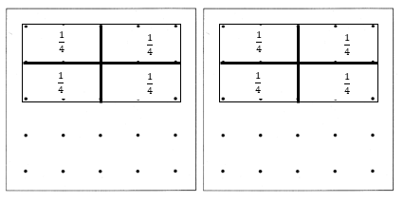
- Have students shade three of the four fractional pieces from the first rectangle and name the shaded amount. Three of four equal pieces is represented as $\frac{3}{4}$ and is called a proper fraction. Have them shade in the last piece from the first rectangle and two pieces from the second rectangle. Ask, “How many one-fourth pieces are now shaded?” Represent this by writing $\frac{1}{4}$ + $\frac{1}{4}$+ $\frac{1}{4}$ + $\frac{1}{4}$ + $\frac{1}{4}$ +$\frac{1}{4}$ = $\frac{6}{4}$. Sixth-fourths represents an improper fraction because the numerator is greater than the denominator, meaning it goes beyond the size of the “whole.”
- Ask, “How many whole rectangles did you shade?” and “How many $\frac{1}{4}$ pieces from the second did you shade?” Explain that 1 $\frac{2}{4}$ is another way to represent $\frac{6}{4}$ and that 1 $\frac{2}{4}$ is called a mixed number because it is a whole number and a fraction.
- Repeat steps 3-6, having students make eighths, shading in more than one whole.
- Draw one more rectangle divided like the other two and shade in to represent more than two wholes. Write the improper fraction and the mixed number for what is shaded.

Assessment

Questions
  - How many different ways can you represent $\frac{6}{4}$ ?
  - What is another way of representing 1 $\frac{3}{8}$?
  - Write the improper fraction and mixed number for the following:

  - How would you describe to a friend what an improper fraction is and what a mixed number is?

Journal/writing
  - Represent $\frac{5}{4}$ using a linear model (example: a number line or ruler)?
  - Explain the difference between an improper fraction and a mixed number.

Other Assessments

Pizza Fractions

Extensions and Connections (for all students)
- Distribute the Fraction Strips. Have them cut the strips out to make three strips of equal length. Have students fold each strip to make fourths. Label each section as $\frac{1}{4}$ . Tape each strip together (end to end). Label each $\frac{4}{4}$, as one whole counting each whole (1, 2, 3). Have students find $\frac{3}{4}$, 1 $\frac{2}{4}$, 2 $\frac{3}{4}$. Ask students to locate $\frac{8}{4}$. What is another way to write $\frac{8}{4}$?
- Have the students play the game “Paper Bag Fractions” with a partner. The object of the game is to cover five fractions in a row (horizontally, vertically, or diagonally). In order to play the game each partner should have a “Paper Bag Fraction” game board, one paper bag filled with a linear set of fraction bars shaded (attached), and 20 to 25 counters. Each player will take turn choosing a fraction bar from the paper bag. Students should then name the fraction that is shaded and placing a counter if that fraction is listed on the game board. After each turn, the player should return the fraction bar back to the bag. The first player to cover five fractions in a row wins.

Strategies for Differentiation
- Have students use a variety of shapes to create fractional pieces. Make sure they can identify the whole and prove that their fractional pieces are equal.
- Using pegboards, have students create fractional pieces for thirds, tenths, twelfths and other challenging fractional parts.
- Use pattern blocks to identify the fractional parts of the hexagon.

Note: The following pages are intended for classroom use for students as a visual aid to learning.

Virginia Department of Education ©2018
Pegboard Dot Paper

Fraction Strips
Pizza Fractions
Name: ____________________________________ Date: _________________________
- Four friends shared two pizzas. Each friend ate three slices. Shade below to represent the pizza they ate.

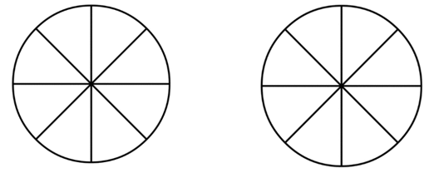

- How much pizza did they eat? Write your answer as an improper fraction then as a mixed number.

Improper Fraction: ____________ Mixed Number: ______________

- Mom baked three pizzas for the party. She put pepperoni on some of the pizza.

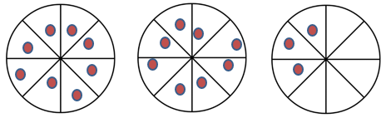

Write the amount of pizza that has pepperoni as an improper fraction and as a mixed number.

Improper Fraction: ____________ Mixed Number: ______________

Paper Bag Fraction Game Board
$$\frac{1}{4}$$ | $$\frac{3}{4}$$ | $$\frac{2}{3}$$ | $$\frac{1}{12}$$ | $$\frac{3}{6}$$
$$\frac{1}{2}$$ | $$\frac{5}{12}$$ | $$\frac{1}{3}$$ | $$\frac{2}{4}$$ | $$\frac{3}{6}$$
$$\frac{4}{4}$$ | $$\frac{2}{6}$$ | $$\frac{4}{6}$$ | $$\frac{3}{3}$$ | $$\frac{3}{12}$$
$$\frac{10}{12}$$ | $$\frac{2}{2}$$ | $$\frac{8}{12}$$ | $$\frac{5}{6}$$ | $$\frac{4}{12}$$
$$\frac{7}{12}$$ | $$\frac{4}{8}$$ | $$\frac{9}{12}$$ | $$\frac{1}{6}$$ | $$\frac{11}{12}$$
Paper Bag Fractions Bars

