Mathematics Instructional Plan – Grade 3

Candy Bar Fractions
Strand: Number and Number Sense
Topic: Naming, Writing and Representing Fractions
Primary SOL: 3.2 The student will
- name and write fractions and mixed numbers represented by a model;
- represent fractions and mixed numbers, with models and symbols
Related SOL: 3.2 c, 3.5

Materials
- Candy Bar Fraction sheet (attached)
- Large sheet of construction paper
- Scissors
- Glue
- Brownie Fractions sheet (attached)

Vocabulary
Fraction, whole, numerator, denominator, proper fraction, improper fraction, mixed number, fair share

Student/Teacher Actions: What should students be doing? What should teachers be doing?
- Activate prior knowledge by asking students to define a fraction and the difference between a fraction and a whole. Ask students to then define a proper fraction.
- Introduce the following problem to students by putting a similar drawing on the board to illustrate the problem.
- Give students the Candy Bar Fractions activity sheet. Explain that you have seven candy bars to share equally between four friends. Ask, “About how many candy bars do you think each student will get?” Tell students to “Use the candy bar rectangles to show how much each student gets. Model the amount each student gets and name it.” Allow them to work with a partner to represent the amount of candy each person gets. Students should post their solutions on construction paper. Solutions should include pictures/representations, numbers, and words.
- Have students post their solutions on the wall around the classroom. Start a gallery walk, giving students the opportunity to view all solutions and make positive comments on sticky notes.
- After the gallery walk, have groups explain their solutions. Discuss the various solutions and how they are the same or different. (Hopefully you have several different representations. Three possible solutions are shown below.). Ask, “Does each solution represent the same amount of candy bar?” “How can we prove that each solution is/is not correct?” At this point, identify and name each different type of fraction using the correct vocabulary for a mixed number or an improper fraction, based on student solutions.
*Possible solutions: Each person gets:
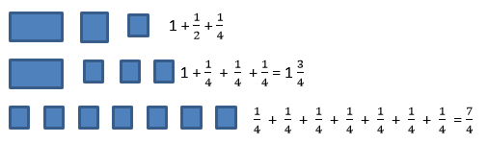

Assessment

Questions
  - How many candy bars would be needed for everyone to have two whole candy bars? Explain your thinking.
  - Are there other solutions or ways to show the same amount?

Journal/writing prompts
  - How could two people share three cookies?
  - Represent 1 $\frac{3}{8}$ using two different models.

Other Assessments

Sharing Brownies activity sheet

Extensions and Connections (for all students)
- Transfer to a linear measurement context such as the following. How could two people share 7 inches of ribbon fairly? Use pictures, numbers and words to illustrate your solution.
- Illustrate the difference between sharing two brownies between five people and five brownies shared between two people.

Strategies for Differentiation
- Some students may need to start dividing whole candy bars equally before working with smaller fractional parts. Start with four candy bars and two people. Then three candy bars and two people. Be sure that they are providing fair shares.
- Challenge students to provide more than one solution strategy for sharing four candy bars between five people.
Note: The following pages are intended for classroom use for students as a visual aid to learning.

Candy Bar Fractions
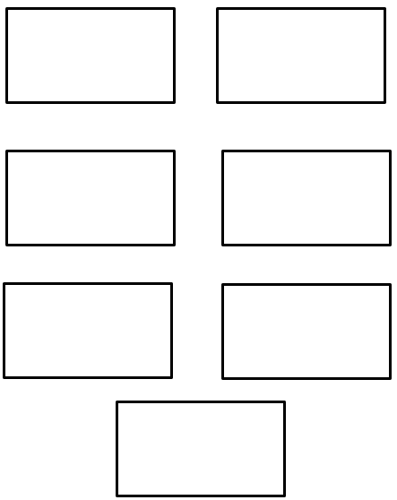
Sharing Brownies
Name ____________________________________ Date ___________________
Represent each fair share and write the fraction for each share.

- Share 1 brownie with 3 people.

- Share 4 brownies with 3 people.

- Share 2 brownies with 5 people.

