Mathematics Instructional Plan – Grade 3

Comparing Numbers
Strand: Number and Number Sense
Topic: Comparing and ordering whole numbers
Primary SOL: 3.1 The student will
- compare and order whole numbers, each 9,999 or less.
Related SOL: 3.1a

Materials
- Number Cards (attached)
- Recording Sheet (attached)
- Place-value Mat (attached)
- Number Line Graphic Organizer (attached)

Vocabulary
compare, digit, equal to (=), greater than (>), less than (<), order, place, place value, value

Student/Teacher Actions: What should students be doing? What should teachers be doing?
- Display an open number line between zero and 1,000. Place four numbers (such as 37, 379, 397, 973) correctly on the number line. Have students determine whether each number is greater than (>), less than (<), or equal to (=) the other numbers as shown by its position on the number line in relation to the other numbers. Next, ask students the following questions:
  - “Are the numbers correctly placed on the number line? How do you know?”
  - “What do you notice about each number?”
  - “Why is 973 so close to 1,000?”
  - “Why are 397 and 379 placed close together?”
  - “What number could come between 397 and 973? Where would you place it?”
- Group students into pairs. Direct one student in each pair to write down a two-, three-, or four-digit number and show it to his/her partner. Direct the partner to create a number that is greater than, less than, or equal to the written number.
- Have students play the Place-value Game. Introduce the game by reviewing place values of whole numbers. Explain that the object of the game is to build the largest four-digit number. Give each student a set of Number Cards and a copy of the Place-value Mat. Group students into groups of three, and give each group a copy of the Recording Sheet. Have group members shuffle their sets of number cards together (each group should have 27 cards) and then draw numbers to decide who goes first.
Player 1 draws a card and chooses a column in which to place it on his/her place-value chart. Once a card has been placed, it cannot be moved. Remind students that each player is trying to build the largest four-digit number they can. Player 2 then draws a card and chooses a column on his/her place value chart in which to place it. Player 3 then takes a turn. At this point, discuss strategies that the students are using to choose the columns. These can be displayed for students to think about as they play the game.
Have students continue play until each player has built a four-digit number and verified which of the group’s numbers is the largest. Highlight the mathematics used in the game.
At the end of the game, have students share their strategies and talk about what happened when they tried someone else’s strategy. Have each student record his/her group’s three numbers from smallest to largest on the Recording Sheet and place the proper symbol between them. The player with the largest number wins one point for this first round. Play continues for 10 rounds. The player with the most points wins.
- Once each group of students has finished their game, discuss with the students how they were able to place their created numbers from their game in order from least to greatest. Where did they have to look within the number in order to do that? The teacher should explain when we compare and order numbers we have to look at the greatest value in each number, and if those values are equal we must then move to the next value.
- To further this discussion, write the following numbers on the board:
  - 123,645
  - 123,465
  - 123,578
  - 123,587
- Have the students order these numbers from least to greatest. Once ordered, ask the students to describe the relationships/differences of each number. Have them discuss the digits in each place value, and why they were important to know when ordering numbers.

Assessment

Questions
- Which symbol is used to show greater than?
- What makes two numbers equal to one another?
- How would you go about ordering the following numbers: 2,745, 2,803, and 2,762

Journal/writing prompts
- Explain what makes a number greater than another number.
- Explain why a four-digit number is always greater than a three-digit number.

Other Assessments
- Write two-, three-, and four-digit numbers on the board, and have students write numbers that are greater than and less than the numbers presented, using the correct symbol (> and <).

Extensions and Connections (for all students)
- Have students formulate their own “greater than,” “less than,” and “equal to” statements about the location of specific places on a map, using symbols and terms.
- Have students write a number that is between the numbers 123,546 and 123,456. How were they able to come up with this number? Have them order these numbers from least to greatest, and then greatest to least.

Strategies for Differentiation
- Have students use the Number Line Graphic Organizer.
- Have students stack their numbers according to place value on notebook paper or graph paper for a visual comparison.
- Have students underline the specific digits to look at when determining whether a number is greater than, less than, or equal to another number (e.g., 2,567 > 2,308).

Note: The following pages are intended for classroom use for students as a visual aid to learning.

Virginia Department of Education ©2018

Number Cards
Print on card stock, and cut apart on the dotted lines.
1 | 2 | 3
4 | 5 | 6
7 | 8 | 9

Recording Sheet
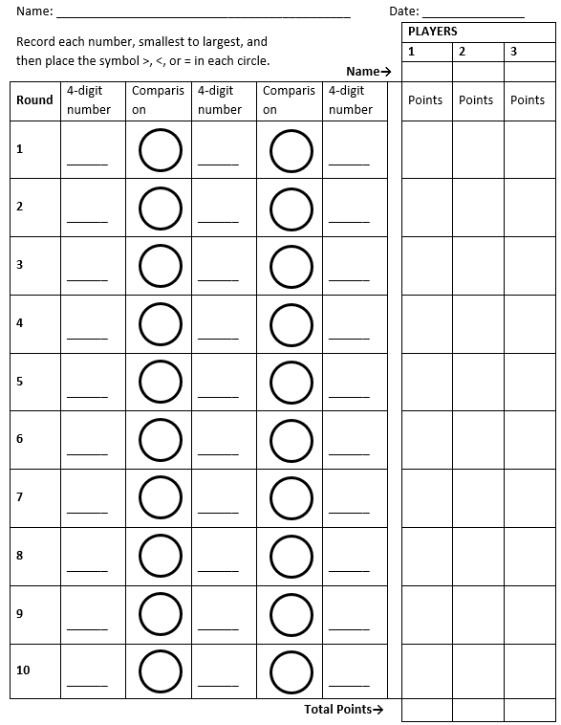
Place-value Mat
Thousands | Hundreds | Tens | Ones
Number Line Graphic Organizer

