Mathematics Instructional Plan – Grade 2

Kite Tail Measurement
Strand: Measurement and Geometry
Topic: Estimating and measuring length in inches.
Primary SOL: 2.8 The student will estimate and measure
- length to the nearest inch.

Materials
- Story or poem about kite flying
- Paper kite shapes, each labeled with a letter (A, B, C, D, etc.), with ribbon tails of various lengths measured in whole units of inches
- Various nonstandard measurement tools close to an inch (e.g., paper clip, standard eraser, connecting cubes)
- Inch rulers
- CD of music that suggests a kite gliding in the sky
- Kite-Tail Measurement in Inches activity sheet (attached)
- Kite Drawing assessment (attached)
- String or yarn

Vocabulary
estimate, inch, instrument, line segment, ruler

Student/Teacher Actions: What should students be doing? What should teachers be doing?
- Enhance students’ background knowledge of kite flying by reading aloud a story or poem about flying a kite.
- Give each student a ruler. Ask students to look at the measurement of an inch, and have them brainstorm some everyday items that measure about an inch. Use a projector to display each everyday item and, using the ruler, measure each to see how they measure up. Discuss with students how we can use these everyday items to estimate the length of something.
- At their seats, have students estimate the length of the paper kite’s ribbon tail and record their estimation to the nearest inch. Remind students that some everyday objects can help us estimate; for example, the length from the tip of your thumb to your first knuckle is about one inch. Give each student a copy of the Kite-Tail Measurement in Inches activity sheet, and have them record their estimate (e.g., Kite A = 12 inches).
- Next, have students use a ruler to measure the tail to the nearest inch and record the measurements on paper, including the letter names of the kites (e.g., Kite A = 14 inches).
- Have students place their kites, rulers, and pencils on their desks and stand up, holding their papers. Explain that when they hear the music, they are to glide safely around the room like a kite up in the sky until the music stops. When it stops, each student must sit down at the nearest desk, measure the kite tail found there, and record the measurement on their paper.
- Repeat this process five times.
- After each student has made and recorded five kite-tail measurements, ask students to help you order the kite tails from the shortest to the longest, using their recorded measurements. Ask guiding questions during this process, such as:
- Is the size of the kite itself important to our ordering? Why, or why not?
- Which kite has the shortest tail? Which has the longest? How do you know?
- Hang the kites in order on a bulletin board.
- Close with the Kite Drawing assessment page.

Assessment

Questions
- What did you notice about your estimations and actual measurements?
- When could you use estimation measurements? Actual measurements?
- How do you use a ruler to measure inches?

Journal/writing prompts
- Mike has never used a ruler before. Describe in detail how you would tell Mike to use a ruler to measure objects to the nearest inch.
- You and your father are building a treehouse. Would you use estimations or actual measurements when building? Why?

Other Assessments
- Use students’ independent work on the Kite Drawing page as a formal assessment.

Extensions and Connections (for all students)
- Repeat the activity, using cutouts of animals and animal tails.
- Call attention to the connection between a ruler and a number line. Allow students to use a ruler as a number line as needed during computation.

Strategies for Differentiation
- Allow students to do the activity in pairs, selecting partners who will support each other’s learning styles.
- For students who need acceleration, provide a separate set of kites with tails that have lengths measured in smaller increments (e.g., 1½ inches).
- Allow students to use linking cubes or inchworms instead of rulers.
- To incorporate physical movement, take students outside or have students participate in a long-jump contest and use their measuring skills to measure the distances in inches and centimeters.
- Extend the activity over two days to allow for a slower pace of work and more thorough discussion. The first day could include the estimation activities; the second day could include the ruler activities.
- Set activity up in five stations and have groups of three to four students move through stations to complete the activity.
  - Round 1: use nonstandard tools (estimate)
  - Round 2: use rulers (measure)
Note: Before the lesson, ask each student to bring in an item from home that can fit in their bookbags.

Note: The following pages are intended for classroom use for students as a visual aid to learning.
Virginia Department of Education ©2018

Kite-Tail Measurement in Inches
Name _________________________________
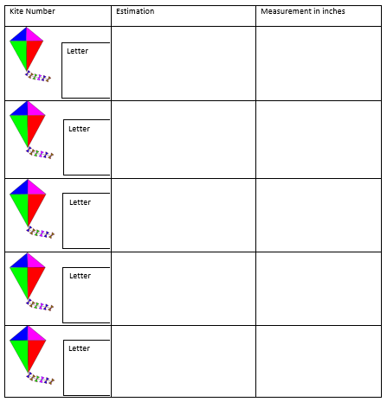

Kite Drawing
Name _________________________________
Draw a tail on the kite provided. Estimate the measurement of your kite tail. Then use a ruler to measure the actual length of your kite tail. If your kite tails are curvy, you may use string to help measure actual length.
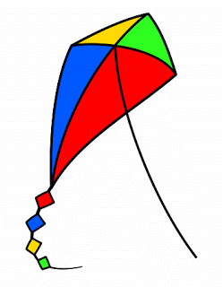

What do you notice about the estimation and the actual length of your kite tail?
__________________________________________________________________
__________________________________________________________________

