Mathematics Instructional Plan - Grade 2

Exercising Patterns
Strand: Patterns, Functions, and Algebra
Topic: Identifying, creating, extending, and transferring repeating and growing patterns
Primary SOL: 2.16 The student will identify, describe, create, extend, and transfer patterns found in objects, pictures, and numbers.
Related SOL: 2.2 a, b

Materials
- Movement Cards sheet (attached)
- Colored linking cubes
- Scissors
- Sentence Strip Template (attached)
- Sentence strips with growing patterns made with letters
- Glue
- Mathematics journal

Vocabulary
change, core, create, extend, growing pattern, pattern, repeating pattern, transfer

Student/Teacher Actions: What should students be doing? What should teachers be doing?
Note: Before conducting this activity, make enlarged copies of the attached movement cards. In order to be successful with this lesson, students should have already had multiple opportunities identifying, describing, creating, extending, and transferring repeating and growing patterns.
- Have students stand up and push in their chairs. Use enlarged movement cards to create a simple repeating pattern on the board (e.g., jump, high five, stretch up, high five, jump, high five, stretch up, high five). Ask students to do the movements shown by the cards. Ask students what they just did. Responses may include exercising, jumping, making a pattern, and moving. If/when students mention a pattern, emphasize that they made a special pattern called a “repeating pattern.” Ask students to identify the core of the pattern on the board.
- Ask whether someone could use the linking cubes to show the same repeating pattern that was just shown with movements (e.g., red, blue, green, blue, red, blue, green, blue). Once the pattern is made, ask another student to extend it.
- Explicitly teach the terms transfer and extend.
- Continue having students create repeating movement patterns and transfer them with linking cubes until students have a strong grasp of identifying and extending repeating patterns.
- Use the enlarged movement cards to create a growing pattern on the board (e.g., high five, run, high five, high five, run, high five, high five, high five, run). Allow students to observe and then act out this movement pattern for several minutes. Ask, “Is this a pattern? Is this a repeating pattern? Why, or why not?” Engage students in a class discussion about a growing pattern, leading them to understand that a growing pattern is one that gets bigger—that grows.
- Ask a student to transfer the same growing pattern with linking cubes (e.g., red, blue, red, red, blue, red, red, red, blue). Ask students to discuss with their neighbors what might come next in this pattern, and have students share ideas about extending the pattern.
- Continue having students create growing movement patterns and transfer them with linking cubes until they have a strong grasp of identifying and extending growing patterns.
- Distribute copies of the Movement Cards sheet, scissors, sentence strip, and glue. Direct students to cut out movement cards and glue them to the sentence strip to create a growing pattern. Then, ask students to name and describe the growing pattern they have created in a complete sentence.
- When students have finished making their growing patterns with movement cards, have them share with other students and act out the movements to describe the growing pattern.

Assessment

Questions
- Why do we need to be able to transfer patterns? What is important to remember when transferring a pattern?

Journal/Writing Prompts
- Describe some patterns that you see in real life, and identify them as either repeating patterns or growing patterns. What type of pattern do you see most often in real life?
- Your physical education teacher created the following pattern: run, jump, high five, run, jump, jump, high five, run, jump, jump, jump, high five.
    - Identify whether this is a repeating or growing pattern. Then, describe the pattern in a complete sentence.
    - Extend the pattern and transfer the pattern using objects, pictures, or numbers.

Extensions and Connections (for all students)
- Explore repeating and growing patterns with numbers by providing students with hundreds charts and colored chips. Give them directions such as, “Cover the number 2. Add 4 more, and cover the next number (6). Add 4 more, and cover the next number (10). What number will you cover now? Is this pattern growing or repeating?”
- What comes next in this number pattern: 6, 9, 12, 15, ___? Is this a repeating or growing pattern? How do you know? 3, 4, 6, 9, 13, 18? Is this a repeating or growing pattern?

Strategies for Differentiation
- This lesson requires physical movement that some students may be unable to perform. For such students, create other movement cards that they can imitate (e.g., snapping, clapping, smiling, frowning, or nodding).
- Consider the readiness of your students for each component of this lesson. Some students may need supports, such as sentence stems for their descriptions, premade patterns to re-create, and vocabulary cards to use when labeling patterns. In addition, some students might benefit from completing this lesson as a small guided mathematics group.
- Redirection and corrective feedback should be given throughout lesson.

Note: The following pages are intended for classroom use for students as a visual aid to learning.

Virginia Department of Education ©2018

Movement Cards
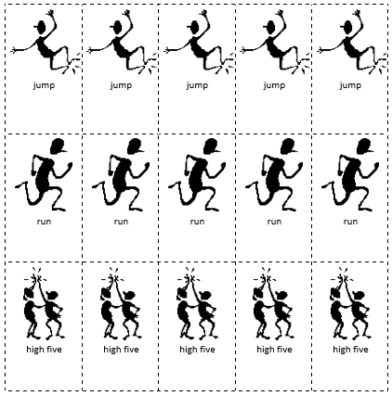

Sentence Strip Template
(Add Letters)
___________________________________________________

----------------------------------------------------------------------------------
___________________________________________________

