Mathematics Instructional Plan – Grade 2

The Graphing Gallery

Strand: Probability and Statistics

Topic: Analyzing data displayed in graphs

Primary SOL: 2.15 The student will
- read and interpret data represented in pictographs and bar graphs.

Related SOL: 2.15 a

Materials
- Season Graph, Animal Graph, Desk Graph, Junk Food Graph (attached)
- Graph questions cards (attached)
- Scissors
- Three envelopes or baggies

Vocabulary
bar graph, data, equal, greatest, least, most, pictograph
Student/Teacher Actions: What should students be doing? What should teachers be doing?
Note: Before conducting this activity, copy and cut out the graph question cards found on the attachments. Place the set of cards for each graph in an envelope or baggie labeled with the name of the graph. Make copies of each type of graph to display around the room. Depending on class size, you may need to make double copies of the graphs so that groups can stay a reasonable size.
- Explain to students that they will participate in an activity that will help them analyze graphs. Group students into three teams with six students on each team. (Form additional groups as needed to make sure that groups do not exceed six students.)
- Display the Season Graph, Animal Graph, and Desk Graph around the room. Place each group next to a different graph. Explain to students that each member of the group will select one question card from the baggie that corresponds to the graph at which they are stationed. Each group member will take turns reading aloud the question on their card to his/her team members. After each team member reads their question card, they will devise an answer to the question and share their answer with the group.
- When the teacher gives a specific signal (e.g., a bell or chime, a stopwatch buzzer), the groups will rotate to a different graph and repeat step 2. Groups should rotate until all groups have been to each graph once. The membership of the teams may be changed throughout the activity, as needed.
- As an assessment at the end of the activity, distribute copies of the Junk Food Graph, and have students analyze it and write statements about the data.

Assessment

Questions
  - Provide students with a graph that does not have a title. What title would best fit with the data and labels shown on the graph?
  - How are pictographs and bar graphs similar? How are they different?
  - How does analyzing the data in a graph help you to better understand what the graph is showing?

Journal/writing prompts
  - You must explain to someone in your family the different types of graphs. Which one did you choose and why?
  - You may choose one type of graph to show a student (i.e., a pictograph or bar graph. Which one would be best to choose? Why?
  - Explain in writing the importance of a title on a graph.

Other Assessments (include informal assessment ideas)
  - Use students’ statements regarding the Junk Food Graph as an assessment.

Extensions and Connections (for all students)
- This game can be played using graphs that students have made in previous lessons. Enlarge the graph(s) for the purpose of display.
- Have students create graphs using a computer program, create questions for the graphs, and then play the game in a learning center. Place each graph and its questions in a baggie to keep them together.
- Have students create a table or chart that shows the same data as in one of today’s graphs.
- Have students create a bar graph that uses the same data shown in the Junk Food Graph.

Strategies for Differentiation
- Have students verbalize statements while a selected scribe records them on paper.
- Redirection and corrective feedback should be given throughout lesson.
- Move the graphs to groups rather than groups to graphs.

Note: The following pages are intended for classroom use for students as a visual aid to learning.
Virginia Department of Education ©2018

Season Graph
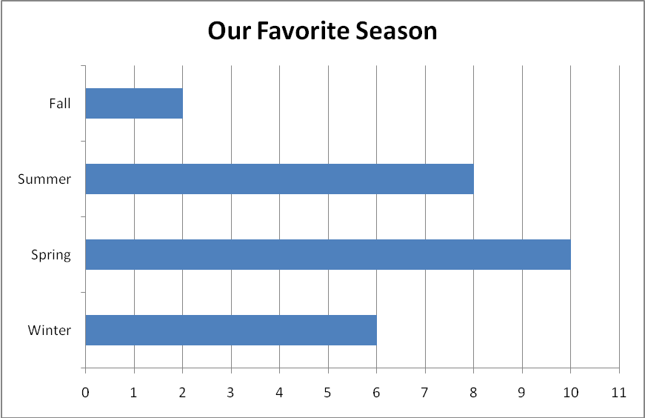

Cut questions apart on the dotted lines.
What statements can you make about the season that was selected the greatest number of times? | What statements can you make about the two seasons that were selected the least? | What statements can you make about the winter data?
What statements can you make about the fall and summer data? | What statements can you make about the title of this graph? | What statements can you make about the data for all four seasons?

Animal Graph
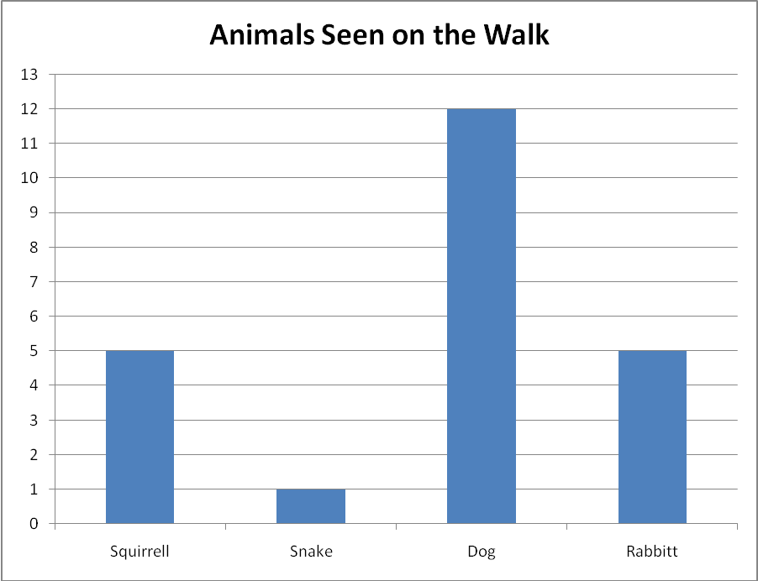

Cut questions apart on the dotted lines.
What statements can you make using the word greatest? | What statements can you make using the word equal? | What statements can you make about the dog data?
What statements can you make using the word least? | What statements can you make about the total number of responses on this graph? | Make a statement from our data about squirrels and snakes.

Supplies in the Desk
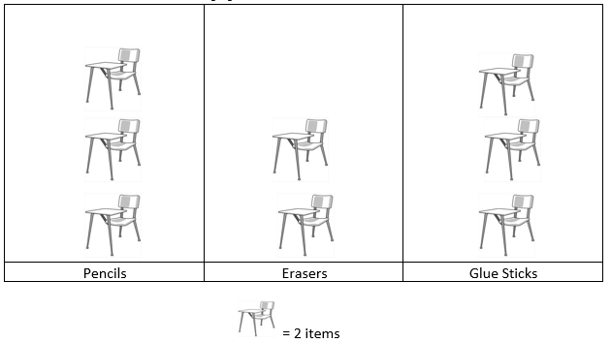

Cut questions apart on the dotted lines.
What statements can you make about the supply that has the greatest amount? | What statements can you make using the word equal? | What statements can you make about the eraser data?
What statements can you make about the key of the graph? | What statements can you make about the total number of responses on this graph? | What statements can you make about the title of this graph?

Junk Food Graph
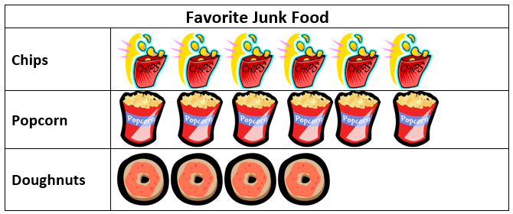

Analyze this graph, and write three statements about the data it shows.

- _____________________________________________________________________________________________________________________________________________________________________________________________

- _____________________________________________________________________________________________________________________________________________________________________________________________

- _____________________________________________________________________________________________________________________________________________________________________________________________

