*Mathematics Instructional Plan – Grade 2*

# We Are Spinning In Second Grade

## Strand: Probability and Statistics

## Topic: Predicting probability experiment outcomes

## Primary SOL: 2.14 The student will use data from probability experiments to predict outcomes when the experiment is repeated.

## Materials

* Spinner A (attached)
* Spinner B (attached)
* Pencils (sharpened)
* Paper clips (one for each student)
* Eight-part Spinner with Eight Different Colors (attached)
* T-chart for students (attached)
* Extension chart (attached)

## Vocabulary

*chance, events, experiment, less likely, more likely, outcomes, predict, probability*

## Student/Teacher Actions: What should students be doing? What should teachers be doing?

1. Ask, *“If you could only play one game at recess—tag or kickball—which would you choose?”* Have students vote on their choice. Say, *“We just took a vote to make a decision, and everybody had a chance to cast a vote! Today in our math lesson we are going to use another way to make a decision: a spinner. We will make predictions about which event is more or less likely to occur when given a spinner.”*
2. Tell students that they are going to spin a spinner to decide whether they will play tag or kickball at recess today. The game that gets the most spins will be the one they play. Show Spinner A. Ask students to predict, *“Which game do you think we will play today?”* Ask students to share their prediction with a person sitting next to them and tell why they made that prediction. Then, have student volunteers share their predictions and reasoning.
3. Allow each student to come up, spin the Recess Game Spinner, and record his/her result on the T-chart. Ask:

* What was your prediction?
* Why did you make that prediction?
* What were the results of the experiment?
* Which game was more likely/less likely to be spun? If you performed the experiment again, would you get the same result?

1. Explain to students that they will be repeating the experiment and collecting data to see which game is more likely and which game is less likely to be played during recess. Distribute copies of Spinner A to students. The game with the most tallies for the spins will be the one played at recess.
2. Model how to spin the spinner:

* Place the spinner on the table/desk.
* Place a paper clip on the paper.
* Place the tip of a pencil inside the paper clip.
* Spin the paper clip.

Have students conduct the experiment by spinning the paper clip 15 times and recording their results.

1. As students conduct the experiment and collect data, circulate and ask:

* What was your prediction?
* Why did you make that prediction?
* What were the results of the experiment?
* Which game was more likely/less likely? If you performed the experiment again, would you get the same result?
* What will happen if we change the spinner?

1. Show Spinner B. Provide students with a blank spinner and have them label each section, as many sections for each as they wish. Using the same process as in step 5, have students make predictions and conduct an investigation using Spinner B.
2. As students are conduct the experiment and collect data, circulate and ask:

* What was your prediction?
* Why did you make that prediction?
* What were the results of the experiment?
* Which game was more likely/less likely?
* If you performed the experiment again, would you get the same result?
* Would you rather use Spinner A or Spinner B to decide which game we will play at recess?
* Why would you make that choice?

1. Have students share the Spinner B they created and their results. This can be done in small groups or as a whole group. Circulate throughout the room if the sharing is done in small groups.

## Assessment

* **Questions**
  + Use the Eight-part Spinner with Eight Different Colors and ask students to predict which color would be more likely to be selected if you spun the spinner 10 times? Why do you predict __________?
  + Use the T-chart to collect your data on the Eight-part Spinner with Eight Different Colors.

### Journal/writing prompts

* Give students a sentence stem: “I would choose spinner _____ because it is more likely that ______________ will be selected.”
* Why is it important to predict?
* When would be a good time to use probability?

### Other Assessments

* Use two-sided tiles or pennies to investigate probability and predict the outcome when flipping.
* Use spinners that have two, three, four, six, and eight parts with different colors. Collect and write data using tallies.

## Extensions and Connections (for all students)

* Add two-sided chips to stations and use the T-chart to collect data.
* Probability cards:
  + Jimmy has 10 red marbles in a bag and 10 blue marbles in the same bag. When given 20 pulls, what color marble would Jimmy most likely pull out? Why?
  + Mary has one red block, one purple block, one green block, and one orange block in a bag. What color block will Mary pull out of the bag most often?

## Strategies for Differentiation

* Students can create their own spinner, with specific criteria for answering the questions below:

Which of two events is more likely to occur?

* + 1. It will be unlikely that the spinner will land on Green.
    2. The spinner will have an equal chance of landing on Blue and Green.
* Use coins to determine probability.
  1. Before flipping, predict whether the coin land on heads or tails more often.
  2. After flipping, what were the results out of 50 flips? Was your prediction correct? Why or Why not?
* Redirection and corrective feedback should be given throughout lesson.

**Note: The following pages are intended for classroom use for students as a visual aid to learning.**

Virginia Department of Education ©2018

**Spinner A**



**Spinner B**

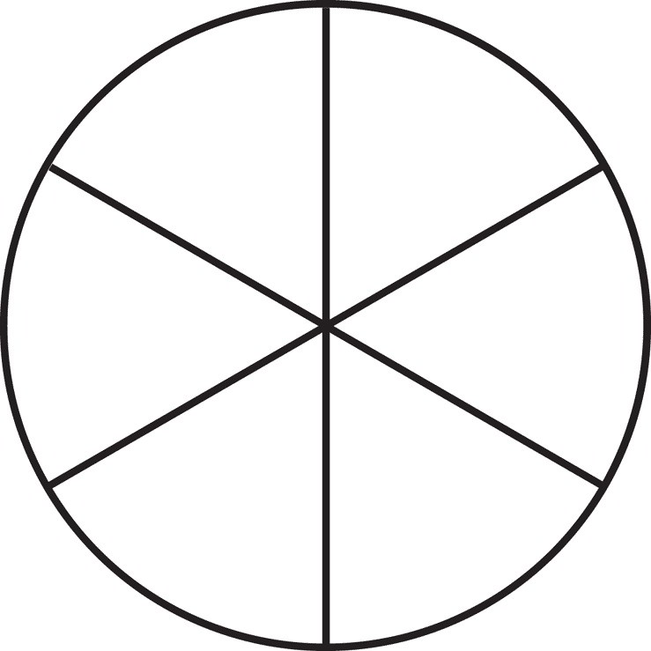

**T-chart for Students**



**Eight-part Spinner with Eight Different Colors**

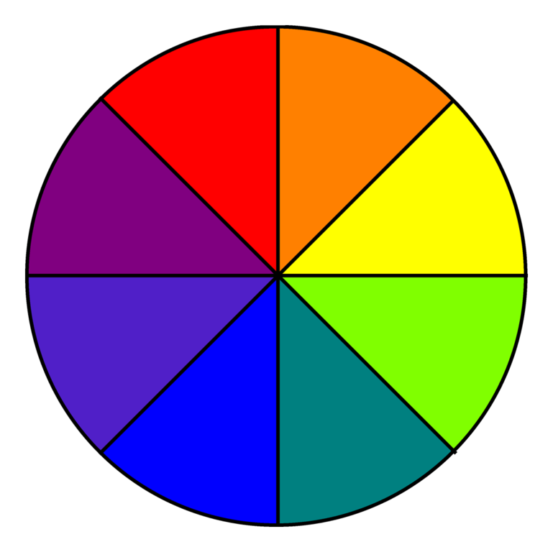

**Extension Chart**

**Name: ____________________________________________**

| Red |  |  |  |  |  |  |  |  |  |  |  |  |  |  |  |  |  |  |  |  |
| --- | --- | --- | --- | --- | --- | --- | --- | --- | --- | --- | --- | --- | --- | --- | --- | --- | --- | --- | --- | --- |
| Blue |  |  |  |  |  |  |  |  |  |  |  |  |  |  |  |  |  |  |  |  |

______________________________________________________________________

**Name: _____________________________________________**

| Red |  |  |  |  |  |  |  |  |  |  |  |  |  |  |  |  |  |  |  |  |
| --- | --- | --- | --- | --- | --- | --- | --- | --- | --- | --- | --- | --- | --- | --- | --- | --- | --- | --- | --- | --- |
| Blue |  |  |  |  |  |  |  |  |  |  |  |  |  |  |  |  |  |  |  |  |

________________________________________________________________________

**Name: ____________________________________________**

| Red |  |  |  |  |  |  |  |  |  |  |  |  |  |  |  |  |  |  |  |  |
| --- | --- | --- | --- | --- | --- | --- | --- | --- | --- | --- | --- | --- | --- | --- | --- | --- | --- | --- | --- | --- |
| Blue |  |  |  |  |  |  |  |  |  |  |  |  |  |  |  |  |  |  |  |  |

____________________________________________________________________________

**Name: _____________________________________________**

| Red |  |  |  |  |  |  |  |  |  |  |  |  |  |  |  |  |  |  |  |  |
| --- | --- | --- | --- | --- | --- | --- | --- | --- | --- | --- | --- | --- | --- | --- | --- | --- | --- | --- | --- | --- |
| Blue |  |  |  |  |  |  |  |  |  |  |  |  |  |  |  |  |  |  |  |  |