Mathematics Instructional Plan – Grade 2

The Shape Show

Strand: Measurement and Geometry

Topic: Investigating plane and solid geometric figures

Primary SOL: 2.13 The student will identify, describe, compare, and contrast plane and solid figures (circles/spheres, squares/cubes, and rectangles/rectangular prisms).

Related SOL:

Materials
- Small cube solids
- The Shape Show Recording Sheet (attached)
- Vocabulary Activity sheet (attached)
- Do You Know Your Shapes? activity sheet (attached)
- Large vocabulary cards for the words face, edge, vertex/vertices, and angle
- Large-display geometric solids (i.e., triangular pyramid, sphere, cube, rectangular prism)
- Construction paper
- Scissors
- Tape
- Comparing Figures Chart (attached)

Vocabulary
angle, circle, compare, contrast, cube, describe, differences, edge, edges, face, identify, plane shape, rectangle, rectangular prism, similarities, solid figure, sphere, square, three-dimensional shape, triangle, triangular pyramid, two-dimensional shape, vertex, vertices

Student/Teacher Actions: What should students be doing? What should teachers be doing?
- Ask each student to bring in one object from home that is three-dimensional but resembles a plane shape, such as circle, square, or rectangle (e.g., cereal box, tennis ball, dice). Assemble these objects in the front of the room. Ask students how these objects could be sorted, and allow one or two minutes for students to think about ways to sort them. Have students share their ideas. The goal is for them to use communication to show how three-dimensional objects can relate to plane geometric shapes—a cube to a square, a rectangular prism to a rectangle, and a sphere to a circle.
- Explain that students will be learning vocabulary to help them describe three-dimensional objects that relate to geometric shapes. Distribute the Vocabulary Activity sheet and cube solids, one to each student, and copies of The Shape Show Recording Sheet. Have students fill in the vocabulary word “Cube” at the top of their sheets.
- Post the vocabulary word cards on the board. Explain that a face is one side of a solid figure and that it may have a plane shape, such as a square, rectangle, triangle, or circle. Model tracing a face of the triangular pyramid on construction paper. Next, ask students to count the number of faces on their cubes (six), record this number on their recording sheets, and trace all of the faces. Ask how the faces are similar and how they are different.
- Ask for thoughts about the next vocabulary word, edge. After thoughts are shared, explain that an edge is a particular type of line segment joining two vertices where two faces come together. An edge is a line segment on the boundary and is often called a side. Model tracing two faces of the triangular pyramid on construction paper, cutting them out, and using tape to join two edges together. Next, ask students to count the number of edges on their cubes (12) and record this number on their recording sheets.
- Explain that the point where line segment edges come together is called a vertex (plural: vertices). Trace two more triangular faces, cut them out, and tape them together with the other triangular faces from step 4. A triangular pyramid has now been formed. Ask student volunteers to come up and point out the vertices they see on the triangular pyramid solid. Next, ask students to count the number of vertices on their cubes (eight) and to record this number on their recording sheets.
- Ask students to look at the edges on their cube and the edges on the triangular pyramid. What is the difference? How are they similar?
- Hold a class discussion about solid geometric figures (triangular pyramid, sphere, cube, and rectangular prism), using the vocabulary words from the activity. Review their faces, edges, vertices, and angles.
- Have students describe the cube, using vocabulary words from the activity. Use descriptions as an assessment.

Assessment

Questions
  - Why is it important that we use the vocabulary we learned today?
  - How can you describe a rectangular prism based on its faces, edges, vertices, and angles?
  - Does this solid figure look similar to any of the plane shapes we have learned about? If so, which one?

Journal/writing prompts (include a minimum of two)
  - Describe the solid figure that is on your table. Use the vocabulary words face, edge, vertex, and angle.
  - Your teacher investigated a triangular pyramid today. You investigated a cube. Describe how these solid geometric figures are similar and how they are different.

Other Assessments
  - Use the Shape Show curtains for student displays. Display one plane shape and its matching solid shape on each stage.

Extensions and Connections (for all students)
- Set up a learning station with a basket of solid figures where students can investigate more such objects. Distribute the Do You Know Your Shapes? activity sheet so students can record data about the faces, edges, vertices, and angles found in the solid figures.
- Have students create model solid figures, using pretzels as the edges and mini marshmallows as the vertices. Guide students in creating each of the faces and then assembling the faces to create the solid figure.
- Have students choose a solid to create with the materials? Then you can have a “Solid shape museum” where students can display their shapes with a description card for others to read and learn about that solid shape.

Strategies for Differentiation
- To help students recognize the faces on a solid figure, allow students to coat the face in washable paint and then print it on paper. Encourage students to investigate whether there is more than one face shape in a given solid figure.
- Redirection and corrective feedback should be given throughout lesson.

Note: The following pages are intended for classroom use for students as a visual aid to learning.
Virginia Department of Education ©2018

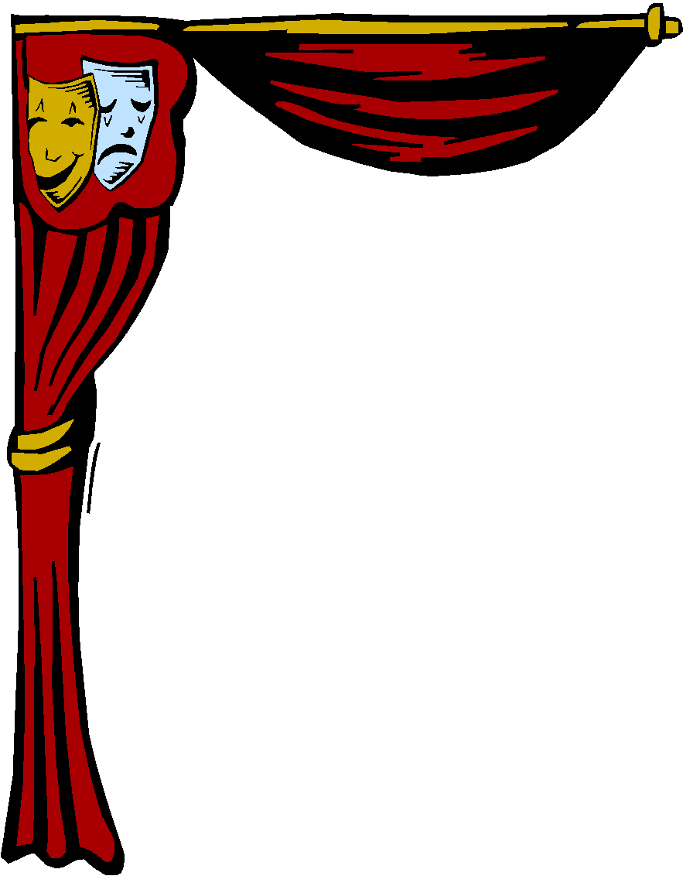

The Shape Show Recording Sheet

Number of faces:
Trace all of the faces here.

Number of edges: | Angles in this solid figure: | Number of vertices:
Use the vocabulary you learned today to describe the solid figure that is on your table.

Name of Plane Shapes | Drawing of Plane Shape | Name of Geometric Shapes | Drawing of Geometric Shape
square
triangle
rectangle
circle

Vocabulary Activity
Write definitions for each mathematical word.
What is the nonmathematical word, or “Everyday Word,” for each?

Example:

Mathematical  Word | My Everyday Word | My Definition
edge | Example: border or around something | Outside an area, all around the outside of something
vertex
vertices
rectangular prism
triangular prism
plane shapes
two-dimensional shapes
three-dimensional shapes
solid figures

Do You Know Your Shapes?
Draw plane shapes and solid shapes and label each with as many details as you have learned.

Identify, compare, and contrast each plane shape to the solid shape.

Write two sentences to explain your thinking. Use one sheet of paper for two comparisons. Fold the paper in fourths and put the plane shapes on the left and its matching solid shape on the right.

See example below to show folds.

