Mathematics Instructional Plan – Grade 2

Symmetrical Shape Fun
Strand: Measurement and Geometry
Topic: Drawing a line of symmetry
Primary SOL: 2.12 The student will
- draw a line of symmetry in a figure; and
- identify and create figures with at least one line of symmetry.
Related SOL: 2.4a

Materials
- Story about snow
- Circular Sled (attached)
- Yardstick or other straight stick
- Symmetric Shapes? activity sheet (attached)
- Yarn or straws (one for each student)
- Scissors
- Symmetrical Shape Sort activity sheet (attached)
- Copies of circles for students to fold
- Demonstration tool (e.g., document camera, digital display)

Vocabulary
fourths, half, halves, line of symmetry, symmetrical, whole

Student/Teacher Actions: What should students be doing? What should teachers be doing?
- Show students a circle. Ask, “What will happen when the circle is folded in half?” Use the think-pair-share strategy to have students think about what might happen.
- Give each student a circle and have them explore what happens when they folded it in half. Provide time to explore and compare findings with their neighbor. Circulate among the students to listen for important sharing points for a whole-class discussion. Ask students what they noticed when exploring with the circle; record highlights of discussion on board for later reference.
- Read a poem or story about children sledding in the snow.
- Display the Circular Sled image. Pose the following scenario: “You want to go down the hill on this sled with your friend. Each of you has to have exactly the same space on the sled. How could you share the space on this sled equally? You need to show the two spaces, using one straight line.” Give each student a copy of the sled and a piece of yarn and ask them to show how they can share the sled with their friend.
- Ask students to come to the board and demonstrate their lines using a demonstration tool (if a projector is not available, use a hula-hoop and yarn). As students share their thinking, use guiding questions like those below to engage them in mathematical conversation.
      - Is this line straight?
- Do you see anything on this side of the sled that is not on the other side of the sled?
- Does this line give you and your friend the same amount of space on the sled?
- Is there another way to share this sled?
- Can we turn the line like this (diagonally, vertically, or horizontally)?
- Can there be more than one way to share this sled equally?
Note: During the exploration and discussion, move about the room to check for student understanding and offer guidance to students who struggle with their line placement.
- Explain that the lines they just formed are called lines of symmetry and that a figure is symmetrical when one shape is divided into the mirror image of the other side.
- Symmetry is the mathematical property of a shape or figure divided into two congruent parts, each of which are a mirror image of the other.
- Line of symmetry divides a figure into two congruent parts, each of which is the mirror of the other; lines of symmetry are not limited to horizontal and vertical lines.
- Share with students that when we divided a shape into two identical pieces, we created two parts of a whole shape. Ask: “How can we describe these two parts? Think about fair shares.” “What other shapes do you think we can divide into halves?” “Do you think we can divide the whole shape into half again using the line of symmetry? If so, what size piece would we have?”
- Distribute the Symmetrical Shapes? Activity sheet. Direct each student to manipulate the yarn or straw to find a line of symmetry on each image and to draw the line of symmetry, if the image has one. Ask early finishers to find more than one line of symmetry in any of the figures.
- After students have found the lines of symmetry in the images, have them cut apart and sort the images into two groups: symmetrical and not symmetrical. Have them use copies of the Symmetrical Shape Sort activity sheet to sort images.
- Review and summarize with the class what students did and learned in the activity. Ask the class to summarize their ideas: “How do you know when a shape is symmetrical?”

Assessment
- Questions
- Can a line of symmetry be curved?
- Can something have more than one line of symmetry?
- If a cake has one line of symmetry, how many people can share it equally? What if it has two lines of symmetry?
- Journal/Writing Prompts
  - Think of a food that is symmetrical and a food that is not symmetrical. Write about why each food is or is not symmetrical.
  - Write your name on a large sheet of paper. Are any letters in your name symmetrical? Does your name have more symmetrical letters than not symmetrical letters?
- Draw a shape that is symmetrical and show the lines of symmetry. Draw another shape that is not symmetrical. Write about how you know the difference and why you placed the line(s) of symmetry where you did in your drawing.

Other Assessments
  - Observation of student folding and cutting shapes.

Extensions and Connections (for all students)
- Have students use paint and construction paper to create a fully symmetrical shape. They can fold the paper in half, drip paint in one or multiple colors on one half of the paper, and then fold the paper again, allowing the paint to make a mirror image on the other half.
- Challenge advanced students to draw their own symmetrical shapes. Have them test the shapes for symmetry by folding the shapes.
- Relate this lesson to fractional concepts by using the vocabulary half, halves, quarter, and quarters.

Strategies for Differentiation
- Emphasize the “s” sound in symmetry and same to help students connect with the vocabulary.
- Complete the Symmetrical Shape Sort with a small group while other groups experiment with mirrors to show lines of symmetry.
- Redirection and corrective feedback should be given throughout lesson.
- Allow students to use moveable adhesive sticks to show many lines of symmetry on an image.
- Redirection and corrective feedback should be given throughout lesson.
- Allow students to use pipe cleaners, string, and craft sticks to help find line of symmetry.

Note: The following pages are intended for classroom use for students as a visual aid to learning.

Virginia Department of Education ©2018

Circular Sled

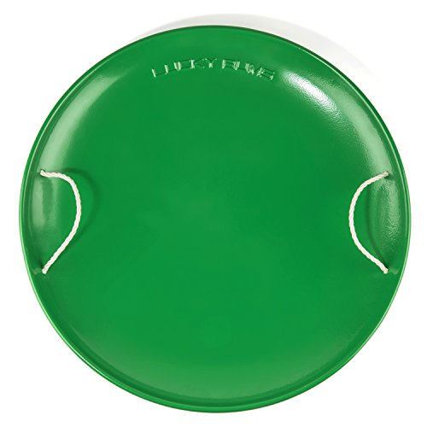
Symmetrical Shapes?

Name _________________________________
Does each shape have a line of symmetry? If it does, draw the line of symmetry.
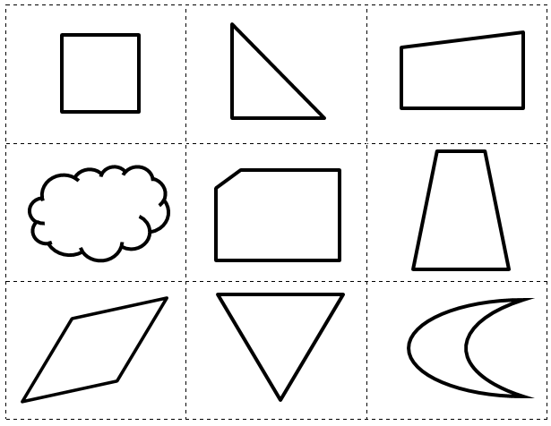

Symmetrical Shape Sort

Name _________________________________
Symmetrical | Not Symmetrical
How do you know whether a shape is symmetrical?

____________________________________________________________________

