*Mathematics Instructional Plan – Grade 2*

# Symmetrical Cube Designs

Strand: Measurement and Geometry

Topic: Identify and create lines of symmetry

Primary SOL:2.12 The student will

1. draw a line of symmetry in a figure; and
2. identify and create figures with at least one line of symmetry.

## Related SOL:

## Materials

* Symmetrical Sort Cards activity sheet (attached)
* One-inch cubes
* Symmetrical Design Grid (one-inch graph paper) activity sheet (attached)
* Music
* Crayons

## Vocabulary

*line of symmetry, symmetrical, unsymmetrical*

## Student/Teacher Actions: What should students be doing? What should teachers be doing?

1. Distribute Symmetrical Sort Cards, one to each student. Ask each student whether the image has a line of symmetry and, if it does, ask students to draw the line of symmetry on the image. Create a T-chart on the board with the two sides labeled “Symmetrical” and “Unsymmetrical.” Ask each student to come up and place their sort card image in the appropriate category. Have the class decide whether the placement is correct.
2. Ask students to write a definition of the word *symmetry*, and then have them share their definitions. Have students collaboratively create a class definition, and post it on the board. Use examples from the sort.

* Symmetry is the mathematical property of a shape or figure divided into two congruent parts, each of which are a mirror image of the other.

1. Explain that students will get to make symmetrical designs today, using one-inch cubes. Give each student the Symmetrical Design Grid activity sheet with a line of symmetry drawn vertically down the center, a set of one-inch cubes, and crayons. Direct each student to create, while you play music, half of a design on one side of the line, using the cubes. Play the music, and tell students to begin. Stop the music, and tell students to move away from their designs to other students’ designs. Play the music again, and have each student use cubes to make the design in front of him/her symmetrical by completing a mirror image of the design on the other side of the line. When the designs are symmetrical, have students use crayons to record the entire symmetrical image.
2. Repeat step 3 as many times as needed during the class period.
3. To conclude, ask each student to select one of the designs they recorded and to trace the line of symmetry with a finger. Ask, “Does this design have more than one line of symmetry?” Discuss responses. If they find other lines of symmetry, have them draw the lines with a crayon.

## Assessment

### Questions

* Does a given design have more than one line of symmetry?
* What would you have to change in a given design to make it symmetrical?

### Journal/writing prompts

* Draw a picture of your teacher and explain whether the image is symmetrical.
* Draw a picture of an animal that is symmetrical, and show the line of symmetry. Does it have more than one line of symmetry?
* Give students several shapes (some that have line of symmetry and some that do not). Have the students determine and sort which shapes have line of symmetry and which do not and then write why certain shapes to state why or what has to occur for a shape to have a line of symmetry.

### Other Assessments (include informal assessment ideas)

* Use the recorded designs as an informal assessment.

## Extensions and Connections (for all students)

* Have students bring in one object from home that is symmetrical and one object that is not symmetrical. Have the class sort the objects. Use tape to show lines of symmetry.
* Challenge students to find an object in the room that has multiple lines of symmetry.
* Find lines of symmetry in pattern block shapes. Then, order the shapes from the least lines of symmetry to the most lines of symmetry.

## Strategies for Differentiation

* Group students in pairs, and repeat the activity as follows: One partner places one cube on his/her side of the line, and then the other partner must match it on the other side. They continue creating the symmetrical design, one cube at a time.
* Give students sheets of one-inch grid paper with a diagonal line drawn on it. Challenge them to create symmetrical designs, using the diagonal line as the line of symmetry.
* Redirection and corrective feedback should be given throughout lesson.
* Have students use cutout shapes to show line of symmetry in one or more ways.
* Give students shapes that do not have a line of symmetry and have them extend the shape to make a line of symmetry.
* Use cutouts and fold on the line of symmetry.

**Note: The following pages are intended for classroom use for students as a visual aid to learning.**

**Symmetrical Sort Cards**

Copy cards on card stock, and cut apart on the dotted lines.

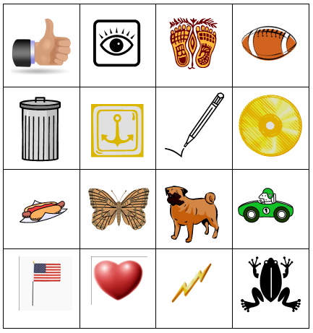

**Symmetrical Design Grid (one-inch graph paper)**

