*Mathematics Instructional Plan – Grade 2*

# Cool Coin Comparisons

Strand:Measurement and Geometry

Topic:Counting and comparing collections of coins

Primary SOL:2.7 The student will

1. count and compare a collection of pennies, nickels, dimes, and quarters whose total value is $2.00 or less; and
2. use the cent symbol (¢), dollar symbol ($), and decimal point (.) to write a value of money.

Related SOL:2.1b, 2.1c, 2.2a

## Materials

* Baggies containing coins whose total value is $2 or less, with each baggie containing a different total value
* Cool Coin Comparisons activity booklet (attached)
* Coin Sorting Mat (attached; optional)
* Paper
* Crayons or pencils

## Vocabulary

*cent symbol (¢), cents, coin(s), decimal point, dime, dollar symbol ($), dollars, equal to, fives, greater than, less than, nickel, ones, penny, quarter, set, tens, twenty-fives, value*

## Student/Teacher Actions: What should students be doing? What should teachers be doing?

1. Distribute baggies of coins and a Cool Coin Comparisons activity booklet to each student.
2. Direct students to pour out the coins in their bags and count the value of the coins. If you wish, provide Coin Sorting Mats to help students with the counting. When counting is finished and the totals have been recorded, guide students in creating rubbings of their coin collection and recording the value of each coin under its image, using the appropriate symbols (¢,$, and decimal point). Be sure students understand that when using the cent symbol, one does *not* use the decimal point (i.e., 15¢ or $0.15, *not* .15¢).
3. Have student put their coins back in their bags. Group students into pairs and have partners exchange bags. Then, have students repeat step 2 with the new coin collection.
4. Have partners check their totals by comparing each other’s work. Instruct students to exchange coin collections again so that each student has their original bag of coins.
5. Direct each student to determine whether their total value of coins is greater than, less than, or equal to the total value of the partner’s coins. Have students record their answers by circling the correct phrases in their booklets.
6. Then, have students determine whether they could use their coins to purchase the cool treats pictured on their page. Have them record their answers in the booklet.
7. If time permits, reassign partners, and give each student a new baggie of coins. Have students repeat the activity.
8. To close, review vocabulary used, and ask students for any further questions that were brought up in the discussion process.

## Assessment

### Questions

* Which cool treat did you choose to buy? How did you know that you were able to purchase that cool treat?
* What was the most expensive cool treat that you could purchase?
* Which bag had the greatest value of coins?
* Which bag had the least value of coins?
* How can you use the greater than, less than, and equal to symbols to write a number sentence about your coin comparison?

### Journal/writing prompts

* You and your partner combine all of your coins, and you want to know the total value. Describe how you would figure this out. Would your new amount of money allow you to buy any cool treats that you could not buy before?
* Allie wants to buy an ice pop that costs $1.72. The box below shows how much money Allie has in her bank. Does Allie have enough money? Explain your reasoning.

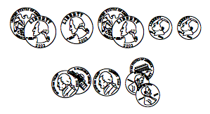

### Other Assessments

* When checking the Cool Coin Comparisons activity booklets, be sure students use the symbols correctly and count the coins correctly.
* As students are working in pairs, circulate and listen for use of comparison vocabulary.

## Extensions and Connections

* Read aloud a story about money. Place coins around the classroom, and allow students to “hunt” for the money. Then, ask them to count their coins and compare the value to the value of their neighbors’ coins. Have students share their comparisons.
* Have students select 10 coins from a baggie and record them on paper, using coin stamps or photocopies of coin images. Finally, have students write the value of each coin and find and write the total value, using cent, dollar, and decimal point symbols.
* Have students develop a rhythm for counting by 25s. Allow them to clap their hands, stomp their feet, or march to the beat while repeating, “25, 50, 75, a dollar, 25, 50, 75, a dollar, etc.”
* If students are able to count values up to $2 with ease, have them count collections of coins whose values are greater than $2.
* Ask students how much change they would get back if they bought a cool treat, using a given set of coins.

## Strategies for Differentiation

* Review counting by ones, fives, and tens to 100, using pennies, nickels, and dimes or pictorial representations of them. You might have students place pennies on a hundreds chart while they count by ones, place nickels on the chart while they count by fives, etc.
* Allow students to use coin stamps or coin cutouts rather than creating coin rubbings in their Cool Coin Comparisons booklets.
* Redirection and corrective feedback should be given throughout lesson.

**Note: The following pages are intended for classroom use for students as a visual aid to learning.**

Virginia Department of Education ©2018

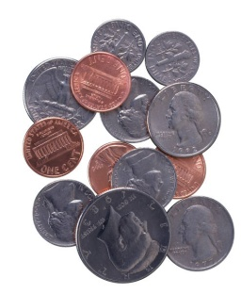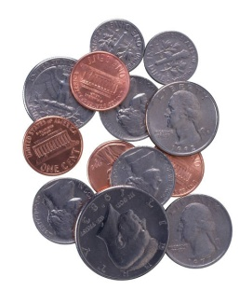

**Cool Coin  
Comparisons**

Name _______________

Page 1

**My Bag of Coins**

Total value of my coins________________________________

Total value of my coins________________________________

1. Circle the words that make the sentence true.

Page 2

**My Partner’s Bag of Coins**

Total value of my partner’s coins________________________

Total value of my partner’s coins________________________

The value of the coins in my bag is

greater than > less than < equal to =

the value of the coins in my partner’s bag.

2. Can you buy this cool treat with your coins?

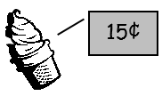

**Yes or No**

Write one sentence to tell why or why not.

___________________

___________________

___________________

___________________

___________________

3. Can you buy this cool treat with your coins?

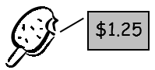

**Yes or No**

Write one sentence to tell why or why not.

___________________

___________________

___________________

___________________

___________________

Page 3

**My Bag of Coins**

Total value of my coins________________________________

Total value of my coins________________________________

**My Partner’s Bag of Coins**

Total value of my partner’s coins________________________

Total value of my partner’s coins________________________

Page 4

1. Circle the words that make the sentence true.

The value of the coins in my bag is

greater than > less than < equal to =

the value of the coins in my partner’s bag.

2. Can you buy this cool treat with your coins?

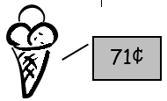**Yes or No**

Write one sentence to tell why or why not.

___________________

___________________

___________________

___________________

___________________

3. Can you buy this cool treat with your coins?

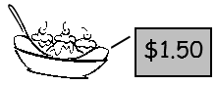

**Yes or No**

Write one sentence to tell why or why not.

___________________

___________________

___________________

___________________

___________________

Page 5

## Coin Sorting Mat

Penny 1¢

Nickel 5¢

Dime 10¢

Quarter 25¢