Mathematics Instructional Plan – Grade 2

What’s the Difference? What’s the Sum?
Strand: Computation and Estimation
Topic: Estimating and finding the difference of whole numbers
Primary SOL: 2.6 The student will
- estimate sums and differences;
- determine sums and differences; using various methods
Related SOL: 2.5 a, b

Materials
- Digit Cards (attached)
- Base-10 blocks (10 rods and 20 cubes per student)

Vocabulary
addend, addition, difference, estimate, minuend, subtract, subtrahend, sum

Student/Teacher Actions: What should students be doing? What should teachers be doing?
- Ask for a volunteer to demonstrate to the class what 37 looks like, using base-10 blocks.
- Then, ask the class to estimate the sum after adding 12 blocks. Have students share their thinking.
- Next, ask the class to estimate the difference after subtracting 12 blocks from 37. Have several volunteers share their thinking.
- Distribute base-10 blocks to students. Have them show 37, then add 12 to 37. Have them record the problem in numerical form (37 + 12 = _____). Have students state and record the sum (37 + 12 = 49).
- Ask students to brainstorm ways to record the problem in pictorial form. A possible pictorial way is shown below:
- Then have students subtract 12 from 37. Have them record the problem in numerical form (37 − 12 = ____). Have students state and record the difference (37 − 12 = 25).

- Ask the students to brainstorm ways to record the problem in pictorial form. Two possible pictorial ways are shown below:
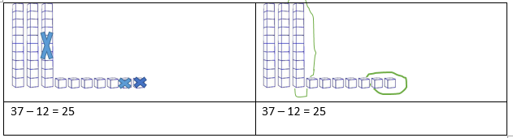
- Instruct students to show the number 42 with their blocks. This time, ask them to estimate the sum after adding 19 blocks and the difference after subtracting 19 blocks. Have several volunteers share their thinking. Have students add 42 and 19, then subtract 19 from 42, using the blocks, and again record the problem in numerical forms (42 + 19 = ____ and 42 − 19 = ____). Have students state and record the sum and difference.
- Ask the class how this addition and subtraction problem is the same as or different from the first one. (It’s the same because they are both addition or subtraction problems. It’s different because you need to regroup to solve).
- Ask students to use the base-10 blocks to complete the addition problem. Most students may have five tens and 11 ones. Demonstrate how to regroup when adding by combining the ones to make another 10 (one rod) so they should have six tens and two ones. Again, have students record the problem in pictorial and numerical forms.
- Demonstrate how to regroup by taking one 10 (one long) out of the tens place and regrouping it as 10 ones cubes. Now, students should be able to subtract 15 from 42. Again, have students record the problem in pictorial and numerical forms. One possible pictorial way is shown below:
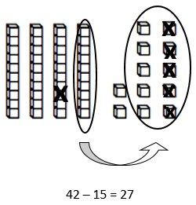
Demonstrate several more examples of addition and subtraction problems with and without regrouping.
- Group students into pairs, and give each student a set of digit cards and a blank sheet of paper to use to record their work. Have each student create a two-digit number by turning over the top two-digit cards. Instruct students to create an addition problem, using their base-10 blocks, as modeled in the beginning of the activity. Have students record in pictorial and numerical forms the addition problem and its solution.
- Next, have pairs of students create a subtraction problem by comparing the two two-digit numbers and subtracting the smaller number from the larger number, using their base-10 blocks, as modeled in the beginning of the activity. Have students record in pictorial and numerical forms the subtraction problem and its solution.
- Review and summarize with the class what students did and learned in the activity.

Assessment

Questions
- How is subtraction with regrouping similar to regrouping in addition?
- Were you able to predict any of the sums or differences? If so, which ones?
- Can you think of any other strategies that can be used for addition or subtraction that were not shared in this activity? If so, what are they?
- Why do you subtract the smaller number from the larger number instead of the other way around?

Journal/writing prompts
- Delman is working with a partner to create two-digit numbers. Delman’s number is 42, and his partner’s number is 67. Draw a picture of what each number would look like in base-10 blocks. Show how Delman and his partner could add and subtract their numbers.
- Katie is working with a partner to create two-digit numbers. Katie’s number is 56, and her partner’s number is 39. Draw a picture of what each number would look like in base-10 blocks. Show how Katie and her partner could add or subtract their numbers.

Other Assessments
- Circulate as students are creating and recording their own problems. Observe the strategies and rationales the students use. Ask questions to determine whether students are absorbing the key points noted above. Note who is having difficulty, and give help, as needed. Collect the papers as an assessment.
- During the activity, occasionally stop and have students answer the question, “How well do I understand what I am doing?” Have students respond to the question by showing thumbs-up (I get it), a sideways thumb (I kind of understand), or thumbs-down (I’m still confused). Give help, as needed.

Extensions and Connections (for all students)
- Have each student write an addition word problem and a subtraction word problem and exchange it with a partner. Allow students to use base-10 blocks or other manipulatives to solve the problems. Encourage students to use strategies for addition and subtraction, such as hundreds charts, number lines, or other invented strategies.
- Have students explore the relationship between subtraction and addition with two-digit numbers.
- Explore practical situations when exact answers to addition and subtraction problems, as opposed to estimated answers, might be needed.

Strategies for Differentiation
- Allow students to use calculators to check their solutions for each problem. A large calculator may be displayed for the whole class to see.
- Have students use place-value mats to keep tens and ones organized.
- Allow students who have difficulty regrouping with base-10 blocks use connecting cubes instead to help them see the grouping and regrouping process.
- Allow students who have difficulty drawing to use base-10 stamps, stickers, or cutouts when creating pictorial representations.
- Redirection and corrective feedback should be given throughout lesson.

Note: The following pages are intended for classroom use for students as a visual aid to learning.
Virginia Department of Education ©2018

Digit Cards
Reproduce cards on card stock. Cut apart on the dotted line.
0 | 1 | 2 | 3
4 | 5 | 6 | 7
8 | 9 | 0 | 1
2 | 3 | 4 | 5
6 | 7 | 8 | 9

