Mathematics Instructional Plan – Grade 2

Target 100

Strand: Computation and Estimation

Topic: Adding two-digit numbers with sums of 99 or less

Primary SOL: 2.6 The student will
- estimate sums and differences;
- determine sums and differences, using various methods; and

Related SOL: 2.5 a, b

Materials
- Number Cube Template (attached)
- Addition Game Board (attached)
- Subtraction Game Board (attached)
- Base-10 blocks (10 rods and 20 cubes per student)

Vocabulary
add, addend, addition, difference, estimate, estimation, reasonable, subtraction, sum

Student/Teacher Actions: What should students be doing? What should teachers be doing?
(Note: Before using this activity, reinforce students’ understanding of regrouping between tens and ones in addition, using base-10 blocks.)
      - Give each student a blank piece of paper folded into fourths. In each fourth, have each student draw a game board, as shown below, and label their four game boards A–D. Or use the Addition Game Board.

    - 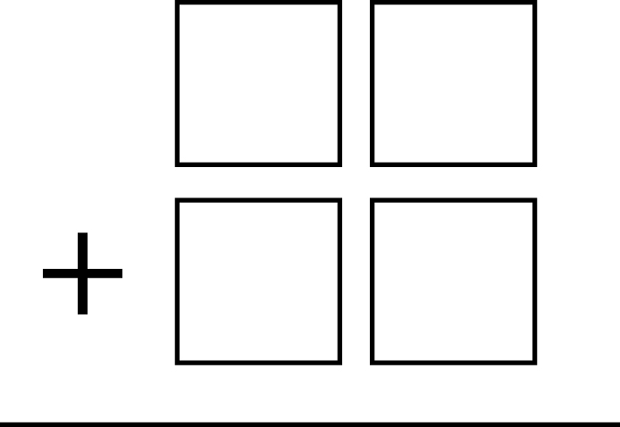

- Group students into pairs, and have partners take turns rolling a dot or number cube four times. With each roll, the players write the number that comes up somewhere in his/her “A” game board in either the tens place or the ones place. Once a number has been written, it cannot be changed. The player also takes the corresponding number of base-10 blocks (e.g., first player rolls a 4, writes 4 in a tens place, and takes four tens rods; second player rolls a 2, writes 2 in a ones place, and takes two ones cubes). After rolling and writing all four digits, each player estimates and then adds their two numbers to find the sum. The goal is to have the sum that is closest to 100 without going over.
- Have students play three more rounds of the game.
- Review and summarize with the class what students did and learned in the activity. Have students share some of the problems they wrote and tell how they found and would record the sums.

Assessment

Questions
  - How can estimating the sum before solving an addition problem be helpful?
  - When playing the game, how did you decide where to place each number rolled? Did you use a specific strategy? If so, what was it?
  - When adding and subtracting two-digit numbers, does the inverse relationship still work?

Journal/writing prompts (include a minimum of two)
  - Megan is playing “Target 100.” She rolls the following numbers: 6, 4, 2, 3. Explain how she can get a sum that is as close to 100 as possible without going over. What two two-digit numbers should she create? What will be her sum?
  - Lorenzo is playing “Target 100.” He rolls the following numbers: 5, 3, 4, 7. Explain how he can get a sum that is as close to 100 as possible without going over. What two two-digit numbers should he create? What will be his sum?

Other Assessments (include informal assessment ideas)
  - Circulate as students are creating and recording their own problems, and observe the strategies and rationales they use. Ask questions to determine whether they are absorbing the key points noted above. Note who is having difficulty, and give help, as needed. Collect the papers as an assessment.
  - Have students create a “One-Minute Paper,” answering the following questions on paper in one minute: “What was the most important thing you learned? What important question remains unanswered?” Be sure to clear up any remaining questions students may have.

Extensions and Connections (for all students)
- Have each student write an addition word problem and exchange it with a partner. Allow students to use base-10 blocks or other manipulatives to solve the problems. Encourage students to use strategies for adding, such as hundreds charts, number lines, or other invented strategies.
- Have students explore the relationship between subtraction and addition with two-digit numbers.
- Work with two-digit numbers to explore the commutative property and the inverse relationship. Ask the students whether these ideas that worked with smaller numbers still works with larger numbers.

Strategies for Differentiation
- Allow students to use calculators to check their solutions for each addition problem created.
- Have students use place-value mats to keep tens and ones organized.
- Allow students who find regrouping with base-10 blocks difficult to use connecting cubes instead to help them see the grouping and regrouping process.
- Allow students to use grid paper to help them line up vertical columns.
- Redirection and corrective feedback should be given throughout lesson.
- Target to zero-start at 100 and work backward to address subtraction.

Note: The following pages are intended for classroom use for students as a visual aid to learning.

Virginia Department of Education ©2018

Addition Game Board

Subtraction Game Board
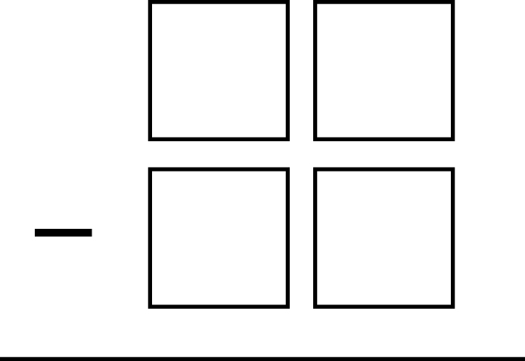

Number Cube Template
Print on cardstock. Cut along perimeter. Fold tabs on the line. Fold on inside square. Shape into a cube. Use glue stick to glue tabs. 