Mathematics Instructional Plan – Grade 2

Hopping on the Number Line
Strand: Computation and Estimation
Topic: Estimating and finding the difference of whole numbers
Primary SOL: 2.6 The student will
- estimate sums and differences;
- determine sums and differences; using various methods
Related SOL: 2.4b

Materials
- Masking tape or chalk (optional)
- Number line for display
- Counters
- Student Number Lines (attached)
- Number Line Addition/Subtraction Recording Sheet (attached)
- Digit Cards (attached)

Vocabulary
addition, difference, estimate, subtract, sum

Student/Teacher Actions: What should students be doing? What should teachers be doing?
(Note: Prepare for this activity by creating a number line on the floor in a manner that is acceptable in your school setting [e.g., painter’s tape, yarn]. Label the line from zero to 20. Students should have experience with number lines and skip counting before engaging in this activity.)
- Inform students that they will use a number line to find the sum. Display an addition problem, such as 11 + 4 = _____. Then ask, “How can we find the sum using the number line?” Ask for a volunteer to demonstrate by starting at 11 and “hopping forward” four places on the number line and then telling his/her stopping position. Repeat this activity several times with other volunteers. Each time, have the student verbalize what they are doing on the number line (e.g., 6 + 7 = ____. “I start on six and hop forward seven spaces to 13; therefore, 6 + 7 = 13).
- Next, inform students that they will now use a number line to find differences. Display a subtraction problem, such as 13 − 5 = ___. Then, ask, “How can we find the difference, using the number line?” Ask for a volunteer to demonstrate by “hopping backward” five from 13 on the number line and then telling his/her stopping position (8). Repeat this activity several times with other volunteers. Each time, have the student verbalize what he/she is doing on the number line (e.g., 15 − 7 = ___. “I start on 15 and hop back 7 spaces to 8; therefore, 15 − 7 = 8”).
- After the class has seen several examples, display a 0-100 number line. Have the class compare this number line to the one on the floor. Ask how it is different. Ask how the class can use this second number line to find sums or differences.
- Give the students an addition problem with larger numbers, such as 42 + 36 = ___. Ask students how they think they can solve this problem on the number line. They will most likely suggest they start at 42 and hop forward 36 (counting on) to find the answer. Encourage students to describe other possible strategies, such a hoping forward by tens, i.e., 42, 52, 62, 72 (which represents three tens) and then count on six more (relate to 2.1b).
- Before solving 42 + 36, ask students to make an estimate (or prediction) about what the sum will be (e.g., 42 is close to 40 and 36 is close to 40, and 40 + 40 is 80. The sum will be close to 80).
- Use the number line to solve 42 + 36 = ______. Be sure to demonstrate various strategies, as mentioned earlier. Call on various students to suggest numbers to use to create several more addition problems, and solve a few more examples with the class.
- Next, give students a subtraction problem, such as 80 − 27 = ___. Ask them how they think they can solve the subtraction problem on the line. They will most likely suggest starting at 80 and hopping back 27 (counting back by ones) to find the answer at the stopping position. Encourage them to describe other possible strategies, such as hopping back two groups of 10 for 20 and then hopping back 7 more.
- Before solving 80 − 27 = ___, ask students whether they can estimate (or make a prediction) about what the difference will be (e.g., 27 is close to 30, and 80 – 30 is 50. The difference will be close to 50).
- Using the number line, solve 80 − 27 = ___ by demonstrating the various methods suggested by the class earlier. Model how to record the hops on the number line as well as how to write the numerical form of the problem. Call on various students to suggest numbers to use to create additional subtraction problems, and solve a few more examples with the class.
- Group the students in pairs, and give each pair a number line, a Number Line Addition/Subtraction Recording Sheet, counters, and digit cards. Direct partners to take turns as one student creates a two-digit addition and subtraction problem, using the digit cards, and the other student uses the number line to find the sum or difference. Encourage students to estimate the sum or difference before solving the problems on the number line. Encourage students to use counters on the number line to hop forward or back. Ask the first student to record the number of hops in pictures related to the problem and to write the numerical form of the problem. Then, have the students switch roles.
- Review and summarize with the class what students did and what they learned in the activity. Have students share some of the problems they created and tell how they found and recorded the sums and differences.

Assessment

Questions
- Why is estimating before solving an addition or subtraction problem helpful?
- Compare using a number line to subtract to using base-10 materials to subtract. How are they the same? How are they different?
- Compare using a number line to add to using base-10 materials to add. How are they the same? How are they different?

Journal/writing prompts
- Marshall’s class is learning to add and subtract using a number line. Explain how a number line can be used to add or subtract. Draw pictures to show your explanation.
- Describe how you can find the sum and difference of 63 and 15 on the number line. Show how this can be recorded in at least two different ways.

Other Assessments
- Monitor students as they are working with their partners. Look for students who are having difficulty working with the number line or completing the number line recording sheet. Collect recording sheets as an assessment.
- Create signal cards (green, yellow, and red) to check for understanding during the activity. Green means “I get it,” yellow means “I’m not sure” or “maybe,” and red means “I’m lost. I need more help.” Pause at different points in the activity, and ask students to hold up their signal cards.
- At the conclusion of the activity, have the class form a circle to participate in a wraparound. Have students take turns telling something that they learned and will remember, and why this is an important discovery.

Extensions and Connections (for all students)
- Have each student write an addition and subtraction word problem and exchange it with a partner. Allow students to use their number lines to solve the problems.
- Discuss how estimation can be used in practical situations involving addition and subtraction.
- Do the activity again, using an open number line.

Strategies for Differentiation
- Allow students to use calculators to check the sums and differences they find.
- Provide enlarged copies of the number line to students who have difficulty using the smaller one.
- Have students use a 10-sided number cube instead of digit cards to create two-digit numbers.
- Have students highlight the tens on the number line to draw attention to them.
- Write in the numbers for each tick mark on the number line.
- Redirection and corrective feedback should be given throughout lesson.
- If student is unable to hop, they can use a pointer to show movement on the number line.

Note: The following pages are intended for classroom use for students as a visual aid to learning.
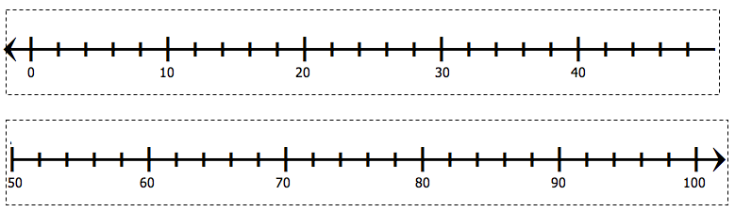

Student Number Lines

Cut strips apart on the dotted lines, and tape end to end.

Number Line Addition/Subtraction Recording Sheet
Directions: Use a number line below to record the hops related to each addition or subtraction problem. Record the numerical form of the addition or subtraction problem under the number line.
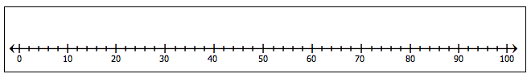

Digit Cards
Reproduce cards on card stock, and cut them apart on the dotted line.
0 | 1 | 2 | 3
4 | 5 | 6 | 7
8 | 9 | 0 | 1
2 | 3 | 4 | 5
6 | 7 | 8 | 9

