Mathematics Instructional Plan – Grade 2

Pattern Block Fractions
Strand: Number and Number Sense
Topic: Identify, write, represent, and compare fractions
Primary SOL: 2.4 The student will
- name and write fractions represented by a set, region, or length model for halves, fourths, eighths, thirds, and sixths;
- represent fractional parts with models and with symbols; and
- compare the unit fractions for halves, fourths, eighths, thirds, and sixths, with models.

Materials
- Paper
- Scissors
- Glue
- Pattern blocks for teacher and each group
- Fraction fish and peanut outlines for each student. (Before the lesson begins, use pattern blocks to create the outline of the fraction fish and peanut on a projector.)
Fraction Fish Fraction Peanut

Vocabulary
one-half, one-third, one-fourth, one-eighth, one-tenth, equal-sized parts, halves, thirds, fourths, sixths, and eighths

Student/Teacher Actions: What should students be doing? What should teachers be doing?
- Group students in fours, placing a set of pattern blocks in the middle of each group.
- Tell students that you found a picture of a fish (display through document camera for students to see), and you are curious as to how it was made. Ask them to help you determine how to make the fish using the pattern blocks. Give students a few minutes to come up with different solutions, using whatever strategies they choose.
- As a class, discuss several of the students’ strategies. Have students come up to the document camera and model the different solutions. As each solution is modeled, stick tape to the back of the pattern blocks to recreate the solution on the board, thereby keeping a record of the different solutions. If students use more than one type of pattern block (e.g., two trapezoids and three triangles), accept the answer, but ask if they can now make the fish using only one type of pattern block (e.g., all trapezoids or all triangles). Students will be trading in/making equivalent fractions to achieve this. Only record those solutions that use one type of pattern block (e.g., three trapezoids or nine triangles).
- Using the patterns stuck on the board, discuss the fractional parts of the fish. Discuss the importance of fair shares, or equal-sized parts, of a whole. Model the fractional notation for each piece. On the overhead, trace the trapezoids inside the fish shape. As you remove each piece, write $\frac{1}{3}$, explaining that the fraction represents one of three equal-sized pieces that make up the fish.
- Repeat step four using nine triangles.
- Model the strategy and steps again, as you have the students make the peanut outline shape. Repeat steps two through four.
- Pass out blank white paper. Have students fold the sheet in half, open it, and draw a line on the fold. Discuss how they started out with one whole sheet of paper and now they have folded it to create two halves. Draw a pictorial representation on the board and write the fractional notation: one-half and $\frac{1}{2}$ on each half of the paper.
- Explain to students that they will now create their own picture shapes using two blue rhombuses. They must follow one guideline: the rhombuses must touch on at least one side. Review the geometry terminology of sides. (The step is important to keep the activity a region/area model; otherwise, it could become the set model.) Students should trace the outline of the completed shape, then use the provided sheet of pattern blocks to cut and color the two rhombuses. On the opposite side of their papers, the students should recreate the picture with the paper pattern blocks, writing the fractional notation as they glue each block. Each student will then pass the paper to his or her partner, who will fill in the outline with other equal-sized pattern blocks. The partners will cut, color, and glue their paper pattern blocks on the outline, writing the fractional notation as they remove each piece. (Four green triangles will fit in the shape, so each traced piece should be marked as $\frac{1}{4}$.) When the puzzle is solved, have students pass back their pictures and explain what they did. Allow students to discuss, explain, and verify their solutions.
- Have students create another shape on the back of their papers using four blue rhombuses. Repeat step eight.
- Have students share their creations, solutions, and fractional notations.
- Summarize the lesson by having students explain that the whole can be made up of more than one piece. It does not need to be one hexagon or one fraction circle. Fractions are equal-sized pieces of a whole. Have students quickly identify and write the fractional parts of a whole for $\frac{1}{2}$, $\frac{1}{3}$, $\frac{1}{4}$, $\frac{1}{8}$, and $\frac{1}{10}$.

Assessments

Questions
  - If the trapezoid is the whole, what does the triangle represent?
  - What do you notice about the relationship between the pattern blocks? How does the hexagon compare to the trapezoid? How does the triangle compare to the rhombus?

Journal/writing prompts
  - How many different ways were you able to make the fish using one type of pattern block? The peanut?
  - What can you create using only triangles? Build and trace it in your journal.

Other Assessments
  - Observe students closely to be sure that they are using pattern blocks correctly. Some may want to use more than one type to fill in the patterns.
  - Question students as you move through the room. Ask them to explain

Extensions and Connections (for all students)
- Have students explore with pattern blocks the various pictures that they can create with one shape. Have them label their pieces accordingly.
- Have students create pictures, with more than one element, using pattern blocks and identify the fractional parts given the hexagon as the whole.

Strategies for Differentiation
- Students who struggle may need to start at a base level. They may need to take a hexagon and build the various fractional pieces first. Then transfer onto the pictures.
- Some may benefit from small group instruction as you build the conceptual understanding of fractional pieces and how they change depending on the whole.

Note: The following pages are intended for classroom use for students as a visual aid to learning.
Virginia Department of Education ©2018

Fraction Fish
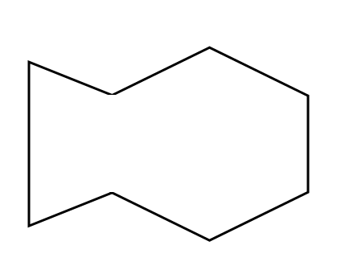

Fraction Peanut

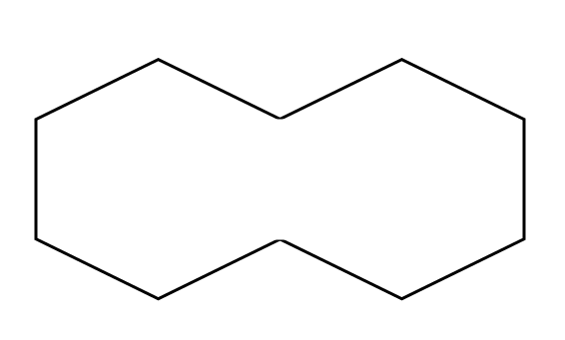

Pattern Blocks

