Mathematics Instructional Plan – Grade 2

Rounding with Base-10 Blocks
Strand: Number and Number Sense
Topic: Rounding two-digit numbers
Primary SOL: 2.1 The student will
d) round two-digit numbers to the nearest ten.

Materials:
- Base-10 blocks
- Rounding Mat (attached)
- Clear plastic sleeves
- Dry erase markers

Vocabulary:
round, rounding, tens, ones

Student/Teacher Actions (what students and teachers should be doing to facilitate learning)
Using Base-10 blocks and the Rounding Mat, model the concept of rounding.
- Under a document camera, build the number 23 using 2 rods and 3 cubes. Put them in the large box on the left of the Rounding Mat. Write the number 23 in the box labeled “Our Number”.
- Next, have the students identify the number of tens in the number 23. Students should be able to see the 2 rods has a value of 20. Write the number 20 in the box labeled “Tens in our number”
- Ask students, “When we count by 10’s what number do we say after we say “20”? Students should reply “30”. Write that number in the box labeled, “The next ten” Build 30 with 3 rods in the large box on the right.
- At this point you can label the number line at the bottom with “20” at the left end and “30” at the right end.
- Ask students which ten they think 23 is closest to. Have them explain their thinking.

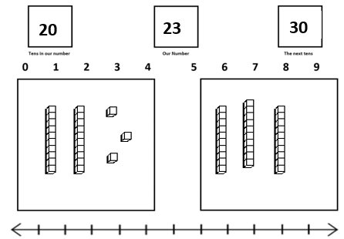

- Show students that by moving the cubes to the numbers at the top of the large boxes (as if counting the cubes) you can see that 23 is closer to 20 than 30.
- Do another example with students using a number that would round to the next ten, such as 48. Ask students, “What do you notice about the numbers that round to the ten within the number?” “What do you notice about the numbers that round to the next ten?”
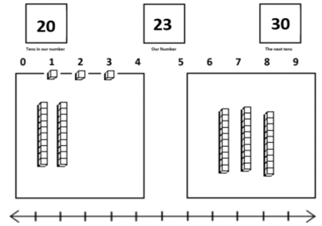

- If you think students are ready, have them work with a partner to round a given number using the base 10 blocks and Rounding Mat (select a different number for each pair). Ask pairs to share their number and the ten that it would round to.
- Engage the class in a discussion on rules and strategies for rounding numbers to the nearest ten.

Assessments

Questions
  - How would you round 98 to the nearest ten? Explain your thinking.
  - How does using a number line help you when rounding?

Journal/Writing prompts
  - Explain to a friend how to round the number 64 to the nearest ten.
  - Explain to a friend how to round the number 85 to the nearest ten.
  - When would you need to round a number? How would rounding a number be helpful?
  - Carla rounded the number 45 to 50. Jessica said that was not correct that it should round to 40. Do you agree with Carla or Jessica? Explain your thinking.

Extensions and Connections (for all students)
- Teach students to draw representations of base 10 blocks to move them from the concrete to the representational stage.
- Use the attached Number Line page to transfer from the Rounding Mat to a number line rounding model.
- Use this same model when teaching estimating sums and differences. Have students build the number first.

Strategies for Differentiation
- Move students through the steps of concrete to representational to abstract as they are ready. Some may rely on the concrete longer than others. The representational step will be significant for those still building number sense.

Note: The following pages are intended for classroom use for students as a visual aid to learning.

Virginia Department of Education ©2019

Number Line Rounding
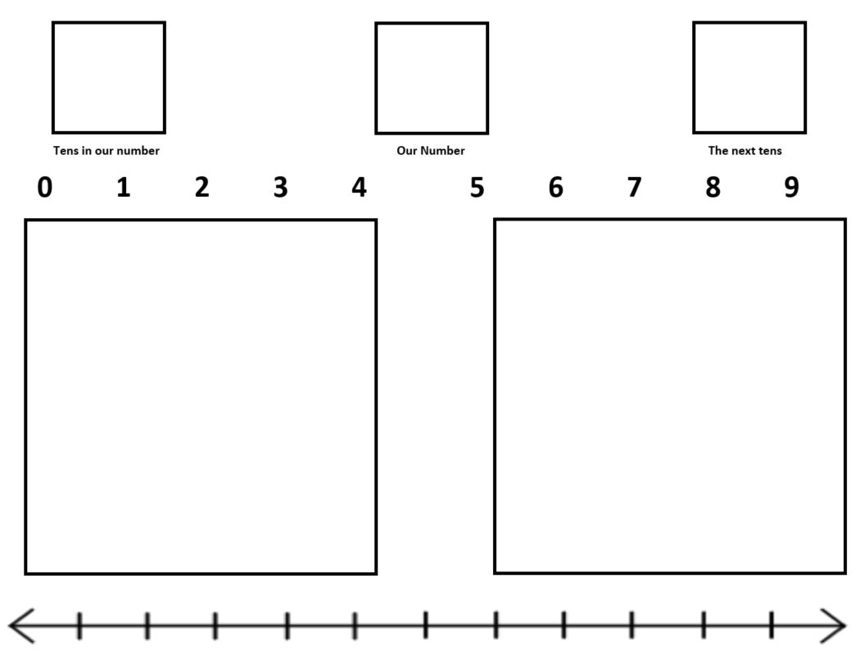
Rounding Mat

