Mathematics Instructional Plan – Grade 2

What’s My Number?
Strand: Number and Number Sense and Computation and Estimation
Topic: 10 more and less, 100 more and less
Primary SOL: 2.1 The student will
- read, write, and identify the place and value of each digit in a three-digit numeral, with and without models place
- identify the number that is 10 more, 10 less, 100 more , and 100 less than a given number up to 999
Related SOL: 2.6

Materials:
- Hundreds charts (1 to 120, 0 to 119, 1 to 200)
- Counters for Hundred chart
- Paper or white boards and markers

Vocabulary:
ones, tens, hundreds, place value, digit, one more, ten more, one less, ten less, sum, difference

Student/Teacher Actions: What should students be doing? What should teachers be doing?
Demonstrate the activity by displaying a 120 chart under the document camera. Have students follow the steps below on their 120 chart as you demonstrate.
- Give each student a 120 chart and several counters.
- Practice by having students put a counter on the number 34. Tell them to add 10 and place another counter on that number. Ask, “What is the sum? What strategy did you use to find the sum?” Some students may already understand that 10 more is just one box below. Discuss counting on and placing the chip at 44. Have students add 10 more to 44 and place a chip. Again, discuss adding 10 and placing the chip on 54. Ask them to predict what 10 more than 54 is. Have them explain their thinking. Lead them into a discussion about adding a ten to the tens place each time.
- Try another example, 76. Ask students to subtract 10 (66). This time students should move their counters up one space on the chart. Engage students in a discussion about 10 less, the tens place and moving up the chart. Do as many examples as necessary until all students can successfully complete the task.
- Next, try adding 11. Tell students to place a counter on 24, and then add 11. Students should move finger down one space to make 10 and then one space to the right, indicating that 11 is the same as 10 + 1. Try more examples until students grasp the concept.
- Move to a subtraction example. Ask students to put a counter on 89, and then subtract 11. Students should move up one space to represent minus 10, and then move one to the left to subtract 1, arriving at the answer of 78.
- Practice adding and subtracting other numbers such as 20, 30, 25, 15 and 12. Ask students to explain what they notice as they move up and down the 120 chart.
- Students should now be ready to play the additional games below. As you play each game, you should see students getting faster at adding and subtracting once they understand how to manipulate (decompose numbers on) the chart.

Assessment

Questions
  - What happens to a number when you go up one space on the hundreds chart? (decreases by 10 or subtract 10)
  - What happens to a number when you go down one space on the hundreds chart? (increases by 10 or add 10)
  - What other patterns did you notice when using the chart?
  - How is this similar to adding and subtracting on a number line?

Journal/Writing prompts
  - Explain to a friend how to subtract 11 from 36 on the hundreds chart.
  - Explain to a friend how to add 25 to 36 on the hundreds chart.
  - Write 5 steps for a friend to add and subtract using the hundreds chart starting at the number 45.

Other Assessments
  - Have students write the number that is 10 more and 10 less than 73.
  - Have students write the number that is 100 more and 100 less than 345.

Extensions and Connections (for all students)
- Use a Two Hundreds Board to reach larger numbers.
- Have students record the equations as you add and subtract numbers to make the connection between the chart and addition/subtraction.
- Have students write the number that is 10 more and 10 less than 625.

Strategies for Differentiation
- Simplify the steps in some of the games.
- For students who have trouble keeping up with the games begin by adding and subtracting 10 and then adding and subtracting 1, 5 and 15. Add steps, as they are able.
- Put charts in clear plastic sleeves and have students use dry erase markers to mark the paths as they add and subtract.
Game One
- Tell students that you’re thinking of a number on the 120 chart. Offer clues to help students identify the number.
- Ask students to place their counters on the sum of 11 and 7. Have them check with a neighbor to make sure everyone is starting on the same number (18).
- Add 20. (Monitor students to check if they move their counters down two spaces to add 20, arriving at the sum of 38.)
- Subtract 2. Ask, “Where are you now? Are you on an even number?”
- Subtract 10, and then subtract 1. Ask, “Is your number the same as the number of pennies in a quarter?” (yes, 25)
- Add 9. (You may notice students adding 10 and then subtracting 1.)
- Add 11. Ask, “Are 5 away from 50?” (yes, 45)
- Subtract 2, and add 21. Ask, “Is the sum of the digits 10?” (yes, 64)
- Add 31, and then subtract 10.
- Add 1, and then subtract 20. Ask, “Are both digits the same?” (yes)
- Ask students: “What’s my number?” (66)

Game Two
- Instruct students to place a counter on the sum of 40 and 40. Have them check with a neighbor to make sure everyone is starting on the same number (80).
- Add 20, and then subtract 2. Ask, “Are you two away from 100?” (yes, 98)
- Subtract 10, and then subtract 1. Ask, “Do you have 3 less than 90?” (yes, 87)
- Add 9, and then subtract 30. Ask, “Do you have the same digit in the tens and ones places?” (yes, 66)
- Add 4, and then subtract 20. Ask, “Do you have the value of 2 quarters?”
- What’s my number? (50)

Game Three
- Instruct students to place a counter on the sum of 25 and 10. (Ask students to answer aloud, so that everyone starts on the same number, 35.)
- Subtract 3. Add 11. Ask, “Is the digit in the tens place one more than the digit in the ones place?” (yes, 43)
- Add 12, and then add 9.
- Subtract 1. Ask, “Is the tens place double the ones place?” (yes, 63)
- Subtract 9, and then add 1.
- Add 20. Ask, “Is this the amount of change you would get from $1, after making a 25-cent purchase? (yes, 75 cents)
- Subtract 3, and then add 8. Ask, “Is this number 8 tens?” (yes, 80)
- Subtract 29. Ask, “Is the sum of the digits 7?” (yes)
- Ask, “What’s my number?” (52)

Note: The following pages are intended for classroom use for students as a visual aid to learning.
Virginia Department of Education ©2019

Hundreds Board
1 | 2 | 3 | 4 | 5 | 6 | 7 | 8 | 9 | 10
11 | 12 | 13 | 14 | 15 | 16 | 17 | 18 | 19 | 20
21 | 22 | 23 | 24 | 25 | 26 | 27 | 28 | 29 | 30
31 | 32 | 33 | 34 | 35 | 36 | 37 | 38 | 39 | 40
41 | 42 | 43 | 44 | 45 | 46 | 47 | 48 | 49 | 50
51 | 52 | 53 | 54 | 55 | 56 | 57 | 58 | 59 | 60
61 | 62 | 63 | 64 | 65 | 66 | 67 | 68 | 69 | 70
71 | 72 | 73 | 74 | 75 | 76 | 77 | 78 | 79 | 80
81 | 82 | 83 | 84 | 85 | 86 | 87 | 88 | 89 | 90
91 | 92 | 93 | 94 | 95 | 96 | 97 | 98 | 99 | 100
101 | 102 | 103 | 104 | 105 | 106 | 107 | 108 | 109 | 110
111 | 112 | 113 | 114 | 115 | 116 | 117 | 118 | 119 | 120
Hundreds Board 0-119
0 | 1 | 2 | 3 | 4 | 5 | 6 | 7 | 8 | 9
10 | 11 | 12 | 13 | 14 | 15 | 16 | 17 | 18 | 19
20 | 21 | 22 | 23 | 24 | 25 | 26 | 27 | 28 | 29
30 | 31 | 32 | 33 | 34 | 35 | 36 | 37 | 38 | 39
40 | 41 | 42 | 43 | 44 | 45 | 46 | 47 | 48 | 49
50 | 51 | 52 | 53 | 54 | 55 | 56 | 57 | 58 | 59
60 | 61 | 62 | 63 | 64 | 65 | 66 | 67 | 68 | 69
70 | 71 | 72 | 73 | 74 | 75 | 76 | 77 | 78 | 79
80 | 81 | 82 | 83 | 84 | 85 | 86 | 87 | 88 | 89
90 | 91 | 92 | 93 | 94 | 95 | 96 | 97 | 98 | 99
100 | 101 | 102 | 103 | 104 | 105 | 106 | 107 | 108 | 109
110 | 111 | 112 | 113 | 114 | 115 | 116 | 117 | 118 | 119

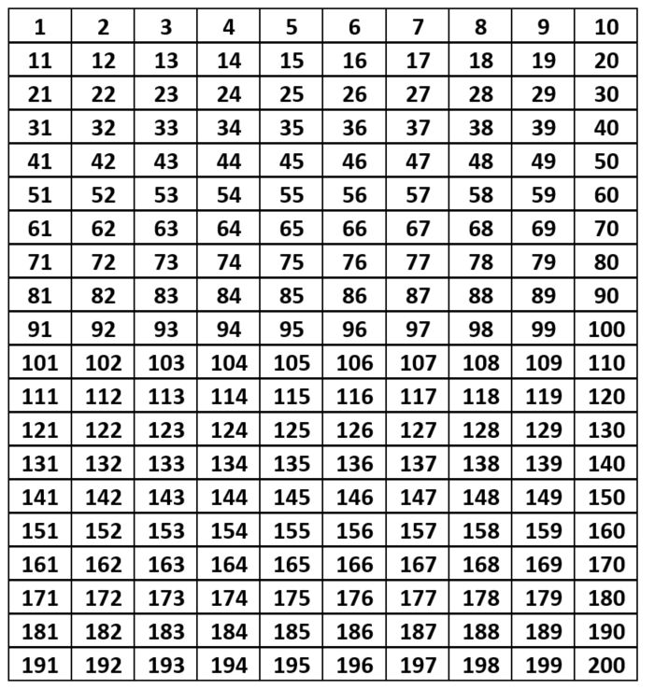
Two Hundreds Chart

