Mathematics Instructional Plan – Grade 1

Shapes
Strand: Geometry and Measurement
Topic: Identifying geometric shapes in the environment
Primary SOL: 1.11 The student will
- identify and describe representations of circles, squares, rectangles, and triangles in different environments, regardless of orientation, and explain reasoning.
Related SOL: 1.11a, 1.13

Materials
- Book about shapes
- Chart paper
- Shape Collection sheet (attached)
- Markers
- Digital cameras or iPads, if available
- 12” x 18” white construction paper
- Glue
- Scissors
- Pencils
- Waxed paper sheets
- Modeling clay/dough
- Shape Hunt Recording sheet (attached)
- Shape Examples and Non-examples sheets (attached)

Vocabulary
angles, circle, triangle, rectangle, representations, right angles, round curved, square, sides, vertex, vertices

Student/Teacher Actions: What should students be doing? What should teachers be doing?
- Read a book about shapes with students. After reading, discuss and review the critical attributes of circles, squares, rectangles, and triangles with students. Use various circles, squares, rectangles, and triangles from the Shape Collection sheet during your discussion with students. You may decide to create a visual chart of each shape, including student-derived descriptions of the shapes for the students to refer to. Include examples of rectangles, triangles, and squares in different orientations, so students begin to realize that the shape’s name does not change even if the shape is rotated in a different way.
- During the discussion, focus on the number of sides, vertices, and angles of each shape. Review the term side, and model how to count the sides of a shape. You may want to highlight the sides on a shape so students can distinguish the difference between sides, vertices, and angles. Review the terms vertices and angle in the same way. Ask students to describe the types of angles that shapes have. Specifically, discuss square corners, or right angles, in rectangles, squares, and some triangles. Right angles resemble a capital L or a corner of an index card. Model how they are similar. Some students may recognize that a square is a special type of rectangle. If students say that rectangles have two long sides and two short sides (a common misconception), say, “Well, that rectangle has two long sides and two short sides, but not all rectangles have two long sides and two short sides. All rectangles have four sides, four vertices, and four right angles.” Ask the following questions: “How can a (shape) be described?” “How are shapes alike and different?” “What makes shapes different from each other?” “Where can we find shapes in the real world?” “Can you show me the difference between a vertex and a side?” “Are all four-sided shapes the same? How do you know?”
- As you listen to students discuss the shapes, consider these questions: What features of shapes do students pay attention to? What aspects of the shapes do students describe? What vocabulary are students using to describe shapes? These student observations will help you guide your instruction for additional geometry lessons for your students.
- Assign each student a partner and give each partner pair a target shape (i.e., circle, square, triangle, and rectangle). Explain to students that they will go on a shape hunt with their partner around the classroom, school building, and/or outdoors, searching for examples of their target shape in the environment.
- Have students record the examples on their recording sheet. Another option would be to have students photograph the shapes as they find them, using digital cameras or iPads. Print the photographs. Have the partner pairs create a poster about their shape on large construction paper, including the examples/photographs they found on the shape hunt. Have students describe the attributes of their shape on their poster. Students can add additional details or labels about their shape to their shape poster.
- When groups are finished, gather students for a whole-group discussion of their posters. Have students pay special attention to the attributes of their shape. Some possible questions to help facilitate the discussion with students are: “Explain how you know it is the (target shape).” “How would you describe your shape to others?” “Did you find different kinds of the same shape?” “How do you know they are similar?” Be on the lookout for shapes that are “almost, but not quite,” a particular shape (e.g., a slice of pizza is like a triangle because it has three sides, but one of the sides is curved). When you spot a shape that is “almost, but not quite,” ask the students what would need to change to make it a ____.
- Provide students with time to reflect upon their learning by making a mathematics journal entry. For example: Today, I found (name of shape). (Name of shape) has _____. Encourage students to write as much as they can about their shape or another shape.

Assessment

Questions
  - Look around the classroom. What objects can you see that are shaped like triangles, squares, rectangles, and circles? Record them in your mathematics journal.
  - What are three different objects shaped like squares in our classroom? How do you know they are squares? How are squares special shapes?
  - Distribute waxed paper sheets and balls of modeling clay/dough. Have students place the sheet on their desks and use the dough to create each of the four shapes (triangle, rectangle, square, and circle). Ask students to describe the attributes of each shape after it has been constructed.

Journal/writing prompts
  - Draw two different shapes and describe at least two attributes of each shape.
  - Write a riddle describing a shape. Turn to a partner and share the riddle that you created.

Other Assessments
  - Provide students with pictures from magazines depicting shapes found in our environment. Have students use highlighters to trace around the shapes they find and describe the attributes of the shapes.
  - Use Geoboards/rubber bands to create shapes. Give the characteristics of a shape and have students create the shape on their Geoboard. (An alternative to this activity would be to use plastic straws cut into a variety of sizes to create shapes.)
  - Give students several examples and non-examples of a shape. Be sure to include a variety of the same shape in different orientations. Have students identify the examples and explain why they are that shape. Also, have students describe why the non-examples are not the shape. The attached examples/non-examples sheets can be used as an assessment opportunity.

Extensions and Connections (for all students)
- Provide modeling clay or dough in a center for students to practice modeling shapes. Cookie cutters may be used, if desired.
- Place several books about shapes in a tub or basket in your mathematics center. Have students read a story and then draw and/or write in their mathematics journals about one of the shapes in the story.
- Distribute newspapers and/or magazines from which to cut out pictures of objects shaped like triangles, rectangles, squares, and circles. Have students save their pictures in a baggie or envelope.
- Using the attached example/non-example sheets, cut apart each sheet to make four sets of cards. Students can sort the cards into Triangle/Not a Triangle, Circle/Not a Circle, Rectangle/Not a Rectangle, and Square/Not a Square. Students should justify their decisions based on the attributes of triangles, circles, rectangles, and squares.

Strategies for Differentiation
- Provide a cutout of a shape for struggling learners to carry with them on the shape hunt.
- Provide shapes for students to outline with yarn to help them differentiate among the shapes.
- Use a black marker to outline a shape on paper. Cover the shape with waxed paper so students may have support in forming shapes with dough or clay.
- For students who may have trouble picking out shapes in the environment, provide pictures of objects for students to identify the correct shape as an alternative to a shape hunt.

Note: The following pages are intended for classroom use for students as a visual aid to learning.

Virginia Department of Education © 2018

Shape Hunt Recording Sheet

I am hunting for _________________________________________.
(name of shape)

Find some examples of your shape. Use pictures and words to show what you found on your shape hunt.

Shape Collection
A | B | C  C
D | e | F
G | H | I
J | 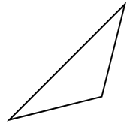  K | 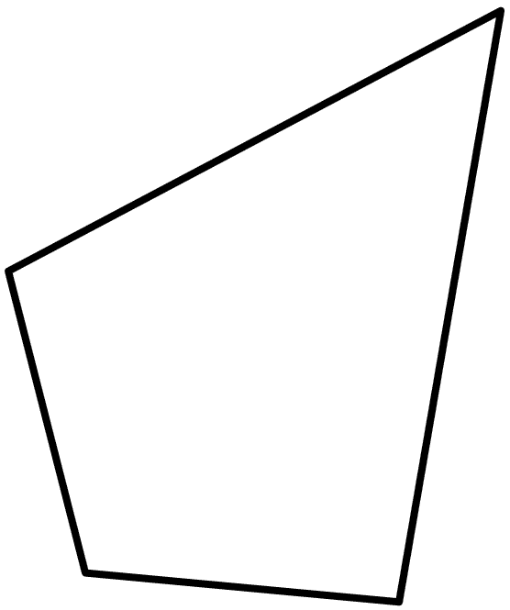  L

M | N | O
P  P | Q | R
S | T | 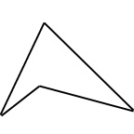  U
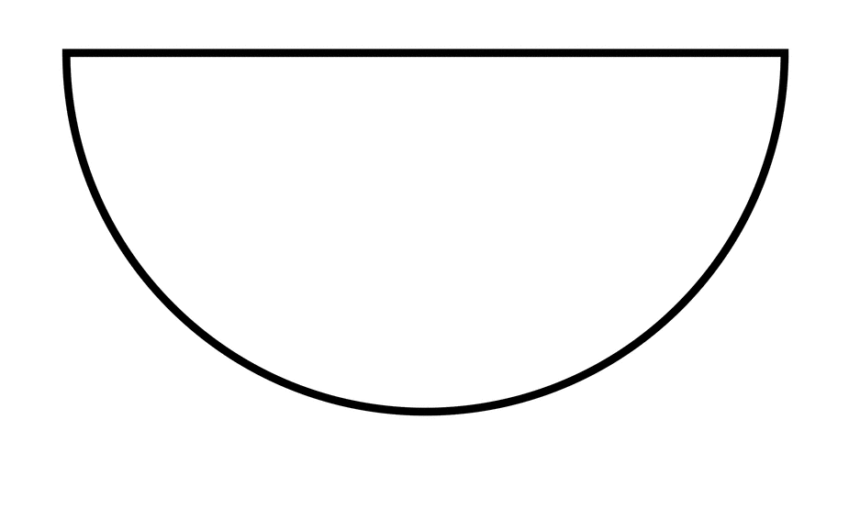  V | W | X

Triangle Examples and Non-examples
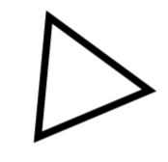 | 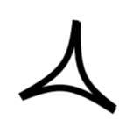 | 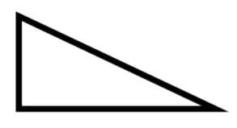
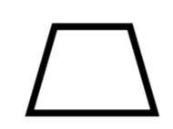 | 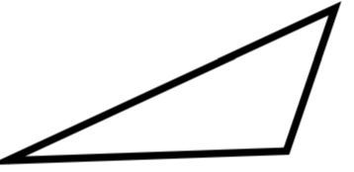 | 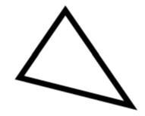
 | 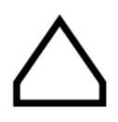
Rectangle Examples and Non-examples
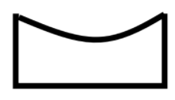

Square Examples and Non-examples
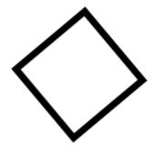
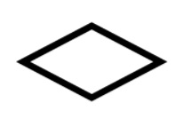

Circle Examples and Non-examples
 | 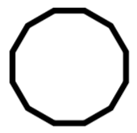 | 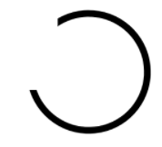
 | 