Mathematics Instructional Plan – Grade 1

Shape Up!
Strand: Measurement and Geometry
Topic: Exploring plane geometry
Primary SOL: 1.11 The student will
- identify, trace, describe, and sort plane figures (triangles, squares, rectangles, and circles) according to number of sides, vertices, and angles.
Related SOL: 1.11b, 1.13

Materials
- Shape Collection cards (one set for each pair of students)
- Yarn or a hula hoop
- 12” x 18” construction paper
- Glue
- Pencils

Vocabulary
angles, circle, curved, plane figure, rectangle, right angles, round, sides, sort, square, straight, trace, triangle, vertex, vertices

Student/Teacher Actions: What should students be doing? What should teachers be doing?
- Gather your students in a circle in an open area in your classroom. You will need a set of shapes from the Shape Collection sheet. Have the shapes spread out in front of the students. You will notice that the shape collection includes some shapes that are not circles, squares, rectangles, or triangles. Including a broader group of shapes allows students to truly focus on the attributes that make up a shape. Students are not expected to know the names of these additional shapes.
- Have each student select a shape card and ask him/her to think of things that they can say about their shape. Go around the group and ask students to share their shape with the group and tell several characteristics about their shape. While students are sharing their shape and characteristics, listen carefully to what your students are saying. How are students describing their shape? Are they using appropriate geometrical vocabulary or not? Do they recognize the shapes, even in different orientations? How are students comparing their shape to others? Do they recognize that their shape is similar or different than other shapes being discussed by students?
- Have students return their shape card to the center. Shuffle them and hand out one shape card to each student. Use yarn (or a hula hoop) to create a large circle in the center of the students.
- Explain to students that they will be playing a game called, “What’s My Rule?” Tell them that you have a secret rule for what shapes can go inside the circle. Explain that the shapes are going to be similar in some way and that they are trying to figure out the secret rule for how the shapes are sorted. Then, place 2 shapes into the circle that have straight sides (This is your rule for this practice round.).
- Explain that in this game, we are going to try to place as many shapes as we can inside the circle before guessing what the rule is for how the shapes are sorted. Direct students to look at their shape card and think about whether it is similar in some way to both of the cards that are in the circle. Ask, “Who thinks they may have a shape card that goes into the circle?”
- Call on students, and if their shape card fits the rule, have the student place their shape card inside the circle. If their shape card does not fit the rule, have them place their card outside the circle.
- Continue this, pausing to ask students to look at the shapes inside the circle and ask them what they notice about the shapes in the circle. Here are some questions to facilitate discussion: “How are the shapes in the circle similar to one another?” “How are the shapes outside of the circle similar?” “How are the shapes inside the circle different from the shapes outside of the circle?”
- Emphasize the importance of examining the shapes that do not fit the rule to see what they may have in common. These clues could help students figure out what attributes the shapes inside of the circle have in common and how they are different from the outside shapes. “What do shapes that don’t fit the rule have in common?” “How are shapes outside of the circle different from the ones inside the circle?”
- When most of the cards have been placed and you think the students may know what the rule is, have them turn and talk to a partner about what they think the rule is. Then ask someone to state the rule.
- Explain that the rule you were thinking of was, “shapes with all straight sides.” Have students look around the circle and see whether the shapes inside the circle meet this rule.
- Have students discuss what they think the rule for the shapes not in the circle would be. Ask them to explain how carefully looking at the shapes outside the circle helped them figure out the rule for the shapes inside of the circle.
- After the discussion, collect the cards and repeat with another rule, such as “shapes with right angles,” “triangles,” “shapes with vertices,” “shapes with four sides.”
- Next, explain to students that they will be working with a partner to sort a set of shape cards into groups. They can have two, three, or more groups but every shape must belong to one of the groups. After they have time to sort the shapes in several different ways, partner pairs will be creating a shape-sort poster and will label the names for their shape groups after they have sorted.
- Assign each student a partner and give them a set of shape cards. Have them try to sort the shapes in several different ways. They must come to a consensus about how to sort the shape cards for their shape poster.
- While students are working, listen and watch students and how they are thinking about how to sort their shapes. How can shapes be sorted? What makes shapes different from each other? How are shapes alike? Which shapes are similar in some way? What would you call this group of shapes? Why did you put this shape into this group and not this other one? Where would this shape go if you are sorting this way? Are students able to describe the differences in shapes? Can students sort the shapes by more than one attribute?
- When students are ready to create their Shape Poster, give each partner pair a sheet of construction paper, glue, and pencils. When partner pairs have everything they need, set them to work on sorting their shapes and creating their posters. They will also need to label their groups. What words could you write here to tell someone looking at this poster why you put these shapes together?
- After partner pairs complete their posters, assemble several groups together and have students share their posters with their peers. Have them discuss how they sorted their shapes and their reasoning for placing shapes in the groups that they did. Here are some possible questions to ask students why they are sharing: “Why did you put these shapes together?” “Are all triangles the same?” “Are all four-sided shapes the same?” “Why did you and your partner decide to sort the shapes as you did?”

Assessment

Questions
  - Use the Shape Collection cards for this activity. Explain to students that you are going to call out the name of a shape, and they are to pick up an example of the shape you name and hold it above their heads for you to see. As you call out each shape, observe which students are able to identify it correctly. For each shape, ask students questions such as, “How do you know this is a (name of shape)?” “What can you tell me about a (name of shape)?” Repeat this with several other shapes and having students identify the names of the shapes as well as reviewing the characteristics of the shapes.
  - Place several of the shape cards in front of a student. Tell the student that you would like them to identify all of the shapes with right angles in the group of shapes. Look around the room and find one object that has a right angle and one object that does not. How did you choose these objects? How do you know you chose correctly?

Journal/writing prompts
  - Look at the Shape Poster you made today and use pictures and words to describe how you sorted the shapes.
  - Write about or draw objects that you can see in the environment that are shaped like a triangle, a square, a rectangle, and a circle.

Other Assessments
  - Work with students to create a riddle book about shapes (e.g., “I have three sides and no right angles, and I have three vertices. Who am I?”).
  - Use attribute blocks and a Venn diagram (or hula hoop) to sort blocks by given attributes.

Extensions and Connections
- Place attribute blocks in a long sock, and have students take turns putting their hand in and describing to the class the attributes of the shape they are feeling. Classmates must identify the shape from the described attributes.
- Have students play Four Corners, in which a shape (circle, square, rectangle, or triangle) is hung in a corner of the classroom. When you count to three, students walk to a corner and wait until the person who is “it” (with eyes shut and facing away from the students) describes the attributes of one of the shapes (e.g., “zero vertices and zero sides”). Students who are under the described shape are “out” and must sit out one turn before returning to the game. Students remaining in the game must change corners after every turn.
- Provide shape templates in a center so students may practice tracing each of the four basic shapes. Have him/her name the attributes of the shapes as s/he works.

Strategies for Differentiation
- Provide visual cues, such as a poster with the names and pictures of the shapes. Label sides, vertices, and right angles on the chart for reference.
- For struggling learners, reduce the number of shapes and/or the number of categories that you give them to sort.
- For students struggling to identify shapes, limit the kinds of shapes you present to students and avoid unfamiliar shapes.

Note: The following pages are intended for classroom use for students as a visual aid to learning.

Virginia Department of Education © 2018

Shape Collection

A | B | C  C
D | e | F
G | H | I
J | 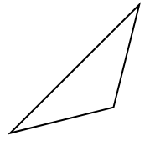  K | 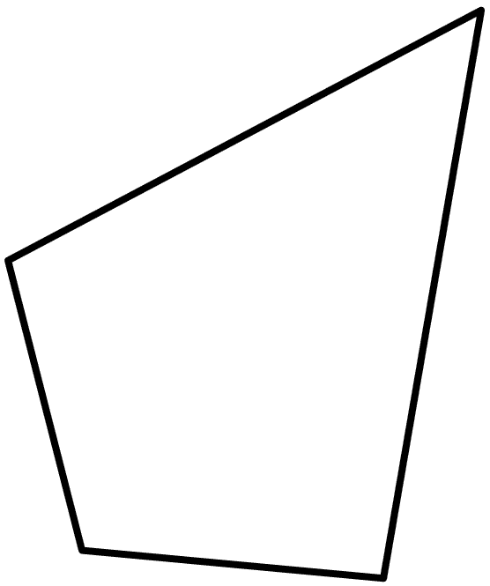  L

M | N | O
P  P | Q | R
S | T | 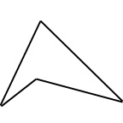  U
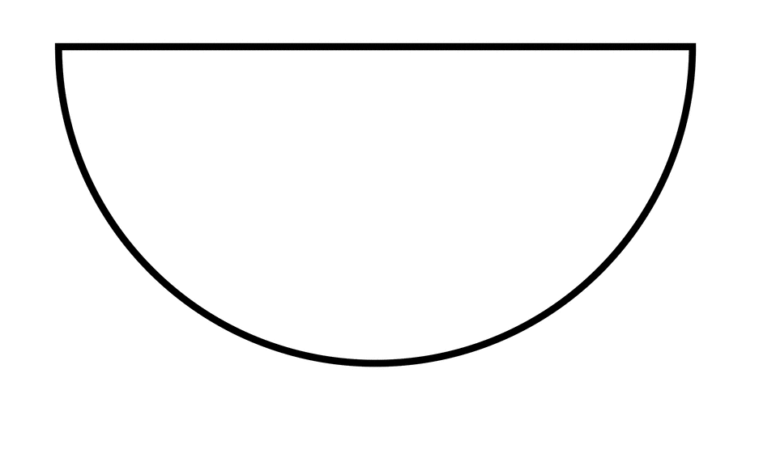  V | W | X

