Mathematics Instructional Plan – Grade 1

Spin to Win with Combinations of 10
Strand: Computation and Estimation
Topic: Recognizing and describing part-whole relationships for numbers up to 10
Primary SOL: 1.7 The student will
- recognize and describe with fluency part-whole relationships for numbers up to 10;
Related SOL: 1.1, 1.6, 1.7b, 1.15

Materials
- Images of 10 cards
- Counters
- Paper/pencil or dry erase marker/whiteboard
- 10 frame spinner
- Game boards (one for each partner pair)
- Two-colored counters (12 of each color for each partner pair)
- Paper clip for spinner

Vocabulary
above, below, beside, combining, group, number relationships, part, strategies, whole

Student/Teacher Actions: What should students be doing? What should teachers be doing?
Note: This lesson has been written to focus on the parts of 10; however, it could be modified to focus on the parts of a different number.
- To begin the lesson and jump start student thinking about the number 10, the teacher will flash cards with different configurations of 10. Students will need counters, paper/pencil, or dry erase markers/whiteboards.
- Flash an image from the “Images of 10” sheet for about 5 seconds and then hide it. Give students time to re-create what they saw using counters, paper/pencil, or dry erase markers/whiteboards. Then, flash the image again and hide it after about 5 seconds. Students can finish their re-creation of what they saw. Finally, show the image again and leave it up so that students can check their work and make any necessary changes.
- Facilitate a discussion with students by asking them what helped them remember what the image looked like. After a student explains their strategy, draw a sketch of the image and record the student ideas by circling how they saw the configuration. Focus on the parts of the number 10 that the students saw and how they put them together to make the whole (10). Ask students how this helped them to think about the total number, or the whole. Have several students discuss their strategies for remembering the image. Ask students to compare the various student strategies: “How is (student’s) way of remembering like (student’s) way? How are they different?” (If students have been introduced to the + sign and = sign, this would be an opportunity to ask students what equation would represent how they saw the image.)
- Repeat this with several other cards using the “Images of 10” sheet or other similar pictures and discuss student strategies. Ask students what they notice about the total number of shapes in the images you flashed to them during this introduction. (They should recognize that all of the images had a total of 10.)
- Explain to students that today’s focus will be working on the number 10. Ask them to share what they know about the number 10. They can use pictures, drawings, and numbers to describe their ideas. Record their ideas on chart paper. For example, a student may say they have 10 fingers or toes, or that 10 is one more than nine, or that there are 10 squares on a 10 frame. Students may discuss various parts that when put together make a total of 10, such as, 5 and 5, 4 and 6, etc. Ask students to explain how they know that these parts make 10.
- After taking a few student suggestions of ways to make 10, explain that students will play a game called “Spin to Win with Combinations of 10” to work on combinations of ten. Students will work with a partner. Each pair of students will need a 10 frame spinner, paperclip, pencil, two colored counters (about 12 of each color), and a game board.
- The objective of the game is to get four spaces in a row vertically, horizontally, or diagonally. Model this game for students before sending them with their partner to play.
- Player 1 spins the spinner and decides what number needs to be added to the number on the 10 frame to make 10. Player 1 covers a space with the corresponding number. There are multiple spaces on the game board that could be covered. This provides an opportunity for students to use strategies to block their opponent as well as get four in a row as they become more familiar with the game. Player 1 must say the number spun and the number that needs to be added to make 10 before play continues. For example, player 1 will say, “____ and ____ is 10, or 10 is ____ and ____.” Discuss how the number 10 is the total or whole and the numbers that make the whole are considered parts of 10.
- Play will alternate between player 1 and player 2, with each player using a different colored counter to mark his/her spaces on the game board.
- If there are no spaces that can be covered for the number spun, the player loses a turn.
- The first player to get four in a row wins the game.
- While students are playing the game with a partner, the teacher should be observing students as they work. Here are some questions to consider while observing students: “Are students determining the correct number to make a combination of 10?” “If there are any misconceptions, what are your next steps for that student(s)?” “How is the student determining the part to make 10?” “Did the student count on from the number spun?” “What other strategies is the student using to figure out combinations of 10?” “Did the student notice any patterns while finding combinations of 10?”
- After students have time to play the game, gather students for a discussion about the combinations of 10 and strategies they used throughout the game. Ask students to share different ways they found to make 10. Record their combinations on chart paper/board. Use pictures, numbers, and words when recording student ideas on the chart. Here are some questions to consider as you facilitate discussion with students: “How did you figure out how many more you needed to make a combination of 10?” “How did you count?” “How did you use combinations that you already found to help you with those you did not know?” “What patterns did you notice?” “What strategies did you use to block your partner from getting four in a row?” “What strategies did you use to get four in a row?”
- This game lends itself well to being played multiple times by students to help them internalize the part-part-whole relationship for the combinations of 10. After it is introduced and students understand how to play, this game could be used as a station while you meet with small groups.

Assessment

Questions
  - What are the combinations of 10?
  - Are there more ways to compose/decompose the number 10?
  - Have you found all the combinations of 10? How do you know?
  - What patterns did you notice? Tell me more.
  - If you spun a 3 on the spinner, how would you figure out which number will make 10? What would you do to solve this problem?

Journal/writing prompts
  - Erin had 10 toy blocks. Some were red and some were yellow. How many of each could she have? How many red? How many yellow? Find as many ways as you can.
  - Jake has three toy cars. Emily gave him some more toy cars. Now Jake has 10 toy cars. How many did Emily give him?
  - Renee has 10 fish in her fish tank. Six of the fish are orange, and the rest are blue. How many blue fish does Renee have?
  - Sam found some seashells at the beach. Josh gave him five more. Now Sam has 10 seashells. How many seashells did Sam have to start with?

Other Assessments
  - Provide a container of counters. Have students count out 10. Hide some of the counters under your hand. Ask students to figure out how many counters are hidden and explain their thinking.
  - Exit Ticket (attached)

Extensions and Connections (for all students)
- If the symbols for addition have been introduced, students could represent their combinations of 10 with equations. For example, 4 + 6 = 10 or 10 = 3 + 7. Share a variety of ways of writing equations with combinations of 10.
- The teacher could connect the combinations of 10 that students found during the activity with number bonds and further discuss the number 10 in terms of parts and wholes.
- Students could write and solve their own story problem using 10.
- Students need many opportunities to experience part-whole relationships for each number through 10 in order to develop fluency. Additional activities that could be introduced and then placed in stations include:
- Fish for 10: Use a deck of number cards 0–10. Deal five cards to each student. Students take turns asking each other for a card that will make 10 with the card in his/her hand.
- Flip 10: Use a deck of number cards 0–10. Turn over the cards in a rectangular arrangement (array) so they cannot see the cards. Partners take turns flipping two cards over to find combinations that make 10.
- Over/Under: Use a sheet of paper and some counters. Determine how many counters to play with, such as 10. Have students count out that many counters. Player 1 hides some of the counters under a sheet of paper and leaves the rest of the counters visible. Player 2 tells how many are under the paper to make a total of 10. Take turns finding different combinations that make 10.
- On/Off: Use ten two-sided counters and a half sheet of paper as a mat. Partners take turns holding a small cup above the mat and spilling the ten counters out. Count up the counters that spilled onto the mat and the ones that spilled off of the mat. Record these numbers in math journals or on whiteboard. Then, add the on and off counters to find the total and record. For example, ___ + ___ = ___. Repeat this procedure with players alternating turns.

Strategies for Differentiation
- Provide a 10 frame mat on which students can place counters while figuring out how many more are needed to make 10, for more visual support.
- Allow students to work on finding combinations of five and use a five frame spinner.
- Students could be given a greater sum to find combinations for and explain how they used combinations of 10 to help them solve.
- Provide a part-part-whole mat or a number-bond mat.
- For students who struggle with seeing things from a distance, provide the students the opportunity to see the image cards at their desks.

Note: The following pages are intended for classroom use for students as a visual aid to learning.

Virginia Department of Education © 2018

Images of 10
Image A | Image B
Image C | Image D

Image E | Image F
Image G | Image H

Ten-Frame Spinner
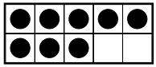
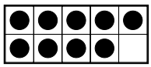
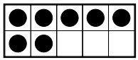
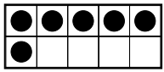
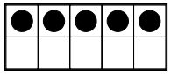
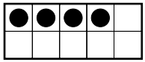
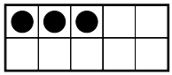
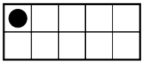
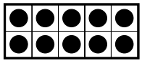
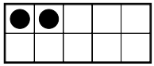
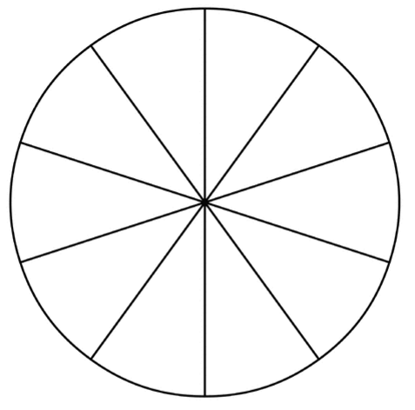

Game Board 1
4 | 7 | 1 | 5 | 9
0 | 6 | 8 | 3 | 0
8 | 9 | 2 | 4 | 6
2 | 3 | 5 | 7 | 1
5 | 0 | 7 | 2 | 8
1 | 9 | 3 | 6 | 4

Game Board 2
1 | 6 | 4 | 2 | 9
4 | 8 | 7 | 5 | 3
2 | 9 | 0 | 8 | 6
5 | 1 | 7 | 3 | 8
6 | 3 | 9 | 4 | 0
0 | 7 | 1 | 5 | 2

Exit Card
- How many more counters do you need to make 10? _____

- Turner made a tower with 5 cubes. How many more cubes does he need to make a tower of 10 cubes? Draw a picture to show your work.

