*Mathematics Instructional Plan – Grade 1*

# Make Ten

Strand: Computation and Estimation

Topic:Developing basic addition and subtraction fact strategies for “make ten”

Primary SOL:1.6 The student will create and solve single-step story and picture problems using addition and subtraction within 20.

Related SOL:1.1, 1.7, 1.15

## Materials

* Double 10 frame cards for “Ten and Some More”
* Double 10 frame card for 9 + 3
* Blank Double 10 Frame
* Counters (magnetic if using a magnetic board, non-magnetic if not)
* Chart paper
* Student Double 10 Frame Mats (Nine counters on the top)
* 10 circular counters for each student (must fit in the 10 frame cells)
* “9 + Bump” game board – one per pair of students
* Set of 1–9 number cards – one set per pair
* 40 counters or cubes in two colors (20 of each) – for each pair of students
* Where are the Make 10 Facts? assessment activity

## Vocabulary

*add, combine/join, doubles, doubling, equation, minus, models, near doubles, number sentence, parts, plus, put together, strategy, subtract, sum, take apart, whole*

## Student/Teacher Actions: What should students be doing? What should teachers be doing?

*Note: This lesson has been written to focus on a “make 10” strategy for basic addition and subtraction facts. Before this lesson, students should have explored and become fairly fluent with combinations that total 10 (see lesson titled “Spin to Win with Combinations of Ten”). Students should also be fluent with seeing and explaining the numbers between 10 and 20 as ten and some more. Using two 10 frames – one filled and one partially filled – is a good way to explore 10 and some more.*

*While this lesson is written as a single-day lesson, it can easily be spread over two or more days depending on the needs of your students.*

1. Begin the lesson with a number talk designed to review “10 and some more,” and encourage children to begin to think about making 10 as a strategy. Using the attached double 10 frame cards with the top frame completely filled in, show a card for about 5 seconds. Then ask: “*How many dots?” “How did you see it?”* After listening to the student responses, show the card again to verify the total. (If this is difficult for your students, do not continue with this lesson. Instead, work on becoming fluent with 10 and some more.) Repeat with several of the double 10 frame cards with a full 10 frame on the top.
2. Next show the double 10 frame card that has nine on the top and three on the bottom. Caution students to look carefully, because something is going to be a little different. Show the card for a little longer than 5 seconds and then ask: “*How many dots?” “How did you figure it out?”* Allow students to share what they saw and how they figured it out. Accept and honor all student strategies. Listen and make a mental note of anyone that is already using a make 10 strategy without making any special mention of it at this point in time. Show the card again, and ask students to tell you what is different about this card than all of the previous cards. (You want to be sure everyone notices the nine counters on the top.) Tell students that today they are going to be learning to use a strategy called “make 10” that will help whenever we are adding nine and another number.
3. Use a demonstration double 10 frame and moveable counters for the rest of the lesson. (This can be drawn on a magnetic board so that you can use magnetic counters, or you can project a double 10 frame using a document camera with non-magnetic counters.)
4. Place nine counters in the top 10 frame, and ask students to tell you how they know it is nine counters. Then place one counter in the bottom 10 frame. Ask: *How many counters in all?* *How do you know?* Then say: “*Our 10 frames show us that we are adding nine and one. You told me that is 10 counters.”* If no one suggested moving a counter, say, *“So, if we have ten counters, could we move this counter (pointing to the one) to the top 10 frame to fill it in?”* Move the counter to the top and ask, “*Do we still have 10 counters?”* Then continue: “*Before, you told me that nine plus one was 10.* (Write the number sentence on the chart paper.) *What number sentence could we write about what we see now?* (10 + 0 = 10.) *So, could we say that 9 + 1 is equal to 10 + 0?* *How would I write that number sentence?* (9 + 1 = 10 + 0)” Ask a student to explain what that means. Follow up with: “*Do you agree or disagree? Does anyone have a different way to explain this number sentence?”*

Your chart paper might look something like this:

Make 10

|  |  |  |
| --- | --- | --- |
| 9 + 1 = 10 | 10 + 0 = 10 | 9 +1 = 10 + 0 |
|  |  |  |
|  |  |  |

*Note: If you have not yet introduced the idea of equality by using the equals sign (=) to link two addition expressions, you may not want to include the last column in this lesson, because the focus should be on understanding the relationships, not the symbolism involved.*

1. Next, show nine counters on the top and two counters on the bottom. Ask students to tell you the number sentence that could be written (9 + 2). Then ask: “*How many counters in all?” “How can we prove there are 11 counters?”* Move one counter from the bottom to the top to show that 9 + 2 is the same as 10 + 1. Write the number sentences that are appropriate for your students.
2. Repeat the process for 9 + 3, 9 + 4, 9 + 5, 9 + 6, 9 + 7, 9 + 8, and 9 + 9. When you have completed the chart, ask students to notice and describe any patterns they see.
3. Next, pass out the double 10 frame mat with nine dots in the top frame to each child. Also pass out about 10 counters to each child.
4. Be sure that students understand that the dots on the 10 frame represent nine counters. Tell students to place four counters on the bottom 10 frame. Write the number sentence 9 + 4 = ___ on the board. Then ask the students to move one counter from the bottom to the top to make an easier problem to solve. Then say: “*We moved one from the four to make 10 and three. How much is 10 and three more?* (13)” Then say, “*If 10 + 3 is 13, what is 9 + 4?* (13)” Fill in 13 in the number sentence on the board. Refer back to the chart to see that 9 + 4 is equal to 10 + 3.
5. Repeat step 8 by asking students to represent different numbers on the bottom of the 10 frame. Continue this activity as long as students stay engaged.
6. Finally introduce “9+ Bump.” To play the game, each pair of students needs one game board, a deck of 1–9 cards (or a 1–9 spinner), and 40 counters or connecting cubes (20 of each of two different colors). Players take turns turning over a card and adding it to nine. The sum is then covered with one of the player’s counters or cubes. If a player gets a sum that is already covered by the other player’s counter or cube, he may bump it off. If the player already has one of his counters or cubes on a number, he may add a second counter or cube to that space. Once two counters of the same color are on a space, that space is frozen and the counters cannot be bumped. The winner is the person who “wins” the most spaces. Model the game so that students understand how to play.
7. After demonstrating the game, allow students to play. Let students use their double 10 frame mats and counters to help them find the sums or verify the sums if they already can use the strategy mentally. The sums can also be verified using the chart that was made. Tell students you expect to hear “make 10” talk. (“I moved one from the five to make 10 and four.”) As students play, observe for the following: *Are students able to model the problems accurately? Can students use the language of make 10 independently? Are any students having to count the number on the bottom 10 frame after moving one to the top? (These students may need more practice with one less.) Do students immediately know the sum of 10 and some more? (If not, those students need practice with ten and some more.) Are any students able to use the make 10 strategy mentally, without having to use the counters and double 10 frame mat?*
8. After students have had time to play, call everyone back together*.* Ask students to turn to a shoulder partner and discuss the following questions: *“How can you make a problem like 9 + 5 into an easier problem?” “Why is this strategy called ‘make 10’?” “How does the 10 frame mat help you?”*

## Assessment

### Questions

* + How does the “make 10” strategy help you find sums to other problems?
  + What is a problem that could be solved using “make 10”?
  + If we had eight counters in the top 10 frame, how many counters could we move from the bottom 10 frame?

### Journal/writing prompts

* + There were nine birds sitting on the tree. Five birds came to join them. Now how many birds are on the tree? Use pictures, numbers, and words to explain your thinking.
  + There were six boys and nine girls in the classroom. How many children were in the classroom? Use pictures, numbers, and words to explain your thinking.
  + Use pictures to show how you can find the sum of 9 and 4.
  + Jerome used 10 + 5 to help him solve another problem. What problem might he have been trying to solve?

### Other Assessments

* + Where are the Make 10 Facts? (See attached): Have students identify facts for which they could use a make 10 strategy. Ask students to explain how they would use the make 10 strategy for each identified problem.
  + Observe and make notes during number talks, games, and problem solving. Watch for students who are applying make 10 reasoning without being prompted to use it.

## Extensions and Connections (for all students)

* Use connecting cubes to model the make 10 strategy. To solve 9 + 5, students make a tower of nine and a tower of five. They move one from the five tower to the nine tower to “make 10.”
* Explore make 10 as a strategy for finding the sum when one of the addends is eight or seven. Student mats are included for exploring make 10 with eight and seven.
* Place the double 10 frame mats at a center. Students can spin a spinner or turn over a card to represent the other addend and then model the make ten strategy.
* After students have had lots of practice with concrete materials to act out the strategy, make quick image cards with double 10 frames where one addend is nine, eight, or seven. For these cards, students must mentally move one, two, or three dots from one 10 frame to the other. This is a nice bridging strategy that moves students toward applying the strategy mentally. These cards can be used during number talks or can be placed in a center for student use. An easy way to make the cards is by using the blank template and dot stickers or a bingo marker.
* Use beaded number frames to model make 10 facts. Students will take one bead from the bottom and add a bead to the top. This representation is a little trickier because the same bead is not moved to the top. The reasoning is slightly different but valuable.
* Help children identify facts that are appropriate for using a “make 10” strategy. Place several flash cards in a pocket chart and have students identify which can be solved using a make 10 strategy.
* After lots of exploration of the strategy with concrete and visual models, use a part-whole or number-bond model to represent make 10 facts.

9 + 4 8 + 7

+

1

3

+

2

5

* Students could write and solve their own story problem using a make ten fact.
* Students need many opportunities to experience part-whole relationships involved in making 10 in order to develop fluency. Remember that the expectation for first grade is that they explore and develop strategies for facts through 20, but fluency is only expected for facts within 10. Additional activities to practice make 10 that could be introduced and then placed in stations include:
* **Make 10 Matching Game:** Create cards that show a visual representation for facts with an addend of nine and the partner 10 and some more facts. Students must then match the representations.
* **Make 10 Number Cubes:** Prepare number cubes. Cube A contains the numbers 8, 8, 8, 9, 9, and 9. Cube B contains the numbers 3, 4, 5, 6, and 7. Students roll two dice, model the addition fact generated on a double 10 frame and find the sum. Create a recording sheet where students can write the fact generated by the number cubes and the partner 10 and some more facts.
* **Bump:** Use the 9+ Bump game from the lesson and the 8+ Bump game (attached) to provide repeated practice with make 10.

## Strategies for Differentiation

* Some students may need to use different concrete and visual models for a longer time to be able to see and internalize the make ten strategy.
* Students who are having difficulty applying the make 10 strategy may need more practice with some of the foundational strategies, depending on where their breakdown seems to be – combinations of 10, 10 and some more, or one or two less.
* Students who have internalized the make 10 strategy can begin applying it to bigger numbers. Make 10 is typically referred to as a compensation strategy when using bigger numbers. (29 + 4, 38 + 7, 28 + 23)

**Note: The following pages are intended for classroom use for students as a visual aid to learning.**

Virginia Department of Education ©2018

**Double 10 Frame**

|  |  |  |  |  |
| --- | --- | --- | --- | --- |
|  |  |  |  |  |
|  |  |  |  |  |
|  |  |  |  |  |
|  |  |  |  |  |
|  |  |  |  |  |





















































































**Make 10 Mat**





















**Make 10 Mat**

|  |  |  |  |  |
| --- | --- | --- | --- | --- |
|  |  |  |  |  |
|  |  |  |  |  |
|  |  |  |  |  |
|  |  |  |  |  |
|  |  |  |  |  |

|  |  |  |  |  |
| --- | --- | --- | --- | --- |
|  |  |  |  |  |
|  |  |  |  |  |
|  |  |  |  |  |
|  |  |  |  |  |
|  |  |  |  |  |

|  |  |  |  |  |
| --- | --- | --- | --- | --- |
|  |  |  |  |  |
|  |  |  |  |  |
|  |  |  |  |  |
|  |  |  |  |  |
|  |  |  |  |  |

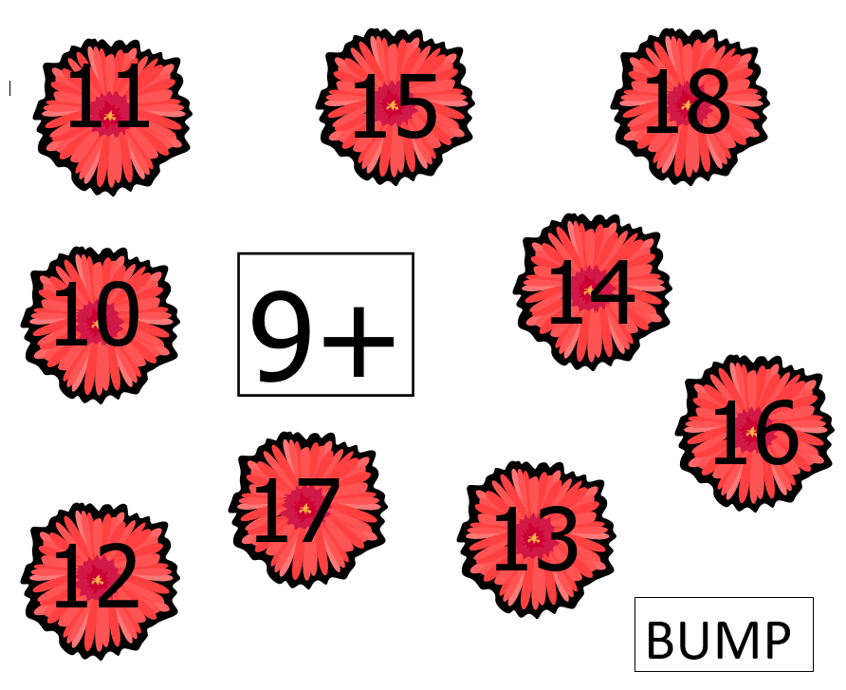

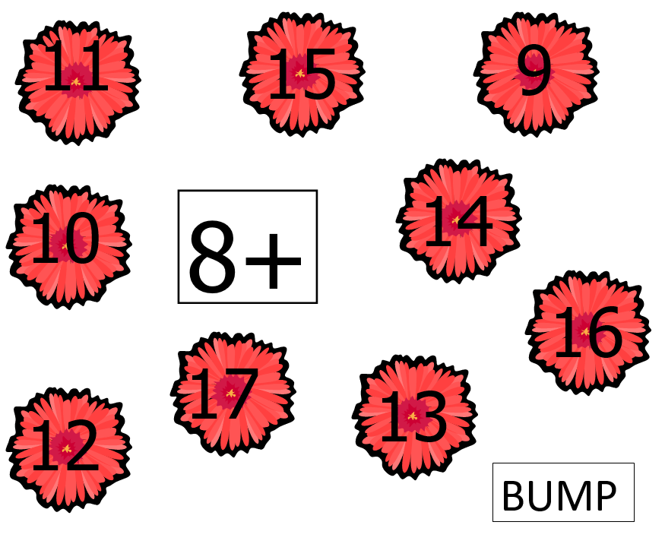

**Number Cards 1–9**

|  |  |  |  |  |  |
| --- | --- | --- | --- | --- | --- |
| **1** | **2** | **3** | **4** | **5** | **6** |
| **7** | **8** | **9** | **1** | **2** | **3** |
| **4** | **5** | **6** | **7** | **8** | **9** |

**Where are the Make Ten Facts?**

3 + 8 = _____ 4 + 4 = _____

9 + 6 = _____ 1 + 7 = _____

6 + 3 = _____ 8 + 4 = ______

9 + 6 = _____ 3 + 2 = ______

0 + 5 = _____ 4 + 9 = ______

7 + 5 = _____ 3 + 5 = ____