Mathematics Instructional Plan – Grade 1

Doubles Facts
Strand: Computation and Estimation
Topic: Developing basic addition and subtraction fact strategies for “doubles”
Primary SOL: 1.6 The student will create and solve single-step story and picture problems using addition and subtraction within 20.
Related SOL: 1.1, 1.7

Materials
- Images of doubles cards
- Counters
- Paper/pencil or dry erase marker/whiteboard
- Acorn problem (glue into mathematics journal)
- Doubles spinner
- Double Cover Game Board
- Exit card

Vocabulary
add, combine/join, doubling, doubles, equation, minus, models, number sentence, parts, plus, put together, strategy, subtract, take apart, whole

Student/Teacher Actions: What should students be doing? What should teachers be doing?
- This lesson has been written to focus on doubles strategies for basic addition and subtraction. While written as a single-day lesson, it could easily be broken apart into two or more days.
- To begin the lesson and jumpstart student thinking about the doubles facts, the teacher will flash cards with different configurations of doubles. Students will need counters, paper/pencil, or dry erase makers/whiteboards.
- Flash a “Double Image” for about five seconds and then hide it. Give students time to re-create what they saw using counters, paper/pencil, or dry erase markers/whiteboards. Then, flash the image again and hide it after about five seconds. Students can finish their re-creation of what they saw. Finally, show the image again and leave it up so that students can check their work and make any necessary changes.
- Facilitate a discussion with students by asking them what helped them remember what the image looked like. After a student explains their strategy, draw a sketch of the image and record the student ideas by circling how they saw the configuration. Focus on strategies used to double the numbers in the configurations. Ask students how this helped them to think about the total number, or the whole. Have several students discuss their strategies for remembering the image. Ask students to compare the various student strategies: “How is _____’s way of remembering like _____’s way?” “How are they different?” (If students have been introduced to the plus sign and equals sign, this would be an opportunity to ask students what equation would represent how they saw the image.)
- Repeat this with several other cards using “Double Image” or other similar pictures, and discuss student strategies. Ask students what they notice about the images that you flashed to them during this introduction. (They should recognize that all of the images had doubles.)
- Explain to students that today’s focus will be working on doubles. Record their ideas on chart paper. Ask them to share what they know about doubles. They can use pictures, drawings, and numbers to describe their ideas. What does doubling mean? What does doubling an amount mean? (For example, a student may define doubles or share examples of doubles. An insect has three legs on one side of its body and three legs on the other, so 3 legs + 3 legs = 6 total legs.)
- After taking a few student suggestions of what they know about doubles, explain that doubling means that you add a number to itself. Refer back to the student ideas that students shared during the doubles discussion.
- Next, explain that students will be solving a problem and using doubles to help them figure it out. Pose the problem: Josh and Sam each found six acorns in the park. How many acorns did they find? Explain your thinking using pictures, numbers, and words.
- Have students determine what information is important in the problem and discuss what they are trying to figure out. It is important to ask students questions to get them talking about their reasoning. For example: “Will your result be more or less than the amount you started with?” “How do you know?”
- Then, have students brainstorm strategies they could use to solve the problem. “What tools will you need?” “How have you tackled similar problems?” “Would it help to draw a picture or representation?”
- Give students time to work individually or with a partner to solve the problem. Have manipulatives readily available and/or dry-erase boards/markers for them to act out what is happening in the problem. Observe students while they are working to see what strategies they are using. Are they working randomly? Are they counting up or back? Do the students understand what it means to double a number? What strategies are students using to double an amount? Do they count all the objects? Do they count on? Can they write an equation to match the problem? Do they just know the combination? Use your observations and student work as you facilitate a discussion about how students solved the problem.
- Ask several students to share their strategies for solving the problem with the group while you record their thinking on chart paper/board. Have them include how they modeled the story problem with manipulatives or drawings. Here are some possible questions to encourage student reflection: “How did you get your answer?” “Can you describe how you solved the problem to us?” “Can you explain what you have done so far?” “Why did you decide to do this?” “What do you think about what _____ said? Do you agree? Why or why not?” “Does anyone have the same answer but a different way of explaining it?” “Does your answer make sense?” “How is _____’s strategy similar to _____’s strategy?” “How are they different?” If there were student strategies that you would like to highlight, have those students share their thinking during the group discussion.
- After students have adequately discussed the problem about doubles, introduce Double Cover, a game that focuses on developing an understanding of doubles. Students will work with a partner. Each pair of students will need a game board, a spinner, and two different-colored counters (one color for each student).
- The objective of the game is to identify doubles of numbers with sums to 20. The player with the most spots covered on the game board wins. Model this game for students before sending them with their partner to play.
- Player 1 spins the spinner and doubles the number. Students can use double 10 frames, rekenreks, cubes, etc., to find the double of the number spun. Player 1 must say, “(Number spun) and (the same number) is (total).” (For example, if the student spins a 3, then he or she would say that 3 and 3 is 6.) Then, player 1 covers up a number on the game board that is the double, or the number added to itself. Player 1 records the number sentence for the double fact in his/her math journal.
- Player 2 now spins the spinner, doubles the number, says the double fact, covers up a space on the game board, and writes the number sentence for the double fact in his/her math journal.
- Play continues with players alternating turns. If there is not a space on the board to cover, then the player loses a turn.
- While students are playing the game with a partner, the teacher should be observing students while they work. Here are some questions to consider while observing students: “Are students using what they know about doubles to solve problems?” “If there are any misconceptions, what are your next steps for that student(s)?”
- After students have time to play the game, gather them for a discussion about the strategies they used to figure out doubles throughout the game. Ask students to share various doubles that they figured out. Record the doubles facts on chart paper/board. Use pictures, numbers, and words when recording student ideas on the chart. Here are some questions to consider as you facilitate discussion with students: “How did you figure out the doubles for numbers?” “How did you count?” “Did you use any other doubles facts that you had already found to help you with those you did not know?” “What patterns do you notice on our chart of doubles facts?”
- After the game is introduced and students understand how to play, this game could be used as a station while you meet with small groups.

Assessment

Questions
  - How do doubles help us solve problems?
  - Explain how you would show a younger child how to double the number 5. Use pictures, numbers, and words to explain your thinking.

Journal/writing prompts
  - The teacher has a fruit salad recipe that she is going to bring to school for a class party. She needs to make a lot of fruit salad, so she needs to double the recipe. Here is her recipe: 2 watermelons, 6 bananas, 4 apples, and 10 strawberries. Please help her create a shopping list with enough fruit to double the recipe. Explain your thinking using pictures, numbers, and words to explain your thinking.
  - Four orange fish were swimming in the fish tank. Four yellow fish were swimming in the fish tank. How many fish were swimming in the fish tank? Explain your thinking using pictures, numbers, and words to explain your thinking.
  - Six girls were collecting rocks at the park. Six boys were collecting rocks at the park, too. How many children were rock collecting at the park? Explain your thinking using pictures, numbers, and words to explain your thinking.
  - Addison had 18 stickers in her sticker collection. She gave half of them to John. How many stickers does Addison have in her sticker collection now? Explain your thinking using pictures, numbers, and words to explain your thinking.
  - How are doubling and halving similar? Different?

Other Assessments
  - Provide a double 10 frame for each student. Have students count out six counters. Ask them how many counters they will have if they double the amount of counters they have. Students need to explain their thinking. Repeat with other amounts, such as 7 or 9. If the student is struggling, give the student smaller numbers to double.
  - Exit Ticket (see attachment)

Extensions and Connections (for all students)
- If symbols for addition have been introduced, students could represent their doubles facts with equations. For example, 3 + 3 = 6, or 5 + 5 = 10.
- The teacher could connect the doubles facts that students found during the activity with number bonds and further discuss the doubles facts in terms of parts and wholes.
- Students could write and solve their own story problem using a doubles fact.
- Students need many opportunities to experience part-whole relationships with doubles facts in order to develop fluency. Additional activities that could be introduced and then placed in stations include:
- Double Towers: Use a game spinner, paper/pencil, and cube counters. Students take turns spinning the spinner and doubling the number. Students will build a tower for the number spun and then double it by making another tower just like it. Students will record the double facts using number sentences in his/her math journal.
- Doubles Go Fish: Use a deck of number cards 0–10 (two or four of each number). Deal five cards to each student. Students take turns asking each other for a card that will go with a card in your hand to make a matching pair. If a player gets a pair of cards with the same number, they must state the doubles fact before they can keep the cards. If you do not get a card that makes a matching pair, take the top card from the deck and the turn is over. The game is over when there are not more cards. At the end of the game, players will make a list of the double pairs made during the game.

Strategies for Differentiation
- Allow students to work on finding doubles facts for sums to 10 before moving to sums of 20.
- For students ready to move past sums of 20, allow them to work with finding doubles for bigger numbers.
- Have a variety of models for struggling students to use to make doubles more concrete for them.
- Use doubles facts to help them figure out facts with near doubles. For example, if you know 3 + 3, how can you use that fact to solve 3 + 4? (An example response could be, I know 3 + 3 is 6, so 3 + 4 is one more so the answer would be 7.) For students who are ready for higher numbers ask, if you know 8 + 8, how can you use that fact to solve 8 + 9? (An example response could be, I know 8 + 8 is 16. I know 9 is 1 more than 8 so 8 + 9 is 17.)
- Create and display doubles picture posters that include a visual cue for doubles.
  - Eyes (Double 1 is 2.)
  - Legs on a Dog (Double 2 is 4)
  - Legs on an Insect (Double 3 is 6)
  - Legs on a Spider (Double 4 is 8)
  - Fingers on Two Hands (Double 5 is 10)
  - Eggs in an Egg Carton (Double 6 is 12)
  - Days in Two Weeks (Double 7 is 14)
  - Crayons in a Crayon Box (Double 8 is 16)
  - Wheels on an Eighteen-Wheeler (Double 9 is 18)

Note: The following pages are intended for classroom use for students as a visual aid to learning.

Virginia Department of Education ©2018

Double Images
Image A | Image B  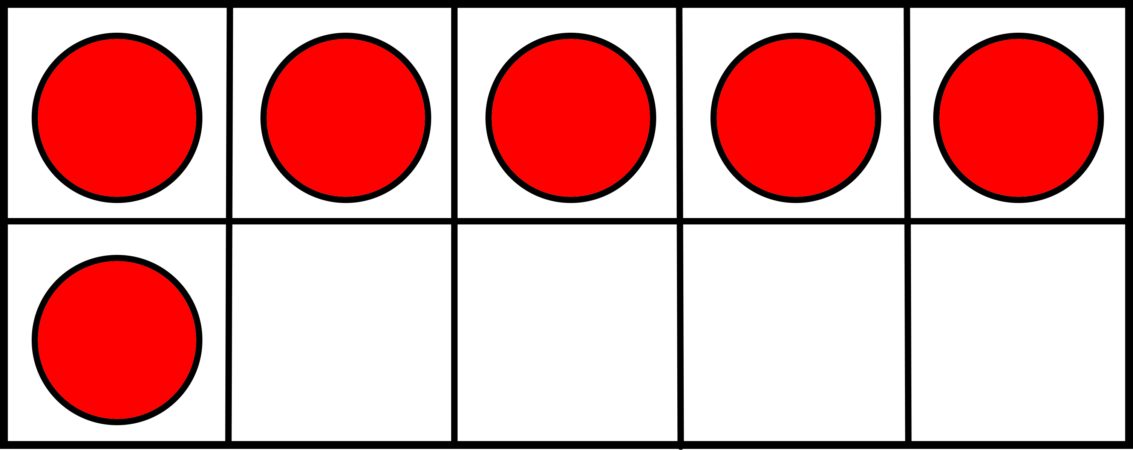
Image C | Image D

Image E | Image F  If you know 5 + 5 = _____,  then how can that help you figure out 5 + 6 = _____?
Image G  If you know 7 + 7 = _____,  then how can that help you figure out 7 + 8 = _____? | Image H  If you know 8 + 8 = _____,  then how can that help you figure out 8 + 9 = _____?

Acorn Problem

Josh and Sam found 6 acorns each in the park. How many acorns did they find? Explain your thinking using pictures, numbers, and words.

Acorn Problem

Josh and Sam found 6 acorns each in the park. How many acorns did they find? Explain your thinking using pictures, numbers, and words.

Acorn Problem

Josh and Sam found 6 acorns each in the park. How many acorns did they find? Explain your thinking using pictures, numbers, and words.

Acorn Problem

Josh and Sam found 6 acorns each in the park. How many acorns did they find? Explain your thinking using pictures, numbers, and words.

Acorn Problem

Josh and Sam found 6 acorns each in the park. How many acorns did they find? Explain your thinking using pictures, numbers, and words.

Acorn Problem

Josh and Sam found 6 acorns each in the park. How many acorns did they find? Explain your thinking using pictures, numbers, and words.

Acorn Problem

Josh and Sam found 6 acorns each in the park. How many acorns did they find? Explain your thinking using pictures, numbers, and words.

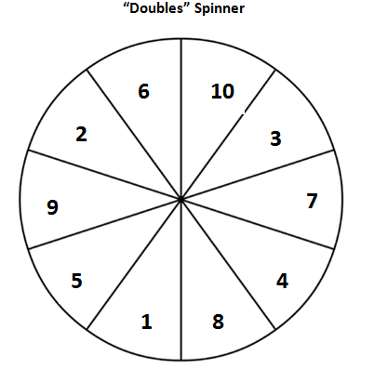

Double Cover Game Board
4 | 10 | 6 | 12 | 20
6 | 4 | 18 | 10 | 16
18 | 12 | 14 | 2 | 8
14 | 8 | 20 | 4 | 18
10 | 6 | 2 | 16 | 14

Exit Card

- Explain what it means to double a number.

- There were 4 birds sitting on a tree branch. Four more birds flew over to the tree branch. How many birds are sitting on the tree branch now? Explain your thinking using pictures, numbers, and words.

