Mathematics Instructional Plan – Kindergarten

Time: Longer or Shorter?
Strand: Measurement and Geometry
Topic: Comparing two events, using direct comparison, according to time (longer, shorter)
Primary SOL: K.9 The student will compare two objects or events, using direct comparisons, according to one or more of the following attributes: length (longer, shorter), height (taller, shorter), weight (heavier, lighter), temperature (hotter, colder), volume (more, less), and time (longer, shorter).
Related SOL: K.8

Materials:
- Pocket chart, labeled “Longer” and “Shorter”
- Event cards (attached)
- “Longer or Shorter?” worksheet

Vocabulary
compare, more, less, time

Student/Teacher Actions: What should students be doing? What should teachers be doing?
- Ask students to name a few things they did to get ready for school today. Discuss the length of time it takes to complete each task: Brushing your teeth doesn’t take very long, while eating breakfast may take a bit more time. Explain that time is the measure of an event from its beginning to end. Bring up a few more events from the school day (i.e., going down the slide, walking from the classroom to lunch, music class, etc.) and discuss whether they take more or less time than each other.
- Display the pocket chart with labels. Explain that you are going to show two pictures, and the students will decide which picture shows an event that is longer. Classify each picture under “longer” or “shorter.” Continue with other picture pairs. With each pair of events, ask a student to make a comparison statement using the words “longer” and “shorter.” (The time it takes to watch a movie is longer than it takes to brush my teeth. The time it takes to brush my teeth is shorter than watching a movie.) Students will need much practice in verbally constructing a sentence to make these comparisons.
- Pass out the “Longer or Shorter?” worksheet. Have students fill in the boxes using pictures from the chart or other events with which they are familiar.
- Bring students together as a whole group and compare the drawings. Review using the words “longer” and “shorter” with regard to time.

Assessment

Questions
  - What did you think about in order to compare the two objects?
  - Can you name an event that takes more time than brushing your teeth but less time than our school day?

Journal/writing prompts
  - Draw something that takes a longer amount of time. Draw something that takes a shorter amount of time.
  - What are some things that you can do quickly? What are some things that take more time?

Other Assessments
  - Use the pictures from the lesson. Show a picture and ask students to name something that takes longer or shorter than the event pictured.

Extensions and Connections (for all students)
- Red Light, Green Light Game: Call out an activity or event. If it takes a longer amount of time, have students take three long steps. If it takes a shorter amount of time, have students take three short steps. (This can also work as an informal assessment.)
- Ask students to compare the length of a day and a week, a week and a month, a month and a year.

Strategies for Differentiation
- For high-ability students, provide three (or more) event cards. Have the students sequence cards in order of time needed to complete the task (i.e., sneezing takes the least time, then brushing your teeth, then watching TV).
- For those who need it, have students act out the event shown on the card (i.e., student can mime hair brushing, demonstrate mopping the floor).
- Allow students to use hand signals (hands close together vs. arms wide open) to show shorter and longer amounts of time.
- Provide sentence frames to compare times: ______ takes longer than ______. _____ takes shorter than _______.
- Use a sand timer as a benchmark. Students can compare how long it takes to do something compared to the sand timer. An actual or digital sand timer can be used.

The following pages are intended for classroom use for students as a visual aid to learning.

Virginia Department of Education © 2018

Event Pictures

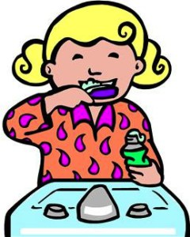  brush your teeth | 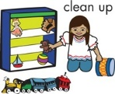  put away your toys | eat a muffin
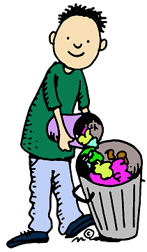  take out the trash | 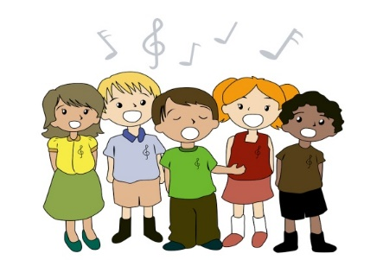  sing a song | 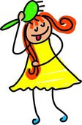  brush your hair
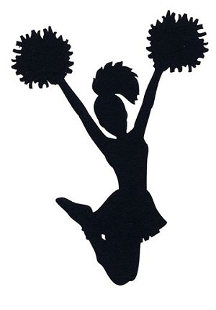  give a cheer | 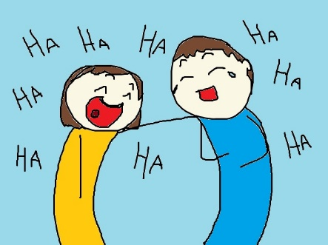  tell a joke | 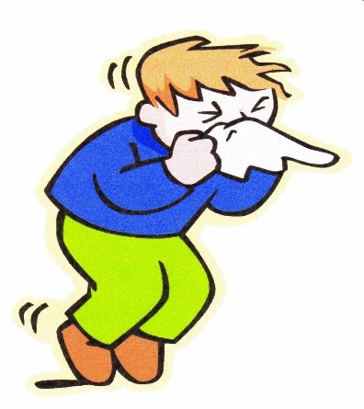  blow your nose
Event Pictures

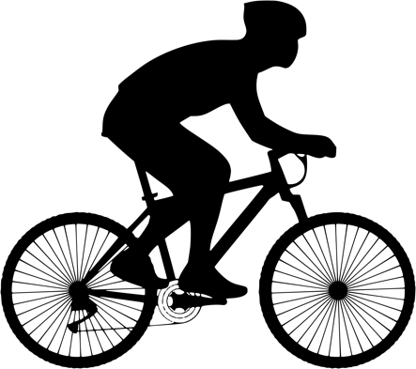  go on a bike ride | 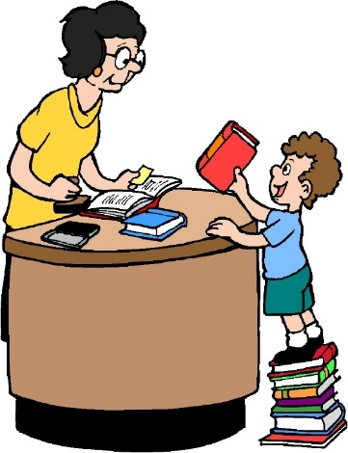  go to the library | 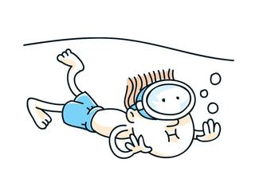  go swimming
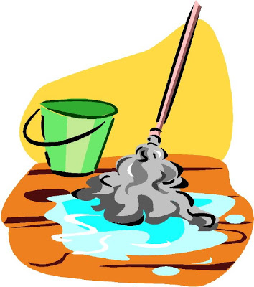  mop the floor | 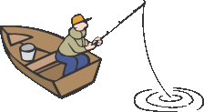  go fishing | 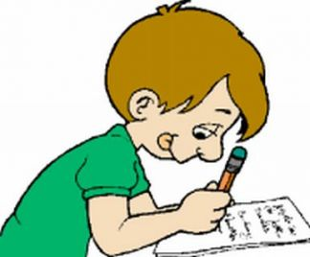  do homework
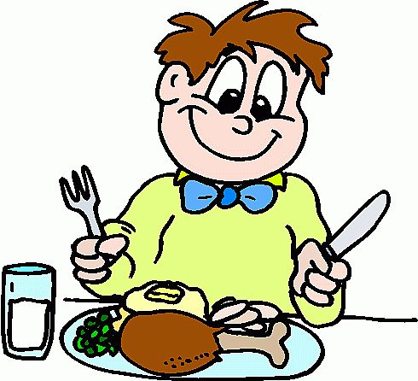  eat a meal | 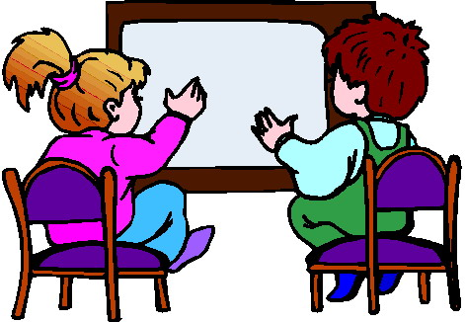  watch a TV show | 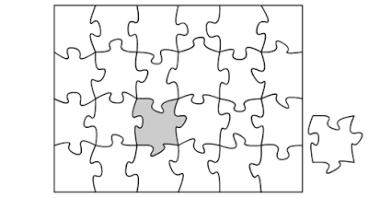  put a puzzle together

Name: _____________________________
Longer or Shorter?
Longer | Shorter

