Mathematics Instructional Plan – Kindergarten

Sorting Collections
Strand: Patterns, Functions, and Algebra
Topic: Sorting and classifying objects according to attributes
Primary SOL: K.12 The student will sort and classify objects according to one attribute.
Related SOL: K.13

Materials
- Children’s literature relating to collections of objects (e.g., buttons, bugs)
- Letter to parents requesting donations of small “junk” objects (e.g., bread tags, bottle caps, plastic milk carton lids, keys, buttons, old nuts and bolts, rocks, shells)
- Small boxes for holding collections (e.g., check boxes, plastic pencil boxes)

Vocabulary
attribute, color, describe, different, same, shape, size, sort, thickness

Student/Teacher Actions: What should students be doing? What should teachers be doing?

Note: Early in the school year, send home the attached letter asking for “junk” donations. Before this lesson, assemble collections (e.g., buttons, shells, lids, shells, rocks, etc.) that can be used by groups of students.
- Introduce students to the concept of collections, using a relevant children’s story.
- Choose a collection of objects (e.g., buttons) and show children one object from that collection. Ask students to describe the button you have chosen. Write their ideas on the board. Once children have finished suggesting words that describe the button, ask students to identify what each of their words tells us about the button (i.e., red tells the color of the button, round and circle describe the shape of the button). Using a different color write each of those attributes next to the words the children suggested. Explain that when we describe things we think about attributes. Write “attributes” in the same color that you wrote the words that name the attributes.
- To help children key into attributes, play “One of These Things is Different.” Choose four buttons from the button collection. Three of the buttons should have the same attribute, but one button should be different. Ask children to think about the attributes of the buttons and try to find the one that is different. As children identify the one that is different, ask, “How did you know that was different? What was the same about the other three? Could you find another one that would fit with the three that are alike?” Be aware that children often will identify a different attribute than the one you had in mind and may very well be correct! Repeat this activity several times.
- Tell children that now you are going to sort the collection. Explain that sorting means putting objects into groups that are alike in some way – like the three objects from the previous activity. Explain that when you sort, you must choose one attribute (perhaps color) and then put the objects into groups according to that attribute. Tell students that you want to use the attribute of color to sort the buttons. Choose one button and have the children identify the color. Then choose another and ask students whether we should put it with the first button or start a new group. Ask students to justify their decisions: Why do you think it goes with this one? Or, Why doesn’t it go with this one? Continue sorting the collection with the students’ help. (You may not need to sort the entire collection, but continue until you have sorted 12–15 items.)
- Return all of the buttons to the box. Then using the same collection (buttons), ask children to suggest a different attribute and repeat the process in step 4 using the new attribute the students suggest. Repeat as many times as time allows to help children see that the same collection can be sorted in different ways.
- Show students a different collection and ask students to name some of the attributes that are exhibited by that collection.
- Put students into small groups, and give each group a handful of objects from one of the collections. Have groups decide on an attribute and then sort according to that attribute. As groups work, observe for the following: Are students able to identify an attribute? Are students able to keep that one attribute in mind as they consider all of the objects in the collection? Is each student able to explain the sort by identifying the attribute that was used? Once the group has explained their sort, they may mix up their objects and sort in a different way. Have groups repeat this procedure as many times as possible in the time allotted.
- To conclude the lesson, ask students to find a friend from another group and tell the friend about the objects that they sorted and the attributes they used to sort.

Assessment

Questions
- (Show a collection of objects.) What attributes could be used to sort these objects? Why could we sort by _____?
- (Show a collection of objects that are all the same color.) Could we sort these objects by color? Why or why not? How could we sort them?
- (Show the students a set of sorted objects.) How are the objects sorted? How do you know?

Journal/writing prompts
- Remember sorting the buttons. Draw or write two ways you sorted the buttons.
- (Display a collection of paper shapes cut out from different colors of construction paper.) Draw or write how you could sort these shapes. Tell what you would call (how you would classify) each sort. (Students could also glue the sorted shapes into their journals.)

Other Assessments
- Distribute a handful of one type of object (e.g., toy cars, buttons, leaves, seeds) to each student. Have students sort their objects by a certain attribute, such as size, shape, color, or type, using bowls for sorting. Have students label (classify) the bowls according to the attribute they chose and then share the information with the class.
- Provide a set of attribute blocks. Have students identify all of the different attributes they notice. Then ask students to sort by one of the attributes. Students can sort again using a different attribute.

Extensions and Connections (for all students)
- Place the collections in stations or centers for students to use for sorting and patterning activities.
- Play “Read My Mind” with the students. Without telling students how you are sorting, sort a group of students by a certain attribute, such as kind of shoe (tennis shoes/not tennis shoes) or color of hair (brown hair/not brown hair). Ask students to guess the rule by which you sorted. After the students have played and understand the game, allow students to be the sorters.
- Have the class sit in a circle on the floor. In the middle of the circle, create two large circles with yarn. Use two rules to sort a set of objects (e.g., use attribute blocks and label one circle “Triangles” and the other circle “Squares”). Have students sort the objects. Repeat with different rules, but use rules that allow some objects to fit into both categories (e.g., “Squares” and “Red”). Ask students what to do with objects that fit both rules (overlap the yarn circles and put objects inside both circles). Ask what to do with objects that do not fit either rule (put outside of both circles).
- After sorting and classifying collections of objects, have students graph the results.
- Suggest that the students sort eating utensils at home by putting knives, forks, and spoons into a drawer tray with dividers.
- Suggest that students help sort laundry at home into darks, lights, and/or towels.
- Have students sort words by initial consonants.

Strategies for Differentiation
- Have students use a sorting mat or Venn diagram to sort objects.
- Use larger objects for students who have trouble handling small ones.
- Limit the number of attributes or choices for a particular attribute.
- Provide a list of possible attributes with picture cues.

The following pages are intended for classroom use for students as a visual aid to learning.
Virginia Department of Education © 2018

Dear Parents,
This year, students will be learning about counting, sorting, classifying, and patterning. To help us have a variety of things that we can use, I am enlisting your help in collecting “junk” items that will become math tools. Place the items you collect in small bags of like items and send them in with your child. Please be sure that the items are clean. The following types of objects would be very much appreciated:
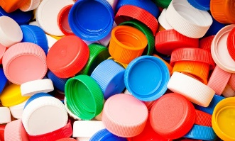  lids from milk cartons and drink bottles | 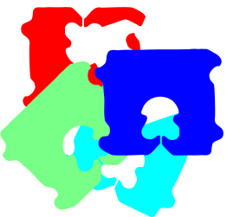  bread tags | 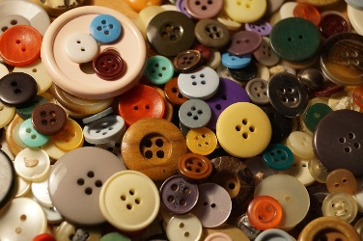  buttons
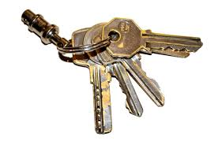  old keys | 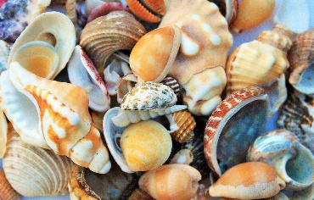  shells | 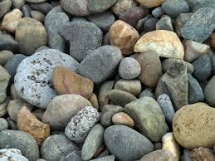  small rocks/stones
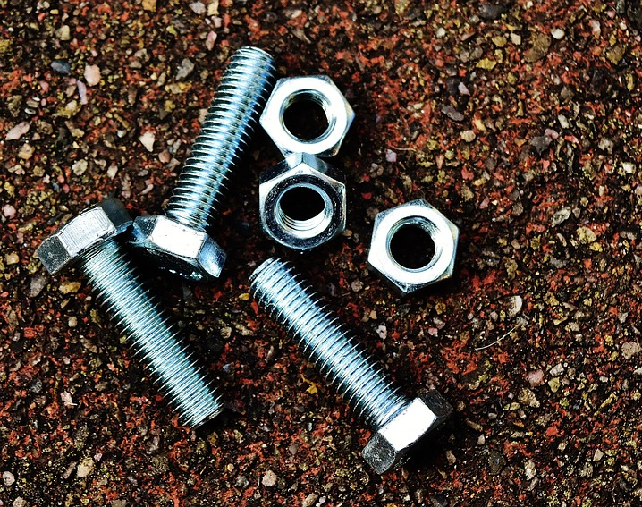  nuts and bolts – nothing sharp, please | Please check with me if you have something other than the pictured items that you would like to contribute.

These items can be sent in at any time, because we will always be adding to our collections!
Thanks for your help!
Sincerely,

