Mathematics Instructional Plan – Kindergarten

Shape Detectives
Strand: Measurement and Geometry
Topic: Identifying and describing, circles, triangles, squares, and rectangles
Distinguishing between examples and non-examples of identified geometric figures
Primary SOL: K.10 The student will
- identify and describe plane figures (circle, triangle, square, and rectangle);
- compare the size (smaller, larger) and shape of plane figures (circle, triangle, square, and rectangle); and
- describe the location of one object relative to another (above, below, next to) and identify representations of plane figures (circle, triangle, square, and rectangle) regardless of their positions and orientations in space.
Related SOL: K.11, K.12, K.13

Materials
- Large shape cards (circle, triangle, rectangle, square; attached)
- Chart paper–four pieces
- Shape cards (multiple circles, triangles, rectangles, and squares; attached)
- Shape Detective cards (one set of the triangle cards and one set of the rectangle cards cut apart for teacher use [enlarged if a document camera is not available]; attached)
- Shape Detective cards (one set per pair of students, cut and placed in bags; attached)

Vocabulary
alike, compare, circle, curved, describe, different, rectangle, round, shape, side, square, triangle, vertices (vertex)

Student/Teacher Actions: What should students be doing? What should teachers be doing?

Note: While this lesson is written to be conducted over two days, it could also be conducted over four days, focusing on one shape each day.

Day 1: Circles and Triangles
- Display a circle and a triangle (see attached cards). Tell students that they are both shapes, but they look very different. Ask whether anyone knows the name of each shape, and record each name (with a picture of the shape) on a separate piece of chart paper. Then ask students to compare the shapes and describe what makes them different. As students compare the shapes, list the characteristics students name about each shape on the appropriate chart using both words and pictures. Be sure that students are associating the words round and curved with the circle. As students describe the triangle, they may use words like flat and pointy. Use the descriptions that the students suggest as an opportunity to introduce the vocabulary words side (which students may refer to as flat parts, straight lines, or sticks) and vertices (which students may describe as points, corners, or the places where the two sides come together). Throughout the lesson pair the familiar student words with the new math vocabulary words to help students learn the new words. If students have not counted the sides and vertices on the triangle, invite them to do so.
- Display the card that has several circles on it and ask students whether each of the shapes is a circle. Use the characteristics that were generated on the chart to prove they are circles.
- Display the card that has several triangles on it and ask students whether each shape is a triangle. Use the characteristics that were generated on the chart to prove they are triangles. Make any additions or modifications necessary to the chart as students consider other triangles.
- Tell students that they are now going to take a close look at triangles. Explain that mathematicians look for three sides and three vertices when they look for triangles. Using the cards cut from the “Triangle Detective” sheet, show one shape at a time. Ask students to decide whether they think the shape is a triangle. Have them justify their reasoning. Continue to emphasize that it is a triangle if it has three sides and three vertices. (If students get stumped by the curves, remind them that a circle is curved, but sides on a triangle are always straight – no curves.) As students discuss the shapes, add to the chart paper any new ideas that arise. Be sure to discuss that the orientation of the shape does not determine whether it is a triangle.
- Pass out a set of Triangle Detective cards to each pair of students. Ask them to work together to sort them into two piles: TRIANGLES and NOT TRIANGLES. Tell students that you want to hear them telling each other why it is or is not a triangle. As students work, observe for the following: What characteristics are most troublesome for students? Are students paying attention to the number of sides and vertices? Do they always want to have the triangle oriented with one of its sides on the bottom? Do they not consider it a triangle if it is too long and skinny or too short and fat? Do not be alarmed if some children have difficulty; they will need many experiences with these ideas to develop a rich concept of a triangle. You will need to come back to these ideas often.
- After all children have finished, choose a few of the cards and discuss the pile into which they should be sorted, asking students to justify their choice.
- End the class period by having students tell you what a good triangle detective might look for.
Day 2: Rectangles and Squares
- Review the circle and triangle charts from the first day by having students tell you the characteristics of a circle and a triangle.
- Display a circle, a triangle, and a rectangle. (See attached cards.) Ask for the shapes to be named and write “rectangle” on the top of a new piece of chart paper. Then ask children to compare the rectangle to the other two shapes, describe what is different

about it, and record their ideas using both words and pictures. If no one mentions the number of sides and the number of vertices, invite students to count them. If students suggest that the rectangle has two long sides and two short sides, say something like, “Well, this one has two long sides and two short sides, but I wonder if all rectangles have two long sides and two short sides?” to lay the groundwork for combatting this misconception. If no student brings up the idea of square corners or right angles, say something like, “I notice something really interesting when I look at the corners of a rectangle that I didn’t notice about the triangle.” Point out that the corners all look like nice neat corners in which you could fit a cube. Use a small cube to see how the cube fits like a puzzle piece into each corner. Try it with some of the corners on the triangle to see that it doesn’t fit just right. Explain that mathematicians call these special corners right angles. (Note: Students are not expected to call them right angles at this age, but they need to be exposed to this idea because it is the most important way rectangles are identified.) One way to represent right angles in a picture is to draw a rectangle and make a small box in each corner. Use whatever terminology for right angles that seems to make sense to your children.
- Display the card that has several rectangles on it. Ask students whether each shape is a rectangle. Use the characteristics that were generated on the chart to prove that each shape is a rectangle. One of the shapes on this chart is a square. Students probably will say it is not a rectangle. Let children know that a mathematician considers a square to be a special kind of rectangle because it has four sides, four vertices, and special corners. Make any additions or modifications necessary to the chart as students consider each of the rectangles, especially if you have written two long sides and two short sides on the chart. It is important for students to realize that many rectangles have two long sides and two short sides, but that is not true for all of them. (It is correct to say that opposite sides are the same length, although at this age students might not be ready to understand opposite sides.)
- Display the card with one square and write “Square” at the top of a piece of chart paper. Ask students to compare the square and the rectangle to tell you how they are alike. Record their ideas, being sure to include four sides, four vertices, special corners. Then ask students to tell you what is special about squares (all four sides are equal).
- Tell students that they are now going to look closely at rectangles. Explain that mathematicians look for four sides and four vertices and those special corners when they look for rectangles. Using the cards cut from the attached Rectangle Detective card, show one shape at a time. Ask students to decide whether they think the shape is a rectangle. Have them justify their reasoning for each. As students discuss the shapes, and add to the chart paper any new ideas that arise. Be sure to discuss that the orientation of the shape does not determine whether it is a rectangle.
- Pass out a set of Rectangle Detective cards to each pair of students. Ask them to work together to sort them into two piles: RECTANGLES and NOT RECTANGLES. Tell students that you want to hear them telling each other why it is or is not a rectangle. As students work, observe for the following: What characteristics are most troublesome for students? Are students paying attention to the number of sides and vertices? Do they always want to have the rectangle oriented with one of its sides on the bottom? Do they not consider it a rectangle if it is too long and skinny or too short and fat? Do they include the square as a rectangle or not? Do not be alarmed if some children have difficulty – especially with the idea that a square is a special rectangle. They will need many experiences with these ideas to develop a rich concept of a rectangle. You will need to come back to these ideas often.
- After all children have finished, choose a few of the cards and discuss which pile they should be sorted into and why.
- End the class period by having students tell you what a good rectangle detective might look for.

Assessment

Questions
  - Describe a circle (or triangle, rectangle, or square).
  - Is this shape a ______? How do you know?
  - How are a triangle and a rectangle alike? How are they different?

Journal/writing prompts
  - Draw several triangles. (or rectangles, squares, or circles)
  - Draw a circle. Now draw a shape that is round but is not a circle.
  - Draw a picture that uses only rectangles.

Other Assessments
  - Use the shape detective sorts as a formative assessment tool.
  - Display one of the large cards with multiple examples of a particular shape. Ask the student to describe what makes all of the shapes alike.

Extensions and Connections (for all students)
- Use the Circle Detective cards and the Square Detective cards to have students sort, similar to what they did with the triangle and rectangle cards in the lesson. These cards can be placed in stations for students to sort independently or with a partner.
- Play “One of These Things Doesn’t Belong.” Using cards from the various Shape Detective sorts, show four shapes, three that have a characteristic in common and one that is different. Have students identify the shape that is different and explain why it is different. (Examples: three rectangles and a triangle; three shapes with straight sides and one that is curved; three squares and one that looks similar to a square but has rounded corners.)
- Read books about shapes and have students identify the shapes they see pictured in the books. Students should justify why they gave a shape a particular name.
- Use a set of attribute blocks to have students sort by shape or size. (Note: Attribute blocks do not provide enough variations of rectangles and triangles for students to get a rich concept of these ideas.)
- Using a set of cut-out shapes, place them in a bag and, without looking, have students try to find a particular shape or a particular characteristic.
- Go on a shape hunt. Have students look for shapes in their environment. When a shape is spotted, students should identify and describe how they know it is that shape. Pictures can be taken and printed to make a class book. Have discussions about whether an object is exactly that shape or is almost like a shape. (For example: A slice of pizza is like a triangle because it has three sides, but it is not quite a triangle because one of the sides is curved.)
- Provide students with toothpicks and yarn, and have them create the geometric figures with the art supplies. Alternatively, spread shaving cream on the tabletop and have students draw geometric figures in the shaving cream.
- Have students use a drawing program on the computer to create pictures using geometric figures. Allow them to print their creations. Ask students to describe the shapes in their creations.
- Provide a set of shapes for students to sort by shape. After sorting, students can create a graph comparing how many of each shape were in the collection.
- Use geometric shapes to create patterns.

Strategies for Differentiation
- Have students mark on the shapes as they count the sides and vertices.
- Have students sort a basic set of shapes (the shapes found on the shape cards) by number of sides before asking students to name shapes.
- Allow students to create shapes on geoboards.
- Focus on one attribute at a time: straight sides vs. curved sides, vertices vs. no vertices.

The following pages are intended for classroom use for students as a visual aid to learning.

Virginia Department of Education © 2018

Circles

Triangles

Rectangles

Squares

Triangle Detective
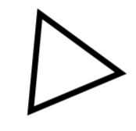 | 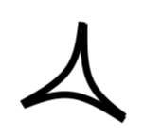 | 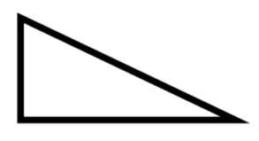
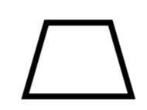 | 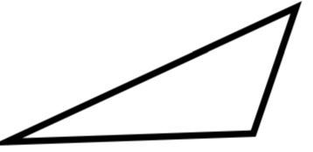 | 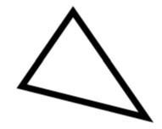
 | 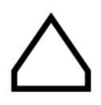
Rectangle Detective
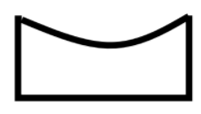

Square Detective
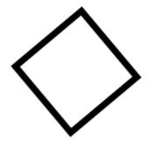
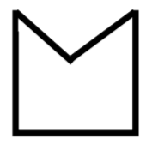
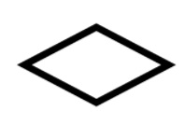

Circle Detective
 | 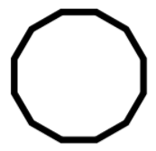 | 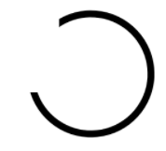
 | 