Mathematics Instructional Plan – Kindergarten

Hot or Cold?
Strand: Measurement & Geometry
Topic: Comparing two objects, using direct comparison, according to temperature (hotter, colder).
Primary SOL: K.9 The student will compare two objects or events, using direct comparisons, according to one or more of the following attributes: length (longer, shorter), height (taller, shorter), weight (heavier, lighter), temperature (hotter, colder), volume (more, less), and time (longer, shorter).
Related SOL: None

Materials
- Children’s book about temperature
- Temperature pictures, including seasonal pictures from summer and winter (attached)
- Pocket chart

Vocabulary
colder, compare, hotter, temperature

Student/Teacher Actions: What should students be doing? What should teachers be doing?
- Formally introduce the concept of temperature by reading a children’s book about temperature. Discuss the term temperature. Explain that temperature is how hot or cold something is. Have students describe what it feels like when it is hot. Have them describe what it is like when it is cold.
- Show students seasonal pictures from summer (e.g., swimming at the beach, wearing summer clothes, playing in a pool), and ask whether these pictures show a day when it is hot or when it is cold. Using wintertime pictures, go through the same process. Explain that different seasons typically have different temperatures where we live. Summer is a hotter season, while winter is a colder season.
- Display a pocket chart labeled with the headings “hotter” and “colder.” Distribute the temperature pictures. Have students classify their pictures by placing them into the correct column on the pocket chart. Students should explain why they classified each picture as hotter or colder.
- Provide the following sentence frames: _____ is hotter than ____. ____is colder than _____. I know this because _______. Ask students to choose a picture from each column of the chart and use a sentence frame to compare. Repeat several times.
- Direct students to return to their seats. Have students fold a piece of paper in half and label one half “hotter” and the other half “colder.” Ask students to draw one picture on each side, with labels if able. Pair students and ask the partners to compare the objects they have drawn using the sentence frames from the previous activity.
- Bring students back together. Choose an item from one student and an item from another and have the class identify which is hotter and which is colder and compare using the sentence frames.

Assessment

Questions
- What can you tell me about some things that are hot? What can you tell me about some things that are cold?
- How do you know whether it will be hot or cold outside?

Journal/writing prompts
- Draw a picture of what you do when it is hot outside.
- Draw a picture of what you wear when it is hot. Draw another picture of what you wear when it is cold.
- Draw a picture of a food that is served hot. Draw a picture of a food that is served cold.

Other Assessments
  - Distribute pictures of hot and cold events. Have students sort the pictures by placing the “hot pictures” under a picture of a sun and placing the “cold pictures” under a picture of a snowflake.
  - Label two clear plastic glasses A and B. Fill one with cold water and one with warm water. Divide the class into small groups of three or four, and supervise each group in dipping one finger into each of the cups to determine which water is hotter and which is colder. Direct students to record the results on a recording sheet.

Extensions and Connections (for all students)
- If a gym or large room is available, tape a sign on one wall that says “hotter,” and on another wall, tape a sign that says “colder.” Shout out an item or scenario (e.g., ice cube, day at the beach), and have students run to the wall with the correct temperature comparison word.
- Incorporate hotter and colder as you discuss seasons in science and during calendar time. (Yesterday was hotter than today. Tomorrow is going to be colder than today, so wear your coats.)

Strategies for Differentiation

Provide a prelabeled T-chart (hotter/colder) for students who have difficulty writing. A sun and a snowflake can be included with each word as a visual clue.

Preteach vocabulary (hot, cold) as needed.

Use craft sticks with a visual for hot and cold as a pupil response option.

The following pages are intended for classroom use for students as a visual aid to learning.

Virginia Department of Education © 2018
Temperature Pictures

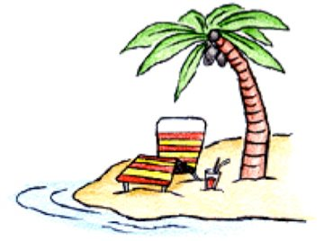 | 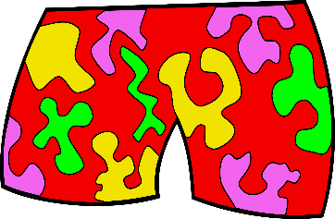 | 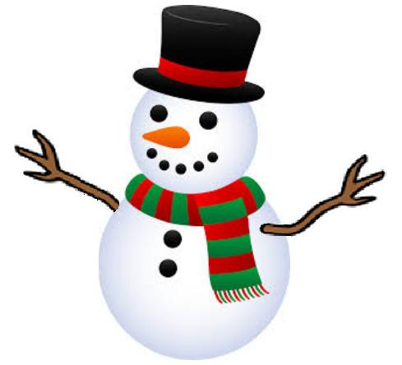
 | 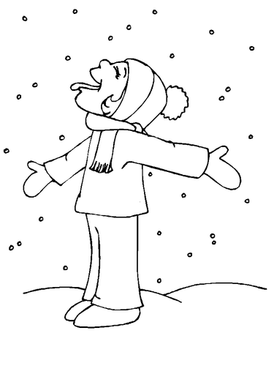 | 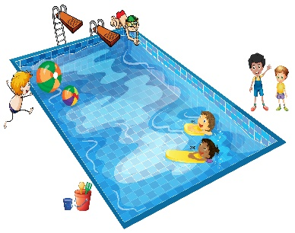
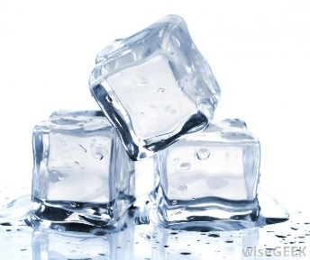

Temperature Pictures

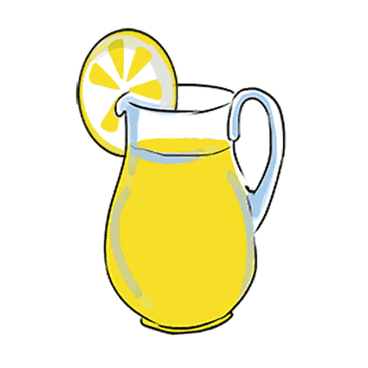 | 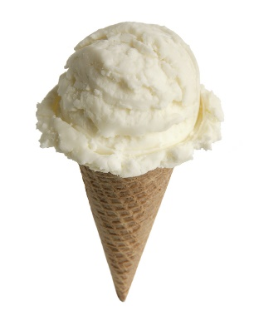 | 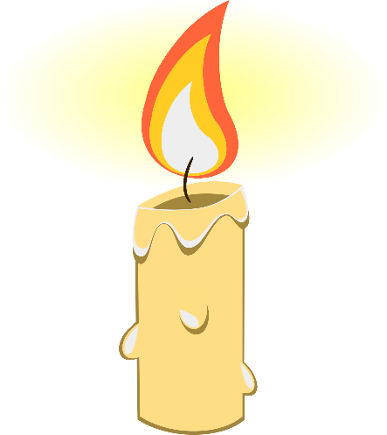
 | 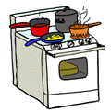 | 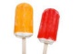
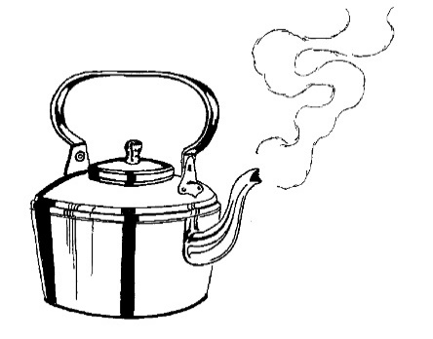 |  | 