Mathematics Instructional Plan – Kindergarten

Coin Values

Strand: Measurement and Geometry
Topic: Identifying the number of pennies equivalent to a nickel, dime, and quarter
Primary SOL: K.7 The student will recognize the attributes of a penny, nickel, dime, and quarter and identify the number of pennies equivalent to a nickel, a dime, and a quarter.
Related SOL: K.1, K.2, K.10, K.11, K.12

Materials
- Anchor charts from the “Coins and Socks” lesson
- Penny, nickel, dime, and quarter for the teacher (real coins can be projected with a document camera, or large proportional cutouts can be used)
- A large collection of pennies (plastic or real)
- “What’s My Value” activity sheet (attached)
- “Value Match” – coin cards copied on one color paper, value cards colored on a different color

Vocabulary
cents, dime, nickel, penny, quarter, value, one cent, five cents, ten cents, twenty-five cents

Student/Teacher Actions: What should students be doing? What should teachers be doing?
- This lesson should be completed after the “Coins and Socks” lesson.
- Display a penny, nickel, dime, and quarter and the anchor charts from the “Coins and Socks” lesson. Quickly review the attributes of each coin and then explain that today we will be adding one more attribute to each chart.
- Explain that each coin has a value, or how much the coin is worth. Introduce the word cent as word that we use when counting pennies. Explain that we say a penny has a value of 1 cent. Add “one cent” to the penny anchor chart. Hold up a pencil and say: When I went to the store, the sign said that this pencil costs 15 cents. How many pennies do you think I would need to buy that pencil? Count out 15 pennies by saying one cent, two cents, three cents, etc. Do a few more situations with small objects that cost 30 cents or less – choosing a different student to count out pennies each time. Ask students to notice how long it takes to count out all the pennies.
- Explain that people got tired of always counting out pennies, so they created other coins that had different values. Show a nickel and explain that a nickel’s value is 5 cents. Explain that if you wanted to buy an eraser that cost 5 cents, you could count out five pennies or you could just use a nickel because even though it is just one coin, it has a value of 5 cents. Ask students whether it would be easier to pay with a nickel or to count out five pennies. Pretend to be a store clerk and let two students come up to “buy” the eraser. One student will pay with a nickel and the other will need to count out five pennies. Explain that both students paid 5 cents, but one used a nickel and the other used five pennies. Emphasize that a nickel is like having five pennies; the nickel has a value of 5 cents or is worth 5 cents. Add “five cents” to the nickel anchor chart. Use the words value and worth concurrently throughout the lesson.
- Repeat step 4 with a dime and then with a quarter to establish the value of each of these coins. Be sure to add the value to each anchor chart.
- When you have finished, ask students what attribute was added to the anchor charts. (The attribute of value, or how much something is worth.) Help students to notice that the size of the coin does not necessarily correlate with its value. (The dime is the smallest in size, but it does not have the smallest value.) Review by asking students to tell you the value of each coin.
- Pass out the activity sheet “What’s My Value?” Review the directions. Students look at the coin shown, show the value of the coin by counting out pennies, and then write the value.
- Demonstrate how to play “Value Match.” Students work in groups of two, three, or four. Each group has a set of coin cards (one color) and a set of value cards (a different color). All cards are spread out face down. On each turn, a student turns over one coin card and one value card. If the cards match, the student gets to keep the cards and play goes to the next person. If the cards do not match, the cards are turned over and they lose their turn. The winner is the person with the most matches. As students play, they should name the coin and its value aloud. As students play, observe the following: Do students name the coins correctly? Are students assigning the correct value to each coin?
- Bring students back together after the game. Review the values of each coin. Ask students which coin is worth the most and which is worth the least.

Assessment

Questions
  - What is the value of a penny? A nickel? A dime? A quarter?
  - What coin has the same value as 25 pennies? Ten pennies? Five pennies?

Journal/writing prompts
  - Draw a picture of a coin that is worth more than a nickel.
  - Draw pennies to show the value of a dime.
  - Karri found a coin that was bigger than a dime, but it had a value less than a dime’s value. What could Karri’s coin be?
  - I have a silver coin in my pocket. How many pennies could my coin be worth? (Use any attribute.)
  - A pack of gum costs 25 cents. Draw two ways I could pay for my gum.

Other Assessments
  - Show a penny, a nickel, or a dime. Ask the student to name it, describe it, and tell how many pennies are equal to it.
  - Provide a bowl of coins. Ask students to sort the coins by type (pennies, nickels, dimes, and quarters) and then tell how many pennies each coin is worth.

Extensions and Connections (for all students)
- Play Three in a Row. Pass out a blank three-by-three grid to each student. Have each student place a coin in each section of the grid. Then call out clues. (Examples: Cover a coin that has the same value as 10 pennies. Cover a coin that is small and has bumpy edges. Cover a coin that is brown. Cover the coin with George Washington’s picture.) When students cover three coins in a row – vertically, horizontally, or diagonally, they win!
- Frequently review coin values and coin descriptions.
- Set up a play store. Assign stickers with prices on different items for students to buy. Students use play coins to purchase item. (Be sure you have ample items with a price of five cents, 10 cents, and 25 cents so that students get practice with nickels, dimes, and quarters.)
- Discuss how coins are used to purchase items we need and want. (History and Social Science SOL K.7b)
- Discuss the presidents pictured on the coins–especially George Washington and Abraham Lincoln–and why their pictures might be on the coins. (History and Social Science SOL K.1a and K.9)

Strategies for Differentiation
- Use songs and poems to help students learn the attributes and values of coins.
- Focus on fewer coins in one sitting.
- Use coin stamps to stamp the coins on the recording sheet.

The following pages are intended for classroom use for students as a visual aid to learning.

Virginia Department of Education © 2018

What’s My Value?
Coin | Show the value using pennies. | Write the value.
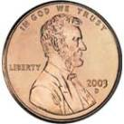  penny |  | _____ cent
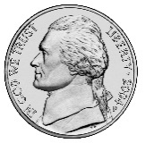  nickel |  | ______ cents
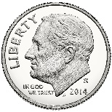  dime |  | _______ cents
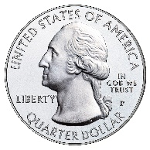  quarter |  | _______ cents
Value Match – Coin Cards (Copy on color A)
 | penny
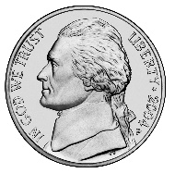 | nickel
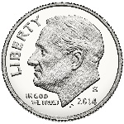 | dime
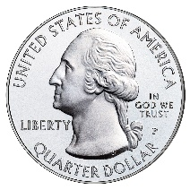 | quarter
Value Match – Value Cards (Copy on Color B)
1 cent
5 cents
10 cents
25 cents

