Mathematics Instructional Plan – Geometry

Circles in the Coordinate Plane
Strand: Polygons and Circles
Topic: Writing and applying the equation of a circle
Primary SOL: G.12 The student will solve problems involving equations of circles.
Related SOL: G.3a, G.3d, G.11

Materials
- Coordinate Plane Circle activity sheet (attached)
- Circles in the Coordinate Plane activity sheet (attached)
- Graph paper and compass (or dynamic geometry software package)
- Demonstration coordinate plane (document camera, overhead projector, or graphing board)
- Teacher’s demonstration compass and straightedge

Vocabulary
center, circle, coordinate plane, diameter, distance formula, equation, image, midpoint, midpoint formula, radius, reflect, x-axis, y-axis

Student/Teacher Actions: What should students be doing? What should teachers be doing?
- Using a coordinate plane class demonstration (through a document camera, overhead, or other), use a compass to graph a circle with the center at the origin and radius of 5 units, explaining what you are doing as you construct the circle. Have students follow along using graph paper, compass, and pencil.
- Ask students to mark points on the demonstrated circle identifying coordinates.
- List the following ordered pairs for students to see: (3, 4), (−4, −4), (−3, 4), (−1, 5),
(−3, −4), (3, −4), (2, −4) and direct students to plot these points.
- Ask students to identify which points are on the circle.
- Ask, “What do all of the points that are on the circle have in common?” Remind them about the definition of a circle and the distance formula, if necessary. Mark the origin as (0,0) if you have not already. Encourage the class to “discover” that the distance from the origin to all the points on the circle is (exactly) 5 units. Demonstrate this.
- Ask students whether the points (2,$\sqrt{22}$) and (−2,$\sqrt{21}$)$√21$ lie on the circle. (You can add them to the list.) If necessary, remind them about what they just discovered about points that lie on a circle.
- Mark any other point on the circle, and label it (x, y).
- Write out the distance formula. Ask and write the following: “What is the distance from (x, y) to (0,0)?”
- Plug in (x, y) (0, 0) and 5 into the formula. Point out to students that you are writing (x – 0) rather than (0 – x). Simplify and square both sides.
- Point to the equation and ask, “What is this?” (an equation) If necessary, point out the equal sign as a hint.
- Explain that this is the equation of a circle with center (0, 0) and radius 5 units. Show how different points on the circle satisfy the equation.
- Draw a circle on the coordinate plane with center (0, 0) and radius 6 units on the coordinate plane at the board. (Erase the first circle if the graph is too cluttered.) Mark a point on the circle and label it (x, y). Have the class use the distance formula to find the equation of the circle.
- Draw a circle for demonstration (not on a coordinate plane). Label the center (0, 0), draw a radius, and label the radius r. Mark a point on the circle, and label it (x, y). Have the class derive the equation of a circle with center (0, 0) and radius r units using the distance formula.
- Graph a circle with radius 5 units and center (1, 2).
- Mark a point on the circle and label it (x, y). Have the class use the distance formula to find the equation of the circle. Have them square both sides of the equation, but tell them not to expand the expressions (x − 1)² and (y − 2)².
- Explain that this is the equation of a circle with center (1, 2) and radius 5 units. Demonstrate different points on the circle that satisfy the equation.
- Draw a circle for demonstration (not on a coordinate plane). Label the center (h, k). Point out that these are the variables that are usually used to identify the center of a circle.
- Draw a radius, and label the radius r. Mark a point on the circle and label it (x, y). Have the class find the equation of a circle with center (h, k) and radius r. As before, students should not expand the expressions (x − h)² and (y − k)², and students should square both sides.
- Have students work in pairs to complete the Coordinate Plane Circle and Circles in the Coordinate Plane activity sheets. Each student should record his/her own findings. Have students discuss the findings with their partners. Discuss the findings as a whole group.

Assessment

Questions
  - Use the distance formula to find the equation of a circle with center (−2, 3) and radius 4.
  - Determine whether the point (6, −8) lies on the circle with equation ${(x-1)}^{2}+{(y+4)}^{2}=169$Justify your answer.
  - Find the radius and center of the circle with equation ${(x-1)}^{2}+{(y+4)}^{2}=169$.
  - The diameter of a circle has endpoints located at (3, 4) and (−3, −4). Write the equation of the circle. Justify your answer.
  - P (1, 0) and Q (3, −2) are endpoints of a diameter of the circle W. What is the radius of the circle?

Journal/writing prompts
  - Explain how the equation of the circle ${(x-1)}^{2}+{(y+4)}^{2}=169$ is related to the distance formula.
  - Explain how you would find the equation of a circle whose graph is given.

Other Assessments (include informal assessment ideas)
    - Have small groups of students design a circle design of their own like the one in the Coordinate Plane Circle activity. Students should then write directions using a variety of descriptions (including equations) and create a table, as in the activity. Students should also provide a key (the graph and completed table). Use these student-created activities for assessment purposes.

Extensions and Connections (for all students)
- Have students explore translations and dilations of circles in the coordinate plane and the effect on the equations.
- Is the graph of a circle a function?

Strategies for Differentiation
- Allow students use dynamic geometry software.
- Provide students with predrawn circles or paper and compasses.
- Encourage students to use colored pencils after their initial pencil work.
- Review graphing calculator skills and experiment with manipulating variables other than those listed in the lesson.
- Station activities that progress from simple to more rigorous.

Note: The following pages are intended for classroom use for students as a visual aid to learning.

Virginia Department of Education ©2018
Coordinate Plane Circle
Name Date
Graph the following circles on the same coordinate plane, using graph paper and a compass or a dynamic geometry or graphing software package, and complete the table.
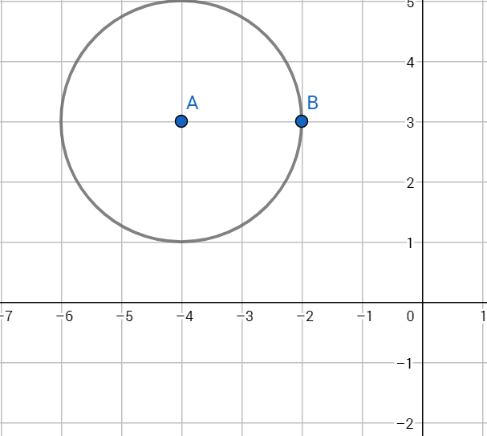
- Circle C₁ has equation (x – 3)² + (y – 4)² = 25.
- Circle C₂ has center (0, 0) and radius 2.
- Circle C₃ has center (0, 0), and (−3, 4) is one point on the circle.
- Circle C₄ has center (−3, 0), and (−3, 2) is one point on the circle.
- Circle C₅ has center (3, 0) and is congruent to c₃.
- (1, 0) and (−1, 0) are two points on a diameter of the circle C₆.
- Reflect circle C₆ across the x-axis. The image is circle C₇.
- Circle C₈ has the following graph.

 | center = (h, k) | radius = r | List four points on the circle. | Equation of the Circle
C₁
C₂
C₃
C₄
C₅
C₆
C₇
C₈

Circles in the Coordinate Plane
Name Date
Graph the following equations, using a graphing calculator or graphing software. Then, answer the questions using the following vocabulary: center, diameter, radius, quadrant, x-axis, and y-axis.
- Graph the equations $x^{2} + y^{2} =1$ and $x^{2} + y^{2} =4$ on the same graph. What is the difference between the two graphs? How does this relate to the difference between the two equations? Be specific.

- Graph the equations $x^{2} + y^{2} =1$ and ${(x -2)}^{2} + y^{2} =1$ on the same graph. What is the difference between the two graphs? How does this relate to the difference between the two equations? Be specific.

- Graph the equations $x^{2} + y^{2} =1$ and $x^{2} + {\left(y -2\right)}^{2} =1$ on the same graph. What is the difference between the two graphs? How does this relate to the difference between the two equations? Be specific.

- Graph the equations $x^{2} + y^{2} =1$ and ${\left(x -2\right)}^{2} + {(y -2)}^{2} =1$ on the same graph. What is the difference between the two graphs? How does this relate to the difference between the two equations? Be specific.

