*Mathematics Instructional Plan ­– Geometry*

# Angles, Arcs, and Segments in Circles

**Strand:** Polygons and Circles

**Topic:** Investigating angles and segments of circles

**Primary SOL:** G.11 The student will solve problems, including practical problems, by applying properties of circles. This will include determining

1. angle measures formed by intersecting chords, secants, and/or tangents; and
2. lengths of segments formed by interesting chords, secants and/or tangents.

**Related SOL:** G.7

## Materials

* Angles, Arcs, and Segments in Circles activity sheet (attached)
* Segments in Circles activity sheet (attached)
* Angles, Arcs, and Segments in Circles (Teacher’s Reference) (attached)
* Dynamic geometry software (Lesson can be modified for use without computers.)
* Straightedge
* Protractor
* Pencil

## Vocabulary

*AA similarity, angle measure, arc, arc angle, arc length, arc measure, central angle, chord, circle, chord, corresponding sides, diameter, exterior angle, inscribed angle, interior angle, major arc, minor arc, proportion (proportionality), radius, secant, tangent, vertical angle, segment*

## Student/Teacher Actions: What should students be doing? What should teachers be doing?

1. Have students complete the Angles, Arcs, and Segments in Circles activity sheet, using a dynamic geometry software package. Completing this activity in software packages is easier to do than in others. The assignment can be completed over multiple days or class periods.
2. Have students discuss their findings with their partner after each item is completed. Each student should record his or her findings on their own activity sheet. Discuss the findings as a whole class. If some parts were assigned to groups, have the groups present their results.
3. Have students complete the Segments in Circles activity sheet. Have students discuss their findings with their partner. Discuss the findings as a whole class.

## Assessment

### Questions

* + Using Figure 1, what is *v° + w° + x° + y° + z°*? Explain your reasoning.  
    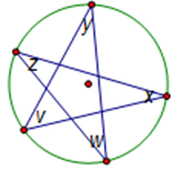 Figure 1
  + Using Figure 2, find m∠*BAC*. What kind of triangle is ΔABC? Explain your reasoning.  
    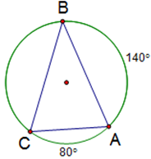

Figure 2

* + In Figure 3, what is the value of x? Explain your reasoning.

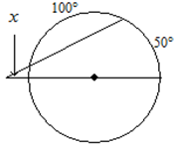

Figure 3

* + In Figure 4, find m∠*2*. Show and justify your work.

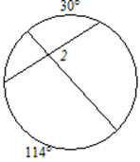 Figure 4

* + Which is longer: a chord that is 8 centimeters from the center of a circle and has a radius 10 centimeters, or a chord that is 12 centimeters from the center of a circle and has a radius of 13 centimeters? Explain your reasoning.
  + In Figure 5, FG = 16 and CD = 12. Find FC. Explain your reasoning. *Assume that segments that appear tangent are tangent.*

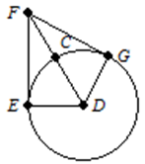Figure 5

### Journal/writing prompts

* + Complete a journal entry summarizing the activity.
  + Explain how an angle formed by a tangent and a chord is like an inscribed angle.
  + Explain how the formula relating the segments formed by intersecting chords is related to similar triangles.
  + Explain the difference between a tangent and a secant to a circle.
  + Explain how to construct a tangent to a circle through a given point.
  + Decide whether a central angle is an interior angle. Explain.

### Other Assessments

* + Have students work in small groups and present findings to whole class.
  + Have students work in small groups to write test questions. Use these questions for assessment purposes.

## Extensions and Connections

* After constructing $∠$ BEC in the inscribed angle investigation, have students move the point E so that it lies on the arc BC. Have students explore how $∠$ BEC and $∠$ BDC are related. Use this construction to explore opposite angles in quadrilaterals inscribed in circles.
* Have students explore circle constructions, such as the following: Given a triangle, construct a circle that passes through all three vertices, or construct a circle that is tangent to all three sides of the triangle.
* Take students to the gymnasium. Have them use the circle at the center of the court and use rope or string to draw tangent lines and secants to the end of the courts. Have students identify segments, angles, and arcs.
* Assign different teams of students to use a dynamic geometry software package to investigate different circle theorems that have not been covered in this activity. Have the teams present their findings to the class, using their dynamic geometry software package sketch to illustrate the theorem.
* Have students create quizzes, games, presentations, or graphic organizers.

## Strategies for Differentiation

* Give students a software file with the circles and angles already made and measured.
* Provide an alternative format for the directions on the activity sheets (e.g., tape the directions or problems, reword them, and divide the information into smaller pieces).
* Use memory strategies that include keywords, first-letter mnemonics, visual imagery, and rhymes. For example, have students sing a song to help them remember the key concepts (sung to the tune “My Bonnie”): “A secant cuts through the circle, inscribed comes from the ending. The central angle is like pizza, but tangents only touch the ending. Cutting, forming, more secants and tangents for me, for me, cutting, forming, more secants and tangents for me.”
* Using the software program, have students color-code secants, tangents, arcs, and angles.
* Use visual learning software to create assistive learning tools (such as a webbing activity with a central idea and key concepts tied together to be used for a reference sheet) for students.
* Use presentation software to isolate or highlight key points of the lesson. This may be helpful when breaking down the student activities into smaller steps.
* Create a mathematics glossary or folded graphic organizer with examples, pictures, and definitions.
* Have students create summary statements that compare and contrast the key terms in the lesson.
* Create a class word wall of vocabulary with diagrams.

**Note: The following pages are intended for classroom use for students as a visual aid to learning.**

Virginia Department of Education ©2018

**Angles, Arcs, and Segments in Circles**

**Name Date**

Complete the following activities, using a dynamic geometry software package.

**Central Angle**

1. Open a new sketch.
2. Draw a circle. Label the center *A* and a point on the circle *B*.
3. Draw a second point on the circle, and label it *C*.
4. Construct segment $\overline{AB}$.
5. Construct segment $\overline{AC}$.
6. ∠*BAC* is called a *central angle*, because the vertex is the center of the circle. Find m∠*BAC*.
7. Construct the arc *BC*. If arc *BC* is a major arc, move *B* or *C* until arc *BC* is a minor arc. Arc *BC* is called the intercepted arc for ∠*BAC*.
8. Find the measure of arc *BC* (the arc *measure*, which may be called the arc angle, *not* the arc length).
9. Gently move one of the points on the circle (without making arc *BC* a major arc), and notice what happens to the measure of the central angle and the measure of its intercepted arc. Describe your findings.
10. Sketch your circle, and write an equation relating m∠*BAC* and the measure of arc *BC*.
11. Name your file as directed by your teacher.

**Inscribed Angles**

1. Open a new sketch.
2. Draw a circle. Label the center *A* and a point on the circle *B*.
3. Draw a second point on the circle, and label it *C*.
4. Draw a third point on the circle, and label it *D*. Place *D* so that neither segment $\overline{BD}$ nor $\overline{CD}$ would go through *A* (the center of the circle).
5. Construct segment $\overline{BD}$ and segment $\overline{CD}$.
6. ∠*BDC* is called an *inscribed angle* (an angle formed by two chords that intersect *on* the circle). Find m∠*BDC*.
7. Construct $\hat{BC}$. The arc should *not* contain the point *D*, but it is OK if $\hat{BC }$ is a major arc.
8. Find the measure of $\hat{BC}$ (the arc *measure*, which may be called the arc angle, *not* the arc length).
9. Compare m∠*BDC* and the measure of $\hat{BC}$. How are they related?
10. Gently move one of the points on the circle, (without moving D onto $\hat{BC}$) and notice what happens to the measure of the central angle (m∠*BDC*) and the measure of its intercepted arc. Describe your findings.
11. Sketch your circle, and write an equation relating m∠*BDC* and the measure of the intercepted arc.
12. Draw another point on the circle, and label it *E*. Move *E* if necessary so *E* is not on $\hat{BC}$.
13. Construct segment $\overline{EB}$ and segment $\overline{EC}$.
14. ∠*BEC* is also an inscribed angle. Find m∠*BEC*.
15. What is the intercepted arc of ∠*BEC*?
16. Compare m∠*BEC* to m∠*BDC* and the measure of arc *BC*. What do you notice? What can you conclude?
17. Name your file as directed by your teacher.

**Chords and Interior Angles**

1. Open a new sketch.
2. Draw a circle. Label the center *A* and a point on the circle *B*.
3. Draw a second point on the circle, and label it *C*. Draw the chord $\overline{BC}$.
4. Draw two more points on the circle, label them *D* and *E*, and draw chord $\overline{DE}$.
5. If the two chords do not intersect, move the points *B, C, D,* and *E* until the chords intersect. Label the point of intersection *F*.
6. The four angles formed by the intersecting chords are called *interior angles* (because the vertex is inside the circle). Find m∠*BFE*.
7. Construct the intercepted arc *BE* for ∠*BFE*.
8. What angle is vertical with m∠*BFE*? _________ Construct the intercepted arc for this angle as well.
9. Find the measures of the two intercepted arcs.
10. Figure out a formula, using the measures of the intercepted arcs, so that m∠*BFE* will be the same as the value of the formula. *(Note: This is not as obvious as some other formulas. You may use a textbook or other reference source.)*

| $$m∠BFE$$ | arc BE | arc CD | $$arc BE+arc CE$$ |
| --- | --- | --- | --- |
|  |  |  |  |

1. Move the points *B, C, D,* and *E* and adjust the circle, keeping $\overline{BC}$ and $\overline{DE}$ as intersecting chords. Does your formula still work?
2. Find the measure segments $\overline{BF}, \overline{CF}, \overline{DF},\overline{EF}.$
3. Figure out a formula that relates the products of the four segments using the measures of the segments. *(Note: This is not as obvious as some other formulas. You may use a textbook or other reference source.)*
4. Name your file as directed by your teacher.

**Secants and Exterior Angles**

1. Open a new sketch.
2. Draw a circle. Label the center *A* and a point on the circle *B*.
3. Draw a second point on the circle, and label it *C*.
4. Draw a point outside the circle, and label it *D*.
5. Construct segment $\overline{BD}$ and segment $\overline{CD}.$ If these segments are not secant segments, move point *D* and point *C* until $\overline{BD}$ and $\overline{CD}$ are secant segments.
6. $∠BDC$ is called an *exterior angle* (because the vertex is outside the circle). Find m∠*BDC*.
7. Draw the point on segment $\overline{CD}$ where the secant intersects the circle, and label it *E*.
8. Mark the point on segment $\overline{BD}$ where the secant intersects the circle, and label it *F*.
9. Construct arc *BC* and arc *EF*. Find the measures of the two arcs.
10. Figure out a formula, using the measures of arc *BC* and arc *EF,* so that m∠*BDC* will be the same as the value of the formula. *(Note: This is not as obvious as some other formulas. You may use a textbook or other reference source.)*
11. Move the point *D*, and adjust the circle, keeping $\overline{BD}$ and $\overline{CD}$ as secant segments. Does your formula still work?
12. Name your file as directed by your teacher.

**Tangents**

1. Open a new sketch.
2. Draw a circle. Label the center *A* and a point on the circle *B*.
3. Draw a point outside the circle, and label it *C*.
4. Draw $\overline{AC}$.
5. Construct the midpoint of $\overline{AC}$. Name it *D*.
6. Construct a circle with center *D* and radius $\overline{CD}$.The two points where the circles intersect are points of tangency. Label them *E* and *F*.
7. Draw the two tangent segments $\overline{CE}$ and $\overline{CF}$ and the two radii $\overline{AE}$ and $\overline{AF}$. Hide the second circle (with center at *D*).
8. Measure the angles formed by the tangent segments and the radii (∠*AFC* and ∠*AEC*). What do you notice?
9. Move the point *C* and adjust the circle. What can you conclude about angles formed by a tangent and a radius drawn to the point of tangency?
10. Measure the lengths $\overline{CE}$ and $\overline{CF}$. What do you notice?
11. Move the point *C* and adjust the circle. What can you conclude about the two tangent segments to a circle drawn from one exterior point?
12. Name your file as directed by your teacher.

**Angles formed by a Tangent and a Chord (“Like Inscribed Angles”)**

1. Open a new sketch.
2. Draw a circle. Label the center *A* and a point on the circle *B*.
3. Draw $\overline{AB}$.
4. Construct a line through *B*, perpendicular to $\overline{AB}$.This line is tangent to the circle. Label a point *C* on the perpendicular line.
5. Construct a chord from the point *B* to a new point on the circle. Name the new point *D*.
6. Hide *A* and the radius $\overline{AB}$. (Do not hide *B*!)
7. The intercepted arc for ∠*DBC* is arc *BD*. Why?
8. Construct and measure the arc *BD*.
9. Draw another point *E* on the circle. If *E* is on the intercepted arc *BD* for ∠*DBC*, then move it so it is no longer on the intercepted arc.
10. Draw segments $\overline{EB}$ and $\overline{ED}$.
11. What is the intercepted arc for angle ∠*DEB*?
12. Compare the intercepted arcs for ∠*DBC* and ∠*DEB*. What do you notice?

1. Measure the angles ∠*DBC* and ∠*DEB*. What do you notice?
2. What kind of angle (central, inscribed, interior or exterior) is ∠*DBC*? Write a formula relating m∠*DBC* and the measure of arc *BD*.
3. Write a formula relating m∠*DEB* and the measure of arc *BD*.
4. Move the point *C,* and adjust the circle. What can you conclude about angles formed by a tangent and a chord?
5. How is an angle formed by a tangent and a chord like an inscribed angle?
6. Name your file as directed by your teacher.

**Congruent Chords**

1. Open a new sketch.
2. Draw a circle. Construct a chord $\overline{BC}$. Draw another point on the circle, and label it *D*. Construct a chord with one endpoint *D* that is congruent to chord $\overline{BC}$.(Draw a circle with radius $\overline{BC}$ and center *D*. Label one of the points where the two circles intersect as *E*. Create chord $\overline{DE}$. $\overline{DE}≅ \overline{BC}$. Hide the second circle.)
3. Construct the *minor* arc *BC* and *minor* arc *DE*. Each of these is called an arc of the chord. Find the measure of arc *BC* and the measure of arc *DE*. What do you notice? What can you conclude?
4. Name your file as directed by your teacher.

**Circles**

Draw two circles. Investigate the different ways two circles can intersect. Draw diagrams of the different ways of they intersect.

**Segments in Circles**

**Name Date**

On the Angles, Arcs, and Segments in Circles activity sheet, we learned about the arcs and angles formed when chords, secants, or tangents of a circle intersect. In this activity, we explore the segments that are formed.

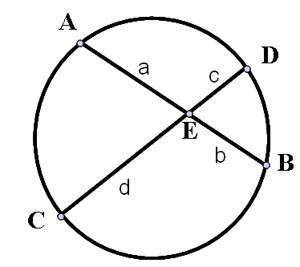**Chord-Chord**

1. In this series of questions, you will explore the relationship between a, b, c, and d in the diagram at right, and s, e, r, and c in the following diagram.
2. Use a straightedge to draw the segments $\overline{AC}$ and $\overline{BD}$.
3. What can you say about m∠*AEC* and m∠*DEB*? Why? Mark your diagram appropriately.
4. What can you say about m∠*CAE* and m∠*BDE*? Why? (Hint: Consider their intercepted arcs.) Mark your diagram appropriately.
5. What can you say about Δ*CAE* and Δ*BDE*? Why? (State the postulate or theorem you used.)
6. Use what you discovered about the triangles in Step 4 to find a proportion relating a, b, c, and d.
7. Cross-multiply to get an equation in terms of a, b, c, and d that does not involve fractions.

**Secant-Secant**

Follow the steps to show that  in the diagram at right.

1. 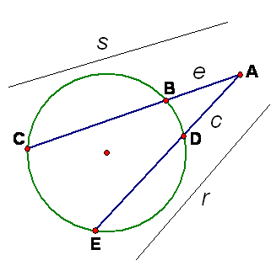Draw the segments $\overline{EC}$ and $\overline{BD}$.
2. What can you say about ∠*CAE* and ∠*DAB*? Why? Mark your diagram appropriately.
3. What can you say about ∠*BDE* and ∠*BDA*? Why?
4. What can you say about ∠*BDE* and ∠*ECB*? Why? (Hint: Consider the sum of their intercepted arcs. The angles are *not* congruent.)
5. What can you say about ∠*ECB* and ∠*BDA*? Why? Mark your diagram appropriately.
6. What can you say about ∠*ECB* and ∠*ECA*? Why?
7. What can you say about ∠*ECA* and ∠*BDA*? Why?
8. What can you say about Δ*BDA* and Δ*ECA*? Why? (State the postulate or theorem you used.)
9. Use what you discovered about the triangles in Step 14 to find a proportion relating *s*, *e, r,* and *c*. (Pay attention to corresponding sides. You may want to sketch the two triangles separately.)
10. Cross-multiply to get an equation in terms of s, e, r, and c that does not involve fractions.

**Secant-Tangent**

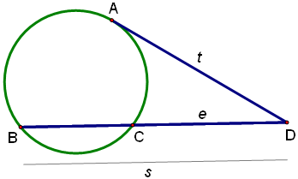 $\overline{AD}$ is tangent to the circle. Show $s ∙ e = t^{2}$.

1. Draw the segments $\overline{AB}$ and $\overline{AC}$.
2. What can you say about ∠*ADB* and ∠*CDA*? Why? Mark your diagram appropriately.
3. What is the intercepted arc of ∠*ABD*?
4. What is the intercepted arc of ∠*CAD*?
5. What can you say about ∠*ABD* and ∠*CAD*? Why? (Hint: Consider their intercepted arcs and their angle types [central, inscribed, “like inscribed,” interior, or exterior.]) Mark your diagram appropriately.
6. What can you say about Δ*ABD* and Δ*CAD*? Why? (State the postulate or theorem you used.)
7. Use what you discovered about the triangles in Step 6 to find a proportion relating *s*, *e*, and *t*. (Pay attention to corresponding sides. You may want to sketch the two triangles separately.)
8. Cross-multiply to get an equation in terms of *s*, *e*, and *t* that does not involve fractions.

**Tangent-Tangent**

1. Use the **Tangents** investigation Nos. 11–12 from the Angles, Arcs, and Segments in Circles activity sheet to get an equation relating *t* and *q*:

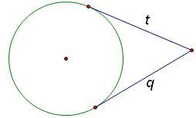

**Angles, Arcs, and Segments in Circles (Teacher’s Reference)**

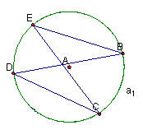**Central Angle Inscribed Angle**

m∠CAB = 92.47°

a1 = 92.47°

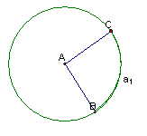

m∠BDC = 35.50°

a1 = 71.01°

= 35.50°

m∠BEC = 35.50°

**Tangents Circles**

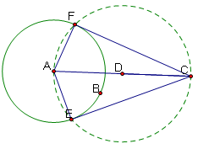

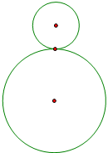

m∠AFC = 90.00°

m∠AEC = 90.00°

m FC = 3.98 cm

m CE = 3.98 cm

**Exterior Angle “Like Inscribed” Angle (tangent-chord angle)**

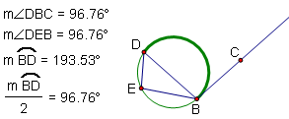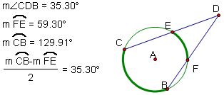

**Interior Angle Congruent Chords**

