Mathematics Instructional Plan – Geometry

The Pythagorean Relationship
Strand: Triangles
Topic: Exploring the Pythagorean Theorem and its converse
Primary SOL: G.8 The student will solve problems, including practical problems, involving right triangles. This will include applying
- the Pythagorean Theorem and its converse.
Related SOL: G.3a, G.5

Materials
- Exploration of Right Triangles activity sheet (attached)
- Exploration of the Converse of the Pythagorean Theorem activity sheet (attached)
- The Schoolyard Problem activity sheet (attached)
- Eleven-pin Geoboards, electronic version of 11-pin Geoboard, or dot paper
- Demonstration Geoboard (through document camera, digital display)
- Ruler
- Protractor
- Centimeter grid paper

Vocabulary
converse, distance, hypotenuse, leg (of a right triangle), length, Pythagorean theorem, right triangle, square

Student/Teacher Actions: What should students be doing? What should teachers be doing?
- Using a demonstration Geoboard, construct a right triangle in which one leg is a horizontal line and the other is a vertical line. Have students follow along using centimeter grid paper.
- Ask a student to construct (or draw) a square on each leg and then on the hypotenuse of the triangle.
- Ask students to find the area of each square. (It may be difficult for some students to recognize a way to find the area of the square on the hypotenuse, so you may need to assist them.)
- Distribute the Exploration of the Right Triangle activity sheet. Have students complete it in small groups. Each student should record his/her own findings. Have students discuss their findings in their group. Discuss the findings as a whole group.
- Distribute the Exploration of the Converse of the Pythagorean Theorem activity sheet. Have students fill in the data from the example completed by the whole class.
- Have students work to find several other examples and record them in the chart. Then, have students present their findings to the whole class.
- Distribute The Schoolyard Problem activity sheet. Have students draw their possible paths individually. Organize students into groups of two or three. Have groups produce a poster that shows a joint solution to the task. Have students give clear reasons for their choice of routes. Students will need to justify how they know they have found the shortest route.

Assessment

Questions
    - How can you find the distance from home plate to second base on a square baseball diamond that measures 90 feet on each side?
    - The shortstop is standing halfway between second base and third base on a baseball diamond (a square that measures 90 feet on each side.) What is the length of a throw from the shortstop to first base?
    - Which is longer, the diagonal of a rectangle with sides that measure 9 and 11 inches or the diagonal of a square with sides that measure 10 inches?
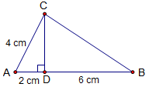
    - A doorframe that appears to be rectangular has height 213 cm, width 92 cm and one diagonal that measures 231 cm. Is the doorframe really rectangular? Explain.
    - Using figure 1, how can you explain that $∆ABC$ is a right triangle?

Journal/writing prompts
Figure 1
    - Complete a journal entry summarizing one of the activities.
    - Explain what you can determine about a triangle by using the converse of the Pythagorean Theorem.

Other Assessments
    - State the Pythagorean Theorem in your own words. Include a diagram and explain your reasoning.
    - Have students take turns rolling three dice, and have students determine whether a right triangle is formed by the three lengths (if any). Repeat several times.

Extensions and Connections
- Have students investigate the Pythagorean Triples and make generalizations about those lengths.
- Have students explore similar right triangles.
- Have students research parallax.
- Invite a carpenter, builder, or city planner to demonstrate to the class how they use the Pythagorean Theorem in their jobs.
- Have students investigate the theory of square roots by constructing the following.
    - An isosceles right triangle with leg lengths of 1 unit. (Students will need to start with a segment that is 1 unit long.) The hypotenuse is $\sqrt{2}$ units.
    - A right triangle with one leg the hypotenuse of the last triangle and the other leg 1 unit long. The hypotenuse is $\sqrt{3}$units.
    - Repeat the last step to construct $\sqrt{4}$, $\sqrt{5}$, ….
- Provide an enlarged map of your area, and plot key points (e.g., school, park). Use the distance formula or Pythagorean Theorem to calculate the distances between key points. Use spreadsheet software to tabulate results.
- Have students investigate when c² > a² + b² and when c² < a² + b² and the types of triangles formed.

Strategies for Differentiation
- Bring various lengths of two-by-fours to the classroom and lean them against the walls. Have groups of students go around the room and measure the length of each board and its height on the wall. Then ask students to calculate the distance from the base of the wall to the bottom of the board. Have the groups report back their findings to the large group.
- Use colors for the different sides (i.e., mark the hypotenuse with the same color consistently).
- Allow students to use dynamic geometry software to complete the lesson.
- Color-code the different squares and different sides of triangles.
- Use presentation software to isolate or highlight key points of the lesson.
- Have students work in groups to make up their own quizzes.
- Have students use a chart to organize what they know, what they want to learn, and what they have learned to organize information presented in the unit.

Note: The following pages are intended for classroom use for students as a visual aid to learning.

Virginia Department of Education © 2018

Exploration of Right Triangles
Name Date
Use the measures in the table to construct right triangles on centimeter grid paper. Construct (or draw) a square on each side of the triangle. Label the shortest side a, the middle side b, and the longest side c. Complete the table.
Length of side a | Length of side b | Length of side c | Area of square on side a | Area of square on side b | Area of square on side c | a² + b²
3 | 4 | 5
5 | 12 | 13
6 | 8 | 10
7 | 24 | 25
8 | 15 | 17
- Across from what angle do you always find side c, the longest side?

- State the relationship in words, using the letters a, b, and c.

An Algebraic Approach to the Pythagorean Theorem
W

Z

X

Y

T

S

U

V

a

a

a

a

b

b

b

b

c

c

c

c

Fill in expressions for each of the indicated areas.
- Area of the large square
WXYZ = (a + b)² = (a + b)(a + b) = _______________

- Area of the large square WXYZ =
area of square STUV + 4 (area of triangle XST) = __________________ + __________________

- Set the expressions from Nos. 1 and 2 equal to each other and simplify. Where have you seen this before? Shade a right triangle in the drawing for which the relationship is true.

Exploration of the Converse of the Pythagorean Theorem
Name Date
Using your Geoboard or dot paper, construct different types of triangles. Use a ruler to measure side lengths, if necessary. Complete the table. Note that c should be the length of the longest side.
Length of side a | Length of side b | Length of longest side c | Sketch of Triangle | c² | a² | b² | Is c² = a² + b²
- What patterns do you see?

- State the relationship in words, using the letters a, b, and c.

- What generalizations can be made?

The Schoolyard Problem
Some children are playing a game in a rectangular schoolyard ABCD that is 16 yards by 12 yards.
The diagram shows the schoolyard viewed overhead.
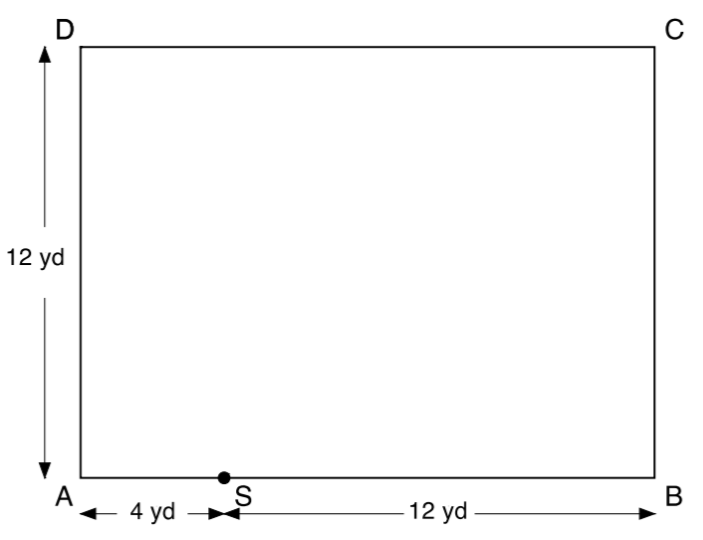
The children start at point S, which is 4 yards along the 16-yard wall AB. They have to run and touch each of the other three walls and then get back to S. The first person to return to S is the winner.
- What is the shortest route for the students to take?
- Explain how you know this is the shortest path. Justify your response.

