*Mathematics Instructional Plan – Geometry*

# Similar Triangles

**Strand:** Triangles

**Topic:**  Exploring congruent triangles

**Primary SOL:** G.7 The student, given information in the form of a figure of statement will prove two triangles are similar.

**Related SOL:** G.3a

## Materials

* Which Triangles Are Similar? activity sheet (attached)
* Similar Triangles: Shortcuts activity sheet (attached)
* Triangles from Midpoints activity sheet (attached)
* Triangles from Midpoints (Teacher’s Reference) (attached)
* Dynamic geometry software package (optional)
* Straightedge
* Compass
* Graph paper
* Pencil/paper

**Vocabulary**

*AA similarity postulate, congruence statement, congruent angles, congruent triangles, corresponding angles, corresponding sides, counterexamples, defined terms, dilation, included angle, midpoint, postulates, proof, proportion, proportional, ratio, reflexive angle, reflexive side, similar triangles, similarity statement, SAS similarity postulate, SSS similarity postulate, theorem, undefined terms*

## Student/Teacher Actions: What should students be doing? What should teachers be doing?

1. Define *similar triangles,* and compare the definition to that of congruent triangles. Review congruence shortcuts with students, and discuss why AAA is not a congruence shortcut. Tell students they will be exploring similarity shortcuts.
2. Distribute the Which Triangles Are Similar? activity sheet, and have students work in pairs to complete it. Applets on the similarity theorems can be found at websites for the National Council of Teachers of Mathematics and Math Open Reference by searching for similar triangles applets. Each student should record his/her own findings. Have students discuss the findings with their partners. Discuss the findings as a whole group.
3. Distribute the Similar Triangles: Shortcuts activity sheet, and have students work in pairs to complete it. Each student should record his/her own findings. Have students discuss the findings with their partners. Discuss the findings as a whole group. If students are not using a dynamic software package, have them complete the chart with other students’ measurements. (It may be necessary to review the steps for dilating a figure.)
4. Distribute the Triangles from Midpoint activity sheet, and have students work in pairs to complete it. Each student should record his/her own findings. Have students discuss the findings with their partners. Discuss the findings as a whole group.

## Assessment

### Questions

* + - Why don’t we call AA similarity AAA similarity?
    - What are three methods for proving triangles are similar? Explain each and include diagrams.
    - Is it true that all isosceles triangles with a 100-degree angle are similar? Explain.
    - Is it true that all isosceles triangles with a 40-degree angle are similar? Explain.
    - Are all isosceles triangles similar? Explain why or why not, or give a counterexample.

### Journal/writing prompts

* + Complete a journal entry summarizing the activities.
  + Describe a practical example that uses ratio and proportion.
  + Describe a practical example that uses similar triangles.
  + Explain how congruence and similarity are relations.

### Other Assessments

* + - Have students complete the Triangles from Midpoint activity for a different triangle.
    - Have groups of students create problems by drawing two triangles and labeling them with information that can be used to determine whether the triangles are similar. Each group should create one problem with a separate solution for each method (AA similarity, SSS similarity, and SAS similarity). Have groups swap sets of problems with other groups.

## Extensions and Connections

* Have students investigate patterns of similarity in practical contexts.
* Have students explore indirect measurement, the use of a hypsometer, or surveying methods.
* Have students explore similar right triangles formed by an altitude drawn to the hypotenuse of a right triangle.
* Does SSSS similarity work for quadrilaterals? Have students draw two quadrilaterals whose corresponding sides have ratio 1:2 but are not similar.
* Invite a surveyor or carpenter to come to the class to demonstrate how he or she uses indirect measurement when surveying land or measuring unreachable spaces.
* Working in groups, assign students a practical situation such as: 1) planning a triangular-shaped garden to be broken in equal-sized portions; 2) use similar triangles to find the heights of objects that cannot be measured; and 3) use the properties of similar triangles to find the dimension of one triangle if the dimension and perimeter of another are known. For example, the lengths of the sides of a triangle are 16, 23, and 31. If the perimeter of a similar triangle is 280, find the length of the similar triangle’s longest side.

## Strategies for Differentiation

* Provide dynamic geometry software packages for students to use.
* Use colors so that corresponding sides are the same color. Mark the vertices of corresponding angles with dots of the same color. (Mark sides and opposite angles with the same color.)
* Have students color-code each segment of the triangle to visually discriminate differences.
* Provide students a paper with a labeled triangle on it. Have them use string to outline each side of the triangle. Have them fold the string in half to arrive at the midpoint of the segment. Once students have found the three midpoints, have them connect the three strings to get the inner triangle.
* Provide a large piece of felt (2’ x 3’ x 4½’). Using additional felt the same size but of different colors, cut one of the triangles on the midsegments so there are four similar triangles. Have students use these triangles to demonstrate their understanding of the key points of the lesson, including which triangles are congruent.
* Divide the vocabulary into two groups. One group is the definitions: undefined terms, defined terms, postulates, and theorems. The other group contains geometric shapes: coordinates, midpoints, line segments, similar triangles, and congruent angles. Ask students to divide the subgroups into a vocabulary notebook. For the first list, have students write or dictate an original short story using those terms. For the second list, have students draw or describe true items that appear in their environment and that illustrate these shapes.
* Have students cut a sheet of notebook or computer paper into a triangle, folding each tip across its midpoint so that the imprint of four triangles is present on the paper. Have students use the imprinted triangles to illustrate or otherwise identify the key points of the lesson.
* Develop a graphic organizer with the students that summarizes the triangle similarity theorems.

**Note: The following pages are intended for classroom use for students as a visual aid to learning.**

Virginia Department of Education © 2018

**Which Triangles Are Similar?**

**Name Date**

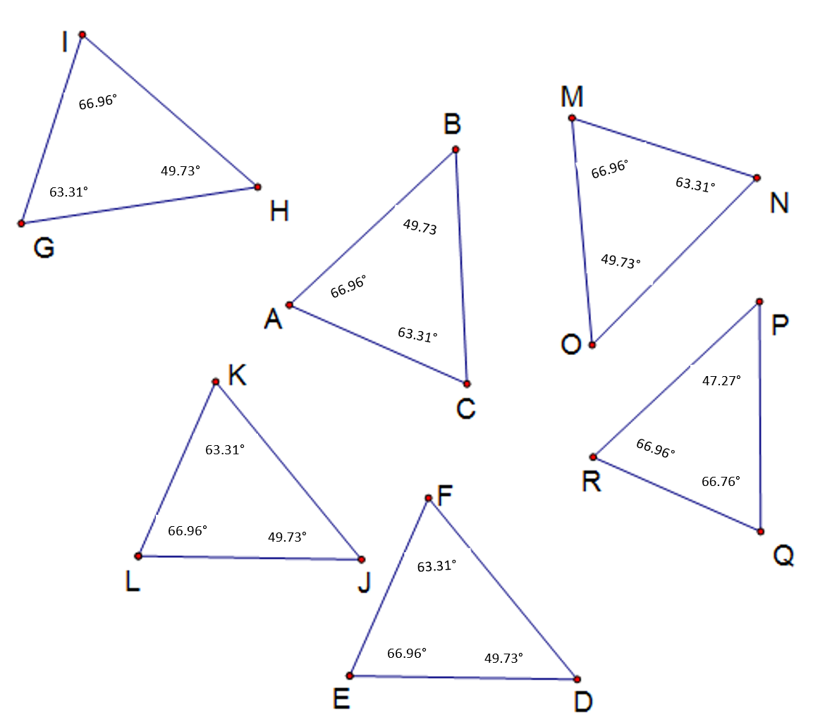Answer the questions using the diagram and angle measures shown below.



1. Is there enough information to determine whether the triangles are congruent? Explain.
2. What can you say about some of the triangles, using the angle measures? The lengths of the sides are given below:

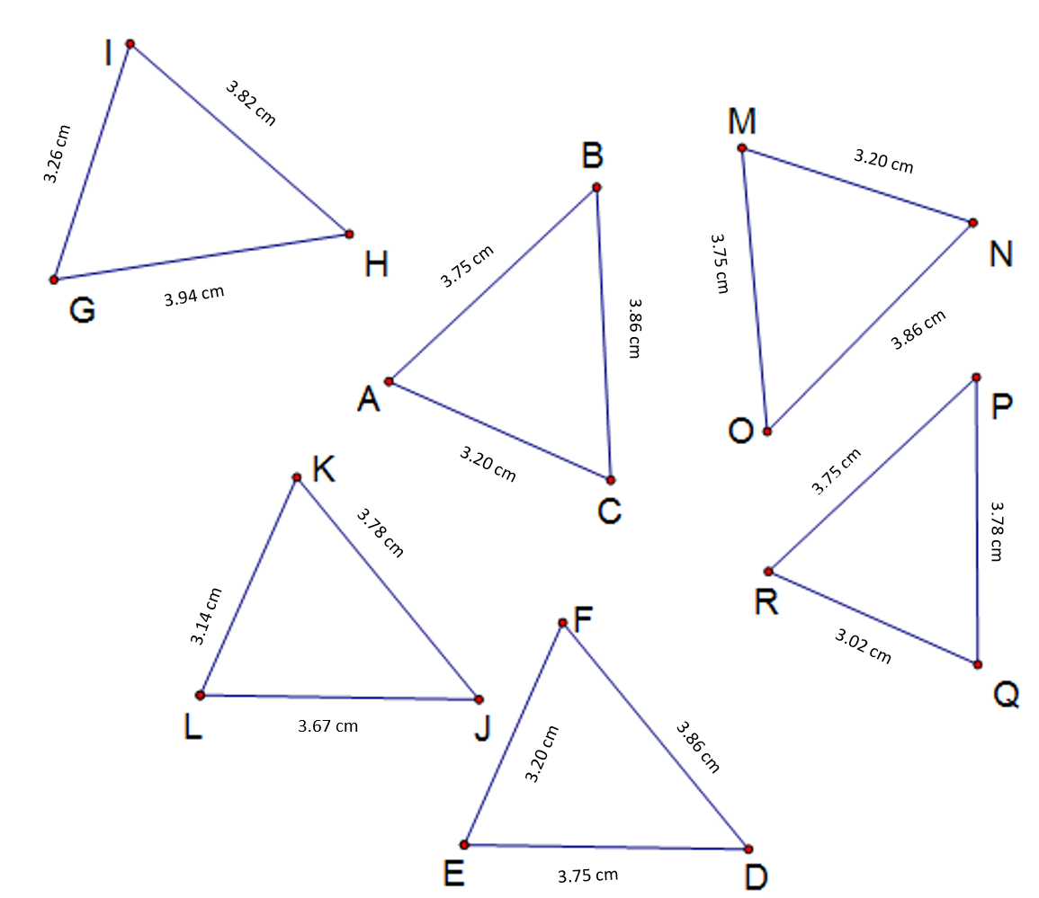



1. Are any of the triangles congruent to $∆ABC$? If so, write congruence statements (such as $∆ABC ≅ ∆UVW$) for the congruent triangles. (Remember the order of the letters matters!)
2. Are any of the triangles similar but not congruent to $∆ABC$? If so, write similarity statements (such as $∆ABC ≅ ∆UVW$) for the similar triangles.
3. According to the table of angle measures, the sum of the angle measures for $∆PQR$ is not 180 degrees. Why do you think this is?

**Similar Triangles: Shortcuts**

**Name** ___________________________________ **Date**

Complete the following tasks, and answer the questions, using dynamic geometry software or measuring tools.

**Part 1: Is AA a Similarity Shortcut?**

In this activity, you will explore the following question: If two angles of one triangle are congruent to two angles of another triangle, are the triangles similar?

1. Open a new sketch.
2. Draw a triangle, and label it $∆ABC$.
3. Construct a second triangle $∆DEF$ with $∠A ≅ ∠D$ and $∠B ≅ ∠E$. What can you say about $∠C$ and $∠F$? What postulate or theorem allowed you to conclude this?
4. Measure all the angles of the two triangles to verify that corresponding angles are congruent.
5. Look at the definition of similar triangles from No. 1. You know the angles are congruent. What else do you need to know to determine whether the triangles are similar?
6. Measure all of the lengths of the sides of the two triangles. Use the software or measuring tool to compute the ratios of the lengths of corresponding sides. Are the sides proportional. What can you say about the triangle? This is Trial 1. Compete Trial 1 for the table below:

|  |  |  |  |  |  |
| --- | --- | --- | --- | --- | --- |
|  |  |  |  | **Are Sides Proportional?** | **Are Triangles Similar?** |
| **Trial 1** |  |  |  |  |  |
| **Trial 2** |  |  |  |  |  |
| **Trial 3** |  |  |  |  |  |

7. Gently move the vertices off $∆ABC$ and notice what happens to the angles measures and ratios of corresponding sides. This is Trial 2. Record your findings in the table above. If you are not using software, complete the chart with the measurements obtained from the students in your group.

8. Repeat step 7 for Trial 3.

9. Do you think the sides will always be proportional if the angles of two triangles are congruent? Write a conjecture (prediction) about the sides of two triangles with congruent angles.

10. Write a conjecture about two triangles with congruent angles.

11. Save your sketch as directed by your teacher.

For the next sketch, you will construct a dilation of a triangle. To do this, you will need to choose a scale factor or dilation factor and a point as the center of the dilation. This will take the lengths of the sides of the original triangle, multiply them by the dilation factor, and create a triangle with those new side lengths.

**Part 2: Is SSS a Similarity Shortcut?**

In this activity, you will explore the following question: If the sides of two triangles are proportional, are the triangles similar?

1. Open a new sketch.

2. Draw a triangle, and label it .

3. Draw a point outside the triangle, and label the point *D* as the center for the dilation.

4. Choose a scale factor (ratio) such as or 3.

5. Dilate $∆ABC$ by the scale factor you selected using point *D* as the center for the dilation.

6. If you cannot see the dilation, or it overlaps $∆ABC$, move point *D* or change your scale factor until you can see the dilation and it does not overlap

7. Measure the lengths of the sides of $∆ABC$ and $∆ADE$. Compute the ratios of the lengths of corresponding sides. Confirm (check) that the sides are proportional.

8. Gently move the points of the triangles to adjust the lengths of the sides. Confirm that the sides are still proportional. If software is not being used, compare the results of the students in your group.

9. Measure the angles of the two triangles. What do you notice?

10. Do you have enough information to determine whether $∆ABC$ and $∆ADE$ are similar? Explain.

11. Write a conjecture about two triangles with proportional sides.

**Part 3: SAS Similarity**

In this activity, you will explore the following question: If two sides of two triangles are proportional, and the included angles are congruent, are the triangles similar? Use paper, straightedge, and compass for this activity.

1. Use a straightedge, a pencil, and paper to draw an angle and label it $∠A$.
2. Use a straightedge and compass to construct an angle congruent to $∠A$. Label it $∠D$.
3. Mark a point on one of the rays of $∠A$ that is 9 cm from $∠A$. Label this point *B*. Mark a point on the other ray that is 12 cm from $∠A$. Label this point *C*.
4. Mark a point on one of the rays of $∠D$ that is 6 cm from $∠D$. Label this point *E*. Mark a point on the other ray that is 8 cm from $∠D$. Label this point *F*.
5. Compute $\frac{AB}{DE}$ and $\frac{AC}{DF}$. Are these two pairs of sides proportional?
6. Draw $\overline{BC}$ and $\overline{EF}$. Measure the other angles of the triangles. Are the triangles similar? Explain.
7. Write a conjecture about two triangles with two pairs of proportional sides and congruent included angles.

**Triangles from Midpoints**

**Name ____________________________________ Date**

Complete the following tasks and questions, using a dynamic geometry software package or paper, straightedge, and compass:

1. Construct triangle $∆ABC$, and label the vertices *A*, *B*, and *C*.
2. Construct the midpoint of each segment. Label the midpoint of segment $\overline{AC}$, point *F*. Label the midpoint of $\overline{CB}$, point *D*. Label the midpoint of $\overline{AB}$, point *E*.
3. Draw triangle $∆DEF$.
4. Measure each of the six angles of the triangles $∆ABC$ and $∆DEF$, and record the angle measures here.
5. What do you notice? Can you show that triangles $∆ABC$ and $∆DEF$ are similar? If not, what triangles can you show are similar? Explain the process for planning your proof.
6. What postulates or theorems would you use to show that your triangles are similar?
7. Write a similarity statement and list the corresponding angles and sides.
8. Your drawing includes four small triangles. Find the length of each segment, and investigate the relationship among these triangles. (You may need to create the segments first.) Record your findings here.
9. List all congruent angles and segments. Record your findings here.
10. What conclusions can you draw about these four small triangles?
11. How can you prove your conclusion? What postulates or theorems would you use?
12. Assuming this does not work for all triangles, find a counterexample.
13. Discuss where it might be helpful to have patterns such as this.

**Triangles from Midpoints (Teacher’s Reference)**

