Mathematics Instructional Plan – Geometry

Congruent Triangles
Strand: Triangles
Topic: Exploring congruent triangles, using constructions, proofs, and coordinate methods
Primary SOL: G.6 The student, given information in the form of a figure or statement will prove two triangles are congruent.
Related SOL: G.4, G.5

Materials
- Congruent Triangles: Shortcuts activity sheet (attached)
- Congruent Triangles: Shortcuts (Teacher Reference) (attached)
- Proofs Scramble activity sheet (attached)
- DIY Proofs Scramble activity sheet (attached)
- Straightedges
- Compasses
- Pencils
- Scissors

Vocabulary
angle, angle-angle-side (AAS), angle-side-angle (ASA), congruent angles, congruent parts, congruent triangles, construct, corresponding parts, corresponding parts of congruent triangles are congruent (CPCTC), hypotenuse, included angle, included side, line segment, non-included angle, non-included side, reflexive, side-angle-side (SAS), side-side-side (SSS), vertex, vertical angles

Student/Teacher Actions: What should students be doing? What should teachers be doing?
- Define corresponding parts of congruent triangles are congruent (CPCTC). Explain to students that, according to the definition, you need to prove that all three pairs of corresponding angles are congruent and all three pairs of corresponding sides are congruent in order to definitively say that the triangles are congruent.
- Explain that the Congruent Triangles: Shortcuts activity sheet will explore which combinations of three congruent pairs of parts are enough to prove triangles are congruent. Distribute the activity sheet.
- Have students work in pairs to complete the Congruent Triangles Shortcuts activity sheet. Alternatively, applets on the congruence theorems can be found at websites for the National Council of Teachers of Mathematics (NCTM) (https://illuminations.nctm.org/Activity.aspx?id=3504) and the National Library of Virtual Manipulatives (http://nlvm.usu.edu/en/nav/topic_t_3.html) by searching for congruence theorems. Each student should record his/her own findings. Have students discuss findings with their partners. Then, discuss findings as a whole group.
- Have students work in pairs to complete Proofs Scramble activity sheet. Be prepared for students to ask about the order of the pairs of corresponding congruent parts in the proof. Acknowledge that there can be some variation. Each student should record his/her own findings. Have students discuss the findings with their partners. Then, discuss the findings as a whole group.
- Assign groups of two to four students to a proof from your textbook or other source, and have groups complete one copy of the DIY Proofs Scramble activity sheet for their assigned proof. Have students discuss the findings with their group. Groups should share their findings with the class.

Assessment
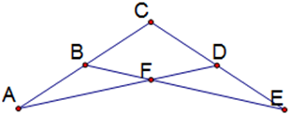
Figure 1

Questions
    - Using Figure 1 above, if $\overline{CB} ≅ \overline{CD}$ and $\overline{CA} ≅ \overline{CE}$, is $∠A≅∠E$? Explain.
    - Draw an isosceles triangle $△RST$ with $\overline{RS} ≅ \overline{RT}$. Label any point U on $\overline{ST}$, and draw $\overline{RU}$. List and mark all corresponding, congruent parts on $∆RSU$ and $∆RTU$ Do you have enough information to say the two triangles are congruent? Explain.

Journal/writing prompts
    - What are the five ways to determine that two triangles are congruent?
    - Explain when SSA is enough information to determine whether two triangles are congruent.
    - Explain why angle-angle-angle (AAA) is not enough information to determine that two triangles are congruent.
    - Explain how AAS follows from ASA.
    - Describe a real-world example that uses congruent triangles.

Other Assessments
    - Have students complete the same activities for different segments and angles.
    - Have students construct two triangles that have two pairs of congruent sides and one pair of congruent angles but are not congruent.
    - Have students draw pairs of triangles that illustrate each of the five congruence shortcuts. One pair should use a reflexive side, and one pair should have a pair of vertical angles.

Extensions and Connections
- Have students draw a segment and two obtuse angles. Have them try to construct a triangle with the segment included by the two angles. Have students discuss any problem with the construction. What theorem or corollary explains the problem?
- Have students draw three angles. Have them try to construct a triangle with these three angle measures. If they are able do this, have them change only one of the angles and try again. Have students discuss their findings. What theorem or corollary explains the problem?
- Ask students to determine whether it is always possible to construct two noncongruent triangles, given two side lengths and a non-included side. Explain why or why not.
- Ask students to discuss whether they can construct congruent triangles given any three segment lengths. What theorem can be used to determine when constructing such a triangle is possible?
- Have students explore the use of a carpenter’s square and explain why this is an application of congruent triangles.
- Have students explore how congruent triangles are related to constructions.
- Research bridge structures and the use of triangles in design and engineering.

Strategies for Differentiation
- Use an interactive whiteboard and software to model and demonstrate triangle characteristics.
- Provide dynamic geometry software packages for students to use.
- Develop a visual component to support the activity sheet.
- Use manipulatives such as straws, spaghetti noodles, or angle legs.
- Use highlighters or colored pencils with the Congruent Triangles: Shortcuts activity sheet. Have students mark the congruent sides the same color. Mark the vertices of corresponding angles with dots of the same color. (Mark sides and opposite angles with the same color.)

Note: The following pages are intended for classroom use for students as a visual aid to learning.

Virginia Department of Education © 2018

Congruent Triangles: Shortcuts
Name ____________________________ Date ________________________
Directions: Use a pencil, straightedge or ruler, protractor, and compass to complete the following tasks and questions.
Part 1: Side-Side-Side (SSS)

- Construct triangle, $∆ABC$ with sides congruent to the segments $\overline{AB}$, $\overline{BC}$, and $\overline{CA}$ above. Label the vertices A, B, and C, corresponding to the labels above.

- Compare your triangle to the triangles of other members of your group using a protractor and ruler. How are they the same? How are they different?

- Is it possible to construct two triangles that are not congruent?

- Write a conjecture (prediction) about triangles with three pairs of congruent sides.

Part 2: Side-Angle-Side (SAS)
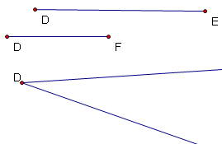

- Construct $△DEF$ with angle congruent to $∠D$, above, and sides congruent to $\overline{DE}$ and $\overline{DF}$ above. Label the vertices D, E, and F, corresponding to the labels above. Note that $∠D$ is called the included angle because $\overline{DE}$ and $\overline{DF}$ form the sides of $∠D$.

- Compare your triangle to the triangles of other members of your group. How are they the same? How are they different?

- Is it possible to construct two triangles that are not congruent?

- Write a conjecture (prediction) about two triangles with two sides and the included angle that are congruent.
Part 3: Angle-Side-Angle (ASA)
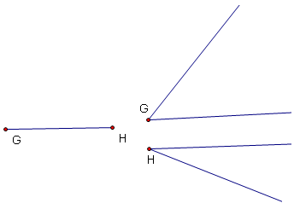

- Construct$△GHI$, with angles congruent to $∠G$ and $∠H$ above and side congruent to the $\overline{GH}$ above. Label the vertices G, H, and I, corresponding to the labels above. Note that $\overline{GH}$ is called the included side because the vertices of $∠G$ and $∠H$are the endpoints of $\overline{GH}$.

- Compare your triangle to the triangles of other members of your group. How are they the same? How are they different?

- Is it possible to construct two triangles that are not congruent?

- Write a conjecture (prediction) about two triangles with two angles and the included side that are congruent.

Part 4: Side-Side-Angle (SSA)
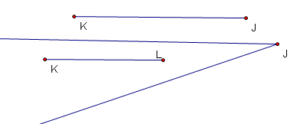

- Construct $△JKL$, with angle congruent to $∠J$ above and sides congruent to $\overline{JK}$ and $\overline{KL}$ above. Label the vertices J, K, and L, corresponding to the labels above. Note that $∠J$ is called a non-included angle because $\overline{JK}$ and $\overline{KL}$ do not form the sides of $∠J$.

- Compare your triangle to the triangles of other members of your group. How are they the same? How are they different?

- Is it possible to construct two triangles that are not congruent?

- Can you say that two triangles with two congruent sides and a pair of congruent non-included angles must be congruent? Could they be congruent?
Part 5: Angle-Angle-Angle (AAA)
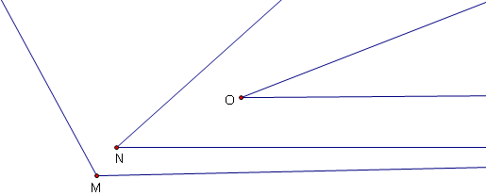

- Construct $△MNO$, with angles congruent to$∠M$, $∠N$ and $∠O$ above. Label the vertices M, N, and O, corresponding to the labels above.

- Compare your triangle to the triangles of other members of your group. How are they the same? How are they different?

- Is it possible to construct two triangles that are not congruent?

- Can you say that two triangles with three pairs of congruent angles must be congruent? Could they be congruent?

- Can you construct a triangle given any three angles? What must be true about the three angle measures?
Part 6: Angle-Angle-Side (AAS)
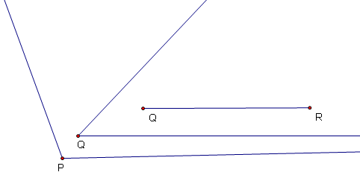

- Construct $△PQR$, with side congruent to $\overline{QR}$ and angles congruent to $∠P$ and $∠Q$ above. Label the vertices P, Q, and R, corresponding to the labels above. Note that $\overline{QR}$ is called a non-included side, because the vertices of $∠P$ and $∠Q$ are not the endpoints of$\overline{QR}$.

- Compare your triangle to the triangles of other members of your group. How are they the same? How are they different?

- Is it possible to construct two triangles that are not congruent?

- Write a conjecture (prediction) about two triangles with two angles and a non-included side that are congruent.

Part 7: Another Side-Side-Angle (SSA )
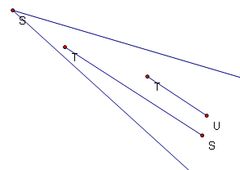

- Construct $△STU$, with angle congruent to $∠S$ above and sides congruent to the $\overline{ST}$ and $\overline{TU}$ above. Label the vertices S, T, and U, corresponding to the labels above. Note that $∠S$is called a non-included angle, because $\overline{ST}$ and $\overline{TU}$ do not form the sides of $∠S$.

- Compare your triangle to the triangles of other members of your group. How are they the same? How are they different?

- Is it possible to construct two triangles that are not congruent?

- What is the difference between this construction and the construction in Part 4, which was also an SSA construction?

Part 8: Side-Side-Angle (SSA) and Hypotenuse-Leg (HL)
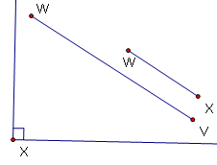

- Construct $△VWX$, with (right) angle congruent to $∠X$ above and sides congruent to the $\overline{VW}$ and $\overline{WX}$ above. Label the vertices V, W, and X, corresponding to the labels above. Note that $∠X$ is called a non-included angle, because $\overline{VW}$ and $\overline{WX}$ do not form the sides of$∠X$. Note also that $\overline{VW}$is the hypotenuse, and $\overline{WX}$ is a leg of a right triangle.

- Compare your triangle to the triangles of other members of your group. How are they the same? How are they different?

- Is it possible to construct two triangles that are not congruent?

- Which of the following applies to your triangle: SSS, SAS, ASA, AAS, SSA, or AAA?

- Write a conjecture (prediction) about two triangles with right angles, congruent hypotenuses, and one pair of congruent legs.

Congruent Triangles: Shortcuts (Teacher Reference)
1. The SSS triangle should be congruent to this triangle.
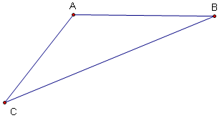

2. The SAS triangle should be congruent to this triangle.

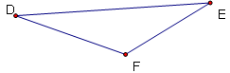

3. The ASA triangle should be congruent to this triangle.
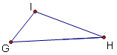

4. There are two possible SSA triangles.
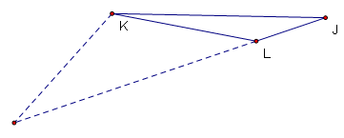
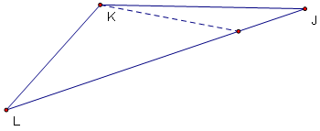
or

5. There are many different AAA triangles. (They are similar.) Here is one.
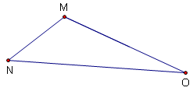

6. The AAS triangle should be congruent to this triangle.
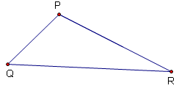

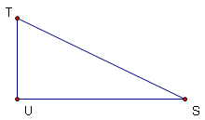
7. This is SSA, but all triangles are not congruent to this triangle.

8. The HL triangle should be congruent to this triangle.
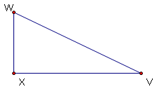

Proofs Scramble
Name __________________________ Date_____________________
The statements and reasons in the proof below are scrambled.
- Cut apart the proof on the dotted lines.
- Assemble the proof.
- Tape or glue your proof, or rewrite it on a sheet of paper.
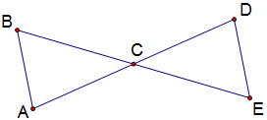
Given:
C is the midpoint of $\overline{AD}$.

⏐⏐

Prove:

Statements Reasons
CPCTC | C is the midpoint of $\overline{AD}$.
given
⏐⏐ | ASA
 | given
Definition of Midpoint
Vertical Angles Theorem | Alternate Interior Angles Theorem

DIY Proofs Scramble
Name_______________________________ Date__________________________
Directions:
- Fill in the outline below for the proof of your assigned problem. Include a diagram!
- Cut apart your proof on the dotted lines.
- Mark the back of each piece with the problem number, and place in an envelope. Label the envelope with the page/worksheet and problem number. Swap with another group, assemble their proof, and write it down or check it with your homework, as directed.

Page or worksheet ______ Problem No. _______
Given:

Prove:
Diagram

Statements | Reasons

