*Mathematics Instructional Plan – Geometry*

# Constructions

**Strand:** Reasoning, Lines, and Transformations

**Topic:** Completing constructions, using a straightedge and compass

**Primary SOL:** G.4 The student will construct and justify the constructions of

1. a line segment congruent to a given line segment;
2. the perpendicular bisector of a line segment;
3. a perpendicular to a given line from a point not on the line;
4. a perpendicular to a given line at a given point on the line;
5. the bisector of a given angle;
6. an angle congruent to a given angle;
7. a line parallel to a given line through a point not on the given line; and
8. an equilateral triangle, a square, and a regular hexagon inscribed in a circle.

**Related SOL:** G.2, G.6, G.9, G.11

## Materials

* Constructions: Part 1 activity sheet (attached)
* Constructions: Part 2 activity sheet (attached)
* Justification Proof activity sheet (attached)
* Straightedge
* Compass
* Pencils

## Vocabulary

*angle, angle bisector, arc, congruent, congruent triangles, construct, equilateral triangle, inscribed, intersection, midpoint, parallel, perpendicular, perpendicular bisector, radius, ray, regular hexagon, segment, square*

## Student/Teacher Actions: What should students be doing? What should teachers be doing?

1. Have students work in pairs to complete the Constructions: Part 1 activity sheet using a straightedge, a pencil, and a compass.
2. Have students compare and contrast the various constructions with their partners. Discuss the findings as a whole group.
3. Make sure students understand that they never should estimate or attempt to draw lines or segments freehand without a straightedge, or to construct circles/arcs freehand without a compass.
4. Have students complete the Constructions: Part 2 activity sheet. Have students compare and contrast the various constructions with their partners. Discuss the findings as a whole group.

## Assessment

### Questions

* + - Use a straightedge and a pencil to draw two angles whose rays do not intersect. Construct an angle whose measure is equal to the sum of the measures of the two angles. How can you check that your construction is correct?
    - Use a straightedge and a pencil to draw two segments. Construct a segment whose length is equal to the sum of the lengths of the two segments. How can you check that your construction is correct?
    - Use a straightedge and a pencil to draw a segment. Construct a perpendicular bisector for the segment. How can you check that your construction is correct?
    - Use a straightedge and a pencil to draw an angle. Construct the angle bisector. How can you check that your construction is correct?
    - Use a straightedge and a pencil to draw a line and a point on the line. Construct a line through the point, perpendicular to the line. How can you check that your construction is correct?
    - Use a straightedge and a pencil to draw a line and a point not on the line. Construct a line through the point, perpendicular to the line. How can you check that your construction is correct?
    - Use a straightedge and a pencil to draw a line and a point not on the line. Construct a line through the point, parallel to the line. How can you check that your construction is correct?
    - The construction of a line parallel to a line, through a point not on the line, uses a postulate about parallel lines cut by a transversal. What postulate is used? How could the construction be changed to use a different postulate or theorem?

### Journal/writing prompts

* + - Complete a journal entry summarizing steps for each construction.
    - Explain how to construct an equilateral triangle.

### Other Assessments

* + - Have students work in pairs to evaluate strategies.
    - Working in pairs, have one student dictate the steps in the construction of an angle bisector, while the other student performs the construction.

## Extensions and Connections (for all students)

* Constructions can be taught as the vocabulary is taught. For example, when congruent segments and segment bisectors are defined, teach those constructions.
* Have students investigate practical problems involving constructions.
* Have students construct familiar polygons, such as equilateral triangles, parallelograms, rhombi, rectangles, and squares.
* Have students construct medians, altitudes, and angle bisectors for triangles.
* Have students create diagrams, using combined constructions.
* Have students use a dynamic geometry software package to perform constructions (without using macros).
* Take students to a football field and have them find examples of line segments, congruent angles, perpendicular lines, etc.
* Invite a surveyor or carpenter to the class to demonstrate how he or she uses bisectors, angles, etc., in their line of work (check with a CTE teacher or coordinator in your school or division).
* Assign students to work in groups to make illustrations of a town, a home, a school, a mall, or any other scene that includes constructions they have learned. The illustrations should be at least poster-sized.

## Strategies for Differentiation

* Use dynamic geometry software.
* Provide a whiteboard-sized compass and straightedge for students to practice with on the whiteboard.
* Use the compass in the software that comes with interactive whiteboards to demonstrate.
* Provide students with patty paper to fold and/or trace equal segments, angle bisectors, etc.
* Use different-colored ink/pencils for line segments, congruent angles, bisectors, etc., so that students can physically see the different steps. Also have students use the different colors as they do their constructions.
* Have students work in pairs, with one student drawing any one of the constructions presented in this unit. Using patty paper, the other student duplicates the construction(s).

**Note: The following pages are intended for classroom use for students as a visual aid to learning.**

Virginia Department of Education © 2018

**Constructions: Part 1**

**Name Date**

1. Constructing a line segment congruent to a given line segment:

Given a line segment, $\overline{AB}$,

*A B*

a. Use a straightedge to draw a line, choose a point on the line, and label it *X.*

*X*

b. Use your compass to measure the length of $\overline{AB}$, drawing an arc as you measure.

*A B*

c. From *X,* draw the exact arc that was drawn on $\overline{AB}$, and label it *Y*.

*X Y*

2. Constructing an angle congruent to a given angle:

Given ∠*ABC*,

*A*

*B*

*C*

a. From point *B,* use your compass to draw an arc that intersects ray *BA* and ray *BC*.

*A*

*D*

*B*

*E*

*C*

b. Draw a ray, and label it $\overline{YT}$.

Y

T

c. From point *Y,* draw an arc with the same radius as the radius of $\hat{DE}$. Label the point of intersection *Z.*

*Y*

*Z*

*T*

d. Use the compass to measure the length of $\hat{DE}$. From point *Z*, draw an arc with radius . (This is different than the radius of arc $\hat{DE}$!)

*Y*

*X*

*Z*

*T*

e. Label the intersection of the two arcs *X.* Draw $\vec{YX}$.

*Y*

*X*

*Z*

*T*

f. Now, ∠*XYZ* ≅ ∠*ABC*.

3. Construct a perpendicular line to a given line at a point on the line:

Given line *k* and point *A* on *k*,



1. From *A,* draw two arcs the same distance from *A* and intersecting line *k*, and label the points of intersection *X* and *Y.*

*k*

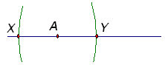

*k*

1. From *X,* draw an arc that intersects line *k* past *A.* Then, draw the same arc from point *Y* and label the point where the two arcs intersect each other *Z.*

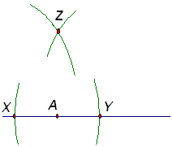

*k*

1. Draw the line that passes through points *A* and *Z.*



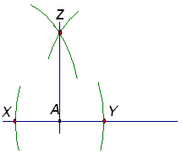

*k*

1. Line *AZ* ⊥ line *k* at *A.*

4. Constructing a perpendicular to a given line from a point not on the line:

Given line *m* and point *A* not on *m*,



*m*

1. From point *A*, draw an arc that intersects line *m* in two points. Call these points *X* and *Y*.

*mm*

1. 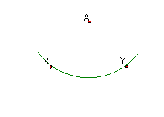From *X*, draw an arc with radius that is more than half the length to point *Y*. Using the same arc radius, draw another arc from *Y* that intersects the first arc. Call the point of intersection *Z*.

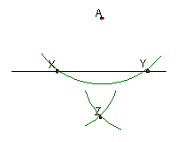

*m*

1. Use a straightedge to draw the straight line through points *A* and *Z*.

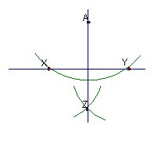

*m*

1. Line ⊥ line *m*.

↔

5. Constructing the perpendicular bisector of a given segment:

Given a line segment, *,*



* + - 1. 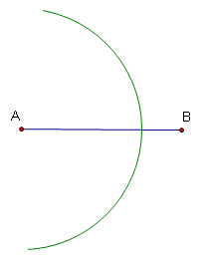From *A,* draw an arc that is more than half the length to point *B.* Draw an arc on both sides of the $\overline{AB}$*.*
      2. 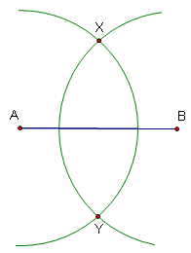Using the same arc length, draw another arc from *B* that intersects the first arc on both sides of the segment. Call the points where the arcs intersect *X* and *Y.*
      3. 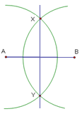Use a straightedge to draw the straight line through points X and *Y.*
      4. $\overset{⃡}{XY}$ is the ⊥ bisector of .

6. Constructing the bisector of a given angle:

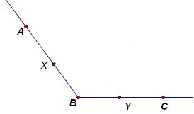 Given ∠*ABC*,

1. 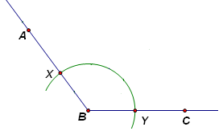From *B*, draw an arc that intersects $\vec{BA}$ at *X* and $\vec{BC}$ at *Y*.

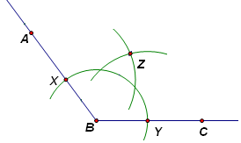b. From *X*, draw an arc that is large enough to reach past *B*. Using the same compass opening and *Y* as the circle center, draw another arc that intersects the first arc. Label the intersection *Z*.

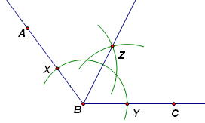c. Draw the ray from *B* through *Z*. Ray BZ is the angle bisector of ∠*ABC*.

d. $\vec{BZ}$ bisects ∠*ABC*.

→

7. Constructing a line parallel to a given line through a point not on the given line:

Note: You must be familiar with the construction of an angle congruent to a given angle to complete this construction.

Given line *m* and point *A* not on *m*.

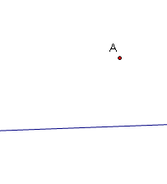

*m*

1. From point *A,* use a straightedge to draw a line that intersects the given line. (This line is called a transversal.) Label the intersection *X.*

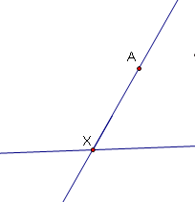

*m*

1. Copy one of the angles formed by the transversal and the given line in the corresponding position at *A* (using the transversal as one side of the angle).

Step 1 Step 2

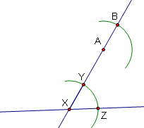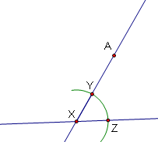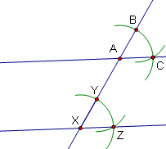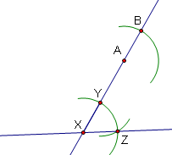

**Step 3 Step 4**

Step 3 Step 4

8. Constructing an inscribed regular hexagon:

Given circle *A* with radius *AB*,

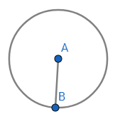

1. Set the compass point on *A*, and set its width to *B*. The compass must remain at this width for the remainder of the construction.
2. Move the compass on to *B* and draw an arc across the circle. This is the next vertex of the hexagon.  
    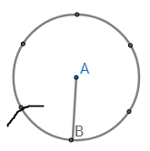
3. Continue until you have all six vertices.   
    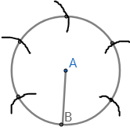
4. Draw a line to connect each successive pairs of vertices.  
   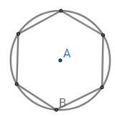

9. Constructing an inscribed equilateral triangle:

 Given circle *A* with radius *AB*,

1. Set the compass point on *A*, and set its width to *B*. The compass must remain at this width for the remainder of the construction.
2. Move the compass on to B and draw an arc across the circle.  
   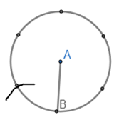
3. Continue in this way until you have six vertices.   
   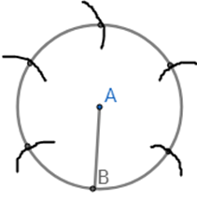
4. Connect every other point to create the equilateral triangle.   
   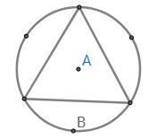

10. Constructing an inscribed square:  
 Given circle *O* with diameter *AB*.  
Note: You must be familiar with the construction of perpendicular bisector to complete this construction.

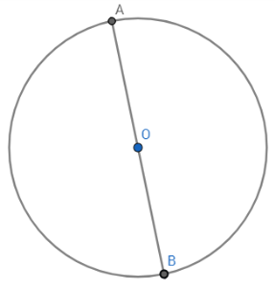

1. Construct the perpendicular bisector of diameter *AB*.   
   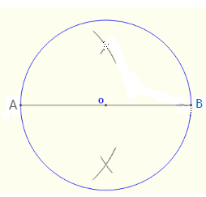
2. Draw a line through the intersection of the arc pairs, making line long enough to touch the circle at top and bottom, and creating the new points *C* and *D*.
3. Draw a line between each successive pairs of points *A, B, C, D*.  
   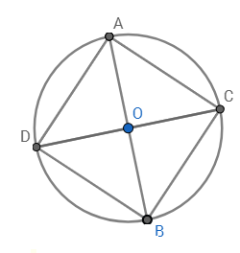

**Constructions: Part 2**

**Name Date**

Construct a line segment congruent to each given line segment.

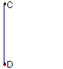

1. 2. 3.

Construct an angle congruent to each given angle.



4. 5. 6.

Construct a line perpendicular to each given line through the given point on the line.





7. 8. 9.

Construct a line perpendicular to each given line through the given point not on the line.





10. 11. 12.

Construct the perpendicular bisector for each given line segment.



13. 14. 15.

Construct the angle bisector of each given angle.







16. 17. 18.

Construct a line parallel to each given line through the given point not on the line.





19. 20. 21.

Construct a regular hexagon inscribed in a circle.

22.

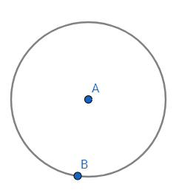

Construct an equilateral triangle inscribed in a circle.

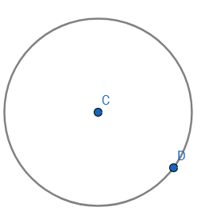23.

Construct a square inscribed in a circle.

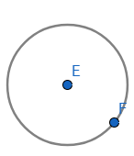24.

**Justification Proof**

**Name Date**

Here is the construction of an angle bisector of a given angle.



The first step of the construction is to draw an arc centered at point *B* that intersects both sides of the given angle. What is established by the first step?

$\overline{BX} ≅ \overline{XY}$

$\overline{BX} ≅ \overline{BY}$

$\overline{BZ} ≅ \overline{BY}$

$\overline{XZ} ≅ \overline{YZ}$

The construction above creates congruent triangles.

Triangle *BXZ* and Triangle *BYZ* are congruent by the ________ theorem.

Circle the appropriate theorem:

Angle – Side – Angle

Angle – Angle – Side

Side – Angle – Side

Side – Side – Side

It follows that $\vec{BZ}$ must be the angle bisector of $∠XBY$ because

Choose the appropriate statement:

$$∠BYZ ≅∠BXZ.$$

$$∠XBY ≅∠XZY.$$

$$∠XBZ ≅∠YBZ.$$

$$∠XBZ ≅∠BXZ$$