Mathematics Instructional Plan – Geometry

Transformations
Strand: Reasoning, Lines, and Transformations
Topic: Identifying translations, reflections, rotations, and dilations of polygons
Primary SOL: G.3 The student will solve problems involving symmetry and transformation. This will include
- determining whether a figure has been translated, reflected, rotated, or dilated, using coordinate methods.
Related SOL: G.3c, G.6, G.14

Materials
- Transformation Cards activity sheet (attached)
- Transformations activity sheet (attached)
- Graphing utility
- Scissors
- Graph paper
- Rulers
- Desmos (free online graphing software and graphing calculator) www.desmos.com
- Paper clips or resealable plastic bags (or other materials management tools)

Vocabulary
similar figures, translation, reflection, rotation, dilation, transformation, preimage, image, scale factor, x-axis, y-axis, origin, coordinates, vertex, dilation factor, center of rotation

Student/Teacher Actions: What should students be doing? What should teachers be doing?
- Students will need to be reminded about the graphs of the lines y = x, y = –x, y = 0, x = 0, y = k, and x = k using a graphing utility or Desmos.
- Distribute scissors and the Transformation Cards activity sheet. Have students cut out the cards.
- Have students work in small groups to match each graph with the description of the transformation. Students can do this either with all cards face-up or as a concentration game.
- Have students discuss the findings with their partners. Then, discuss the findings as a whole group.
- Have students work with a partner or in a small group to complete the Transformations activity sheet. Have students discuss the findings with their partners or small group. Then, discuss the findings as a whole group.

Assessment

Questions
  - In Figure 1 below, .
Figure 1.
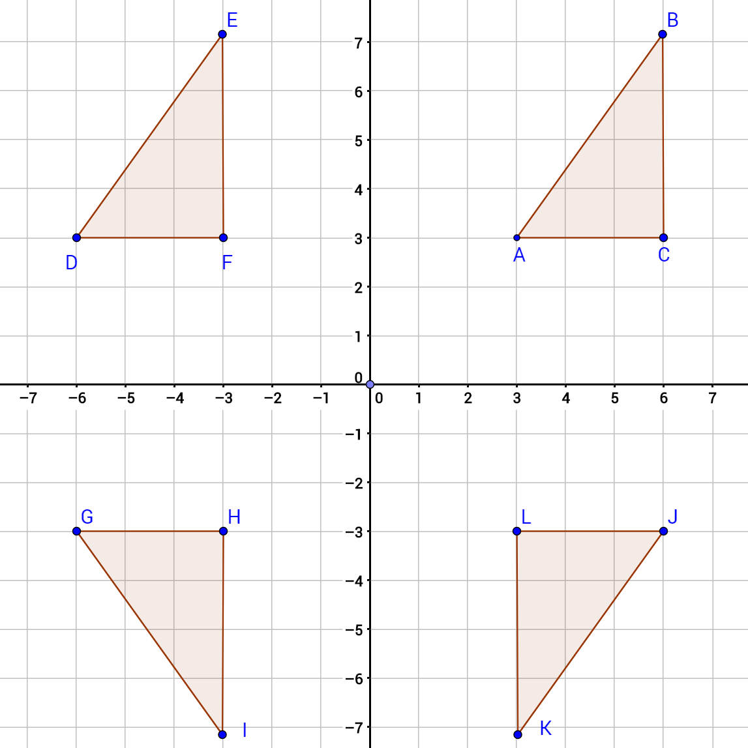

- Using Figure 1, what transformation maps $ΔABC$ onto$ΔDEF$?
- Using Figure 1, what transformation maps $ΔDEF$ onto$ΔGIH$?
- Using Figure 1, what transformation maps $ΔDEF$ onto$ΔJKL$?
- Using Figure 1, what transformation maps $ΔABC$ onto$ΔJKL$?
- Using Figure 1, what combination of transformations maps $ΔABC$ onto$ΔGIH$?
- Using Figure 1, construct $ΔSTU$ as a reflection of $ΔABC$ across the x-axis. What are the coordinates of S, T, and U?
- Construct$ΔMNO$ with vertices M (0, 3), N (3, 2), and O (2, 1) to answer the following questions.
- $ΔPQR$is a translation of $ΔMNO$ with P located at (−1, 0). What are the coordinates of Q and R?
- $ΔVWX$is a 90-degree clockwise rotation of $ΔMNO$ about the origin. What are the coordinates of W?
- $ΔMYZ$ is a dilation of $ΔMNO$ by a factor of 2. (Notice that both triangles contain the same point M, which is the center of the dilation.) What are the coordinates of Y?

Journal/Writing Prompts
- Complete a journal entry summarizing the activity.
- Describe practical examples of translations, reflections, rotations, and dilations.
- In your own words, describe each of the transformations studied. Include descriptions that would help explain them to a student who was absent for the lesson.

Other Assessments
- Have each group present their findings to the class.
- Have students use a figure to demonstrate each of the four types of transformation.

Extensions and Connections (for all students)
- Have students create a design, such as a tessellation or quilt design, and describe the transformations used in their design.
- Have students explore tools used for drawing enlargements.
- Have students practice transformations (especially translations) using graphs of circles in the coordinate plane.
- Show students graphs of quadratic equations such as y = x², y = −x², y = x² + 1,
y = x² − 2, and y = (x − 1)², and ask what transformations map the graph of y = x² onto each of the other graphs.
- Have students take pictures or find images that illustrate transformations on the internet. Have students describe the transformations in their illustrations and explain how they determined the transformation being illustrated.

Strategies for Differentiation
- Cut out the Transformation Cards activity sheet in advance.
- Introduce the vocabulary before students start the activity. The Virginia Department of Education Office of Science, Technology, Engineering, and Mathematics Vocabulary Word Wall Cards for Geometry can provide visual connections for students.
- It may be necessary to work through a couple of examples with the class before they complete the activity.
- Have students draw and cut out a figure. Use that figure to demonstrate the types of transformations (except dilations.) Then have them draw and label an example of each type of transformation of their figure.
- Use patty paper to explore different types of transformations.
- Use mirrors or image reflectors to explore reflections.
- Use physical objects to concretely demonstrate various transformations. Magnets on the back of shapes on the board work well.
- Use pegboards.
- Use dynamic software.

Note: The following pages are intended for classroom use for students as a visual aid to learning.

Virginia Department of Education © 2018

Transformation Cards
Print on card stock and cut out on the dotted lines.
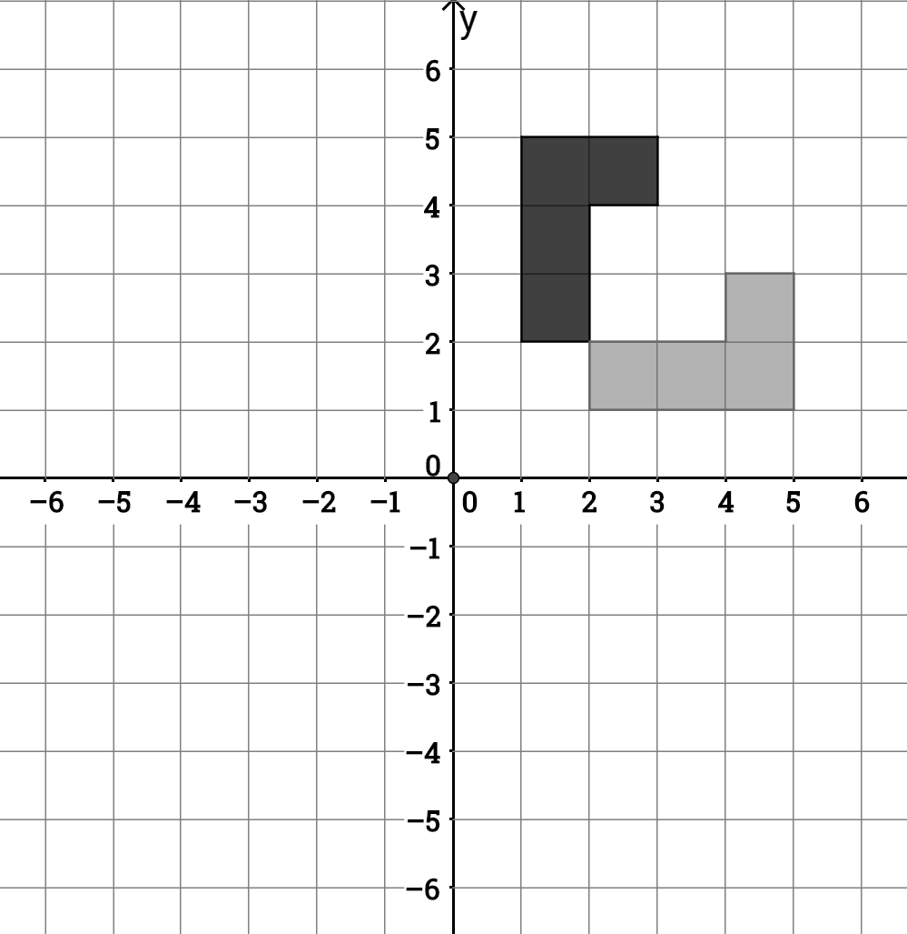 | Rotation of 90 degrees counterclockwise about the point (1, 2)
Reflection of  across the line x = 0 | 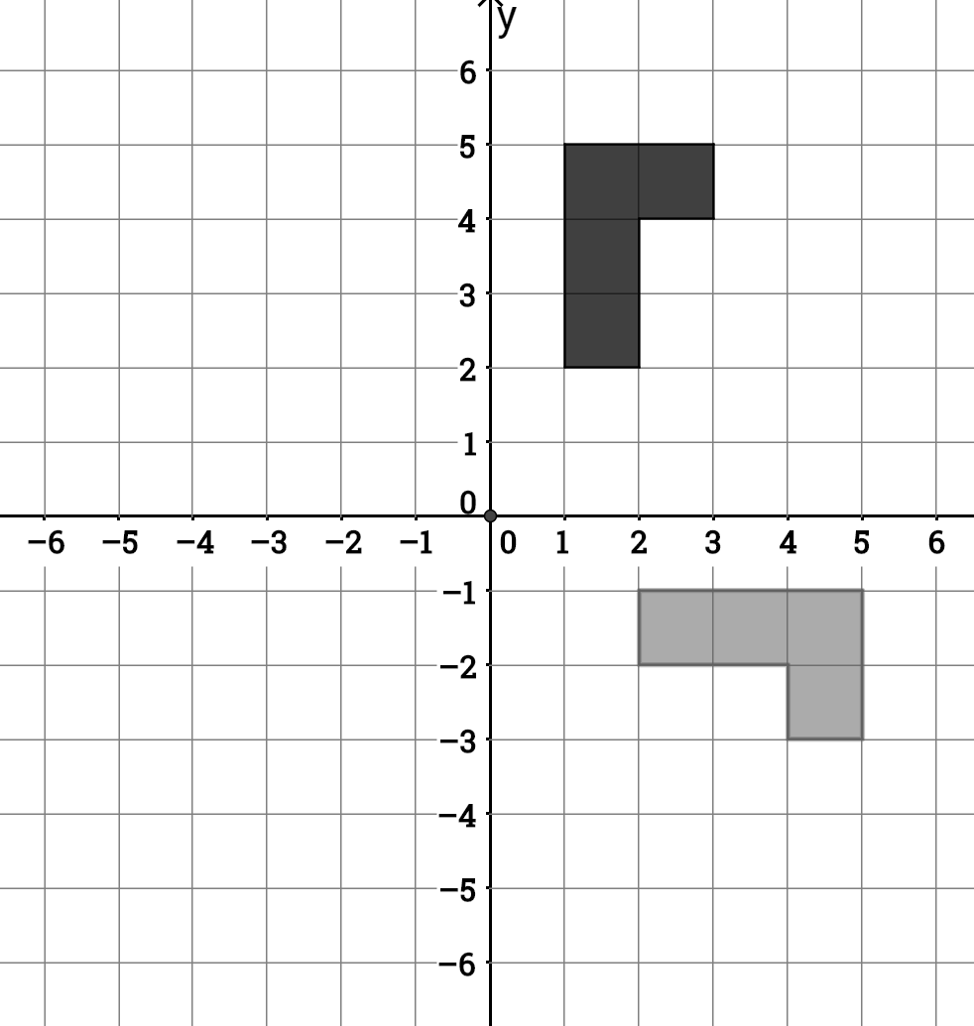
Rotation of 90 degrees clockwise about the origin | 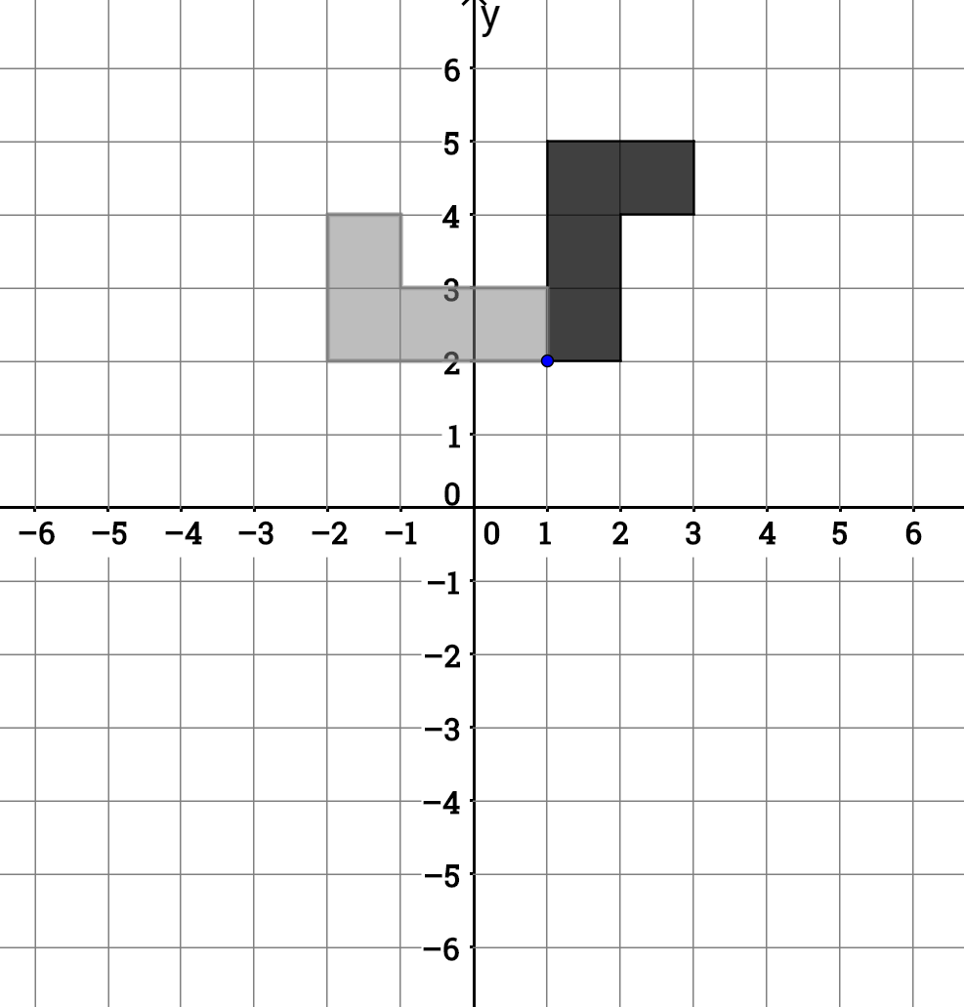
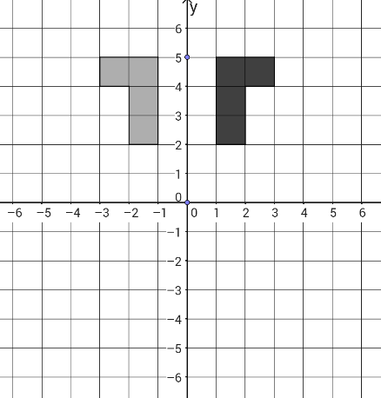 | Reflection of  across the line y = x
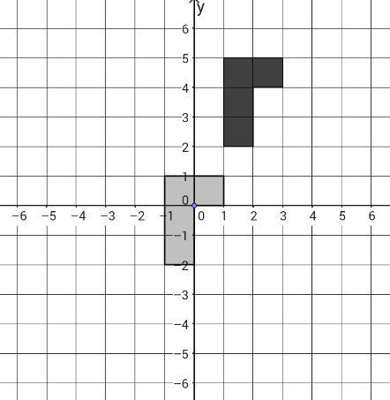 | Reflection of  across the line x = −1
Reflection of  across the line y = −x | 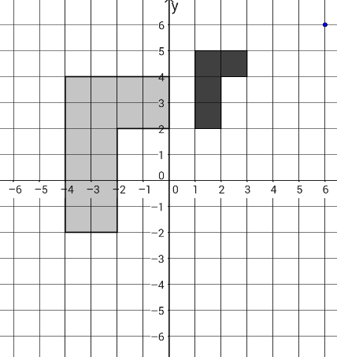
Reflection of  across the x-axis | 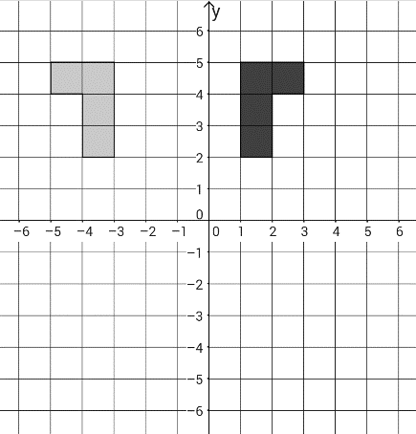
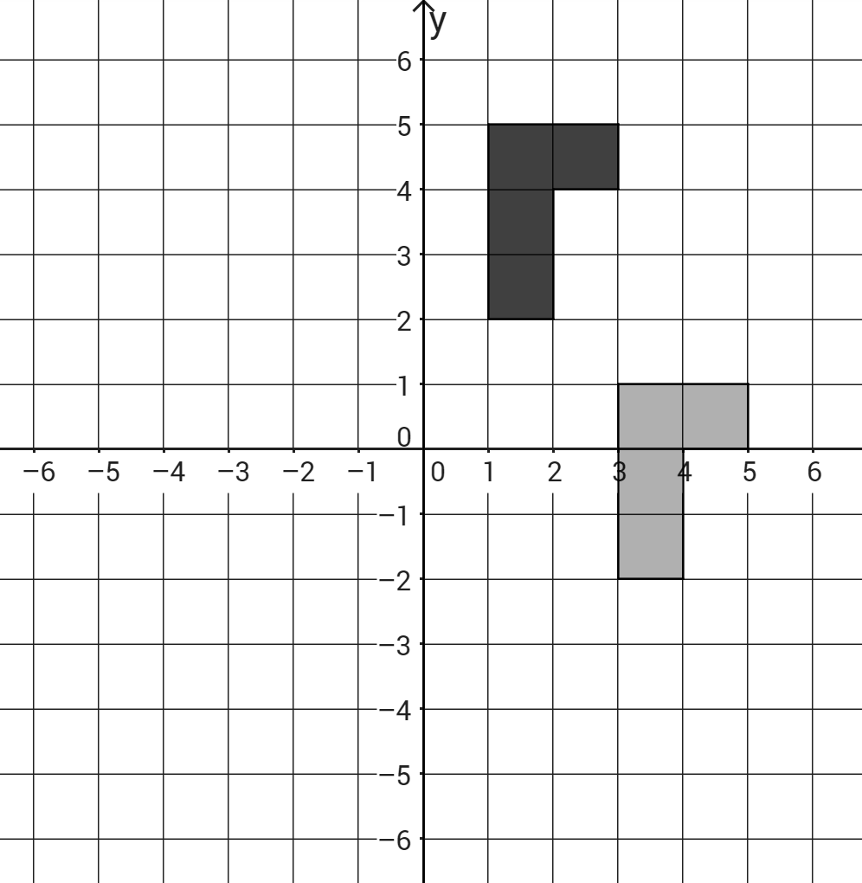 | Translation of  6 units down
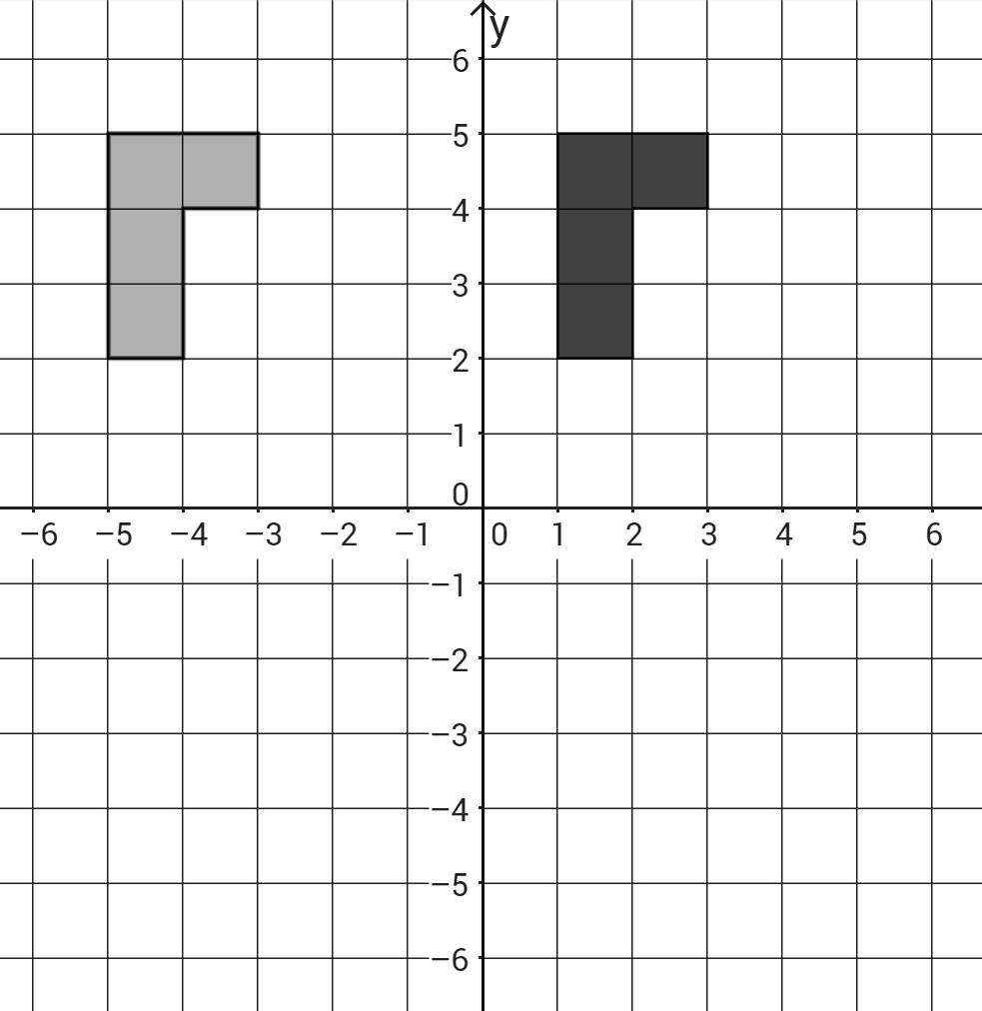 | Translation of  4 units down and  2 units to the left
Dilation of  by a factor of 2 | 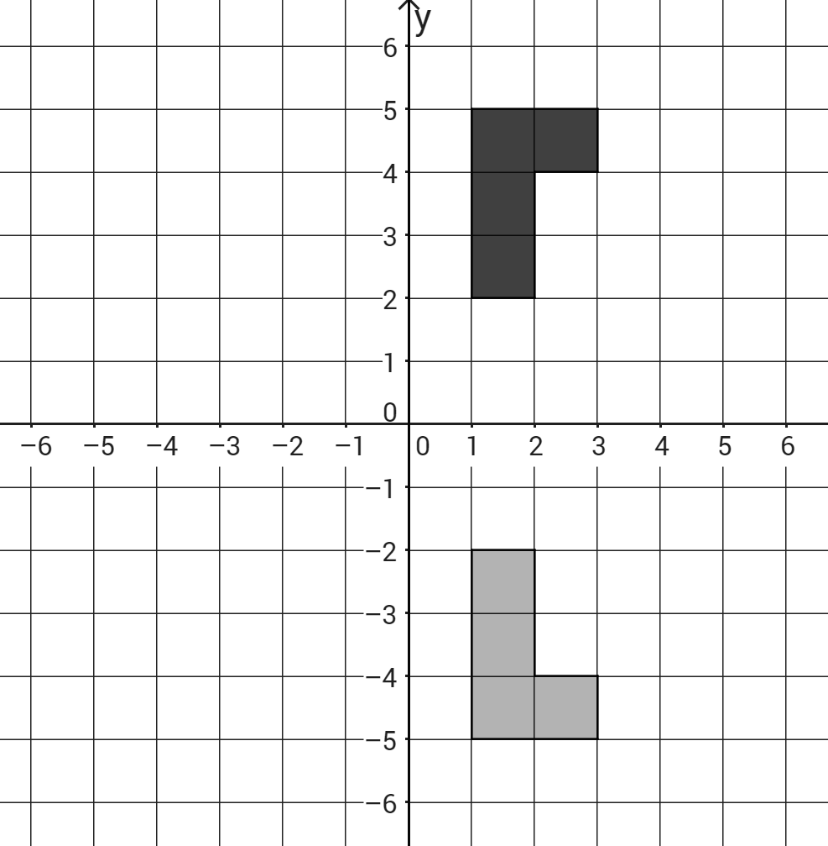
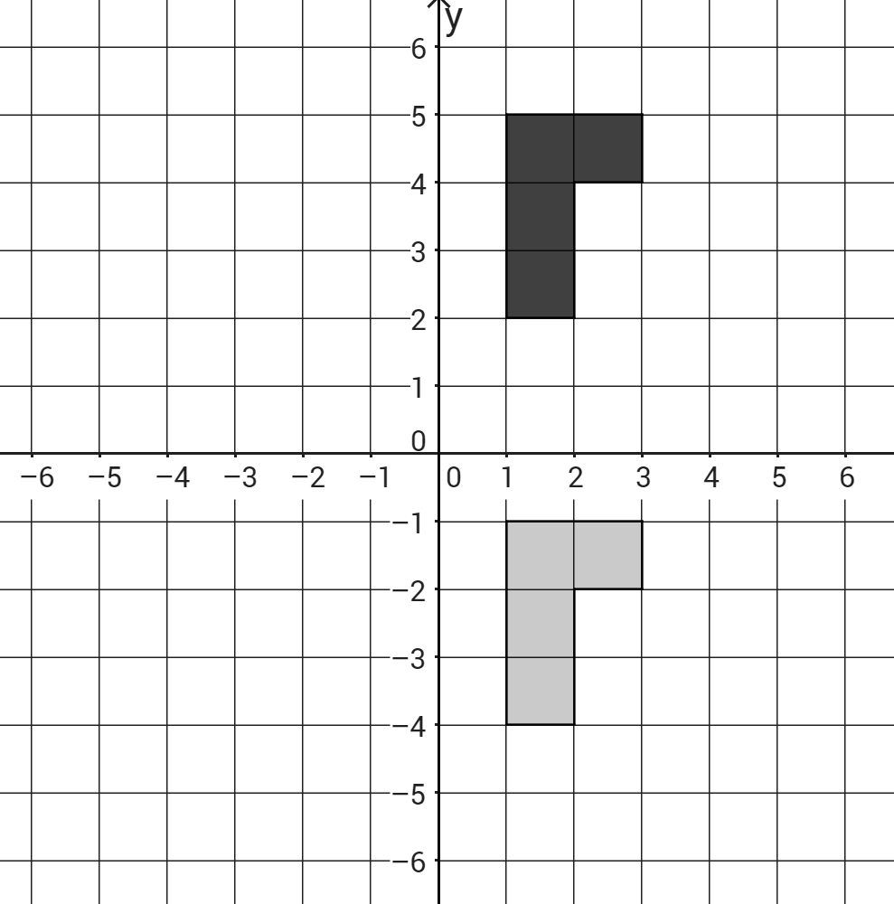 | Translation of  6 units to the left
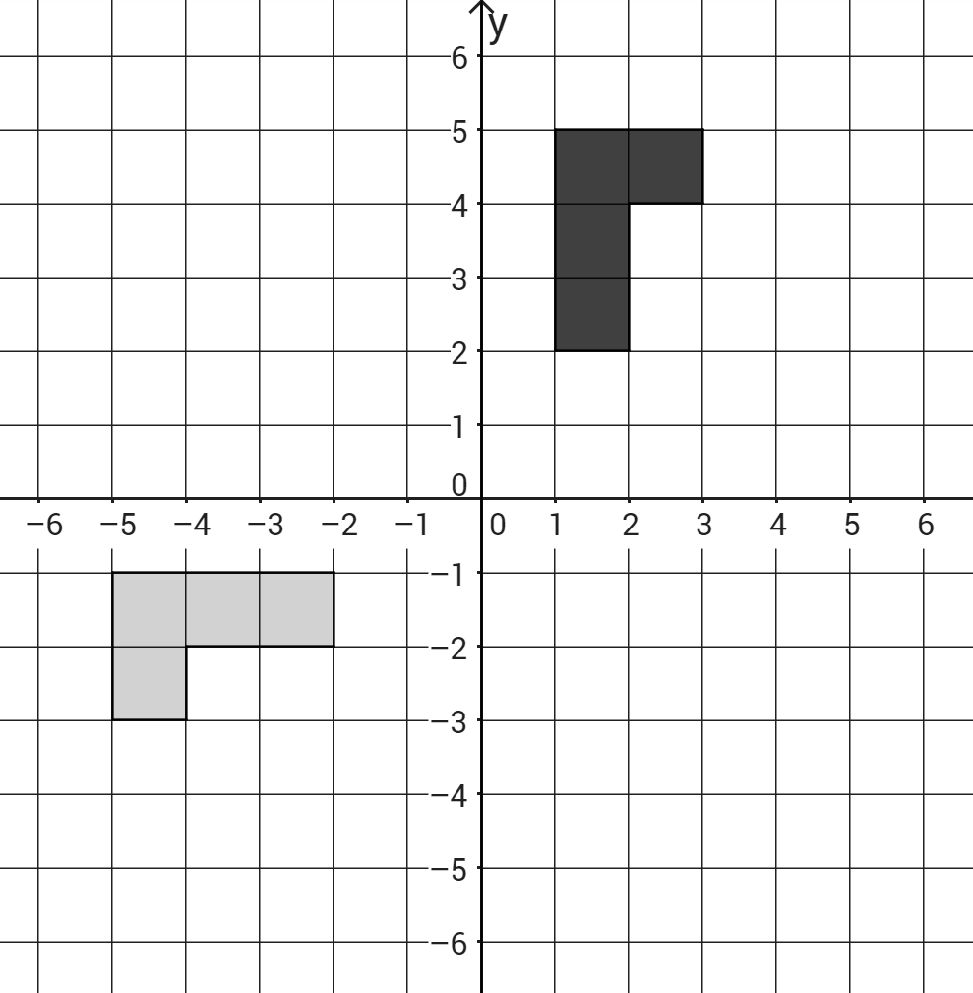 | Dilation of  by a factor of $\frac{1}{2}$
Translation of  4 units down and  2 units to the right | 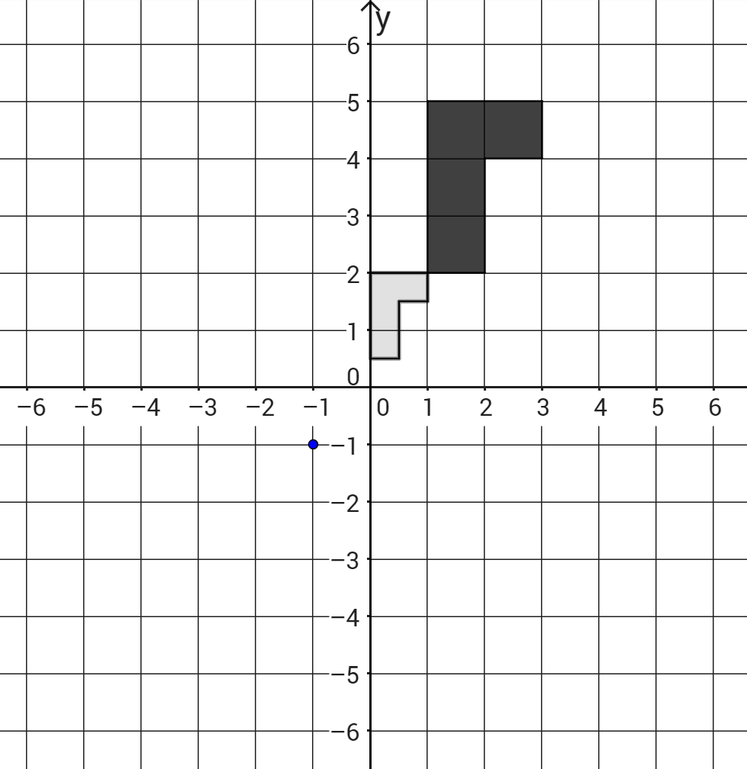
Reflection of  across the line x = –2,  then a translation  5 units down and  3 units to the right | 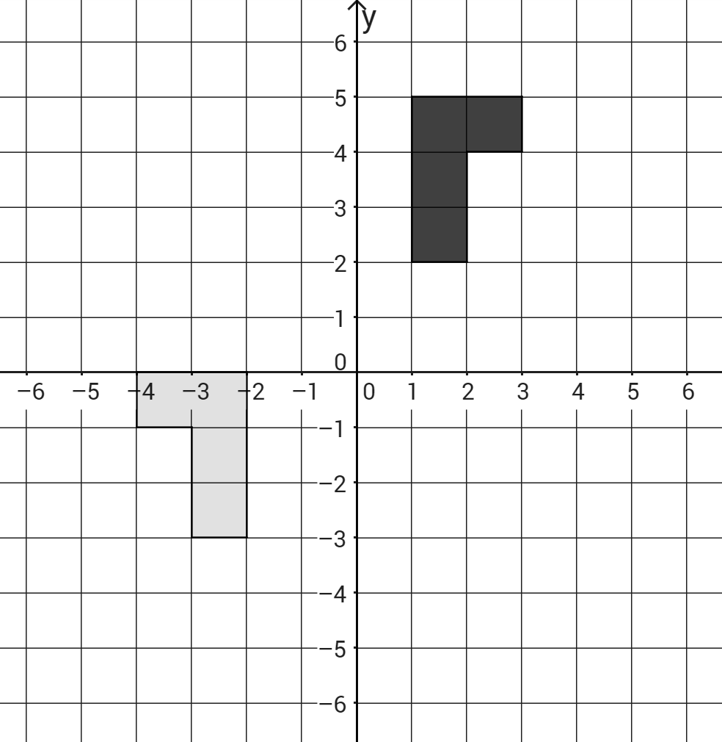
Rotation of  90 degrees clockwise about the origin, then a  translation 1 unit up and  4 units to the left | 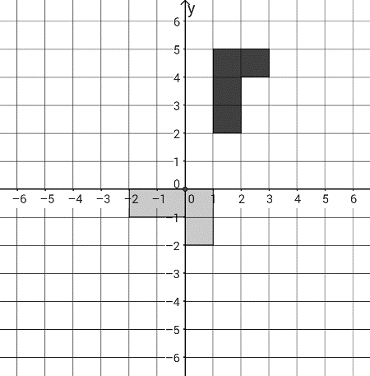

Transformations
Name Date
- Plot the points O (1, –6), P (3, –5), Q (7, –1), and R (5, –2) on a coordinate plane. Draw the quadrilateral. Reflect quadrilateral OPQR across the x-axis, and label the vertices O′P′Q′R′ (identify the ordered pair for each point).

- Plot the points A (1, 1), B (5, 1), C (6, 4), and D (2, 4) on a coordinate plane. Draw the quadrilateral. Translate quadrilateral ABCD six units left and six units down. Label the vertices of the translated image A′, B′, C′, and D′. Rotate A′B′C′D′ 270 degrees counterclockwise about the origin, and label the vertices A”, B”, C” and D” (identify the ordered pair for each point).
- Plot the points E (–5, 1), F (–3, 3), G (–1, 3), H (1, 1) and I (–2, 0) on a coordinate plane. Draw the pentagon. Reflect pentagon EFGHI across the line y = 3. Label the vertices of the reflected image E’, F’, G’, H’, and I’. Rotate E′F′G′H’I’ 90 degrees counterclockwise about the origin, and label the vertices E’’, F’’, G’’, H’’, and I’’ (identify the ordered pair for each point).
- Draw the pentagon ABCDE with vertices A (−3, 3), B (0, 6), C (6, 3), D (6, −3), and E (0, −6) on coordinate graph paper.
- Multiply the coordinates of the vertices by each of the following numbers: $\frac{1}{3}, \frac{2}{3}, \frac{4}{3}, \frac{5}{3}, 2$and complete the table below.
Dilation Factor | A (−3, 3) | B (0, 6) | C (6, 3) | D (6, −3) | E (0, −6)
$$\frac{1}{3}$$ | (−1, 1)
$$\frac{2}{3}$$
$$\frac{3}{3} =1$$ | (−3, 3) | (0, 6) | (6, 3) | (6, −3) | (0, −6)
$$\frac{4}{3}$$
$$\frac{5}{3}$$
$\frac{6}{3} =2$
- Graph each of the five dilations of the pentagon ABCDE on the same graph with ABCDE.
- What do you notice about the ordered pairs (look at the columns) and the six pentagons? Describe what you noticed about the pentagons.

