*Mathematics Instructional Plan – Geometry*

# Parallel Lines and Angle Relationships

**Strand:** Reasoning, Lines, and Transformations

**Topic:** Investigate the angles formed when parallel lines are intersected by a transversal.

**Primary SOL:** G.2 The student will use the relationships between angles formed by two lines intersected by a transversal to

1. prove two or more lines are parallel; and
2. solve problems, including practical problems, involving angles formed when parallel lines are intersected by a transversal.

**Related SOL:** G.1c, G.3a, G.3b

## Materials

* Lines and Angles: Part 1 activity sheet (attached)
* Lines and Angles: Part 2 activity sheet (attached)
* Lines and Angles: Part 3 activity sheet (attached)
* Dynamic geometry software package (computer-based or handheld) or protractors and patty paper

## Vocabulary

*adjacent angles, alternate exterior angles, alternate interior angles, angle, complementary angles, conjecture, corresponding angles, linear pair, parallel lines, same-side (consecutive) interior angles, same side (consecutive) exterior angles, supplementary angles, transversal, vertical angles*

## Student/Teacher Actions: What should students be doing? What should teachers be doing?

1. 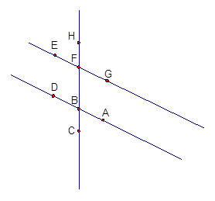Distribute the Lines and Angles activity sheets (Parts 1 and 2), and have students use a dynamic geometry software package to complete them. If software is not available, have students use protractors or patty paper to measure the angles on the worksheet. (If neither measuring tools nor software is available, activities could be easily modified by giving students the angle measures.)
2. Remind students about the vocabulary terms they have seen before, and introduce the new vocabulary.
3. Show students that different angle pairs resemble different letters of the alphabet when traced.

(X—vertical angles, T—linear pair, F—corresponding angles, Z or N—alternate interior angles, C or U—same side (consecutive) interior angles, two Vs or Ls on *opposite* sides of the transversal—alternate exterior angles, Vs or Ls on the *same* side of the transversal same side (consecutive)—exterior angles.

1. Distribute the Lines and Angles: Part 3 activity sheet, and have students complete it.

Figure 1

1. Discuss students’ findings and conjectures with the class.

## Assessment

### Questions

* + - Using figure 1: You are told that ∠*EFH* ≅ ∠*DBF*. What conclusion can you make? Why?
    - Using figure 1: If you are told that ∠*EFB* ≅ ∠*HFG*, what conclusion can you make? Why?
    - Using figure 1: If you are told that ∠*CBD* + *m*∠*DBF* = 180, what conclusion can you make? Why?
    - Using figure: If you are told that *m*∠*GFB* + *m*∠*ABF* = 180, what conclusion can you make? Why?
    - Using figure 1: If you are told that *m*∠*DBF* = *m*∠*GFB* = 70, what conclusion can you make? Why?
    - Using figure 1: If you are told *m*∠*DBC* + *m*∠*EFH* = 180, what conclusion can you make? Why?
    - Using Figure 2: The sides of the quadrilateral *ABCD* are parallel. How do you know this? Explain.

Figure 2

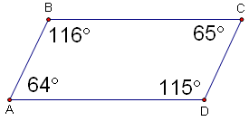

* + - Using figure 3: Given ∠1 ≅ ∠3, can you determine that any segments are parallel? If so, which ones, and why? What if ∠6 ≅ ∠3?

Figure 3

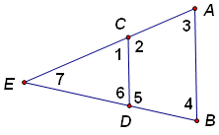

* + - Stairs diagram with angles 1 and 2Using figure 4: One way to build stairs is to attach triangular blocks to an angled support, as shown on the right. If the support makes a 32-degree angle with the floor (*m*∠2), what must *m*∠1 be so the step will be parallel to the floor? The sides of the angled support are parallel.

Figure 4

* + - Using figure 5: Find the measure of ∠x.

41°

x°

35°

Figure 5

### Journal/writing prompts

* + - Summarize the conclusions you have made about parallel lines and special pairs of angles.
    - Name four conditions that involve angles and are sufficient to prove that two lines are parallel.
    - The white lines along the long edges of a football field are called sidelines. Yard lines are perpendicular to the sidelines and cross the field every five yards. Explain why you can conclude that the yard lines are parallel.
* When you hang wallpaper, you use a tool called a plumb line to make sure one edge of the first strip of wallpaper is vertical. If the edges of each strip of wallpaper are parallel and there are no gaps between the strips, how do you know that the rest of the strips of wallpaper will be parallel to the first?

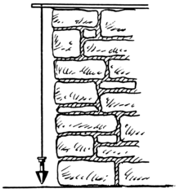

Wiktionary.org

### Other Assessments

* + - Have groups of four students construct a short quiz covering the information presented in the class on a given day, and administer it to another group in the class.

## Extensions and Connections (for all students)

* Have students complete diagrams, using parallel lines and special angles. For example, the students could design a city with parallel streets that are intersected by a transversal street. Give directions such as*, “Place a restaurant and bank at corresponding angles.”*
* Arrange for students to visit a construction site to see how plumb lines are used to make vertical lines from which parallel lines can be drawn and to see how angles are used in construction.
* Invite an architect, carpenter, or builder to visit the classroom to discuss the importance of geometry (specifically lines and angles in this case) in the construction industry.
* Have students research the importance of lines and angles in the fields of architecture and construction. They can create a presentation for the class.
* Have students draw a diagram showing the path of light in a periscope. 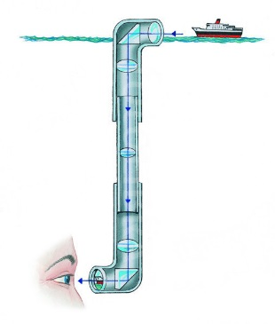

www.fotolibra.com

* Discuss practical applications of parallel lines. Examples might include: the construction of stairs, use of a plumb line, how a periscope works, agriculture and planning for crops, orchards, orange groves, city planning for housing developments and roads, etc.

## Strategies for Differentiation

* Allow students to use a calculator (e.g., talking calculator, large number calculator).
* Vocabulary words can be illustrated and audio added into presentation software. This can then be converted to video and played on an mp3 player.
* Provide students with index cards and have them write the definition of each word in a specific color of ink or pencil. Have them draw an illustration of the word in another color of ink or pencil. Trace the pair of angles in a color. They can use these cards to study at home or with another student.
* Using a dynamic geometry software package, have students color-code lines and angles to differentiate between them. If not using software, have students highlight the parallel lines
* Have students use two colors of yarn or string to lay out parallel lines and transversals. On worksheets, they can highlight the parallel lines in one color and the transversal in another.
* Have students use straws or long pieces of licorice to visualize parallel lines and transversals before using the software.
* Use patty paper to verify congruent angles.
* In a think-pair-share activity, have students pair up: One student draws lines with transversals, and the other tries to determine whether the lines are parallel.
* In a think-pair-share activity, have students pair up and find examples of parallel lines, different angles, etc., in the classroom. Then have them share their findings with the rest of the class.
* Ask students to go out into the community and find examples of parallel lines and angles (both complementary and supplementary). They can either draw them or take photographs of them to share with the class.
* Have students paste vocabulary words with illustrations onto 8.5” x 11” sheets of paper in their notebooks.
* Use painters’ or masking tape on the floor to create a set of parallel lines and a transversal. Call out an angle relationship (corresponding, alternate interior, etc.) and have the students place their feet in the correct positions. Once they catch on, add music to help with fluency. Put them in partners and have the partner verify the position of the feet. Then they switch places.

**Note: The following pages are intended for classroom use for students as a visual aid to learning.**

Virginia Department of Education © 2018

**Lines and Angles: Part 1**

**Name** _____________________________ **Date**

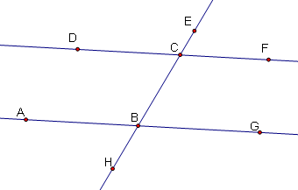We are going to explore pairs of angles. Start a new sketch in a dynamic geometry software package, following the steps below.

1. Draw a line containing two points. Name the points *A* and *B*.
2. Draw a point not on that line. Label it *C*.
3. Construct a line through *C* parallel to $\overset{⃡}{AB}$.
4. Construct $\overset{⃡}{BC}$.
5. Draw and label points *D, E, F, G*, and *H*, as shown on the diagram at the right.
6. Measure the angles listed below:

 _________ _________

 _________ _________

 _________  _________

 _________  _________

1. List the pairs of angles whose measures add up to 180 degrees.
2. List the pairs of angles that are congruent.
3. Is there any relationship between the measures of, , , and the measures of angles , , , and ?
4. Save your file as “Activity.1”.

**Lines and Angles: Part 2**

**Name** _______________________________ **Date**

Start a new sketch in a dynamic geometry software package, following these steps:

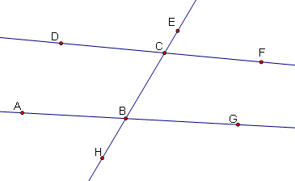

1. Draw a line containing two points. Name them *A* and *B*.
2. Draw two points not on the line $\overset{⃡}{AB}$. Label them *C* and *D*. (Both points should be on the same side of $\overset{⃡}{AB}$.
3. Construct the line $\overset{⃡}{CD}$.
4. Construct $\overset{⃡}{BC}$.
5. Draw and label points *D, E, F, G*, and *H*, as shown on the diagram at the right.
6. Measure the angles listed below:

 _________ _________

 _________ _________

 _________  _________

 _________  _________

1. List the pairs of angles whose measures add up to 180 degrees.
2. List the pairs of angles that are congruent.
3. Is there any relationship between the measures of , , , and the measures of angles , , , ?
4. What is the difference between the angles and lines in Activity Sheet 1 and this activity sheet?
5. Save your file as “Activity.2”.

**Lines and Angles: Part 3**

**Name** _____________________________ **Date**

Use the diagram you formed in Activity 1 to complete the following:

1. Name all pairs of vertical angles.
2. Name all linear pairs.
3. Name all pairs of corresponding angles.
4. Name all pairs of alternate interior angles.
5. Name all pairs of alternate exterior angles.
6. Name all pairs of same-side (consecutive) interior angles.
7. Name all the pairs of same-side (consecutive) exterior angles.
8. Which pairs of angles are congruent, and which are supplementary in questions 1–7 above? Are the same pairs of angles congruent or supplementary in Activity 2?
9. Make conjectures (predictions) about when angle pairs will be congruent or supplementary.
10. Rewrite each conjecture in “If …, then” form. For example, “If two parallel lines are cut by a transversal, then corresponding angles are congruent.” “If the measures of two angles add up to 90 degrees, then those angles are complementary.” “If two angles are vertical, then they are …”