# What is the Normal Curve?

**Strand:**  Data Analysis

**Topic:**  Properties of the normal curve

**Primary SOL:** AFDA.7 The student will

1. identify and describe properties of a normal curve.

## Materials

* What is a Normal Curve? activity sheet (attached)
* What is Standard Deviation? activity sheet (attached)
* Pennies or random-coin-toss generator (<https://goo.gl/XCfddJ>)
* Computer with internet access
* Spreadsheet software
* Graphing utility

## Vocabulary

*central tendency, dispersion, mean, normal curve, probability, standard deviation*

## Student/Teacher Actions: What should students be doing? What should teachers be doing?

*Time: 90 minutes*

1. Using a document camera or other projection device, flip one penny and ask students to notice whether the result was heads or tails. Ask, *“When I flip the coin, what are the possible outcomes?”* Flip three coins and ask the students about the possible outcomes. Then pose the following question, *“How many possible outcomes are there if we toss 10 coins?”*
2. Ask, *“What if we don’t want to know the possible number of total outcomes, but we’d like to know how many heads we’d get? Is it possible that we would get no heads at all? How many ways could that happen?”* Students should reply that there would only be one way to get zero heads, and that is if all of the coins came up tails. Ask, *“How many ways could we get all heads?”* Again, students should respond “one.”
3. Distribute the What is the Normal Curve? activity sheet and have students record their responses.
4. Discuss how many ways we could get just one head. It may be helpful to lay out the 10 pennies with tails up and then show them that, because there are 10 pennies, there are 10 ways we could get one head. Ask, *“What other case would this apply to?”* The students should reply with nine heads since there would be 10 ways to get one tail. Have the students calculate  so that they can see that the combination gives the same value.
5. Have the students complete the table in the What is the Normal Curve? activity by calculating the combinations.
6. Introduce the students to the experiment of tossing the coins 1,024 times. Emphasize that this would be tough to do by hand but that we could easily do this with a computer program or simulation (i.e., <https://goo.gl/XCfddJ>). We can calculate the theoretical probability much more easily, though. Have students calculate the theoretical probabilities and the percent to complete the table.
7. Once the students have completed the table, they should calculate the sum of the theoretical probabilities and notice that they add up to one, pointing to the idea that the area under the curve is 1; this is one of the characteristics of the normal curve.
8. Have the students graph the theoretical probabilities on the given graph while you graph them for demonstration. Show your graph on large chart paper or using a document camera or similar projection device. Connect the points and have the students discuss the properties of the curve in pairs or small groups. Have the students use the properties to identify the normal curves and research normal data.
9. Distribute copies of the What is Standard Deviation? activity sheet. Have students open the [probability simulator](https://goo.gl/uP2wP4), or open it on a computer projection device. Have the students select all of the balls and click the play button. Students should observe that most of the balls fall toward the center. Point out to the students that this is similar to our coin-flipping experiment because the binary probability is 0.5. Note the mean and standard deviation of the simulation. You can click the ideal button to show the students the ideal normal curve. Students should also note that all of the balls drop within four standard deviations of the mean.
10. Have students clear their screen using the eraser at the bottom left, set the program to five rows and click the play button. Stop the simulation after at least 200 balls have dropped. Students should record the number of balls dropped, the number of balls in the center of the curve and the corresponding standard deviation.
11. Have students clear the screen again, set the number of rows to 20, and begin dropping balls. Have students attempt to drop the same number of balls dropped previously. The easiest way to do this is to stop the simulation as you get close to the desired number and change the simulation to dropping a single ball. Drop a single ball until you have the same number of balls as was dropped before.

Record the number of balls dropped, the number of balls in the center of the curve and the corresponding standard deviation. Students should notice that the larger the standard deviation, the fewer balls fall into the center and the shorter the curve. Have the students summarize by asking, *“What happens to the curve as the standard deviation goes up?”*

These explorations can also be done by hand with a number line and a fixed number of pennies. Give the students a specific number of pennies and ask them to create a curve with a given mean and standard deviation. Have them sketch a picture of this curve on their paper. Next, have them create a new curve with the same number of pennies, the same mean, but a different, smaller standard deviation. The students should notice that the curve must get taller to accommodate the pennies and still be within the standard deviations.

1. Have students complete the information about the mean and the standard deviation and work in pairs or small groups to complete the practice problems.

## Assessment

### Questions

* + What happens to the graph of a normal curve if we increase the standard deviation?
  + What happens to the graph of a normal curve if we decrease the mean?

### Journal/writing prompts

* + The average score on the SAT has stayed pretty much the same over the years but the standard deviation has gone down. What does this say about the scores on the test? Explain your answer.
  + Domino’s sugar sells 5 lb. bags of sugar. The bags come from the packaging plant having an average weight of 5.2 lbs. with a standard deviation of 0.05 lbs. The grocery store sells its own brand of 5 lb. bags of sugar, and the average weight of their bags is 5.15 lbs. with a standard deviation of 0.1. Compare the amount of sugar you are getting for your money from each brand.

### Other Assessments

* + Have students match normal curves with their mean and standard deviations

## Extensions and Connections

* Use sports data from the internet to give the students the opportunity to look at a practical use of normal curves.
* Look at the breakdown of data by standard deviation as an introduction to the empirical rule.

## Strategies for Differentiation

* Use vocabulary cards for related vocabulary listed above.
* Create a word wall for the statistics unit with a visual example of each term.
* Have students gather data about the heights of their peers and create a large histogram on the board or classroom floor. Discuss whether the curve is a normal curve.
* Have students create a foldable summary of the normal curve and standard deviation information.

**Note: The following pages are intended for classroom use for students as a visual aid to learning.**

## What is a Normal Curve?

|  |  |  |  |
| --- | --- | --- | --- |
| **Number of Heads** | **Expected Frequency** | **Theoretical Probability** | **Percent Likelihood** |
| 0 | 1 |  |  |
| 1 |  |  |  |
| 2 |  |  |  |
| 3 |  |  |  |
| 4 |  |  |  |
| 5 |  |  |  |
| 6 |  |  |  |
| 7 |  |  |  |
| 8 |  |  |  |
| 9 |  |  |  |
| 10 |  |  |  |

1. Complete the Percent Likelihood column by converting the theoretical probabilities to a decimal and then to a percent.
2. What is the sum of all of the probabilities?

1. What observations can you make about the data in the table thus far?
2. On the axis provided, plot the theoretical probability for each number of heads.







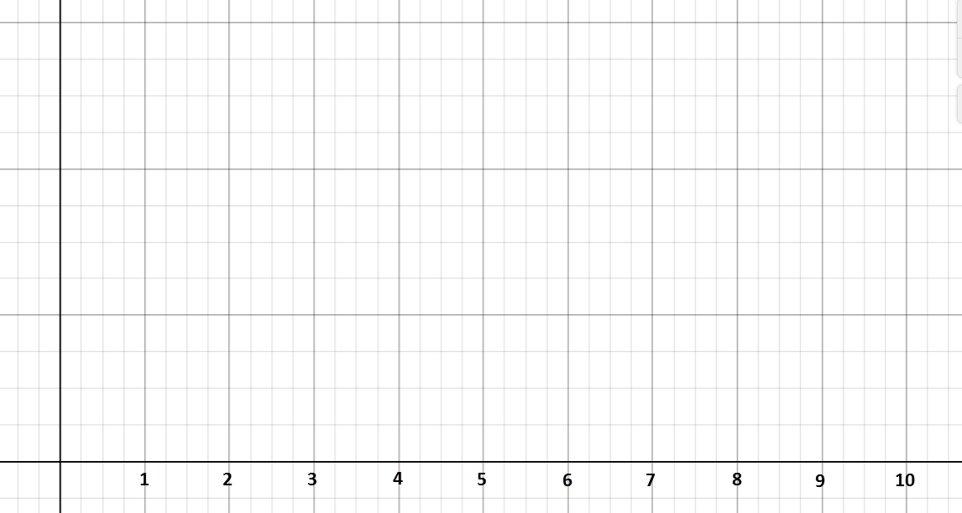

1. Connect the data points with a smooth curve; the result is a normal curve.
2. What do you observe about the graph’s:

* Shape?
* Symmetry?
* Highest point?

1. Find and compare the mean, median, and mode probabilities.

Mean Probability: _________ Median Probability: ________

Mode Probability: _________

________________________________________________________________________________________________________________________________________________________________________________________________________________________

1. Read about the characteristics of a normal curve below and discuss how the curve you drew compares to the characteristics.

**The graph of a normal distribution in a normal curve** and every normal curve has the following characteristics:

* The mean, median, and mode are equal.
* They are bell-shaped and symmetrical about the mean.
* The curve never touches, but it comes closer and closer to the

horizontal axis as it gets farther from the mean.

* The total area under the curve is equal to 1.

1. Which of the following appear to be normal curves?

|  |  |  |  |
| --- | --- | --- | --- |
| a) |  | b) |  |
| c) |  | d) |  |
| e) |  | f) |  |

1. Conduct research in texts and using the internet to find five examples of data that is normally distributed.

_______________________________ ________________________________

_______________________________ ________________________________

_______________________________

1. Conduct research in texts and on the internet to find five examples of data that is *not* normally distributed.

_______________________________ ________________________________

_______________________________ ________________________________

_______________________________

## What is Standard Deviation?

Standard deviation (): the spread of a given set of data

1. Open the [PhET Probability Simulator](https://goo.gl/uP2wP4) and click the link to “Lab.”
2. Click on the multiple-balls button at the upper right. Click the play button, and let the simulator run until at least 500 balls drop.

What do you notice about the shape of the curve at the bottom?

What is the mean  of the data? What is the standard deviation?

Evaluate  Evaluate 

What is the farthest that the curve extends in each direction?

How does this relate to the mean and the standard deviation?

1. Clear the simulation by pressing the eraser in the lower-left corner. Change the number of rows to 5 and drop at least 250 balls.

|  |  |
| --- | --- |
| Sketch your curve, and label the mean and endpoints. | |
|  | Number of balls dropped = ________    Number of balls in center section = _________  Standard deviation = _________ |

1. Clear the simulation again and change the number of rows to 20. Drop the same number of balls as in question step 3 (or as close as you can get).

|  |  |
| --- | --- |
| Sketch your curve, and label the mean and endpoints. | |
|  | Number of balls dropped = ________    Number of balls in center section = _________  Standard deviation = _________ |

What do you notice about the number of balls in the center when the standard deviation is smaller?

When the standard deviation is **large**, the curve is ____________ and ____________.

When the standard deviation is **small**, the curve is ____________ and ____________.

1. Each graph in the figure below is a normal curve. Match the curve (1–4) to the corresponding mean  and standard deviation.

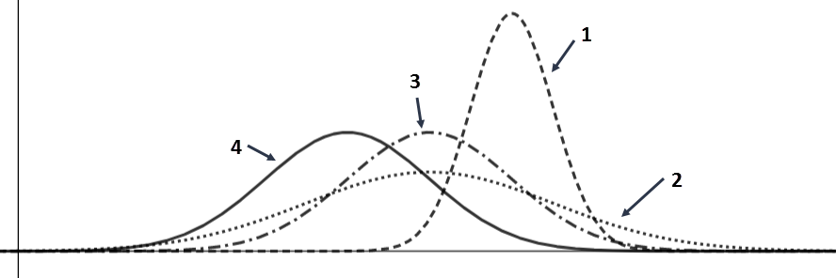

|  |  |  |  |
| --- | --- | --- | --- |
|  | a) Mean = 5; Standard Deviation = 1 | b) | Mean = 4; Standard Deviation = 1 |
|  |  |  |  |
|  | c) Mean = 6; Standard Deviation = 0.5 | d) | Mean = 5; Standard Deviation = 1.5 |
|  |  |  |  |

1. On each of the following axes, draw two normal curves with the given information.

|  |  |
| --- | --- |
| a) Same mean and different standard deviation. | 1. Different mean and same standard deviation. |
|  |  |