Permutations and Combinations
Strand: Probability
Topic: Permutations and combinations
Primary SOL: AFDA.6d The student will calculate probabilities. Key concepts include counting techniques (permutations and combinations).
Related SOL:

Materials
- Fundamental Counting Problem activity sheet (attached)
- Permutations and Combinations activity sheet (attached)
- Index cards
- Poster paper (or other paper for students to display strategies and solutions)
- Demonstration tool (e.g., interactive whiteboard)
- Manipulatives – representations of student desks (e.g., square tiles, two-sided counters)
- Graph paper

Vocabulary
combination, factorial, fundamental counting principle, permutation, probability, probability of dependent events, probability of independent events, probability of mutually exclusive events

Student/Teacher Actions: What should students be doing? What should teachers be doing?
Time: 90 minutes
- Use a two-minute talk with students to activate prior knowledge about combinations and permutations. Group students in pairs or threes. Provide each group with a sheet of blank paper for brainstorming/note-taking. Prompt students to write as much as they know about combinations and permutations. If students complete this task quickly, ask them to add the Fundamental Counting Principle to their notes/brainstorm.
- After two minutes, display a chart to the class using a demonstration tool. Ask students to share information/characteristics about combinations, and add their comments to the chart. Then, follow the same process for permutations. Once the information is recorded on the board, ask, “Based on the data we gathered and presented, what is the primary difference between a combination and a permutation?” Once students have shared, pose this question: “What clues/cues are available to us to indicate whether we use combinations or permutations to find a solution?”
- Now ask students to share what they know about the Fundamental Counting Principle. Support students in recognizing the following ideas:
  - When order matters, such as in a list, students are working with a permutation. Think: finishing order of a race.
  - When order does not matter, such as in a group, and there is no repetition, students are working with a combination.
  - The Fundamental Counting Principle – share the vocabulary word wall cards available on the VDOE website. Post the card on the board or project it using an interactive whiteboard or document camera. Pose the first question in the assessment section of the lesson: “How do you find the total number of outcomes in a sequence of events using the Fundamental Counting Principle?” Ask students to share their responses with a neighbor and record their collaborative response on an index card.
- Distribute copies of the Fundamental Counting Problem activity sheet and one index card to each student.
- Students will share their responses with the class. Facilitate a dialogue or mathematics talk with students to identify the similarities and differences between the Fundamental Counting Principle and tree diagrams.
- Allow students to work in pairs or groups of three to find a solution for the task presented in the Fundamental Counting Problem activity sheet. Students should record the answers on their individual sheets. Once students have developed a problem-solving plan and arrived at a possible solution, give each group a large piece of paper to record their work to present to the class.
- Distribute copies of the Permutations and Combinations activity sheet. Students may want to use the available manipulatives or graph paper to work individually on the assignment. Monitor student progress and identify which students should be paired together for partner checks. Once students have completed their work, allow them to check their work with a partner.

Assessment

Questions
  - How do you find the total number of outcomes in a sequence of events using the Fundamental Counting Principle?
  - How do you find the number of ways that r objects can be selected from n objects using the permutation rule?
  - What is the difference between a combination and permutation? What is the formula for a combination? What is the formula for a permutation?
  - When do we use the Fundamental Counting Principle?
  - How do we find outcomes with the Fundamental Counting Principle, permutations, and combinations?

Journal/writing prompts
  - Write down as many words that you can make from the letters in permutation. Explain how the results are a permutation.
  - What is the relationship between factorials and permutations?

Other Assessments
  - Have students present a task involving a permutation. Allow students to research the concept using approved internet sources. The student should present their task to the class and explain how the scenario meets the criteria for a permutation.
  - Why is it called a combination lock when it is actually a permutation?

Extensions and Connections
- Allow students to create task scenarios for permutations. Pair students to review their tasks and provide feedback to each other’s work. Each student needs to find the solution for their partner’s task.
- Identify the similarities and differences between permutations and combinations using a graphic organizer. Then, explore the relationship of permutations and combinations with the fundamental counting principle.

Strategies for Differentiation
- Use vocabulary cards for related vocabulary listed above.
- For the Fundamental Counting Problem activity, decrease the numbers of options so that students can realistically create a tree diagram to prove that the Fundamental Counting Principle works.
- For the Permutations and Combinations activity, provide students with manipulatives (e.g., square tiles, unit pieces from algebra tiles, plane figure template) and graph paper to create a model of the desk arrangements.

Note: The following pages are intended for classroom use for students as a visual aid to learning.

Fundamental Counting Problem
Scenario
Adam, Carter, Evan, and Ryan decided they wanted burgers and french fries for dinner after baseball practice. They go to a popular burger restaurant which claims you can order a burger in more than a half-million different ways. Evan and Ryan argue that it is not possible. Adam and Carter challenge them to prove it. There are four options for a basic burger (single patty, single patty with cheese, double patty, double patty with cheese). Then, you can get the burger with or without a bun. Condiment selections include ketchup, mustard, mayo, steak sauce, barbecue sauce, and hot sauce. There are 10 toppings that include bacon, lettuce, tomato, and relish. Conduct research on the Five Guys website to confirm all the possible options, condiments, and toppings.

How can you prove or disprove the claim?

Use representations to show your thinking and solution plan.

Explain how the Fundamental Counting Principle facilitates finding a quick solution for the task.

Permutations and Combinations
A combination is the number of possible ways to select or arrange objects when there is no repetition and order does not matter.
Scenario
Mr. Vander has 24 students in his AFDA class. He decided that students need to sit in small groups during the next week for a project. How many different ways can he group the desks so that students are sitting in groups with at least two desks?

Mr. Vander decides to put Amber, Brittany, Chase, Destiny, and Eduardo in the front row of his classroom. He has five desks in the front row but is undecided about which student should go in which desk.
1. How many different students could he place in the right-most desk?

2. After selecting a student for the right-most desk, how many different students could he place in the next desk?

3. After selecting a student for the first two desks, how many different students could he place in the next desk?

4. After selecting a student for the first three desks, how many different students could he place in the next desk?

5. After selecting a student for the right four desks, how many different students could he place in the left-most desk?

6. Using the Fundamental Counting Principle, write an expression that would find the number of different ways Mr. Vander could choose to arrange these five students.

7. How many different ways can he arrange the students?

8. If Mr. Vander had six desks in the front row and wanted to put Felicia in the front row too, write an expression that would find the number of different arrangements that are now possible.

9. How many different arrangements are now possible?

The process of multiplying every counting number from 1 to n can be abbreviated as n!, which is spoken as “n factorial.” Therefore,
and .

10. Write 2! as a multiplication problem, then find the value of 2!.

11. Write 7! as a multiplication problem, then find the value of 7!.

Because 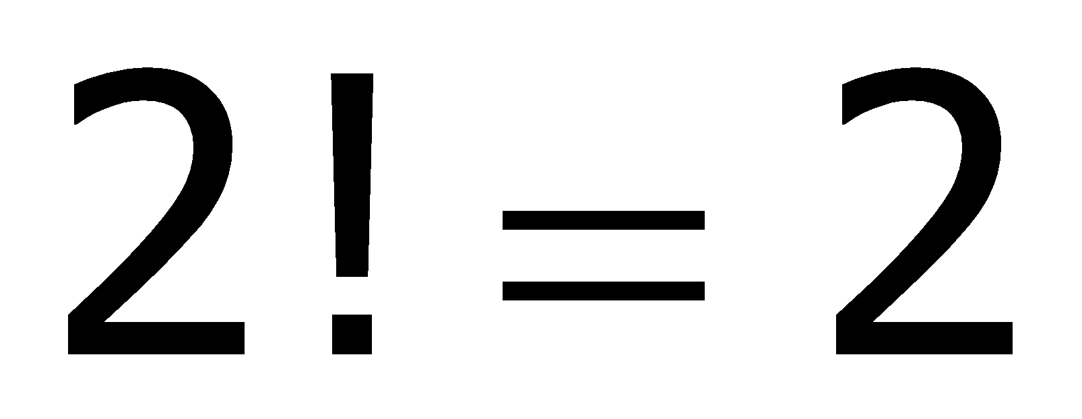 and 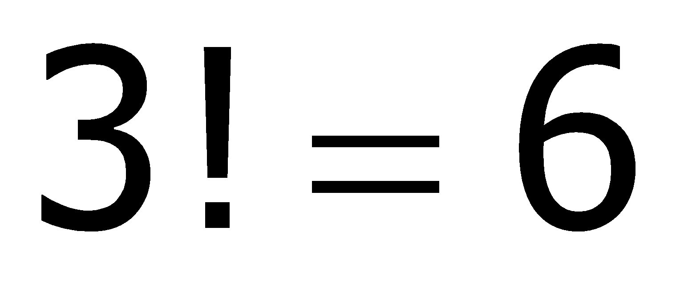, then
Because and , then
Because and , then

12. Because _________ and _________, ____________ = __________

13. Because and , ____________

14. Mr. Vander has 25 students and 25 desks in his class. Using factorials, how many different ways could he create a seating chart?

15. Mr. Vander has 12 poster-size pictures of his cat that he wants to line up on the wall above his chalkboard. Using factorials, how many different ways could he hang them on the wall?

16. Mr. Vander discovered that his cat posters are too big to fit all 12 on the wall. Instead, he will only be able to hang four of his posters.
a) How many different posters can he select for the first position on the wall?

b) After selecting the first poster, how many different posters can he select for the second position?
c) After selecting the first two posters, how many different posters can he select for the third position?

d) After selecting the first three posters, how many different posters can he select for the fourth and final position?

e) Using the Fundamental Counting Principle, write an expression for the number of ways Mr. Vander can hang four cat posters.

f) How many different ways can Mr. Vander hang four of these posters?

17. For the back wall, Mr. Vander has room for three of his seven poster-size pictures of his goldfish. How many different ways can Mr. Vander hang three of these posters?

18. How many goldfish posters did Mr. Vander not use?

19. How many ways can seven posters be arranged?

20. How many ways can the posters that were not used be arranged?

21. What do you find if you divide your answer from question 19 by your answer from question 20?

22. Using this idea, what would be another way to calculate 16f (Mr. Vander’s cat posters)?

Permutations are used to calculate the number of possible arrangements of n objects taken r at a time. For example, 12 posters are taken 4 at a time or 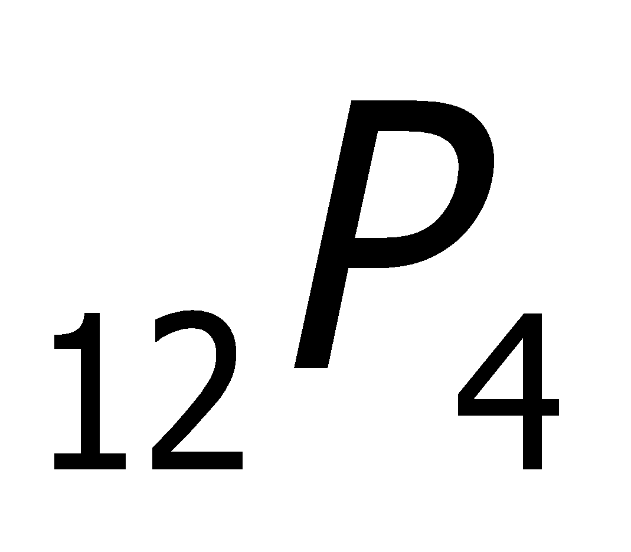.

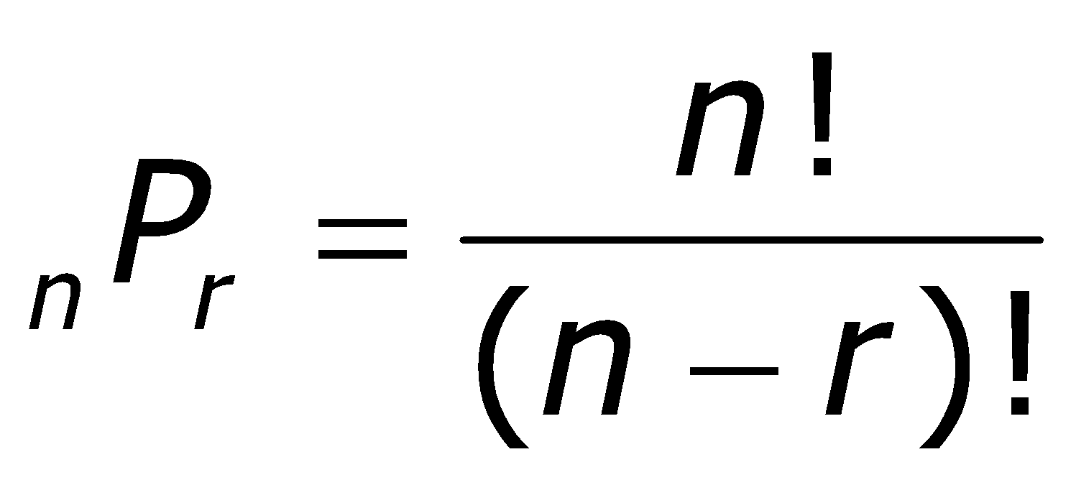
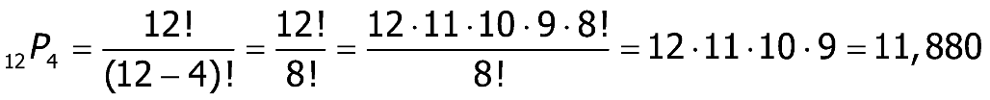
For example,

23. Mr. Vander has five desks in the front row of this classroom and 25 students in the class. How many different ways can he seat students in that first row so that every seat is filled?

24. Ms. Pi has eight seats in the first row of her classroom and she has 14 students in class. How many different ways can she seat students in that first row so that every seat is filled?

25. Joseph has six classes he still has to take to graduate. He will take four of them in the fall semester and then the other two plus two electives in the spring. How many different schedules could Joseph have in the fall semester?

