Data Modeling
Strand: Algebra and Functions
Topic: Modeling Data Using an Appropriate Function
Primary SOL: AFDA.3 The student will collect and analyze data, determine the equation of the curve of best fit in order to make predictions, and solve practical problems using models of linear, quadratic, and exponential functions.

Materials
- Find the Appropriate Model activity sheet (attached)
- Graphing utility
- Laptop or any device with internet access

Vocabulary
function family, model, regression equation, scatterplot

Student/Teacher Actions
Time: 90 minutes
- Have students use the internet to find a data set on a 10-year price history of a house. Students may use their home address or the address of any other property. Students will simply type a house address on the website www.zillow.com, and it provides the price and tax assessment history of the property.
- Distribute copies of the Find the Appropriate Model activity sheet to students. Have students complete the activity individually. Review and discuss students’ findings as a whole-class activity. You may want to have students present their findings in presentations or on poster paper. If students present on poster paper, divide the class in half and have half of the students remain with their findings while the other half of the class does a gallery walk. Students should be able to explain their findings to participants in the walk. Next, have the groups switch positions so that all students have an opportunity to share their findings and review other’s findings in a gallery walk.

Assessment

Questions
  - What will you do with the data set so that you can determine the appropriate function family to model the data?
  - How do you know that the function is a good fit for the data set? Explain your reasoning.

Journal/writing prompts
  - Discuss the uses and limitations of using a regression equation to predict the values of the dependent variable for a given value of the independent variable.
  - Write a letter to a classmate who is absent today explaining how to find an appropriate regression model for a data set, using the concepts you learned in this lesson.

Other Assessments

Consider creating a model using the average price history of the neighborhood and the year or the average price history of the city/county and the year.

Extensions and Connections

Have students create a marketing brochure for the house. Students should use the data collected to highlight selling points in addition to the following information:

Picture of the house

Description of the house

Amenities

Price history of the house in a table or graph

Price projection of the house using the model equation

Strategies for Differentiation
- Have students work in pairs or in groups of three, assigning each member a specific task from the whole activity. Then have each group create a digital slide show presentation of their output and present it to the whole class.
- Use vocabulary cards for related vocabulary listed above.

Note: The following pages are intended for classroom use for students as a visual aid to learning.

Find the Appropriate Model
Direction: In this activity, you are expected to find a data set on the internet and present the data using graphs and tables. Determine an appropriate function model (linear, exponential, or quadratic) to find an equation for the curve of best fit, and use the equation to make predictions. Then, evaluate the reasonableness of the mathematical model.

- Go to the Zillow.com website, then type a house address of your choice.

- Scroll down the page and look for the price history of the house for the last 10 years by clicking this.
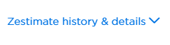
- You will see a graph like the sample shown below. Drag the vertical line back and forth to see the price history of the house for the past 10 years. There is a price comparison between the house, the average price in the neighborhood, and the average price of the city/county. 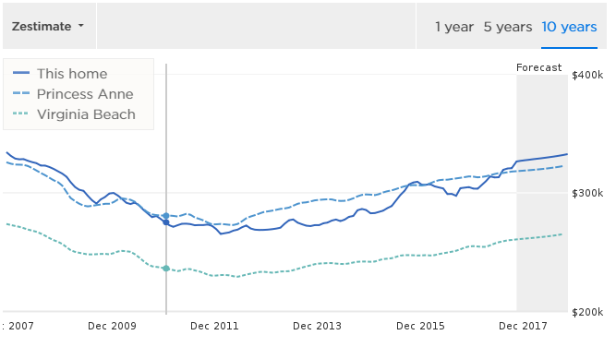
- If the price history is not available, use the tax assessment history for the past 10 years. Then, plot the points (year, tax assessment) and create a scatterplot of the data.

- Complete the table below to indicate the estimated price of the house for the past 10 years.
Year | Price of this home | Average Price of the Neighborhood | Average Price of the City/County
2007
2008
2009
2010
2011
2012
2013
2014
2015
2016
2017

- Using a graphing utility, input the data, create a scatterplot, and determine an appropriate function that models the data.
  - Model 1: Year vs. Price of the home _________________________

  - Using the equation in Model 1, what could have been the estimated price of the house in 2009? __________
2012? __________
2015? __________
Compare the estimate using the equation and the actual value from the table.
How well does the equation fit the data set? Explain your thinking.

  - Using the equation in Model 1, predict the value of the house in
2019 ____________
2022 ____________
2025 ____________
Are the predicted values reasonable? Explain your answer.

  - Do you think the equation in Model 1 can be used to predict the value of the house in the next 10 years? What are the limitations of the model?

