Comparing Linear and Exponential Models
Strand: Algebra and Functions
Topic: Comparing Linear and Exponential Models
Primary SOL: AFDA.3 The student will collect and analyze data, determine the equation of the curve of best fit in order to make predictions, and solve practical problems using models of linear, quadratic, and exponential functions.
Related SOL: AFDA.1, AFDA.2

Materials
- Who Wants to be a Millionaire? activity sheet (attached)
- Graphing utility, laptop, or other device
- Poster paper
- Markers

Vocabulary
curve of best fit, exponential function, line of best fit, linear function, regression equation, scatterplot

Student/Teacher Actions: What should students be doing? What should teachers be doing?
- Using the Who Wants to be a Millionaire activity sheet, ask students to read the problem first and ensure that everyone understands what each option means.
- Divide the class into three groups and have each group work on one of the available options. Require each group to complete the table, input the data on a graphing utility, create a scatterplot, decide what regression equation to use, and find the regression equation that best fits the data. Ask each group to use the regression equation to predict the salary on day 30.
- After each group has completed the task, have them write their output (table, scatterplot, equation, and predicted value using their equation) on poster paper and present their output to the whole class.
For schools with one-to-one technology, students can use a graphing utility such as www.desmos.com to input the table of values, create a scatterplot, and determine a line of best fit and a best fit equation. Then, ask each group to project their output to the whole class. An example is shown here:
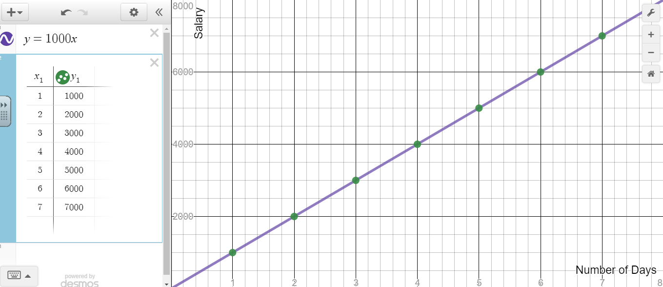

Assessment

Questions
- What is the unit of the slope in the regression equation? What does the slope represent in the context of the activity?
- What is the y-intercept of the regression equation? What does the y-intercept represent in the practical situations?
- Why do we need a line/curve of best fit for the data set? Do you think the equation works if you use it to predict the salary beyond 30 days?
- What is the reasonable domain and range of each regression equation created?
- How is option 2 similar to option 1? How are they different?
- After seeing the three options presented, which option yields a bigger value in the end? Why?
- How is option 3 different from options 1 and 2?
- Which function model grows faster over time? Can you think of practical examples that grow exponentially like option 3?

Journal/writing prompts
  - Explain why a linear equation is useful to represent the relationship between two variables (i.e., time vs. salary) in the data set?
  - Explain the similarities and differences between a linear function and an exponential function in terms of their key characteristics.

Other Assessments

The following table gives the value of a cellphone over time after you have purchased it.

Time (months) | 0 | 6 | 12 | 18 | 24 | 30
Value ($) | 650 | 620 | 590 | 560 | 530 | 500

Plot the given information. Label the x-axis and y-axis.
- Calculate the rate of change in dollars per month.

- What is the x-intercept for your equation?

- Write the linear equation for this situation in slope intercept form.

- What does the x-intercept tell us about this situation?

Extensions and Connections
- Ask students to research the price/tax history of any house they like on www.zillow.com by simply entering an address or choosing any house available on the website. Have students write a data table, create a scatterplot, and write a regression equation that they think will fit to the data. Ask them to justify whether the regression equation they created makes sense in practical situations.

Strategies for Differentiation
- Use vocabulary cards for related vocabulary listed above.

Use newspapers, magazines, or internet sites as sources of practical examples of data tables. Ask students to find a table of data from any of these sources and discuss the data to the whole class using graphs and equations.

Provide each group of students with actual data tables from various sources (e.g., value of a car over time, remaining loan amount over time) and have them create a video of their group explaining how to create a scatterplot, find the regression equation, why the equation is the best fit model, and how they can use the regression equation.
Note: The following pages are intended for classroom use for students as a visual aid to learning.
Who Wants to be a Millionaire?
You are sitting in mathematics class and the famous billionaire, Bill Buffett Jobs, offers you the job of a lifetime. You would only need to work for one month (30 days) and could become a millionaire, but there is a catch! He offers you three payment options; to show yourself worthy, you must pick the best option and explain your choice.
Option 1: You earn $1,000,000, evenly distributed over the 30-day period.
Option 2: You earn $3,000 the first day, then for each following day an additional $3,000 will be added to the previous day’s salary for the 30-day period.
Option 3: You earn one cent the first day, two cents the second, and double your salary each day thereafter for 30=day period.
Collecting Data
- Complete the table that assigned to your group.
Option 1 |  |  | Option 2 |  |  | Option 3
Day | Salary |  | Day | Salary |  | Day | Salary
1 |  |  | 1 |  |  | 1
2 |  |  | 2 |  |  | 2
3 |  |  | 3 |  |  | 3
4 |  |  | 4 |  |  | 4
5 |  |  | 5 |  |  | 5
6 |  |  | 6 |  |  | 6
7 |  |  | 7 |  |  | 7
- Input the data into the calculator or create a data table on www.desmos.com.

- Create a scatterplot and determine the best fit model (linear or exponential), then find the regression equation. Use the equation to predict the salary on day 30.

- Present the following information to the whole class for discussion.
- Data table
- Scatterplot with line/curve of best fit
- Regression equation
- Predicted value on day 30

