Quadratic Playground Exploration
Strand: Algebra and Function
Topic: Curve of best fit exploration
Primary SOL: AFDA.3 The student will collect and analyze data, determine the equation of the curve of best fit in order to make predictions, and solve practical problems using models of linear, quadratic, and exponential functions.
Related SOL: AFDA.1, AFDA.2

Materials
- Quadratics Playground Exploration activity sheet (attached)
- Graphing utility
- Whiteboard, document camera, or another demonstration tool

Vocabulary
curve of best fit, decreasing, domain, function, increasing, line of symmetry, linear function, maximum, minimum, parent function, quadratic function, range, x-intercept, y-intercept, zeros

Student/Teacher Actions: What should students be doing? What should teachers be doing?
Time: 90 minutes

Distribute copies of the Quadratics Playground Exploration activity sheet to students.
- Assign the activity to individuals or small groups.
- Read the introductory scenario to the class, and . facilitate a discussion using the following prompts:
  - “What is the problem?”
  - “What is the given information?”
  - “What do I need to know to solve the problem?”
  - “What strategies will work best in this situation?”
- Students (individually or small groups) will complete the chart on pages 1 and 2 of the activity sheet. As students work on the assignment, the teacher will support mathematical conversations and critical thinking by providing feedback.
- Students will exchange their work with another group to review another approach to finding solutions.
- Summarize the problem-solving approaches used by the class.
- Facilitate activity using a whiteboard, document camera, or another demonstration device. Students will use a graphing utility to complete the table. If possible, project a graphing utility to allow students to follow the input of information process.

Assessment

Questions

How do representations, graphs, and charts benefit your understanding of the problem?
  - What are the dimensions of the playground where area is optimized?
  - What are the dimensions of the playground where perimeter is optimized?

Journal/writing prompts

Share/describe another scenario where knowing the relationship between area and perimeter are important.
  - What characteristics of the data would make the curve of best fit appear quadratic?

Other Assessments

Using a geoboard and/or graph paper, students can explore the relationship between area and perimeter. The teacher would assign a specific value for perimeter and area. The guiding questions could be: “What if area is equal to 36?” “What if the perimeter is equal to 24?”
  - Given the values for area and perimeter, pair students to create a floor plan for a tiny house. Using graph paper or a computer software program, students would determine the optimal floor plan based on the customer’s need.

Extensions and Connections (for all students)

MIP Lesson AII.9 Quadratic Curve of Best Fit (currently in the Algebra 1 curriculum – A.11)

MIP Lesson AFDA.1 Quadratic Web Page Investigation

Strategies for Differentiation

Use geoboard to visualize possible solutions for the proposed playground.

Use colored pencils on the graphs to visualize the difference between x- and y-values.
- Students can use graph paper to construct graphs instead of using a graphing utility.

Note: The following pages are intended for classroom use for students as a visual aid to learning.

Quadratics Playground Exploration
Mary Ellen wants to add a playground to the backyard of her home for her small children. For convenience and safety, she wants the playground to be enclosed with a fence, but one side of the play area will be bounded by the house. She went to the store and got a great deal on 60 feet of fencing. She is trying to determine the best dimensions for the playground but is frustrated by the task. She decides to create a chart with the data she has already derived. Using the chart and the corresponding graph will enable Mary Ellen to make a wise decision.

Collecting the Data
1. Complete the following table:

WIDTH | 10 | 15 | 20 | 25 | 30 | 35 | 40 | 45 | 50 | 55 | 60
LENGTH
PERIMETER
AREA

2. Graph the relationship between the width (in feet) and the length (in feet) of the playground.
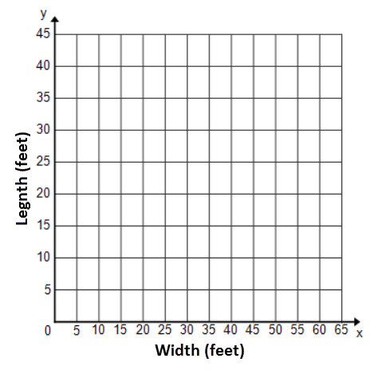
  - Describe the change in the playground by comparing the width (in feet) to the length (in feet).

  - What type of function models the curve relating width to the length of the playground? Explain your reasoning.

  - Determine the function that describes the curve relating width to length. (Note: Use a graphing utility to help you.)

y = ___________________________________

  - In your own words, describe how the curve relates width to length.

3. Graph the relationship between width (in feet) of the playground to its overall area (in square feet).
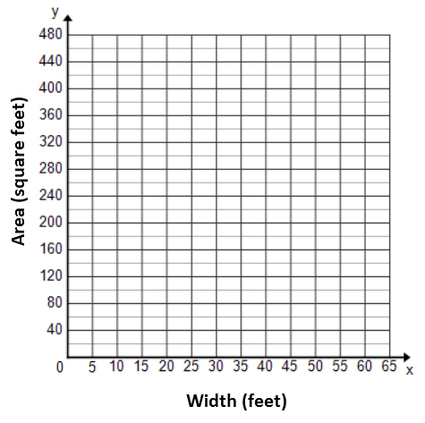

        - Describe the change in the playground by comparing the width (in feet) to the overall area (in square feet).

        - What type of function models the curve relating width to the area of the playground? Explain your reasoning.

        - Determine the function that describes the curve relating width to the area of the playground. (Note: Use a graphing utility to help you.)

y = _____________________________________

  - In your own words, describe how the curve relates width to the area of the playground.

4. You have made your decision about the best length and width of the playground.
The maximum area will be ___________________________, which is created using the following dimensions: _______________________.

5. Describe how you might determine the answers to maximize the area and determine the dimensions using the graphs.

6. Determine the following for the given scenario.
a. Domain - ____________________; Range - ___________________________

b. Explain and state the equation written in (h, k) form that represents the data.

c. What is the equation for the line of symmetry for the graph illustrating the scenario?

d. Describe what is happening in the practical situation when the graph is increasing and/or decreasing.

e. Describe the relationships between the data represented in the table, on the scatterplot, and as elements of the function.

