Mathematics Instructional Plan – Algebra II

Calculating Measures of Dispersion
Strand: Statistics
Topic: Calculating mean absolute deviation, variance, and standard deviation
Primary SOL: AII.11 The student will
- identify and describe properties of a normal distribution.

Materials
- Graphing utility

Vocabulary
dispersion, mean, measure of center, median, mode, notation, range, standard deviation, summation, variance

Student/Teacher Actions: What should students be doing? What should teachers be doing?
Time: 90 minutes
- Display the following scenario: “Students in Mrs. Smith’s Communication Club are interested in how many hours they spend watching television each week. They collected the following data for the number of hours each of them watched television in one week: 3, 8.5, 9, 9, 12.5, 14, 16.5, 18, 19, 20.5.” Ask students to think about what they could do with this data. Have them work in small groups or with partners to do what they can with the data. Some may represent it graphically, while some may find the mean, median, mode, or range.
x | x − μ
3
8.5
9
9
12.5
14
16.5
18
19
20.5
- Ask students to share what they chose to do with the data. Question students about what their graphs or statistics say about the information (e.g., “What do the measures of center tell us about the data? What does the range tell us about the data?”). In the discussion, stress that mean, median, and mode are measures of center, while range is a measure of the dispersion or spread of the data.
- Tell students that another way to measure dispersion is to compare the elements of the data set to the mean. Have students help you find the deviation of each value from the mean (i.e., the distance each data element is from the mean). Ask students how they would find this distance or deviation (subtract the mean from each value). Create a display chart like the one at right showing the original values in the first column and the deviations from the mean in the second column. Record the mean beside the chart, introducing the symbol μ for mean.
- Have the class help you fill in the chart. Ask them to calculate the average distance from the mean, or average deviation. Ask for their observations. (The deviations’ sum will be zero.) Ask students whether the sum of the deviations will always be zero, and have them explain why or why not. Once students determine that this will always occur because of the negative values, ask students how they could ensure that a number is always positive. Continue the discussion until the idea of absolute value emerges.
- Tell students that there is another method for finding the dispersion about the mean. Guide students to think of other ways to have no negatives in a set of numbers. Asking questions may get students thinking about experiences with quadratics and squaring numbers.
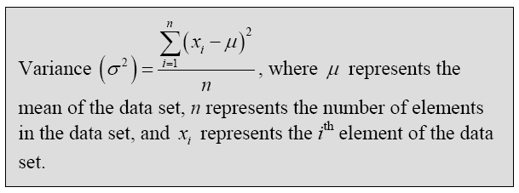
- Have students find the squared deviations. (Note: You may want to add another column to the chart for this.) Then, have students find the average of the squared deviations. Introduce this value as the variance, another measure of dispersion. Introduce the symbol for variance: σ². Also, show the formula for finding the variance, and have students explain how the formula correlates to what they did to compute the variance.
- Ask students what the unit of the variance is in this data set (hours²). Ask how they could get the unit to be the same as the units in the data (by taking the square root of the variance). Explain that this is called the standard deviation, which is another measure of dispersion. Introduce the symbol for standard deviation: σ. Provide students with the formula for finding standard deviation, and have them explain how this formula addresses dispersion.
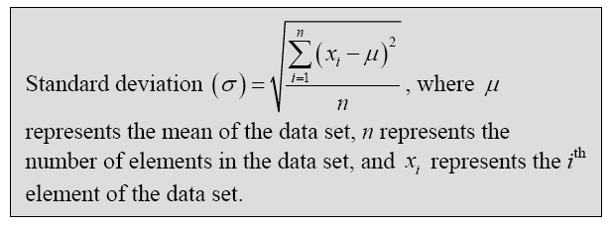
- Ask students what the standard deviation could tell them about the data. What would a high standard deviation indicate? What about a low value for the standard deviation?

Assessment

Questions
    - What are some ways you can measure the dispersion of a set of data?
    - How can you calculate each of these measures without using a graphing utility?

Journal/writing prompts
    - Explain why the methods of mean absolute deviation, variance, and standard deviation are used to measure dispersion.
    - Compare and contrast standard deviation and mean absolute deviation.

Other Assessments
    - Have students collect data from the class members and compute the standard deviation and mean absolute deviation. Have them use a graphing utility if the data set is large. Restrict the data elements to fewer than 10 if they are finding calculations without the aid of a graphing utility.

Extensions and Connections
- Have students remove the outlier in the data and recompute the standard deviation and mean absolute deviation. Have them determine which one seems to be more affected by an outlier.

Strategies for Differentiation
- Have students create a visual diagram to compare and contrast standard deviation and variance.
- Use vocabulary cards for related vocabulary listed above.
- Have students create a graphic organizer showing the vocabulary, statistics notation, and steps for calculating measures of dispersion.
- Give students with visual discrimination/processing issues a sheet that includes the formulas and definitions from the gray boxes in this lesson and examples of problems with data and correct numbers plugged into the formulas.
- Provide problems before the lesson that review symbols and operations used within various statistics formulas. For example:
    - Evaluate the following, if x = 6, y = 2, and z = 4.
$\frac{x − y}{z}$
    - Evaluate the following, if x₁ = 9, μ = 4, and σ = 4.
(x₁ − μ)²
$\frac{x1 − μ}{σ}$

