*Mathematics Instructional Plan – Algebra II*

# Normal Distribution

**Strand:**  Statistics

**Topic:**  Analyzing and using the standard normal curve

**Primary SOL:** AII.11 The student will

1. identify and describe properties of a normal distribution;
2. interpret and compare z-scores for normally distributed data; and
3. apply properties of normal distributions to determine probabilities associated with areas under the standard normal curve.

## Materials

* Statistics Review activity sheet (attached)
* Normal Distribution Exploration, Part 1, activity sheet (attached)
* Normal Distribution Exploration, Part 2, activity sheet (attached)
* Normal Distribution Exercises activity sheet (attached)
* Normal Distribution Practice activity sheet (attached)
* Normal Distribution Exploration, Part 3, activity sheet (attached)
* Standard Normal Probabilities Tables (attached)
* Graphing utility
* Normal curve graph paper

## Vocabulary

*area under a curve, descriptive statistics, discrete vs. continuous data, dispersion, empirical rule, mean, measures of center, median, mode, normal curve, normal distribution, percentile, probability, probability density function, quartile, standard deviation, variance, vertical line of symmetry, z-score, 68-95-99 rule*

## Student/Teacher Actions: What should students be doing? What should teachers be doing?

*Day 1, Time: 90 minutes*

1. Write the following terms on the board – *mean, median, mode, standard deviation*. Ask students to think-ink-pair-share what they know about the terms. Remind students they learned these terms in elementary and middle school. Once students have completed their brainstorm, present the vocabulary word wall cards to the students (post on the board or project using a demonstration tool). Discuss the definitions for each of the terms to ensure all students understand their meaning. Then pose the following questions:

* *“What is the relationship between mean and median?”*
* *“What does each value tell us about the measure of center?”*
* *“When is the mean not the best measure of center?”*
* *“What does standard deviation tell us about the distribution of data?”*

1. Distribute the Statistics Review activity sheet. Have students complete problems 1 and 2 individually or with a partner. When they are finished, have the whole class discuss problems 1 and 2. (*Note: Refer to curriculum frameworks for grades 6–8 for essential questions, skills, and knowledge to activate prior knowledge.*)
2. Ask students to review problem 3 and pose the following questions:

* *“What do you remember about probability from elementary and middle school?”*
* *“Look at the diagram. How do you record the experimental data for tossing four individual coins? How does the tree diagram support your understanding of the experiments?”*

1. Have students work in pairs or small groups to complete problem 3. Once the groups have completed the problem, ask students to share their solutions and explain how their problem-solving approaches.
2. Distribute the Normal Distribution Explorations, Part 1, activity sheet. Students may continue to work in small groups to complete the exercises. Introduce the problem scenario to the class and record student responses to the questions on the board. Note that flipping 10 coins 1,024 times is a complex task requiring extensive data collection and notetaking. Share with students one or two examples of software or applications which generate and record data for coin flipping and die rolling (e.g., Random.org’s [Coin Flipper](https://www.random.org/coins/?num=10&cur=60-usd.0001c)). (*Note: This problem connects discrete data and a histogram with the normal curve. Emphasis should be placed on interpreting the meaning of the height of each bar and the sum of the heights of all the bars.*)
3. Distribute the Normal Distribution Explorations, Part 2, activity sheet. Because the analysis along with reading a z-table is new, have students participate in a whole-class activity to complete it. (*Note: This activity focuses on finding area under a normal curve and interpreting the associated probability. The exercise can be done with the attached Standard Normal Probabilities Tables or with a graphing utility.*)

*Day 2, Time: 90 minutes*

1. Review the properties of normal curves and the empirical or 68-95-99.7 rule related to how data is positioned in a normal distribution. Then, distribute the Normal Distribution Exercises Activity Sheet and Normal Distribution Practice activity sheets, and have students use the practice handout to complete the exercises.
2. Distribute the Normal Distribution Explorations, Part 3, activity sheet, and have students work in pairs to complete it, discussing strategies they might use to identify the mean and standard deviations for each graph.

## Assessment

### Questions

* + - What are ways that the area under a standard normal curve is interpreted?
    - Why is the area under a normal curve equal to 1?

### Journal/writing prompts

* + - Explain what types of things you would look for in a data set that would indicate that the set is normally distributed. Provide examples and explain your rationale.
    - Describe a z-score in your own words.

### Other Assessments

* + Pose the following task/problem to students: *“How do your grades this marking period align with the class distribution?”* Students will work in small groups to create a graph of the overall class distribution of grades. The teacher will facilitate a review of each group’s work as a class to identify similarities and differences in each group’s graph. Once consensus is reached, each student will calculate their current grade and locate where their grade falls within the class distribution. Students will explain in writing where they belong in the overall class distribution of grades.
  + Student work in small groups to collect data, which can be displayed using a normal distribution (e.g., shoe sizes of students in a class, department, and/or school; heights of students in a class, department, and/or school, pulse rates, steps walked in a day by a person). Once the data is collected, students will analyze the data to create a normal distribution graph. Students can use a graphing utility to analyze the data and create the graph. Graphs can also be created using other multimedia tools (e.g. Excel).

## Extensions and Connections

* Think about collaborating with science teachers to collect data in a science lab (e.g. animal population density, genetics) related to normal distribution. The analysis of the data would be facilitated by both science and mathematics teachers to demonstrate the need for mathematical skills outside the classroom setting.
* Think about collaborating with history teachers to collect data related to population density changes during each decade of the 20th and 21st centuries. Students will make a stronger connection between statistical information included in their texts and reading material to the process of statistical analysis in their mathematics classes.

## Strategies for Differentiation

* Teach this topic over a longer period, using smaller amounts of information in each lesson.
* Create a human line plot according to students’ heights, and discuss how “normal” it is.
* Have students create and use flash cards with vocabulary on one side and descriptions or pictures on the other.
* Use an interactive whiteboard to demonstrate shading under the standard normal curve and to model use of a Standard Normal Table.

**Note: The following pages are intended for classroom use for students as a visual aid to learning.**

Virginia Department of Education © 2018

**Statistics Review**

**Problem 1**

You are given the data set {13, 10, 2, 2, 4, 12, 8, 6, 5, 9, 11, 14, 11, 8, 5, 8}.

1. Find the mean, median, and mode.
2. Add two different data values to the set that will not affect the mean, median, or mode.
3. Construct a histogram of the data, including the data values you added.
4. Using a graphing utility, find the standard deviation of the data set, including the new values.
5. Which values are within 1 standard deviation of the mean? Are any data values more than 2 standard deviations from the mean?
6. Add two more data values, one above and one below the mean, which will increase the standard deviation. Calculate the new standard deviation.

**Problem 2**

A z-score indicates the location of a data value relative to the mean in terms of standard deviation units. You are given a data set with a mean of µ = 10 and a standard deviation of σ = 2.

1. Why would a data value of 12 have a z-score of 1? Why would a data value of 8 have a z-score of −1?
2. What z-score would be assigned to 6? To 14? To 5? To 20?
3. What data value would have a z-score of −3? Of 4? Of zero? Of 2.5?
4. Write a formula to determine the z-score for any value, *x*, in this data set.

**Problem 3**

An experiment consists of flipping four coins and recording the number of heads.

1. Complete the table of possible outcomes shown at right.

**Outcomes**

H

T

H

H

H

H

H

H

H

H

H

H

H

H

H

H

T

T

T

T

T

T

T

T

T

T

T

T

T

T

|  |
| --- |
| HHHH |
|  |
|  |
|  |
|  |
|  |
|  |
|  |
|  |
| THHT |
|  |
|  |
|  |
|  |
|  |
|  |

Coin 1

Coin 4

Coin 3

Coin 2

1. Are all outcomes equally likely? Why, or why not?
2. What is the probability of getting THHT? Of getting TTHH? Of getting HHHH?
3. What is the probability of getting exactly four heads? Of getting two heads and two tails? Of getting one head and three tails?
4. What is the sum of all the probabilities?

**Normal Distribution Exploration, Part 1**

What is normal? What makes normal curves different? If you flip 10 coins 1,024 times, what is the total number of times you will get heads? You can test this if you want, but let us first focus on the theoretical probabilities. Using *combinations*, we can obtain the expected values and theoretical probabilities shown in the table.

|  |  |  |  |
| --- | --- | --- | --- |
| **Number of heads** | **Expected frequency value out of 1,024** | **Theoretical probability** | **Percent likelihood** |
| 0 | 1 |  |  |
| 1 | 10 |  |  |
| 2 | 45 |  |  |
| 3 | 120 |  |  |
| 4 | 210 |  |  |
| 5 | 252 |  |  |
| 6 | 210 |  |  |
| 7 | 120 |  |  |
| 8 | 45 |  |  |
| 9 | 10 |  |  |
| 10 | 1 |  |  |

1. What is the sum of all the probabilities?
2. Complete the percent likelihood by converting the theoretical probability to a decimal.
3. What observations can you make about the data in the table so far?
4. On the axis below, complete the histogram of the theoretical probability for each number of heads.

0 1 2 3 4 5 6 7 8 9

**Number of Heads**



**Probability**

1. Draw a point at the midpoint of the top of each bar.
2. Connect the data points with a smooth curve.
3. What do you observe about the graph’s shape?
4. What do you observe about the graph’s symmetry?
5. What do you observe about the graph’s highest point?
6. What do you observe about the graph’s mean/median/mode probability?  
   In the box below, read about the characteristics of a normal curve, and then describe how the curve you drew compares to a normal curve.

**The graph of a normal distribution is a normal curve.**

**Every normal curve has the following characteristics:**

* **The mean, median, and mode are equal.**
* **They are bell-shaped and symmetrical about the mean.**
* **The curve never touches the *x*-axis, but it comes closer to the *x*-axis as it gets farther from the mean.**
* **The total area under the curve is equal to 1.**

**Normal Distribution Exploration, Part 2**

**Problem 1**

|  |  |
| --- | --- |
| **Height (cm)** | **Frequency** |
| **130** | **2** |
| **131** | **7** |
| **132** | **9** |
| **133** | **20** |
| **134** | **38** |
| **135** | **18** |
| **136** | **12** |
| **137** | **10** |
| **138** | **5** |

The table at right shows the heights of all fourth-grade students in a particular school, and the frequency of each height.

1. Construct a histogram of the data on the axis below.

Height (cm)

Frequency

1. What percentage of the students is shorter than 135 centimeters?
2. What is the probability that the height of a randomly selected student would be greater than 132 centimeters but less than 138 centimeters?
3. How many fourth-grade students are represented in the data?
4. What is the mean height of the data set?
5. Does the data appear to be normally distributed? Why, or why not?

**Problem 2**

The graphs below reflect the number of pets veterinarians own. The value associated with each bar represents the fraction of veterinarians with that many pets.

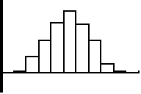

0 1 2 3 4 5 6 7 8 9 10

























0 1 2 3 4 5 6 7 8 9 10























Shade the bars representing owning more than or equal to 5 pets. What fraction of owners has 5 or more pets?

Shade the bars representing owning more than 2 but fewer than 7 pets. What fraction of owners falls into this group?

**Normal Distribution Exercises**

Represent each of the following distributions on one of the normal distribution graphs found on the Normal Distribution Practice sheet. For each, show three standard deviations to the left and three standard deviations to the right of the mean.

1. A normal distribution with a mean of 7 and a standard deviation of 2.
2. A normal distribution with a mean of 500 and a standard deviation of 100.
3. The weights of cattle at the fair this year were normally distributed, with a mean of 800 pounds and a standard deviation of 65 pounds.
4. The amount of time a middle school student studies per night is normally distributed with a mean of 30 minutes and a standard deviation of 7 minutes.
5. The length of hair of a private in the army is normally distributed, with a mean of 1 centimeter and a standard deviation of 0.3 centimeter.
6. The number of crackers in a box of Crackerbox Crackers is normally distributed, with a mean of 75 and a standard deviation of 2. Shade the region under the curve that represents the probability that a box has between 73 and 77 crackers. What is that probability?
7. The length of time it takes to groom a dog at Shaggy’s Pet Shoppe is normally distributed, with a mean of 45 minutes and a standard deviation of 10 minutes. Shade the region under the curve that represents the percent of dog grooming times between 55 and 65 minutes. What is that percent?

Complete the following problems:

1. The College of Knowledge gives an admission qualifying exam. The results are normally distributed, with a mean of 500 and a standard deviation of 100. The admissions department would like to accept only students who score in the 65th percentile or better. Complete the chart below, and then determine which students would qualify and what score is associated with the 65th percentile. Which students qualify for admission?

|  |  |  |
| --- | --- | --- |
| **Student score** | **z-score** | **Percentile** |
| 530 |  |  |
| 570 |  |  |
| 650 |  |  |
| 800 |  |  |
| 540 |  |  |

1. The MP3 player, aPod, made by Mango Corp., has an average battery life of 400 hours. Battery life for the aPod is normally distributed, with a standard deviation of 25 hours. The MP3 player, PeaPod, made by Pineapple Inc., has an average battery life of 390 hours. The distribution for its battery life is also normally distributed, with a standard deviation of 30 hours.

* Find the z-scores for each battery with lives of 250, 350, 410, and 450 hours.
* Which battery lasting 410 hours performed better?
* What percent of aPod batteries lasts between 375 and 410 hours?
* What percent of PeaPod batteries lasts morethan 370 hours?

1. The braking distance for a Krazy-Car traveling at 50 mph is normally distributed, with a mean of 50 feet and a standard deviation of 5 feet. Answer the following without using a calculator or a table.

* What is the likelihood a Krazy-Car will take more than 65 feet to stop?
* What is the probability a Krazy-Car will stop between 45 and 55 feet?
* What percent of the time will a Krazy-Car traveling at 50 mph stop between 35 and 55 feet?
* What is the probability a Krazy-Car will require less than 50 feet or more than 60 feet to stop?

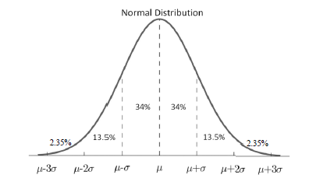**Normal Distribution Practice**

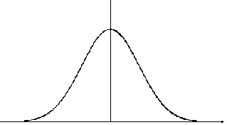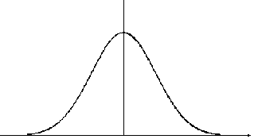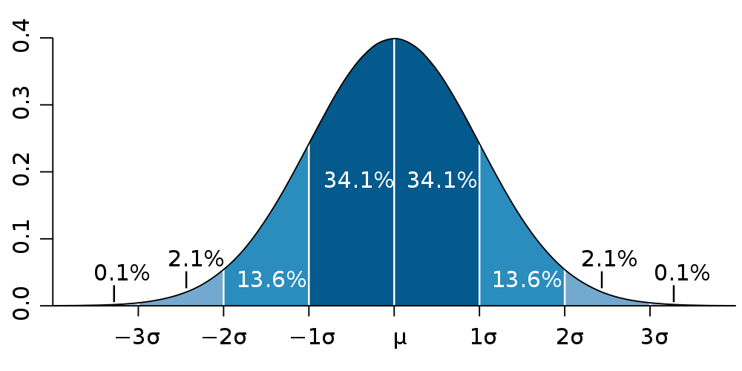

**Normal Distribution Exploration, Part 3**

Areas can be found under a normal curve by using the 68-95-99.7 rule if the areas are bounded at places where an exact standard deviation occurs. Areas that are not bounded at specific standard deviation units can be found by using a graphing utility or a z-table.

**Problem 1**

A corn chip factory packs chips in bags with normally distributed weights with a mean of 12.4 ounces and a standard deviation of 0.15 ounces.

1. On the graph at right, label the mean and three standard deviations above and below the mean.
2. Shade the region that indicates the percentage of bags that contains less than 12.64 ounces.
3. Determine the z-score corresponding to 12.64, using the formula z-score = .
4. Use the Standard Normal Probabilities Table to find the area associated with the z-score obtained in 3. Interpret your result.
5. On the graph at right, label and shade the region that represents the likelihood a bag will contain between 12.1 and 12.76 ounces.
6. Calculate the z-scores corresponding to both 12.1 and 12.76, and find the Standard Normal Probabilities for each, using a graphing utility or the Standard Normal Probabilities Table.
7. Explain how you would use those values to determine the probability a bag chosen at random will contain between 12.1 and 12.76 ounces.

**Problem 2**

The lengths of adult unicorns’ horns are normally distributed, with a mean of 10.1 centimeters and a standard deviation of 1.04 centimeters.

1. On the graph at right, label the mean and three standard deviations above and below the mean.
2. What percent of adult unicorns have horns shorter than 10.1 centimeters? _______ Longer than 10.1 centimeters? ______ Exactly 10.1 centimeters? ______ (For this one, you need to create the normal curve with your graphing utility and find the value of *y* when *x* = 10.1. Your teacher may help.)
3. On the graph at right, shade the region that represents the probability of a unicorn’s horn being longer than 9 centimeters. Calculate the area of that region by finding the appropriate z-score and using the Standard Normal Probabilities Table or a calculator. Interpret your result.



1. On the graph at right, shade the region that represents the probability of unicorn’s horn being longer than 10.5 centimeters or less than 9.5 centimeters. Calculate the area of the associated regions by finding the appropriate z-score and using the Standard Normal Probabilities Table or a graphing utility. Interpret your result.



1. Challenge: In order for a unicorn to be admitted to college, her horn must be in the 75th percentile. That means 75 percent of the unicorns must have horns shorter than hers. On the graph at right, shade the region representing this area, and determine the value associated with the 75th percentile.

**Problem 3**

Graph each of the following normal curves in the same viewing window using a graphing utility. The mean is either 7, 8, 9, or 10. The standard deviation is either 1, 1.5, 2, or 2.5.

Use this information to determine the mean and standard deviation of each graph.



μ = σ =



μ = σ =



μ = σ =



μ = σ =



μ = σ =



μ = σ =



μ = σ =



μ = σ =

**Standard Normal Probabilities Tables**



