Mathematics Instructional Plan – Algebra II

Extrema
Strand: Functions
Topic: Identify the location and value of absolute and relative maxima and minima of functions
Primary SOL: AII.7 The student will investigate and analyze linear, quadratic, absolute value, square root, cube root, rational, polynomial, exponential, and logarithmic function families algebraically and graphically. Key concepts include
- extrema.
Related SOL: AII.6, AII.7a,b,f

Materials
- Locating Extrema Given Graphs activity sheet (attached)
- Locating Extrema Given Equations activity sheet (attached)
- Graphing utility

Vocabulary
absolute maximum, absolute minimum, absolute value, cube root, domain, exponential, function, logarithmic, maxima, minima, polynomial, rational, relative maximum, relative minimum, square root

Student/Teacher Actions: What should students be doing? What should teachers be doing?
Time: 90 minutes
- Discuss with the whole class the difference between relative and absolute maximum and minimums. Distribute the Locating Extrema Given Graphs activity sheet. In pairs or small groups, have students complete the activity sheet.
- Bring the whole class together. Ensure that students have discovered that functions transitioning from increasing to decreasing have an absolute maximum and that functions transitioning from decreasing to increasing have an absolute minimum.
- Distribute the Locating Extrema Given Equations activity sheet. Students will need to use a graphing utility to complete this activity. Many graphing utilities will have the choice to calculate the minimum or maximum between an interval through a calculations menu.

Assessment

Questions
  - Looking at the standard form for a quadratic equation, y = ax² + bx + c, determine whether the quadratic has an absolute minimum or maximum.
  - Is it possible for a function to have both an absolute minimum and maximum? A relative minimum and maximum?

Journal/writing prompts
  - Describe, in your own words, how to determine the absolute maximum or minimum given the graph of a function without the equation.
  - Give the general characteristics of a minimum or a maximum, state similarities and differences.

Other Assessments
  - Use a sorting activity during which students must organize graphs and equations of functions as having an absolute maximum, absolute minimum, or neither.
  - Have students complete a warm-up activity the next day where they must determine the relative minimum or maximum of equations when given the domain.

Extensions and Connections
- Have students find the vertex of quadratic and absolute value functions to determine the absolute minimum and maximum.
- Use questions 7–9 on the Locating Extrema Given Graphs activity sheet to relate slope of the equation to slope of a line tangent, which will be covered in precalculus.
- Have students throw a tennis ball in the air and use two data points, (0, 0), and (time to impact ground, 0) to solve for the constant b in the equation $y=-16x^{2}+bx$. From this equation, have students determine the maximum height of the tennis ball.
- Have students work backward with a graphing utility. The teacher specifies the domain where a function must have a relative maximum or minimum, and students need to find an example.

Strategies for Differentiation
- Have students fold their note sheets to create four quadrants (Absolute Minimum, Absolute Maximum, Relative Minimum, and Relative Maximum) and include definitions and examples of each so that students can better compare and contrast the terms.
- Use vocabulary cards for related vocabulary listed above.
- Have students determine the largest domain that would leave the solutions of questions 6–10 on the Locating Extrema Given Equations activity sheet the same for the relative minimum and maximum.

Note: The following pages are intended for classroom use for students as a visual aid to learning.

Virginia Department of Education © 2018

Locating Extrema Given Graphs
Determine the absolute maximum or minimum of the following functions, if one exists.

1.
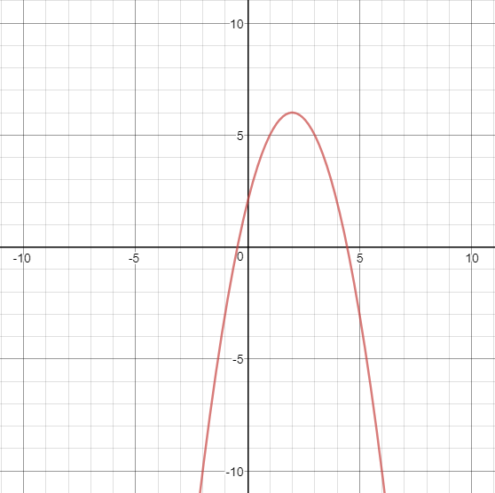

3. 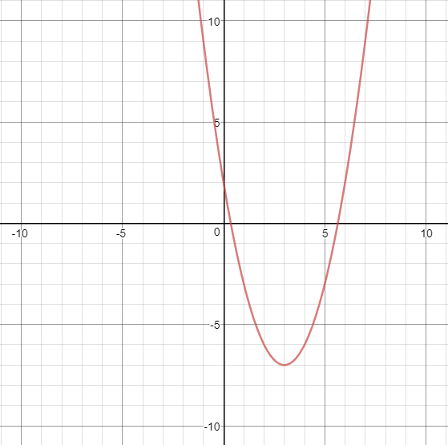

2. 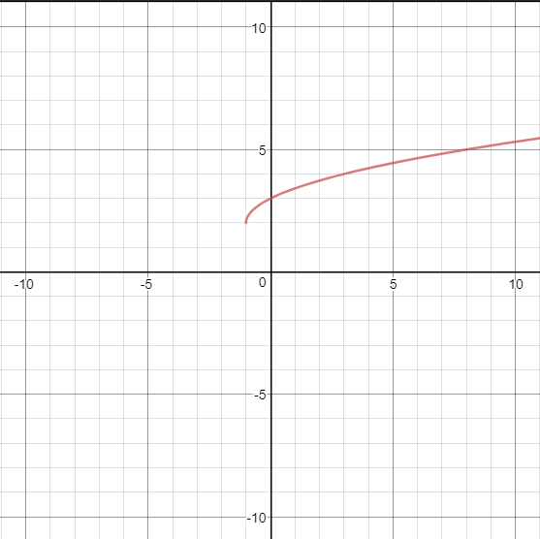

4.
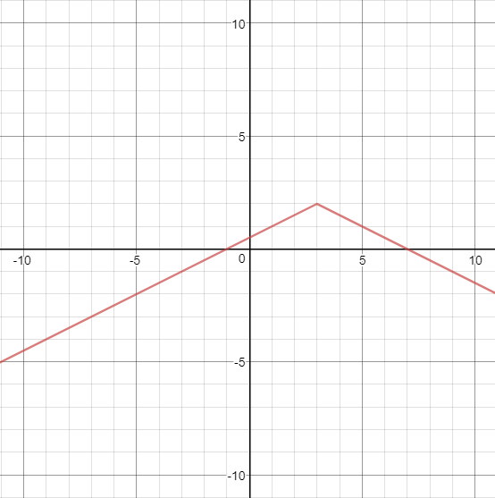

5.
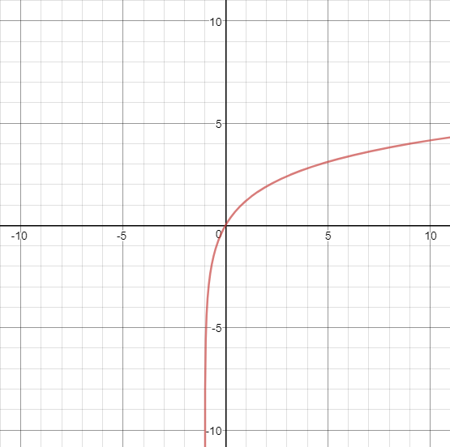

6.
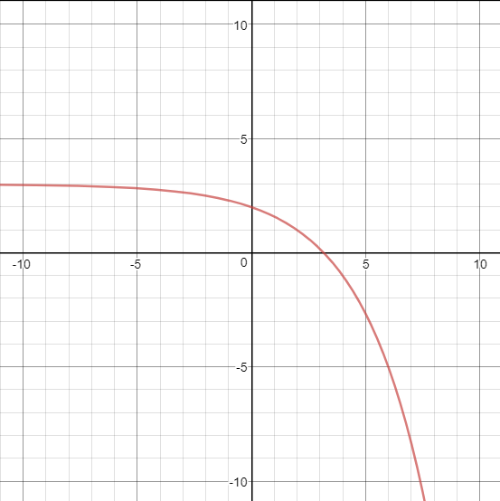
Looking at the graphs for questions 1-6, determine the following:
- For the functions with an absolute maximum, is the function increasing, decreasing, or constant before the maximum? What about after the maximum?
- For the functions with an absolute minimum, is the function increasing, decreasing, or constant before the minimum? What about after the minimum?
- If the function moves from increasing to decreasing or decreasing to increasing, then what might be the slope at the maximum or minimum?
- Of the graphs above, which types of functions do not have a minimum or maximum?

Find the relative maximum or minimum of the following functions over the given domains.

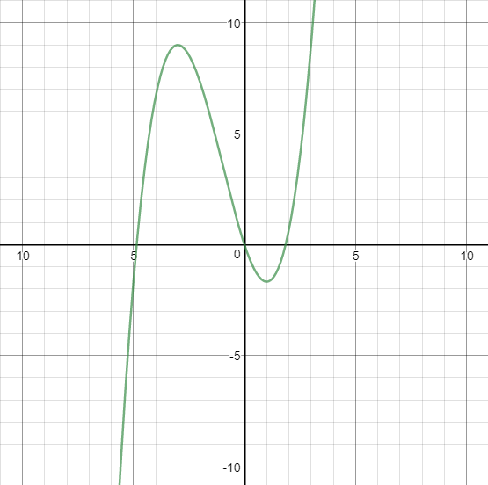
- Relative maximum when $x:(-∞,0)$
- Relative minimum when $x≥0$

- Relative Maximum when $\left\{x | 0<x≤10\right\}$

- Relative Minimum when $\left\{x | -10<x≤0\right\}$

Locating Extrema Given Equations
Use a graphing utility to determine the location and value of the absolute minimum or maximum, if it exists. You may round to the nearest hundredth if necessary.
- $y={2\left(x+2\right)}^{2}-7$
- $y={-(x+2)}^{2}+1$
- $y=\frac{1}{3}\left|x-5\right|+2$
- $y={-(x+2)}^{3}-1$
- $y=x-7$

Use a graphing utility to determine the location and value of the relative minimum or maximum, if it exists. You may round to the nearest hundredth if necessary.
- $y=2^{x}, maximum when x:(-∞,\left.4\right]$
- $y=-x^{3}+2x^{2}+5x-6, maximum when x:\left[0,3\right]$
- $y=-x^{3}+2x^{2}+5x-6, minimum when x:\left[-6,1\right]$
- $y={-(x+2)}^{3}-1, minimum when x:\left[-3,2\right]$
- $y=3x-7, minimum when x:(-∞,\left.3.2\right]$

