*Mathematics Instructional Plan – Algebra II*

# Functions: Extrema, Intervals Increasing and Decreasing

**Strand:**  Functions

**Topic:**  Finding extrema and intervals increasing and decreasing for a function

**Primary SOL:** AII.7 The student will investigate and analyze linear, quadratic, absolute value, square root, cube root, rational, polynomial, exponential, and logarithmic function families algebraically and graphically. Key concepts include

1. intervals in which a function is increasing or decreasing;
2. and extrema

**Related SOL:** AII.6

## Materials

* Ups and Downs activity sheet (attached)
* Extrema, Intervals Increasing and Decreasing Practice activity sheet (attached)
* Graphing utility
* Demonstration tool (document camera, graphing software, or other)

## Vocabulary

*absolute maximum, absolute minimum, extrema, interval decreasing, interval increasing, interval notation, relative maximum, relative minimum, set notation*

## Student/Teacher Actions: What should students be doing? What should teachers be doing?

*Time: 90 minutes*

1. Distribute the Ups and Downs activity sheet to students. Allow students approximately 10 minutes to complete the first section of the activity. Display the graph using a document camera or other projection device and discuss the student results of the activity.
2. Introduce the terms *absolute maximum*, *absolute minimum*, *relative minimum*, and *relative maximum* to describe the highest and lowest points on the roller coaster. Discuss the length, in horizontal feet, of the first rise of the coaster. Use this to introduce the idea of intervals increasing and decreasing.
3. Display the function of example 1 (page 3 of the Ups and Downs activity sheet) using a demonstration tool, and ask students to find the extrema and intervals increasing and decreasing. Students can share their response with a partner, with a small group, or use individual whiteboards to display their answers for a quick assessment. Make sure that students can identify both what the maximums and minimums are and where they occur. For example, a relative maximum is at the point (0, 6). The absolute maximum is 6 and it occurs at *x* = 0. If students have difficulty finding the intervals increasing or decreasing, use an index card or sticky note to cover up the other regions so students can see the axis and identify the interval. Students should be able to write the intervals in both set notation and interval notation.
4. Have students graph examples 2 and 3 on page 3 of the Ups and Downs activity sheet. Remind students that they will need to find the maximum and minimum points for each using a graphing utility. Students may need a review of how to find the minimum and maximum points using the graphing utility available to them. Students should also note that the second example has no absolute minimum but does have an absolute maximum.
5. Let students try examples 4 and 5 and then discuss these as a class. Ask students, “What type of function is shown in example 4?” Have students graph this function and discuss whether it has any extrema points. Ask, *“What does it mean if a function has no extrema points? Where are the increasing or decreasing intervals?”* Have students complete the last example in pairs or in small groups.
6. Distribute the Extrema, Interval Increasing and Decreasing Practice activity sheet. These problems could be done as whole-class practice, or students can work independently based on the current level of understanding.

## Assessment

### Questions

* + Which function families will not have maximum or minimum points? Why?
  + What is the absolute minimum point of the function? What do you notice? Write a quadratic equation with a minimum point at (5, 2).
  + Draw a polynomial function with an absolute maximum of 7 at, a relative minimum of -3 at, and a relative maximum of 4 at. Where is the function increasing?

### Journal/writing prompts

* + Compare an absolute minimum with a relative minimum.
  + Is it possible for a function to have an absolute maximum and an absolute minimum?
  + Create and describe a function, both algebraically and graphically, that would be increasing in two different intervals and decreasing in one interval.

### Other Assessments

* + Using individual whiteboards, have students shade the intervals increasing or decreasing for a given function.

## Extensions and Connections

* Have students compare the slope of a line tangent to the curve where it is increasing versus when it is decreasing or at the maximum or minimum.

## Strategies for Differentiation

* Use a graphic organizer to help students organize vocabulary.
* Use index cards or sticky notes to help students isolate the intervals as they identify them.
* Use vocabulary cards for related vocabulary listed above.
* Review describing intervals using number lines, set notation, and interval notation.

**Note: The following pages are intended for classroom use for students as a visual aid to learning.**

Virginia Department of Education © 2018

**Ups and Downs**

Use the graph of the roller coaster below to complete the following.

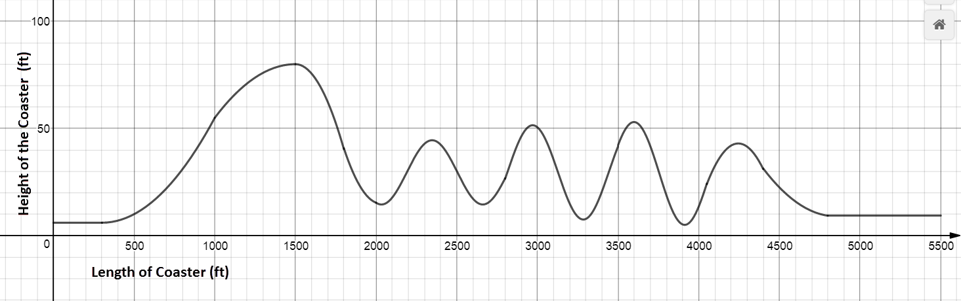

1. How many hills does the roller coaster have?
2. What is the highest point on the coaster? How far from the start of the coaster does the rider reach this height?
3. What is the lowest point on the coaster? How far from the start of the coaster does the rider reach this height?
4. Where is the longest drop (in linear feet) on the coaster? How long is that drop?
5. Where is the shortest drop on the coaster? How long is that drop?
6. Where is the longest hill? (The anticipation is killing you as you climb this one!)
7. How high are the cars at the start of the coaster? At the end?



**Absolute Maximum**: ____________________________________________________________

1. What is the absolute maximum height of the coaster? Where does it occur?

**Absolute Minimum:** _____________________________________________________________

1. What is the absolute minimum height of the coaster? Where does it occur?

**Relative Maximum:** _____________________________________________________________

1. What are the relative maximums? Where do they occur?

**Relative Minimum:** _____________________________________________________________

1. What are the relative minimums? Where do they occur?

**Interval increasing:** ____________________________________________________________

1. List the intervals where the roller coaster is increasing.

**Interval decreasing:** ___________________________________________________________

1. List the intervals where the roller coaster is decreasing.

***Examples***: Find the extrema and the interval increasing and decreasing for each function below.

|  |  |  |
| --- | --- | --- |
| 1. |  | Absolute maximum:  Absolute minimum:  Relative maximum:  Relative minimum:  Interval increasing:  Interval decreasing: |
| 2. |  | Absolute maximum:  Absolute minimum:  Relative maximum:  Relative minimum:  Interval increasing:  Interval decreasing: |
| 3. |  | Absolute maximum:  Absolute minimum:  Relative maximum:  Relative minimum:  Interval increasing:  Interval decreasing: |

|  |  |  |
| --- | --- | --- |
| 4. |  | Absolute maximum:  Absolute minimum:  Relative maximum:  Relative minimum:  Interval increasing:  Interval decreasing: |
| 5. | C:\Users\Lois\AppData\Local\Temp\SNAGHTML1366cc7d.PNG | Absolute maximum:  Absolute minimum:  Relative maximum:  Relative minimum:  Interval increasing:  Interval decreasing: |

**Extrema, Intervals Increasing and Decreasing Practice**

Find the extrema, interval(s) increasing, and interval(s) decreasing for each function below.

|  |  |  |  |
| --- | --- | --- | --- |
| 1. |  | 2. |  |
| 3. |  | 4. |  |
| 5. |  | 6. |  |
| 7. |  | 8. |  |