*Mathematics Instructional Plan – Algebra II*

# Transformational Graphing

**Strand:**  Functions

**Topic:**  Exploring Transformational Graphing

**Primary SOL:** AII.6 For absolute value, square root, cube root, rational, polynomial, exponential, and logarithmic functions, the student will

1. recognize the general shape of function families; and
2. use knowledge of transformations to convert between equations and the corresponding graphs of functions.

**Related SOL:** AII.7

## Materials

* Function Family Matching Cards activity sheet (attached)
* Transformational Graphing activity sheet (attached)
* Graph paper
* Graphing utility

## Vocabulary

absolute value, logarithmic function, mapped, quadratic term, reflection, transformation, vertex, exponential function

## Student/Teacher Actions: What should students be doing? What should teachers be doing?

*Time: 90 minutes*

1. Have students create a table of values in order to graph the following parent functions on graph paper without using a graphing utility.



After students have graphed each function, assign a function to each group of students and ask them to describe the general shape of the graph and the zeros of the function.

1. Have students graph the following functions, referencing the parent functionand using a table of values:

.

Discuss with students the following guiding questions:

* 1. *“How does each function differ from the parent function, $(x)= x^{2}$?”*
  2. *“Why is the horizontal shift to the left when $f\left(x\right)= {\left(x+3\right)}^{2}$ and to the right when $f\left(x\right)= {\left(x-3\right)}^{2}$?”*

1. Debrief students’ responses by asking what makes the value of the *quadratic term* zero. Guide them to relate that to the vertex of each parabola. Stress that the parent function, *y* = *x*2, has a double zero at (0, 0). Because a horizontal shift has no vertical change, the new function still has a double zero, and the vertex is on the *x*-axis.
2. Have students hypothesize what the graphs of the following functions would look like: .

Direct students to write down the transformations they believe will occur. Then, have students check by graphing the functions on their graphing utility. A graphing utility is also available through [Desmos](https://www.desmos.com/calculator/8keeh1pt5l).

1. Transition into a discussion about the similarities of transformations in a quadratic function to absolute value, square root, and cubic and cube-root functions. Lead students to generalize their conjectures about function transformation by having them complete the table below using appropriate mathematical terms.

| **Translations** |  |
| --- | --- |
| $$f(x+h)$$ |  |
| $$f(x-h)$$ |  |
| $$f\left(x\right)+k$$ |  |
| $$f\left(x\right)-k$$ |  |
| **Dilations** |  |
|  |  |
|  |  |
| **Reflections** |  |
| $$-f(x)$$ |  |

1. The VDOE Mathematics Vocabulary Word Wall Cards include cards for linear and quadratic function transformations. Vertical and horizontal dilations may be a struggle for students to discern. The vocabulary cards for quadratic function vertical and horizontal dilations are shown below:

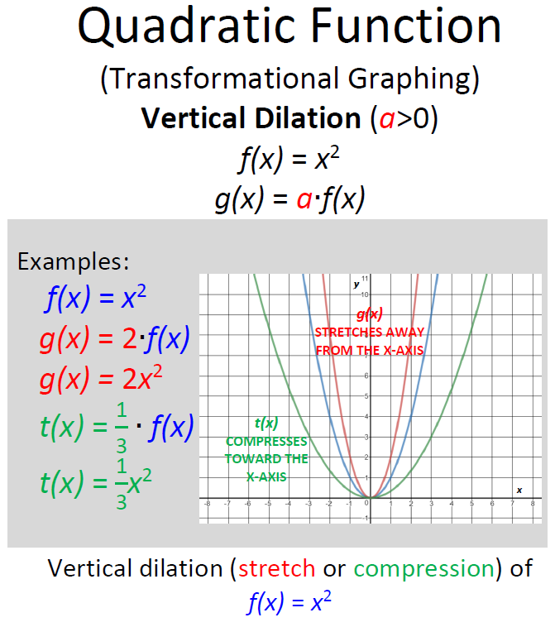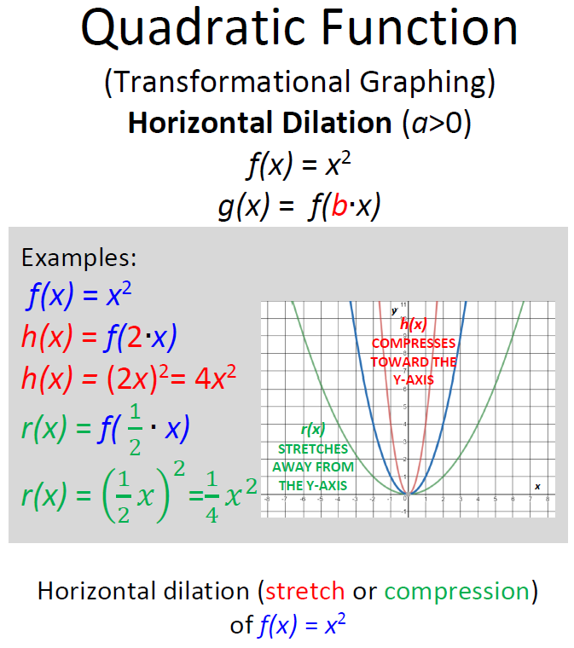

1. Introduce the graph of a logarithmic function and, if you have already taught inverse functions, define it as the inverse of an exponential function (given that the bases are the same). Otherwise, just name it and have students graph it using their graphing utility. Discuss the behavior of the graph of the function. Compare it to the graph they drew of *y* = 2*x*.
2. Conduct the Function Family Matching Cards activity in two different ways:

* Give each group of three or four students an entire set of the Function Family Matching Cards activity sheet. Have groups match each function to its corresponding graph. If they have difficulty, encourage them to separate the cards into the different function families.
* Give each student one card. Have each student who is holding a graph card write the equation that corresponds to the graph. Have each student holding an algebraic function card draw a rough sketch of the graph that corresponds to the function. Then, direct students to find their partners and check their responses.

1. Distribute copies of the Transformational Graphing activity sheet. Have students work with partners to complete it. Have the partners alternate completing the problems, with one taking even-numbered problems and the other taking odd-numbered problems. When each student has completed one problem, have partners exchange papers and check each other’s work. If corrections are necessary, the student who did the problem should make the changes. When both students agree on the first two problems, then the students should move on to the next set of problems. Have them continue in this manner until the handout is complete. Be sure to check students’ work along the way to be sure they are on the right track.

## Assessment

### Questions

* + - What transformations will map?
    - I am a function. My parent function is . My parent function is mapped onto me by a reflection over the line *y* = 0, then a horizontal shift 3 units to the right, a vertical shift 4 units up, and finally a horizontal stretch with a factor of 2. Who am I?

### Journal/Writing Prompts

* + - Given a quadratic function written in the form $f\left(x\right)=a(x-h)^{2}+k$, explain how the values of a, h and k determine the vertex, shape and orientation of the graph compared to the parent function $f\left(x\right)=x^{2}$.
    - Explain the fact that the graphs of  are the same, yet the graphs of  are different.

### Other Assessments

* Duplicate a quiz (such as these about transformational graphing at [Quizziz](https://quizizz.com/admin/search/Transformation%20Graphing)) or create your own quiz a formative assessment instead of using a worksheet.
  + Have students complete the following Khan Academy practice exercises:
  + [“Shifting Functions”](https://www.khanacademy.org/math/algebra2/manipulating-functions#shifting-functions)
  + [“Transforming Functions”](https://www.khanacademy.org/math/algebra2/manipulating-functions/modal/e/shifting_and_reflecting_functions)

## Extensions and Connections (for all students)

* Put students into groups of four, and assign each group one of the following function families: absolute value, quadratic, square root, cube root and cubic, exponential, or logarithmic. Have each group designate two function writers and two function sketchers. The function writers will create algebraic functions that include at least two transformations from a parent function each. The function sketchers will create separate graphs that have at least two transformational differences from a parent function. The sketchers and the writers will then exchange work and write or sketch the function that corresponds to what they are now holding. Creators will check the work of their group members.
* Demonstrate the transformations from  onto.
* Have students write  in vertex form and then graph the function by using transformational mapping from the parent function .
* Present students with the following problem to be solved. Projectile motion refers to the motion of an object acted on only by the force of gravity. The height,  of a projectile at any time,  can be found by using the quadratic function , where *g* is the acceleration due to gravity , is the initial upward velocity of the object, and  is the initial height of the object. If two projectiles are thrown with the same initial velocity but one is thrown from a height of 10 meters while the other is thrown from a height of 42 meters, how would the graphs of the motions of the two objects differ?

## Strategies for Differentiation

* Have students model horizontal and vertical shifts, using body movement.
* Use an overlay, either with an interactive whiteboard or transparencies, to demonstrate transformations on a parent (anchor) function.
* Have students create and use vocabulary flash cards with illustrations to reinforce transformational terminology.
* Have students work in groups to create a video showing how to graph a function family of their choice with translation, dilation, and reflection.

**Note: The following pages are intended for classroom use for students as a visual aid to learning.**

Virginia Department of Education © 2018

**Function Family Matching Cards**

|  |  |
| --- | --- |
|  |  |
|  |  |
|  |  |
|  |  |

|  |  |
| --- | --- |
|  |  |
|  |  |
|  |  |
|  |  |

|  |  |
| --- | --- |
|  |  |
|  |  |
|  |  |
|  |  |

|  |  |
| --- | --- |
|  |  |
|  |  |
|  |  |
|  |  |

|  |  |
| --- | --- |
|  |  |
|  |  |
|  |  |
|  |  |

|  |  |
| --- | --- |
|  |  |
|  |  |
|  |  |
|  |  |

**Transformational Graphing**

Determine and graph the parent function in pen, then the given function in pencil.

1.  2.  3. 

4.  5.  6. 

7.  8. 

9.  10. 

Write the algebraic function represented by the graph.

|  |  |
| --- | --- |
|  |  |
| 11. ________________________________ | 12. ________________________________ |
|  |  |
| 13. ________________________________ | 14. ________________________________ |
|  |  |
| 15. ________________________________ | 16. ________________________________ |